Learning Places Fall 2016
Chin/Swift

SITE REPORT [part III: site of performance]
Signature Theater

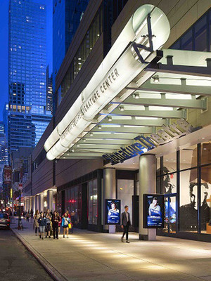

Andrea Cano
11.05.2016

INTRODUCTION
Describe Scope of Activity [identify performance and venue (name of production and building/producing organization]

The requirement for this project was to the tour in the Signature theater and see a play. The choices we had were The Death of the Last Black Man in the Whole Entire World or Master Harold and The Boys.

PRE-VISIT INFORMATION
Write any kind of information and opinions received or images viewed prior to your visit that shaped your eventual reception of the play and site visit. In other words, describe information about the site and/or play that informed your actual visit.
Professor Chin gave us interesting information about Signature Theater that caught my attention. So, I was very interested in the tour to observe everything related to the changes of scenery, maybe had an access to the backstage, but none of the above. Unfortunately, the tour was not interesting. However, I did enjoy the visit to the Signature Theater because it breaks the traditional concept of a theater. First, no ticket is required to enter the building. This theater offers a great public space where people can enjoy the restaurant, bar, and bookstore surrounded by three theaters: The Diamond, The Linney and The Griffin.
After we explored a little bit we had to do the line for our play; I choose The Death of the Last Black Man in the Whole Entire World By Suzan Lori and direct by Lileana Blain. This performance was in the Griffin auditorium.

SITE DOCUMENTATION (photos/sketches)

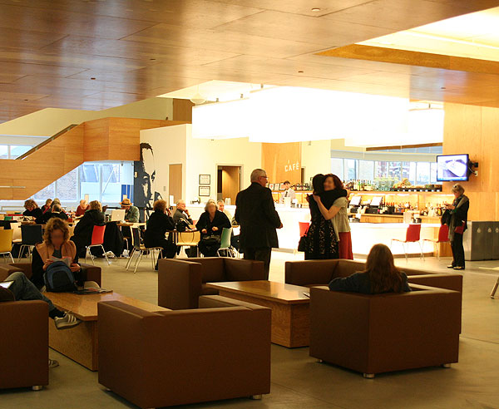
I am not sure if they always have live music, but fortunately, we had the opportunity to hear a couple playing a piano and a harmonica, which was wonderful. The space is large enough where people can sit in comfortable chairs, in the bar, at the restaurants or on the stairs.
It is a place where people can enjoy the ambiance, observing the design of the place, reading a book, or listening to music.

Write description of sketch or photo here, explaining why it is important and what it shows
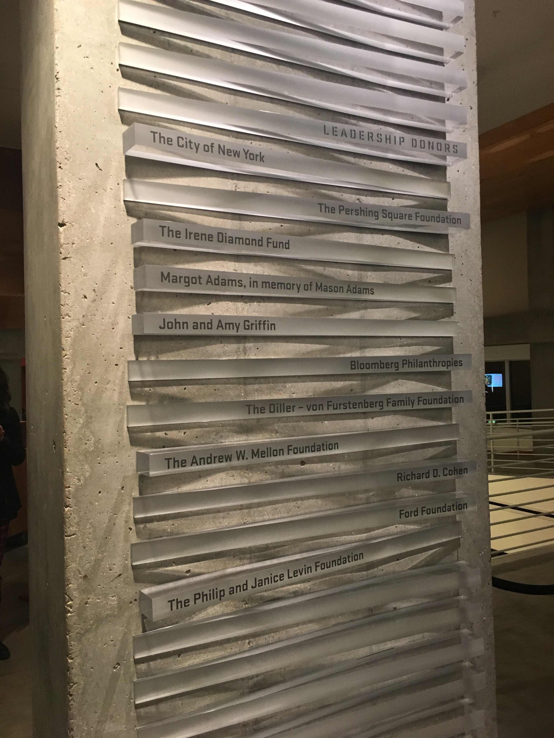
In this picture there is a list of people who have donated to support the theater, young artists, and directors. Also, it makes the price attainable in order to promote the art of theater for everybody. The fees that patrons pay allow the price of the tickets to be affordable.

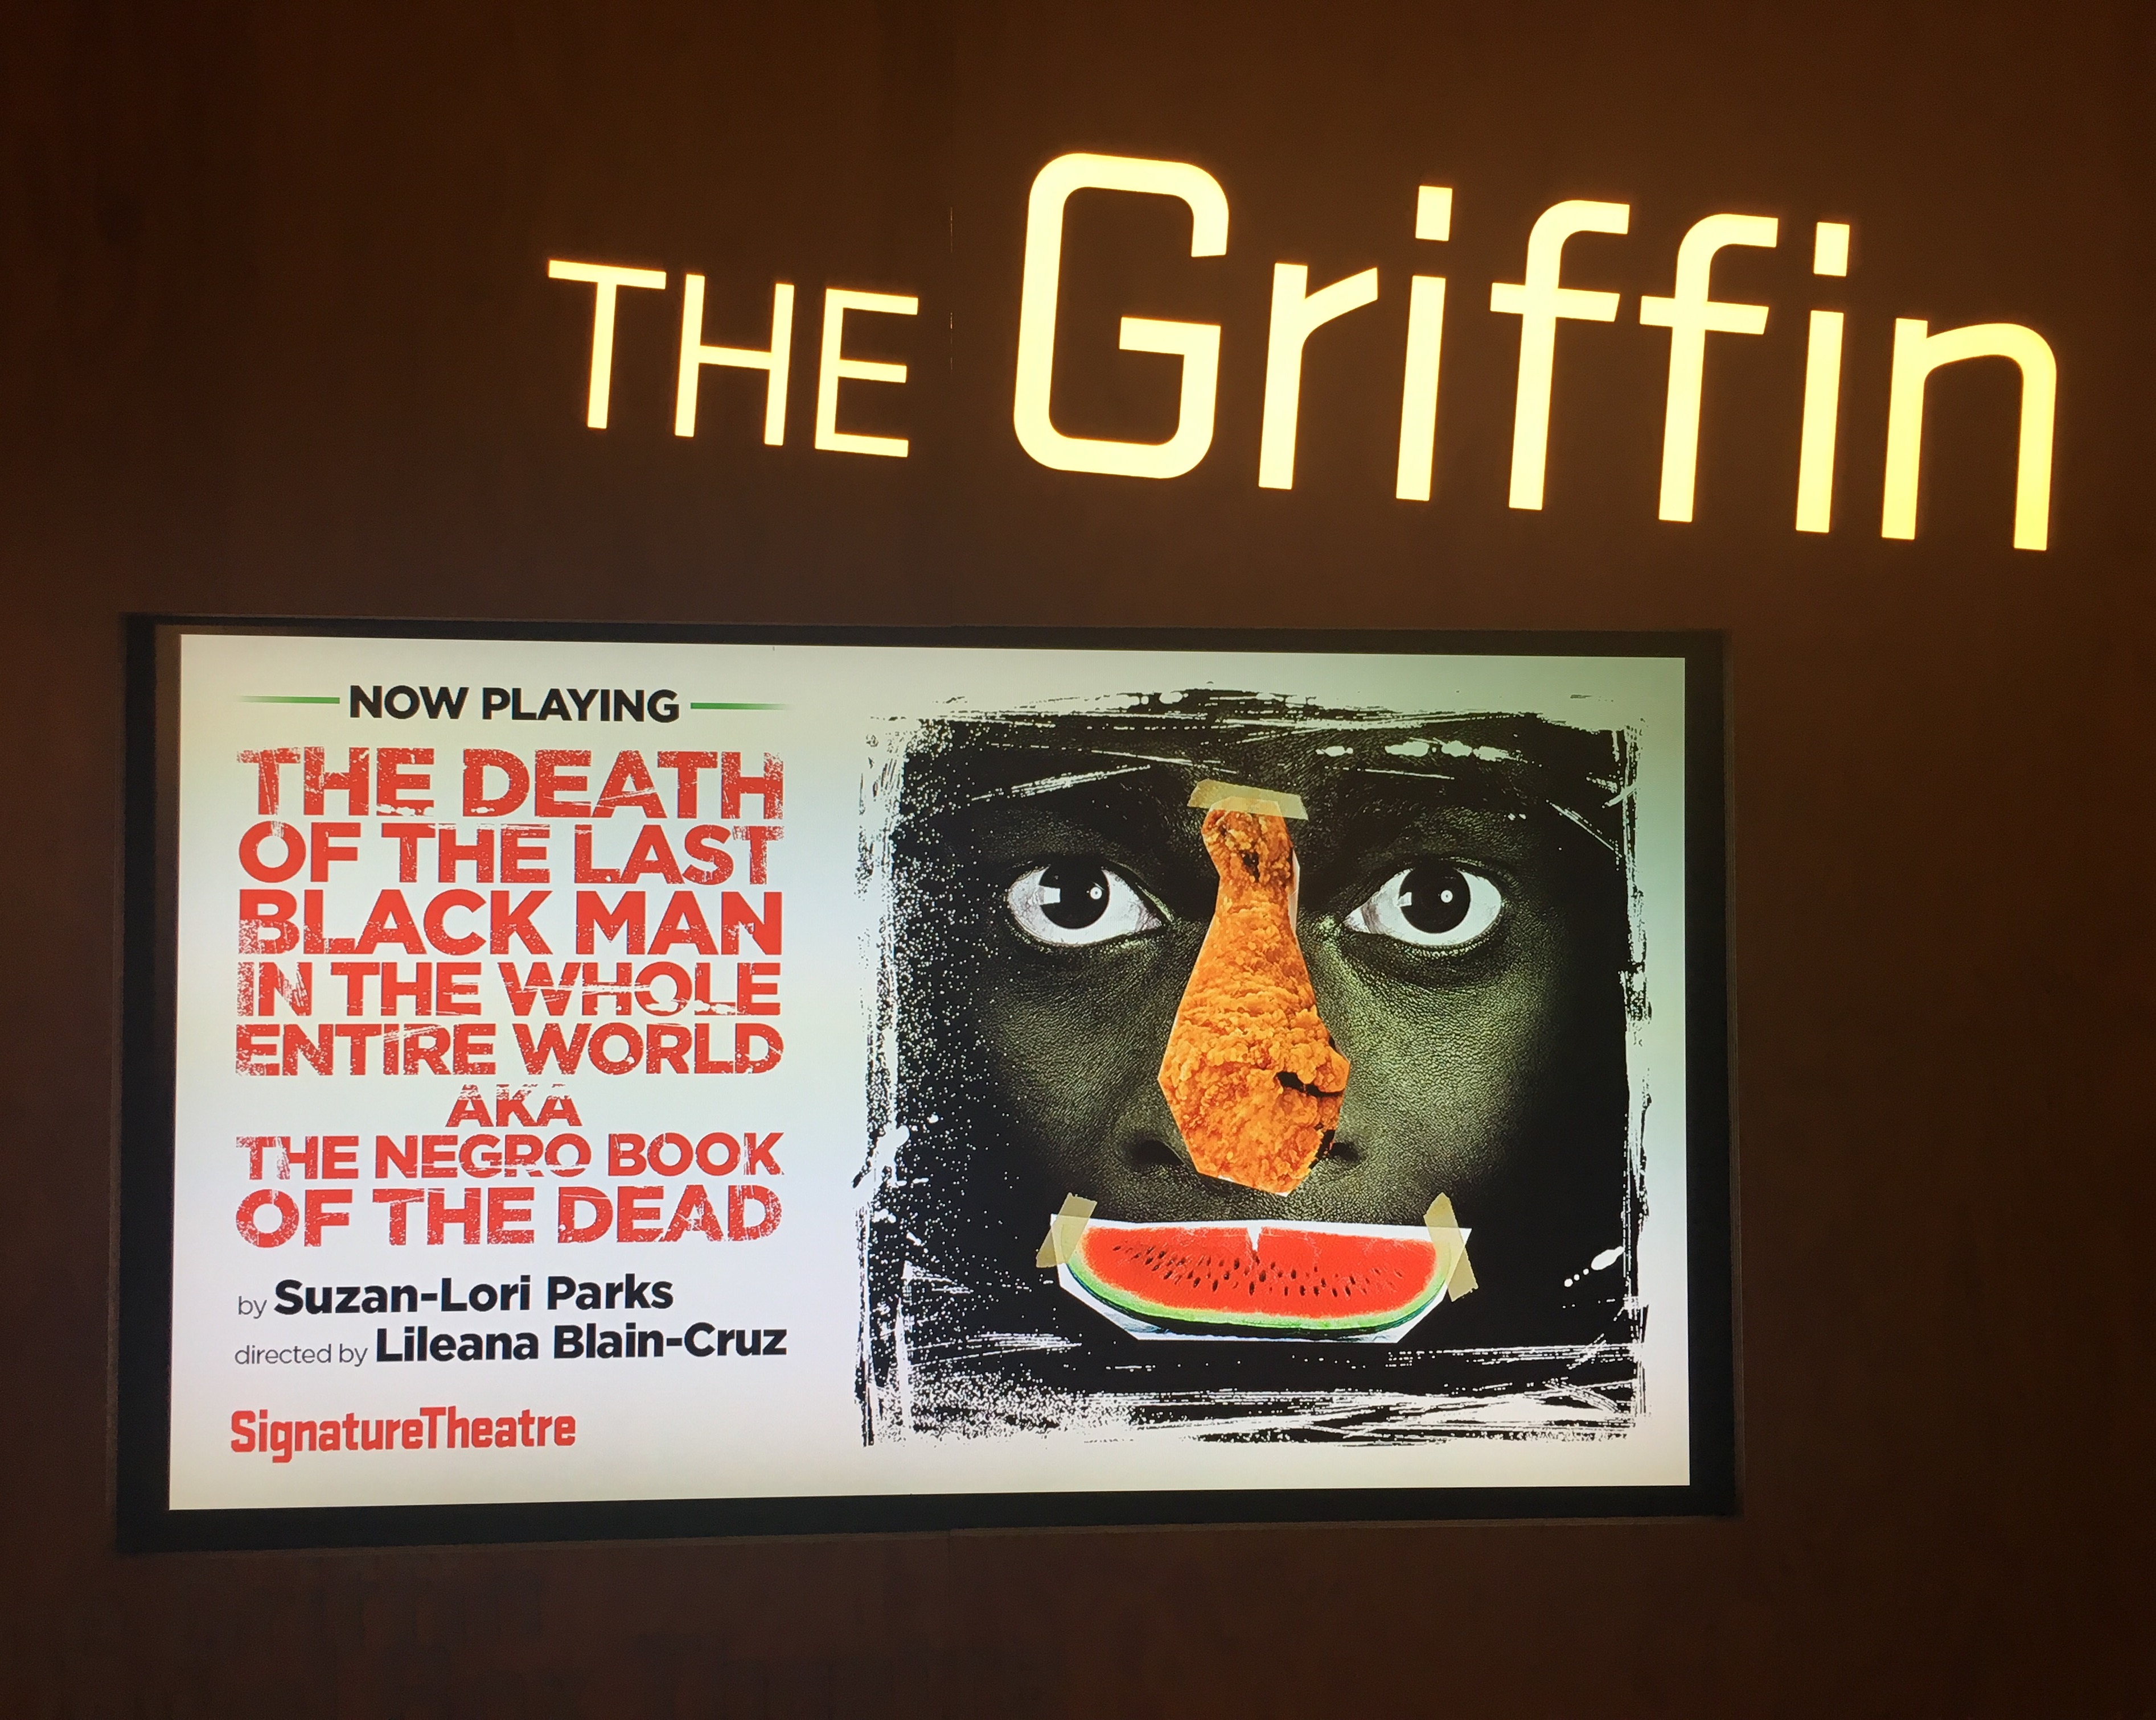
I choose The Death of the Last Black Man in the Whole Entire World By Suzan Lori and direct By Lileana Blain. This performance was in the Griffin auditorium.
This performance was really confused, and I still think the message “ you need to write this down into a rock” was to remember all the Afro-Americans that have been murdered and also an expression of protest that this cannot keep happening. I also believe that it can represent the African American Culture where they show their dances, songs and joy. Also witchcraft beliefs when they show the scene of eggs, and as the actress spoke with the spirit of her husband during the play.

QUALITATIVE SITE OBSERVATIONS
- Description of architectural elements of the auditorium where the performance was held (stage arrangement (proscenium, thrust, in the round, etc.), seating arrangement (amphitheater, orchestra and balcony, etc. aisles, types of seats, risers, etc.)
The design has a combination between concrete, wood and aged iron that gives a very modern touch and it is quite minimalist too.
Inside of The Griffin Theater a “Crafted plywood panels frame the proscenium and wrap around the balcony front, creating a ceiling under the lighting bridges above the audience. It has the horseshoe shape in order to resemble a small European house.” (Signature Theater 2016)

- Description of the physical element on the stage (set pieces, technologies, lighting,
Each wood panel is stained a deep chocolate brown that fades to black as the lights come down on the audience. The panels are acoustically engineered to fill the house with full, clear, and rich sound. Modeled after a miniature opera house, The Griffin features boxes so close to the stage audience members can almost reach out and touch the actors. Whether in the orchestra or in the balcony, The Griffin immerses its audience in the world of the play. (Signature Theater 2016)

- Description of audience (socio-economic, community identity)
Because of its prices and environment this theater is open for everyone. As a spectator you can see people of different ages, culture and socio-economic status.

QUANTITATIVE DATA for Area of Study
Subject | Data
Size of performance space | Stage Dimensions 36’ W x 25” D  Stage Floor 4x8 removable Wenger platforms
Size of spectator space | 140 chairs in Orchestra, 51 Balcony  Proscenium 25’- 11 ¾” W x 19’-9 ¾” D
Number of spectators (range) | Capacity: The Griffin 191 seats
Length (in time) of performance | 2 Hours
Cost of performance (if any) | $37
Other data | Designed by Frank Gehry Architects, Off Broadway - 70,000 sq -
QUESTIONS TO RESEARCH FURTHER
QUESTIONS:
- How many years does the Signature Theater and who is the founder
- Where it started?
- Who is Frank Gehry?
RESEARCH METHOD/SOURCE FOR EACH QUESTION ABOVE:
- Question 1
  - This theater stared 20 years ago.
  - James Houghton is the founding artistic director.
- Question 2
  - 20 years ago in small storefront on Bond st.

- Question 3
  - Canadian- American Architecture known for postmodern designs, including the Walt Disney Concert Hall and the Guggenheim Museum in Bilbao.
  - Gehry is known for his choice of unusual materials as well as his architectural philosophy.
- Gehry's architectural firm is based in Los Angeles (B. 2016)

References
B. (2016, November 2). Frank Gehry Biography. Retrieved November 05, 2014, from http://www.biography.com/people/frank-gehry-9308278
Signature Theatre - The Griffin Theatre at The Pershing Square Signature Center. (2016). Retrieved November 05, 2016, from https://www.signaturetheatre.org/Visit/The-Building/The-Griffin.aspx

