**SITE REPORT** [part III: site of performance] **SIGNATURE THEATRE**

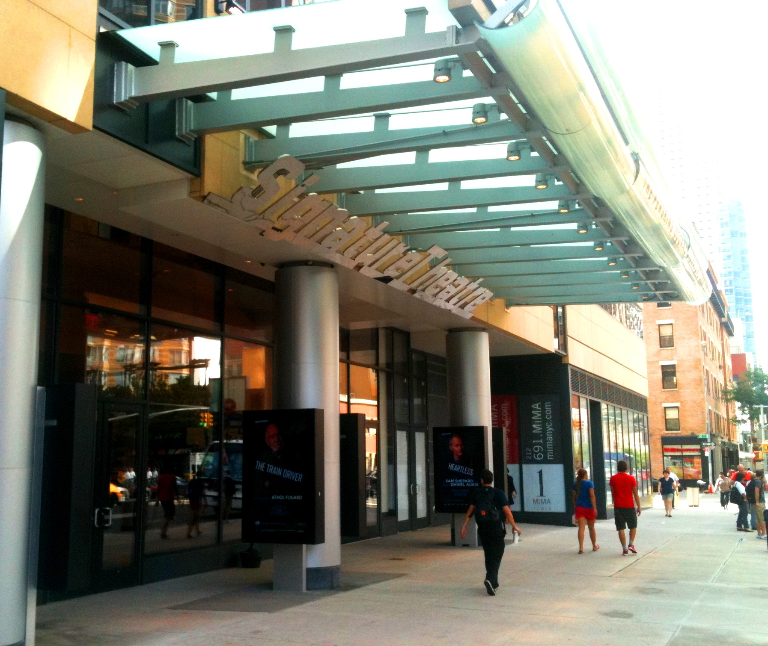

**Ryan Richards**

**INTRODUCTION**

For this site report, we went to Signature Theatre. I chose to watch “The Death of the Last Black Man in the Whole Entire World” play by Suzan-Lori Parks, because the title stood out to me, so I was curious to further see what the play was about.

**PRE-VISIT INFORMATION**

I haven’t visited the signature theatre before viewing this play. I have seen a couple performances years ago, the most memorable was The Lion King on Broadway, I was captivated by the title so I looked forward to what this show was going to be like. The location of the theatre also had me more excited to give it a try.

**SITE DOCUMENTATION (photos/sketches)**

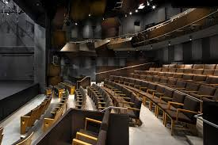

**This image is of the empty theatre.**

The performance space had a very potent theme. It wasn’t the largest however the details were very fine, the partially wooden seats were nice, and the wooden design of the balcony was really nice. What was also interesting was the theatre wasn’t so spacious itself, the stage was. The actors and performers had plenty space to operate. And the acoustics allowed them to be heard vibrantly.

2 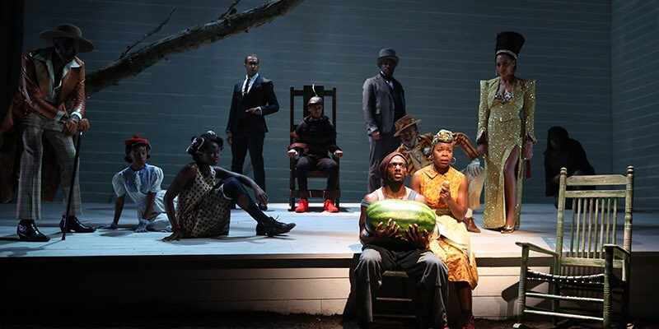

**This image represents the symbolism of the black man holding the “conventional” watermelon**

I chose to incorporate this image because it represents many different messages, as well as the entire play. Throughout the play there were scenes sung in unison, replicating something important that used to happen in black history. Another big message I retrieved from the play was that this man was dying numerous, different deaths, figuratively.

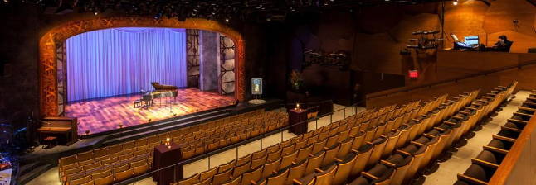

The space is designed to be able to hold a lot of people, in which come some of its flaws. The balconies above, were designed very poorly in terms of space. Just about every person, including myself had to sit with their legs slanted over to the side as to fit in between the narrow space of their seat, and

**QUALITATIVE SITE OBSERVATIONS**

1. Description of architectural elements of the auditorium where the performance was held (stage arrangement (proscenium, thrust, in the round, etc.), seating arrangement (amphitheater, orchestra and balcony, etc. aisles, types of seats, risers, etc.)

The theatre has a potent design; the seats were close to eachotber arranged in 3 sections on the lower level. There were also balconies on top. The seats were designed nicely and fit very well with the overall design of the theater room. In terms of comfort there could have definitely been improvements. At times during the performance it felt like I could not sit anymore without getting up to stretch my legs, which I obviously could not.

1. Description of the physical element on the stage (set pieces, technologies, lighting, The lighting of the play was vibrant, and the pla was rather simplistic so items were very blatent
2. Description of audience (socio-economic, community identity)  
   The audience had to be middle class, I caught the performance on a later date so there wasn’t any students, mainly middle aged people.

3

**QUANTITATIVE DATA for Area of Study**

|  |  |
| --- | --- |
| Subject | Data |
| Size of performance space | The stage appeared sizely. Plently people fit on it with more room to spare |
| Size of spectator space | Compacted, seats close, appears spacious (Speaking in terms of the balconies). |
| Number of spectators (range) | Roughly 200 people |
| Length (in time) of performance | An Hour and 15 mins |
| Cost of performance (if any) | $30+ |
| Other data |  |

**QUESTIONS TO RESEARCH FURTHER**

QUESTIONS:

1. How is the theatre built to set an appropriate stage for the type of shows played there?
2. Is this theatre based off another theatre? Or theme?