Learning Places Fall 2016
Chin/Swift

SITE REPORT [part III: site of performance]
name of site report

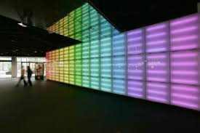

STUDENT NAME
00.00.2016

INTRODUCTION
Describe Scope of Activity [identify performance and venue (name of production and building/producing organization]

PRE-VISIT INFORMATION
Write any kind of information and opinions received or images viewed prior to your visit that shaped your eventual reception of the play and site visit. In other words, describe information about the site and/or play that informed your actual visit.

SITE DOCUMENTATION (photos/sketches)

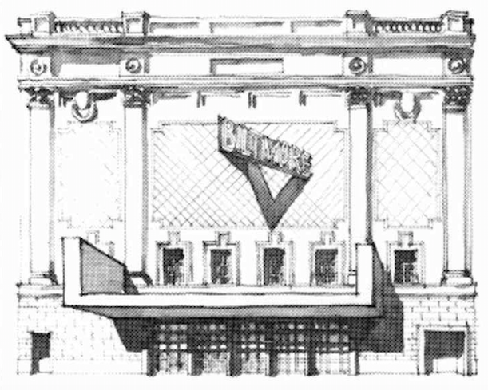

Write description of sketch or photo here, explaining why it is important and what it shows

Write description of sketch or photo here, explaining why it is important and what it shows Write description of sketch or photo here, explaining why it is important and what it shows Write description of sketch or photo here, explaining why it is important and what it shows Write description of sketch or photo here, explaining why it is important and what it shows Write description of sketch or photo here, explaining why it is important and what it show
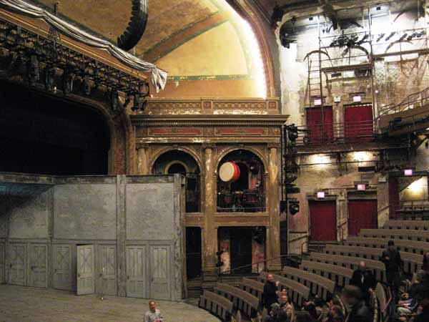

Write description of sketch or photo here, explaining why it is important and what it shows

Write description of sketch or photo here, explaining why it is important and what it shows Write description of sketch or photo here, explaining why it is important and what it shows Write description of sketch or photo here, explaining why it is important and what it shows Write description of sketch or photo here, explaining why it is important and what it shows Write description of sketch or photo here, explaining why it is important and what it shows

QUALITATIVE SITE OBSERVATIONS
- Description of architectural elements of the auditorium where the performance was held (stage arrangement (proscenium, thrust, in the round, etc.), seating arrangement (amphitheater, orchestra and balcony, etc. aisles, types of seats, risers, etc.)

- Description of the physical element on the stage (set pieces, technologies, lighting,

- Description of audience (socio-economic, community identity)

QUANTITATIVE DATA for Area of Study
Subject | Data
Size of performance space
Size of spectator space
Number of spectators (range)
Length (in time) of performance
Cost of performance (if any)
Other data

QUESTIONS TO RESEARCH FURTHER
QUESTIONS:
- Lorem ipsum dolor sit amet?
- Consectetuer adipiscing elit?
- Sed diam nonummy nibh euismod?
RESEARCH METHOD/SOURCE FOR EACH QUESTION ABOVE:
- Question 1
  - xx
  - xx
  - xx
- Question 2
  - xx
  - xx
  - xx
- Question 3
  - xx
  - xx
  - xx

