Learning Places Fall 2016
LIBRARY / ARCHIVE REPORT
name of archive/ library

sqdqdw

Leslie Fuller
00.00.2015

This is a map of 1902. It has street signs that you can visually understand. It shows 59th street thru 65th street. It doesn’t look like as it was today. It is close to Lincoln Center and Fordham University Center. The map has pink and white color

I went to the New York Public Library and saw different old maps that dates back from the 1500’s the way Manhattan used to look like compare today.

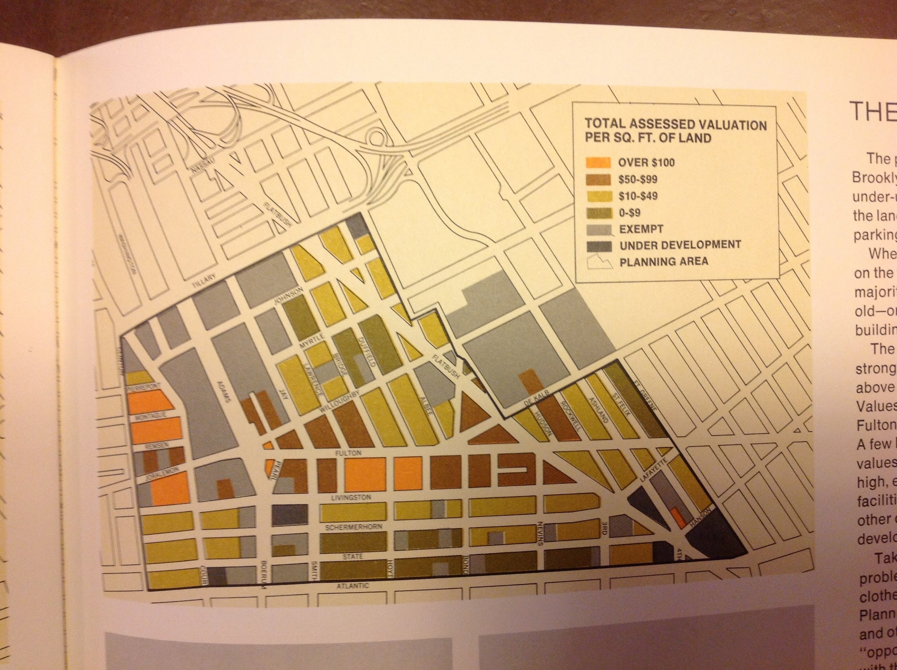

Write description of sketch or photo here, explaining why it is important and what it shows Write description of sketch or photo here, explaining why it is important and what it shows Write description of sketch or photo here, explaining why it is important and what it shows Write description of sketch or photo here, explaining why it is important and what it shows Write description of sketch or photo here, explaining why it is important and what it shows Write description of sketch or photo here, explaining why it is important and what it shows Write description of sketch or photo here, explaining why it is important and what it shows

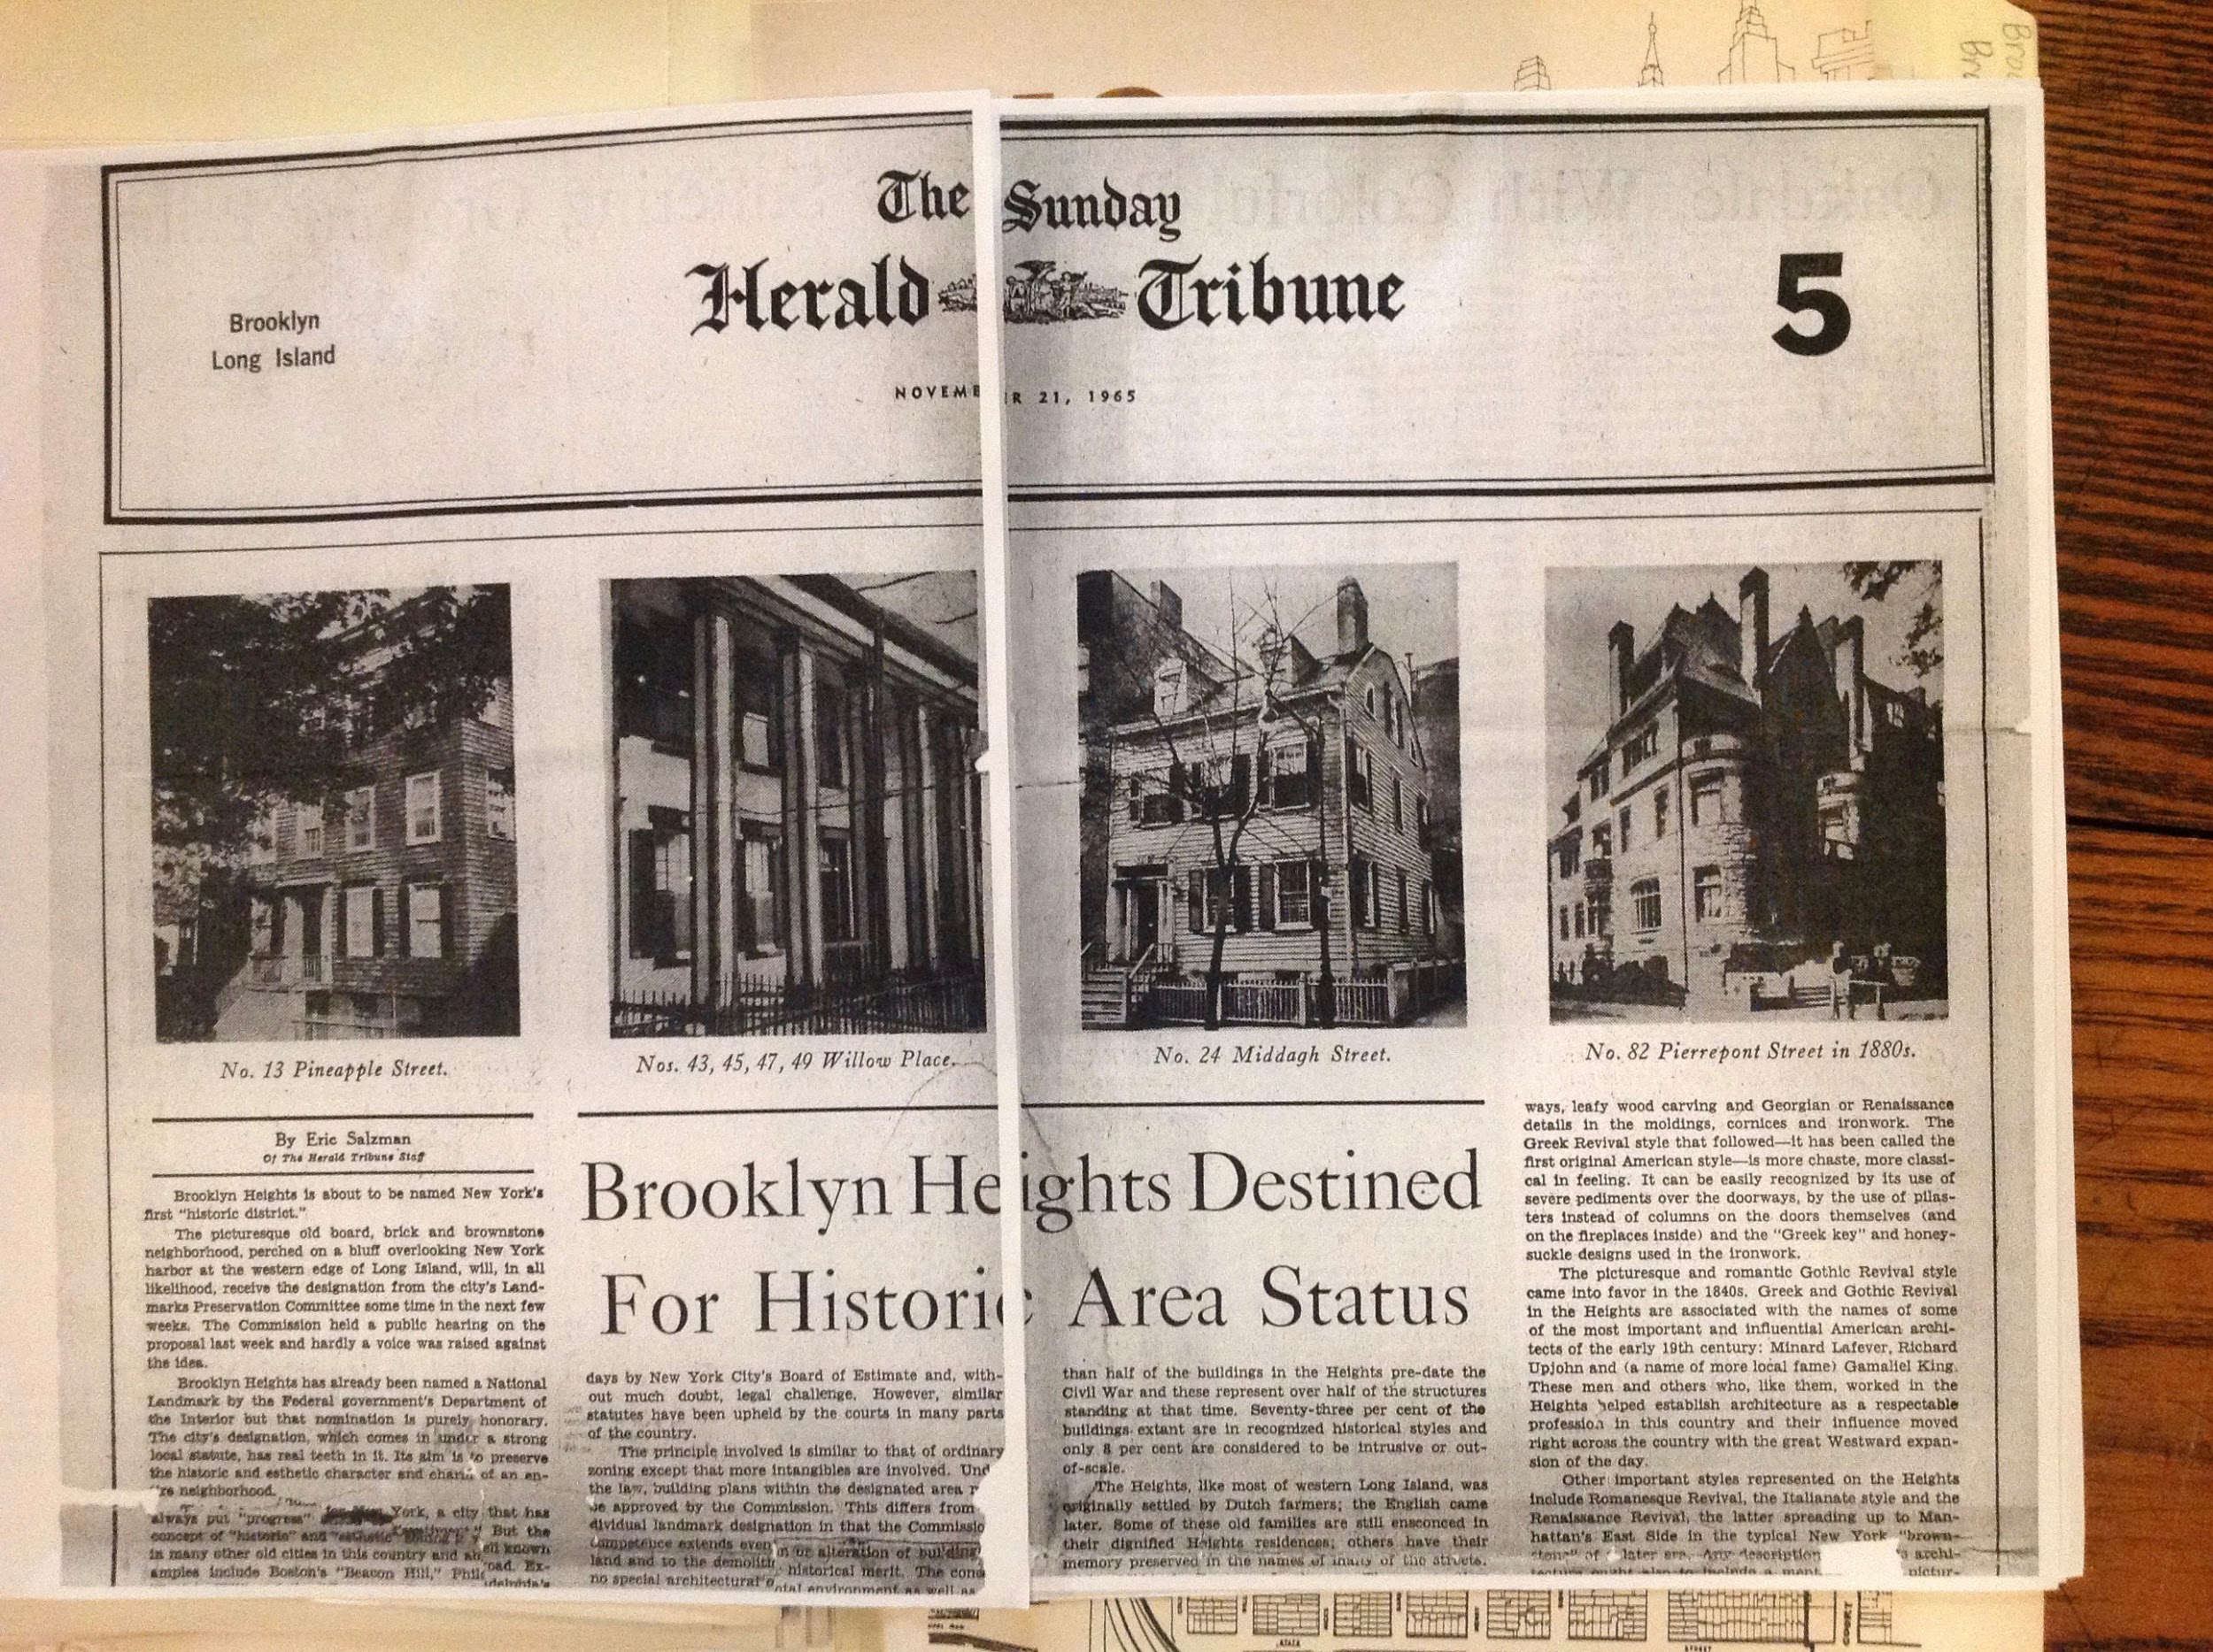

Write description of sketch or photo here, explaining why it is important and what it shows Write description of sketch or photo here, explaining why it is important and what it shows Write description of sketch or photo here, explaining why it is important and what it shows
Write description of sketch or photo here, explaining why it is important and what it shows Write description of sketch or photo here, explaining why it is important and what it shows Write description of sketch or photo here, explaining why it is important and what it shows Write description of sketch or photo here, explaining why it is important and what it shows Write description of sketch or photo here, explaining why it is important
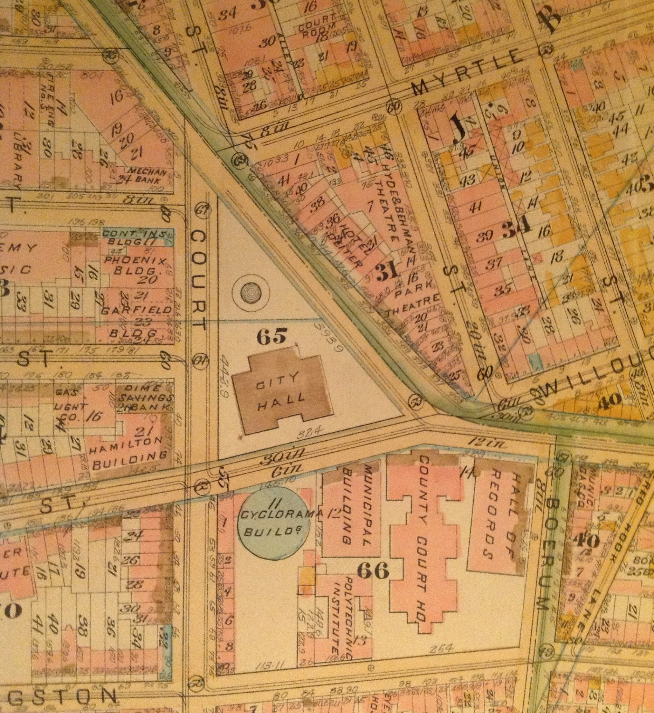
Write description of sketch or photo here, explaining why it is important and what it shows Write description of sketch or photo here, explaining why it is important and what it shows Write description of sketch or photo here, explaining why it is important and what it shows Write description of sketch or photo here, explaining why it is important and what it shows Write description of sketch or photo here, explaining why it is important and what it shows

Write description of sketch or photo here, explaining why it is important and what it shows Write description of sketch or photo here, explaining why it is important and what it shows Write description of sketch or photo here, explaining why it is important and what it shows Write description of sketch or photo here, explaining why it is important and what it shows Write description of sketch or photo here, explaining why it is important and what it shows Write description of sketch or photo here, explaining why it is important and what it shows

DISCOVERIES
- Neighborhood History
  - xx
  - xx
- Key Events / Historical Dates
  - xx
  - xx
  - xx
- Key Players
  - xx
  - xx
  - xx
- Relationship Key Players
  - xx
  - xx
- Public Perception of Key Events
  - xx
  - xx
  - xx
- Important Changes to Neighborhood
  - xx
  - xx
- Other Observations
  - xx
  - xx
  - xx

TOPICS & KEYWORDS
TERMS useful for conducting further research. TERMS useful for conducting further research. TERMS useful for conducting further research. TERMS useful for conducting further research. TERMS useful for conducting further research. TERMS useful for conducting further research. TERMS useful for conducting further research.

QUANTITATIVE DATA for Area of Study
Subject | Data
Land Ownership
Number of Blocks
# of Buildings on a Typical Block
Materials
# of Stories of Buildings
Residential Bldgs
Empty Lots
Commercial Uses
Industrial Uses
Other Data
Other Data
Other Data

QUESTIONS to Research Further
QUESTIONS:
- Lorem ipsum dolor sit amet?
- Consectetuer adipiscing elit?
- Sed diam nonummy nibh euismod?
RESEARCH METHOD/ ADDITIONAL SOURCES NEEDED TO ANSWER EACH QUESTION ABOVE:
- Question 1
  - xx
  - xx
  - xx
- Question 2
  - xx
  - xx
  - xx
- Question 3
  - xx
  - xx
  - xx

SUMMARY / POST VISIT REFLECTION
Lorem ipsum dolor sit amet, consectetuer adipiscing elit, sed diam nonummy nibh euismod tincidunt ut laoreet dolore magna aliquam erat volutpat. Ut wisi enim ad minim veniam, quis nostrud exerci tation ullamcorper suscipit lobortis nisl ut aliquip ex ea commodo consequat. Lorem ipsum dolor sit amet, consectetuer adipiscing elit, sed diam nonummy nibh euismod tincidunt ut laoreet dolore magna aliquam erat volutpat. Ut wisi enim ad minim veniam

