Learning Places Fall 2016
ST. MARK’S CHURCH IN-THE-BOWERY ARCHIVE REPORT

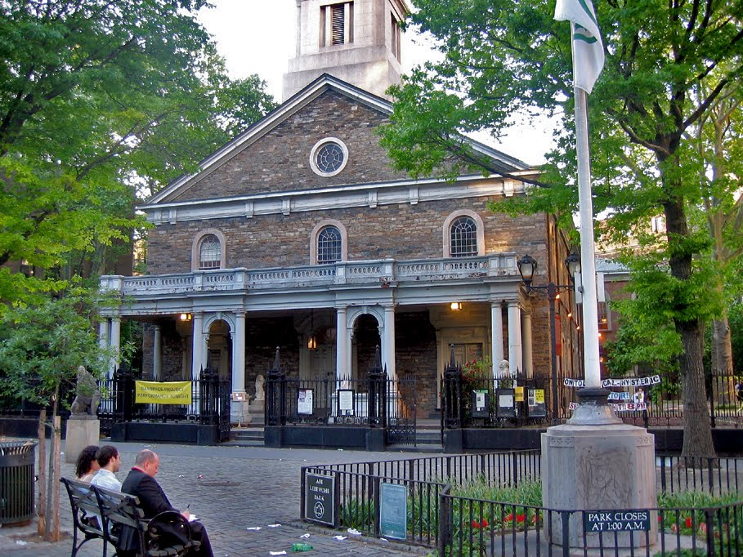

DALEY HOLDER
11.11.2016

INTRODUCTION
Completed and consecrated in 1799, the St. Mark’s Church in-the-Bowery is the second oldest Church in Manhattan. The church was built by architect and mason John McComb Jr. in a Georgian style. A Greek Revival-style steeple (designed by Ithiel Town and Martin Euclid Thompson) was erected in 1828. By 1836, the church was renovated with thinner square pillars in an Egyptian Revival-style replacing the older ones, while cast-iron and wrought-iron fencing was added in 1838. In 1858, a cast-iron portico (designed by James Bogardus) was added. After a devastating fire nearly destroyed the church in 1978, architect Harold Edelman supervised the restoration of the site, completing in 1986 when new stained-glass windows (designed by Edelman, himself) were installed. Today, in addition to being the site of continuous Christian worship, dating back to the mid-17th Century, the St. Mark’s Church also hosts modern artistic performances year round. This includes the Poetry Project, which has hosted a series of new and experimental poetries, and the Danspace Project, which has hosted contemporary dance performances.

DOCUMENTATION of site & resources (maps/archival documents/ photos)

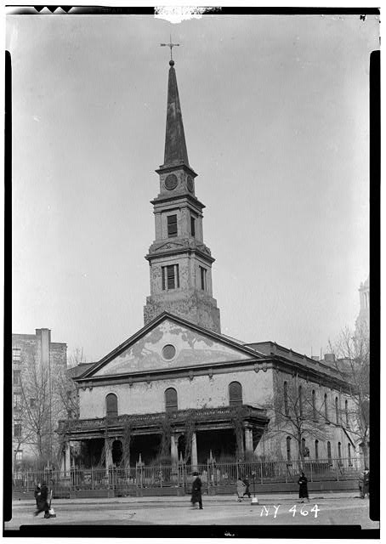

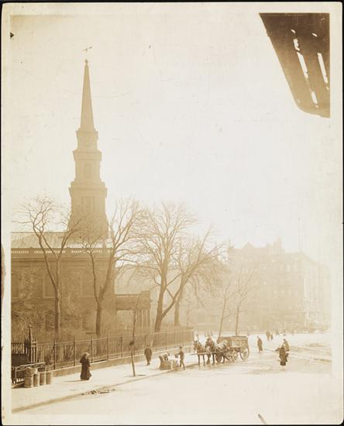

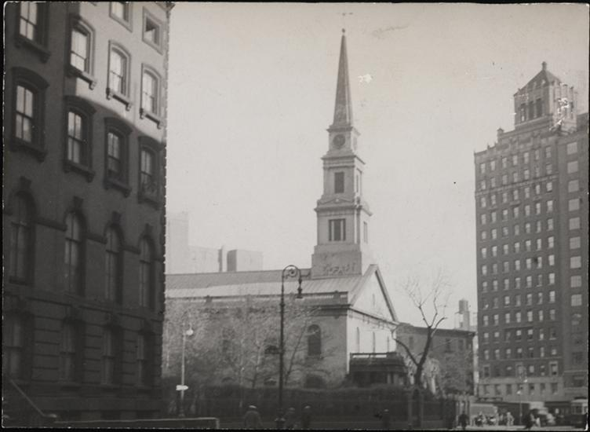

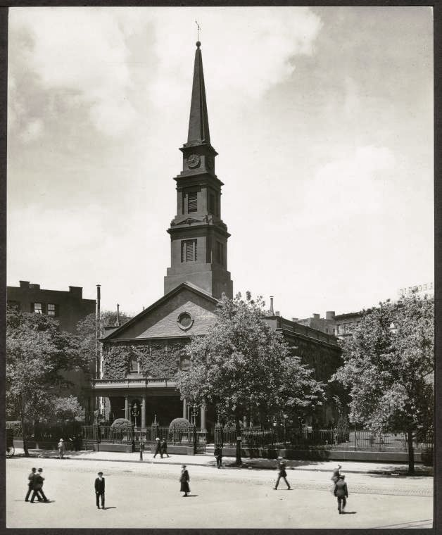

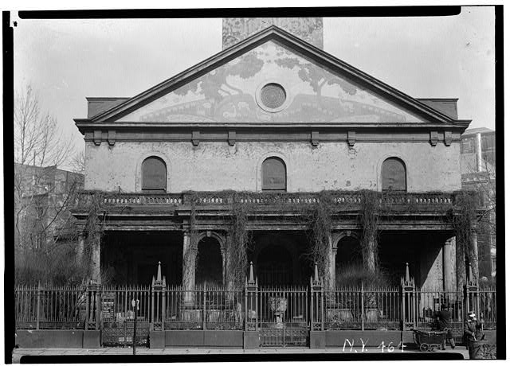

DISCOVERIES
- Neighborhood History
  - Church is located within Abe Lebewohl Park
  - The original Second Avenue Deli, which is now a Chase Bank is located nearby.
  - The Yiddish Walk of Fame is also in this neighborhood.
- Key Events / Historical Dates
  - Isadora Duncan danced in the church in 1922, and Martha Graham in 1930
  - 1964: Sam Shepard staged his first two plays, Cowboys and Rock Garden, at the church
  - April 13, 1969: Mind Garage performed the first nationally televised Christian Rock worship service in the church.
- Important Changes to Neighborhood
  - The Bowery was known as New York’s “Skid Row” between the 1940s and 1970s, as it was synonymous with “Bowery Bums”
  - Today, it has been a part of the Lower East Side’s revival, as luxury condominiums have grown in numbers in the area.
- Other Observations
  - xx
  - xx
  - xx

QUANTITATIVE DATA for Area of Study
Subject | Data
Land Ownership | -
Number of Blocks | 1
# of Buildings on a Typical Block | -
Materials | Fieldstone, cast-iron, wrought-iron
# of Stories of Buildings | 2 (6 if counting the steeple)
Residential Bldgs
Empty Lots
Commercial Uses
Industrial Uses
Other Data
Other Data
Other Data

QUESTIONS to Research Further
QUESTIONS:
- Lorem ipsum dolor sit amet?
- Consectetuer adipiscing elit?
- Sed diam nonummy nibh euismod?
RESEARCH METHOD/ ADDITIONAL SOURCES NEEDED TO ANSWER EACH QUESTION ABOVE:
- Question 1
  - xx
  - xx
  - xx
- Question 2
  - xx
  - xx
  - xx
- Question 3
  - xx
  - xx
  - xx

SUMMARY / POST VISIT REFLECTION
The St. Mark’s Church in-the-Bowery has a lot of history, both as a place of worship and as a place of art. I got to learn more about the church and how its performances bring a certain mystique to the place. I also got to learn how it plays an important role in the neighborhood’s artistic culture.

