Learning Places Fall 2016
Chin/Swift

SITE REPORT [part 1: place]
name of site report

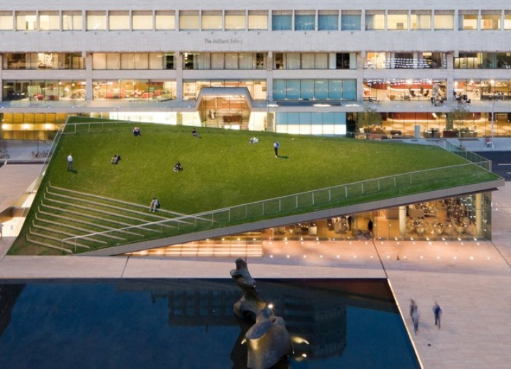

Leslie Fuller
09.30.2016

INTRODUCTION

Hypar Pavilion was built in 2010. It is located in Lincoln Center, New York City, New York in the United States. The architects design was Diller Scofidio and Renfo with FXOWLE. It is mainly a restaurant design by Yui Design.

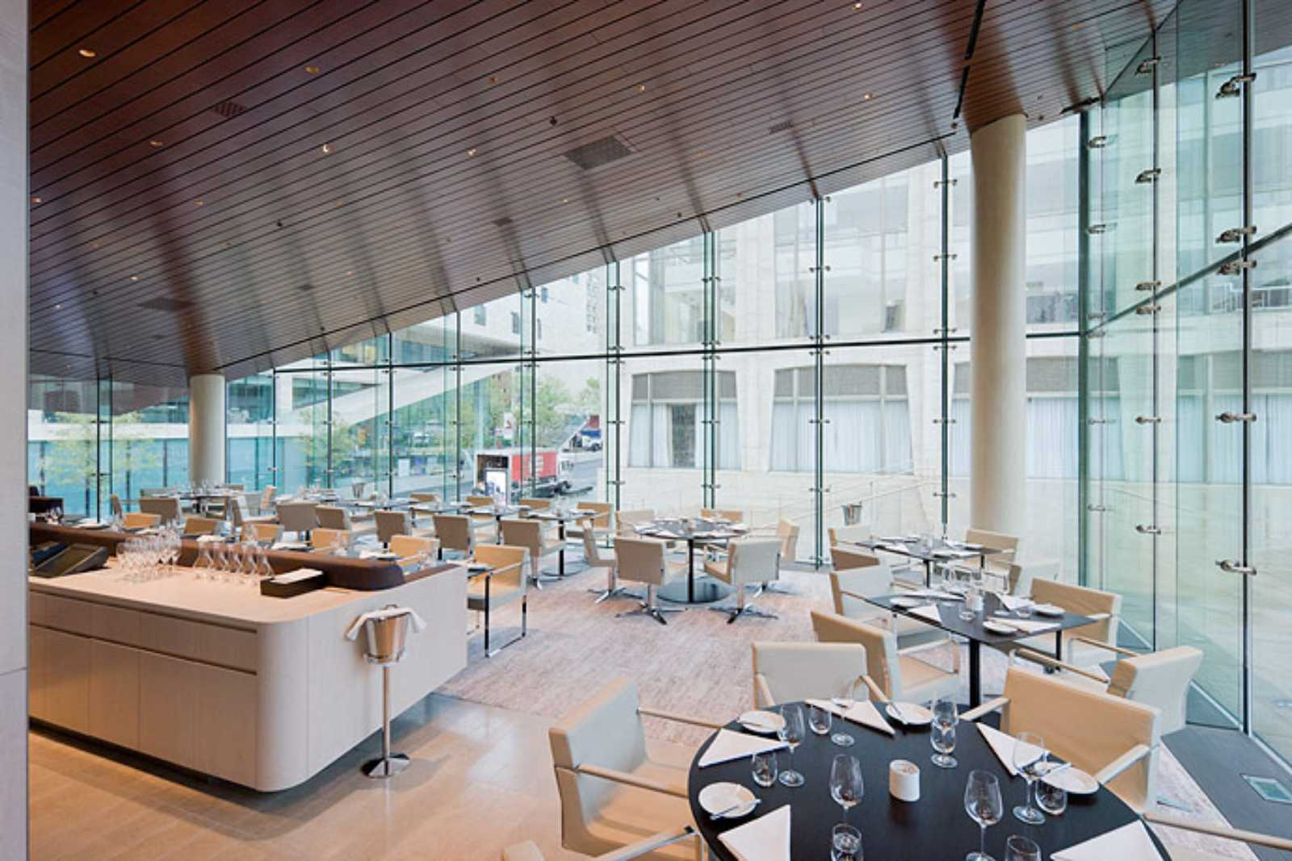

The restaurant occupies two levels. The place has a capacity of 194 guests including a lounge area, bar seating and dining room located 65th street level.

QUALITATIVE SITE OBSERVATIONS
- Neighborhood / Street Character
  - Lincoln Center Area
  - 65 street, New York City
- Vitality of Place
  - General Description
    - It is shaped like a triangle
  - Pedestrian Activity
    - People can go climb the roof
  - Vehicular Traffic
    - It is located 65th street area, nearest busy interchange is broadway
- Age of Buildings (provide evidence for prediction)
  - Early 2010 concept design by Diller scofidio
  - Final completion of the Hypar pavilion was Sept,2010
c.
- Relationship Between Buildings (urbeme)
  - The relationship between the buildings, Opera House,The New York City Ballet, Avery Fisher Hall, Alice Tully Hall, David H. Koch Theater and Julliard School
  - Robert Moses who mainly did the job
- Building Details (historical/architectural styles, morphemes)
  - Garden roof
  - It was built in 2010
  - It is owned by Lincoln Center
- Building Uses
  - Resturant, Lounge and bar
  - Sight seeing on garden roof
- Other Observations
  - It has wooden stairs that climbs up on the roof
  - People can eat and relax in that pavilion
  - Kids can run up and down on the triangle shape

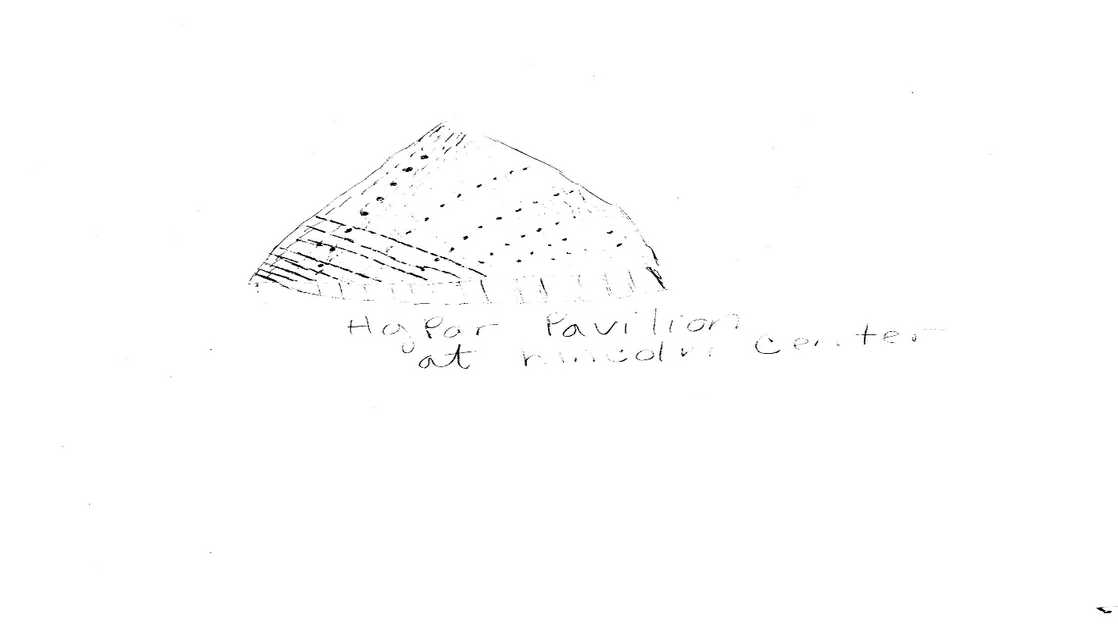

Hypar Pavilion is shaped like a triangle. People can climb up the roof and see the nice view of Lincoln Center

QUANTITATIVE DATA for Area of Study

Data
Street Names
Street Width
Pavement Type
Building Heights
Building Widths (Window Bays)
Building Types/Uses
Empty Lots / Gardens
Shops / Restaurants
Industrial Shops
Other Data
Other Data

QUESTIONS TO RESEARCH FURTHER
QUESTIONS:
- Lorem ipsum dolor sit amet?
- Consectetuer adipiscing elit?
- Sed diam nonummy nibh euismod?
RESEARCH METHOD/SOURCE FOR EACH QUESTION ABOVE:
- Question 1
  - xx
  - xx
  - xx
- Question 2
  - xx
  - xx
  - xx
- Question 3
  - xx
  - xx
  - xx

SUMMARY / POST VISIT REFLECTION
Lorem ipsum dolor sit amet, consectetuer adipiscing elit, sed diam nonummy nibh euismod tincidunt ut laoreet dolore magna aliquam erat volutpat. Ut wisi enim ad minim veniam, quis nostrud exerci tation ullamcorper suscipit lobortis nisl ut aliquip ex ea commodo consequat. Lorem ipsum dolor sit amet, consectetuer adipiscing elit, sed diam nonummy nibh euismod tincidunt ut laoreet dolore magna aliquam erat volutpat. Ut wisi enim ad minim veniam, quis nostrud exerci tation ullamcorper suscipit lobortis nisl ut aliquip ex ea commodo consequat.

