Learning Places Fall 2016
Chin/Swift
SITE REPORT [Part II: Theatre]
TIMES SQUARE

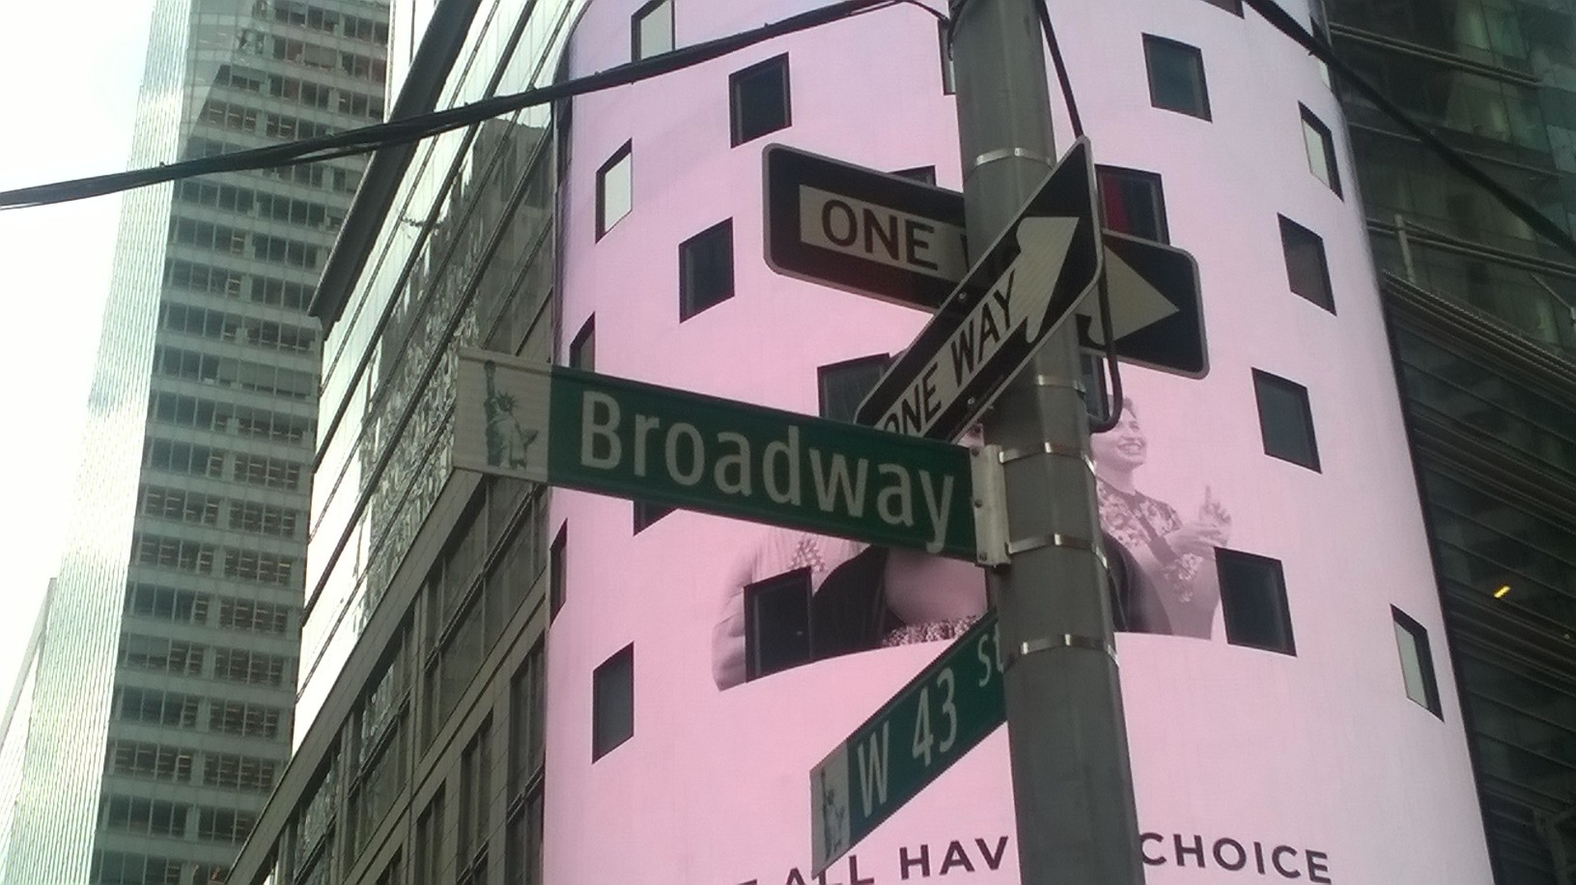

Matthew Norris
09.11.2016

INTRODUCTION
For our second trip to Times Square, our focus was not Times Square but rather its essence These performers who ranged who costumed personnel to semi nude guitarists. These performers have become an aesthetic of Times Square and thus an integral part to what make Times Square enjoyable.

PRE-VISIT REFLECTION

Due to our previous trip, the expectations to witness newer performances were a little low. However, last time our visit was focused on the attractiveness of the Square rather than the meals that attract tenants. These ‘meals’ are the performers, the persons on the billboards, the characters and the street workers.

SITE DOCUMENTATION (photos/sketches)
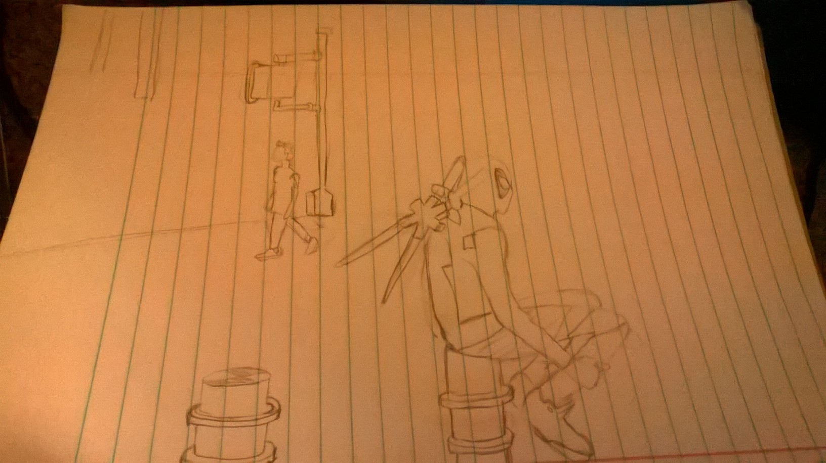
Sketch 1:Deadpool character in Times Square

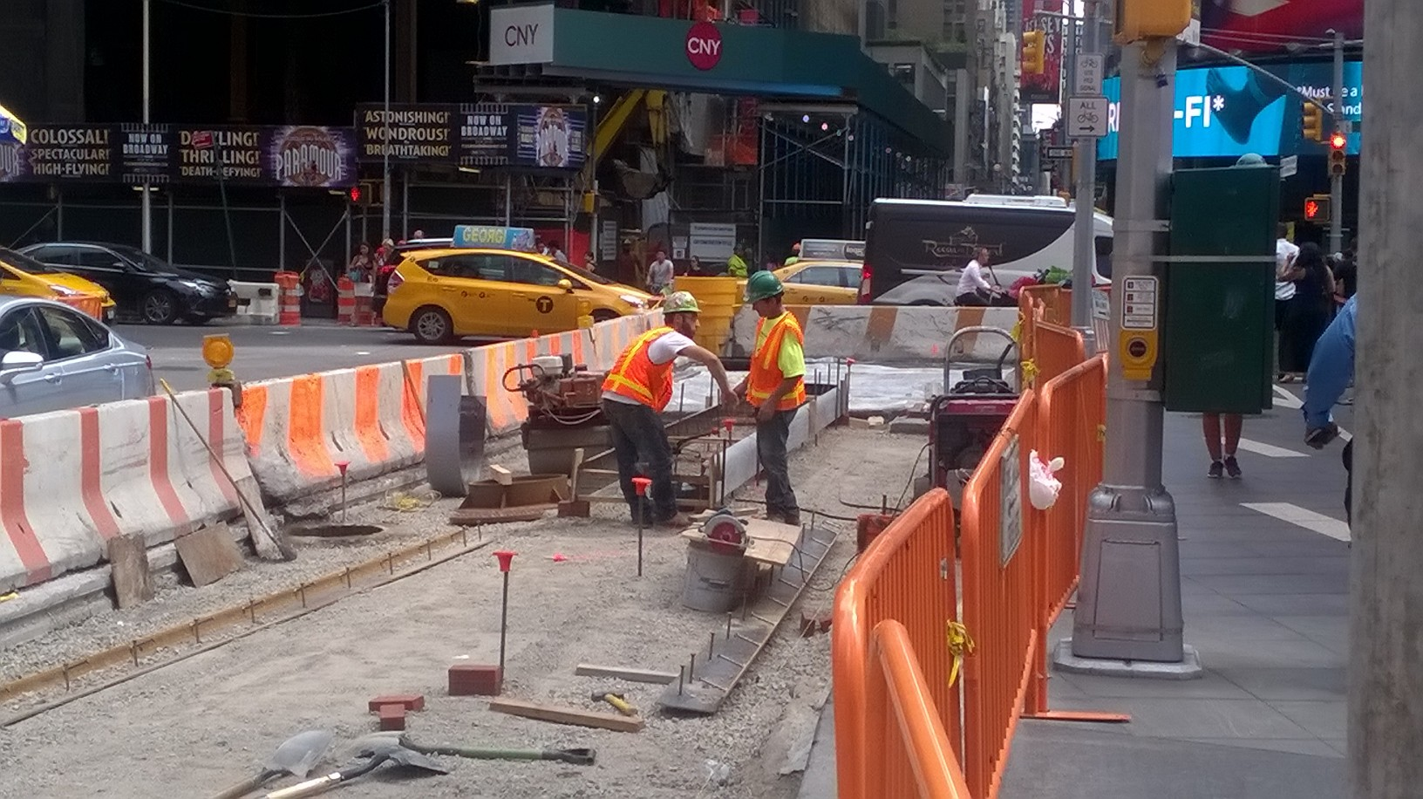

Picture 1: Constructive Criticism
Is work considered a performance? Of course it is. Workers lay the foundation in most instances for actual performances to be held. They construct the buildings that house businesses and billboards and streets where all can perform. The construction workers or the stage crew of time Squares theatre.
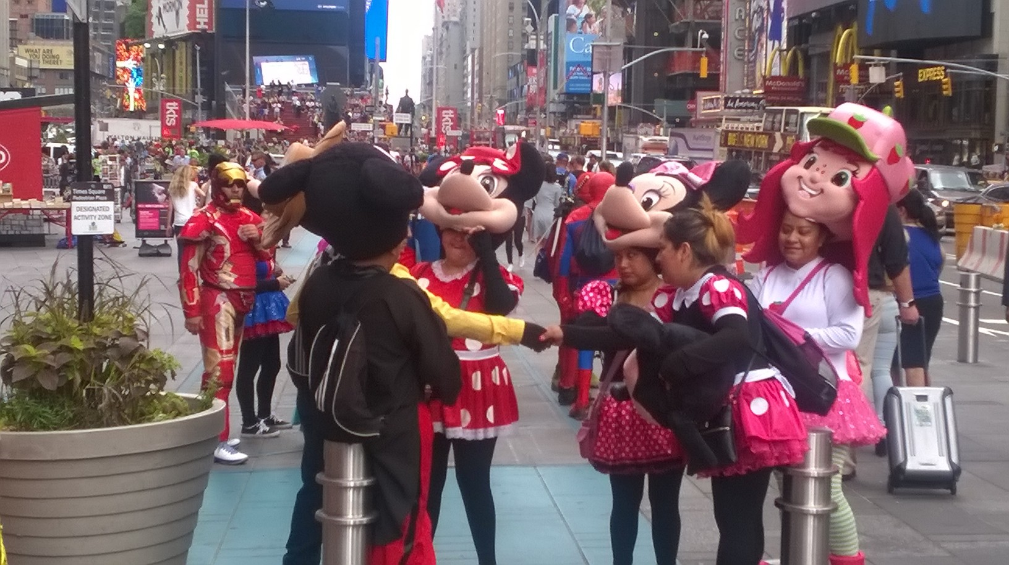

Picture 2: Clowning
The featured picture showcases the costumed characters that I focused on. As you can see, there are patrons interacting with these characters and they are few of many who rush to pictures with caricatures of Disney and even real monuments like the Statue of Liberty.
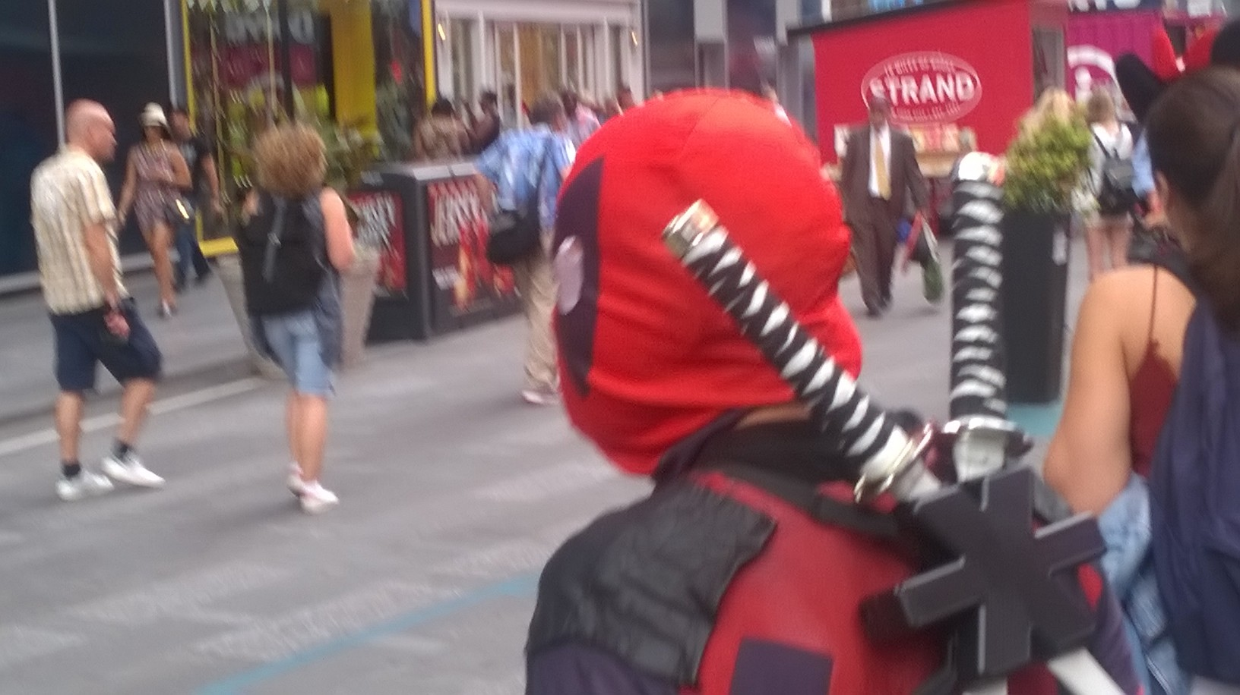

QUALITATIVE SITE OBSERVATIONS
- Description of the performance object, person, or technology (costume, media, text, props, sets, etc.)
For this trip, the main performers were the costume clad persons taking pictures with the public.

- Choreography of performance
In this instance there was no real choreography, more of a random spontaneity to catch the audience’s attention by way of acting as their character or in a jovial manner.

- Description of performance limits (ground, walls, barricades, streets, buildings)
The performers are limited to the sidewalks which are featured with designated green performance areas. Located amongst the busier areas.

- Description of audience (static, moving, direction of attention)
The audience was observed to be mainly tourists or working personnel. The tourists were constantly moving or stopping to take pictures with the characters or of the billboards and the illustrious advertising culture.

- Description of audience (socio-economic, community identity)
The audience seemed to be more middle to upper class and thereby of a higher social standing. The persons always seem to be those of foreign origin/ tourists. However this observation was made during the summer vacation.

- Description of performer/spectator dynamics (engagement, morphology)
Due to Americas.’s boisterous culture, the performers are very forward with their approach even within their limited area. However, they have been placed in such a way that they are easy to be found

- Other Observations

QUANTITATIVE DATA for Area of Study
Subject | Data
Size of performance space | Character space 50 x 10 ft x 8 spaces
Size of spectator space | 2 blocks or 0.1 miles
Range of dynamic change

# of points of focus | More than 10
Number of spectators (range) | 30,000(daily)
Time period of performance | All day
# of repetitions
Cost of performance (if any) | Free
Other data

QUESTIONS TO RESEARCH FURTHER
QUESTIONS:
- What inspires these specific performances?
- Why are they limited to these particular spaces?
- If they disappear, will they affect the flow of tourists?
ANSWER TO EACH QUESTION ABOVE:
- Question 1
In my opinion to the generic air of fun and festivity inspires these specific costumes. The characters parade near to Broadway, the main theatre area within Times Square and thus aid persons advertising actual plays by their own unique performances
- Question 2
I believe that they are limited to these areas to avoid confusion given the high pedestrian traffic in the area. This also allows people to know which streets to find these characters on.
- Question 3

SUMMARY / POST VISIT REFLECTION
Times Square is the adequate open world theatre. It has its own stage crew, performers and props even to the point that in its streets it is riddled with actual theatres. The Square provides an area of expression and opportunity for both the performers and onlookers.

