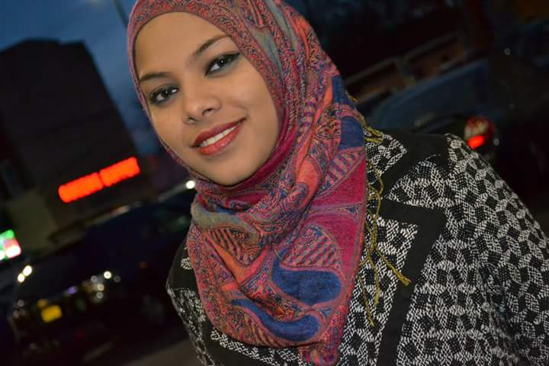
My name is Jakya S. Kamal. I’m from Bangladesh. It’s been 7 years I have been living in Brooklyn NY. I came to America to further my education to allow myself to have more opportunities to live a long and happy life. I came to America in love with creative unique things; One of the things I loved the most is my passion in finding the best style in clothing and art; to me the most I look at is saree; Every piece of clothing I see has a particular story to tell, and sometimes it takes me hours just finding the right one. That passion drove me straight to want succeed in America.
When I came to America I started my education at John Adams High School to purse my high school diploma. During High school year I devolved my skills in Art and Mathematics. The combination of these two subjects led me to choose Architecture as a career path. Also the combination of having unique thought, and having opportunity to tell my own stories to the world made me want to do whatever it takes to succeed in this field. I remember growing up in Bangladesh I dreamed of making my own impression in the world. At that moment I didn’t know what that could have been; but after finding Architecture here in America I realized that I could finally make my own impressions in the world with my designs.
I love interacting with people; and what I love most about is that I love to hear the stories of every person I meet; I feel everybody has a unique story to tell. I love to smile, I feel it is my greatest feature; because I feel the key to make an impression in this world is with the smile. My greatest dream is to inspire others and I think I have finally found my way to inspire with architecture.

