Learning Places Fall 2016
Chin/Swift

SITE REPORT [part 1: place]
Holy Cross Church
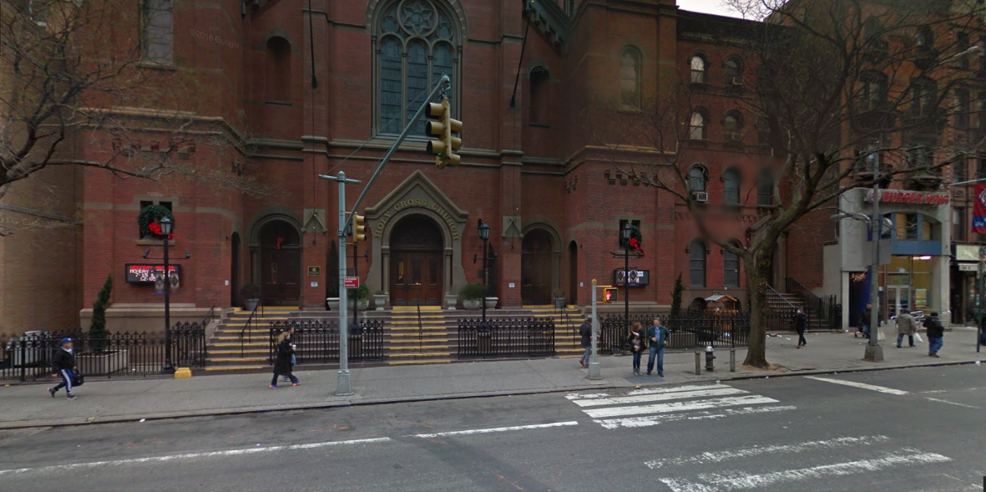

Leslie Fuller

INTRODUCTION
The Holy Cross Church is located in Manhattan 329 West 42nd Street Between 8th and 9th avenues in Hell KIchen. It was built in 1854. It was designed by Henery Engelbert in 1870. The dimension are 100 feet from front 82 feet from the side Up on top there is a cross. It has stained glass window. The distance is 148 feet. It is red brick and terra cotta school façade was designed in Romancque Revival style. It opened December 15, 1850.

PRE-VISIT REFLECTION
I can see old and new buildings. The church was around since the 1800’s and it was their when we had old 42nd street to the new one

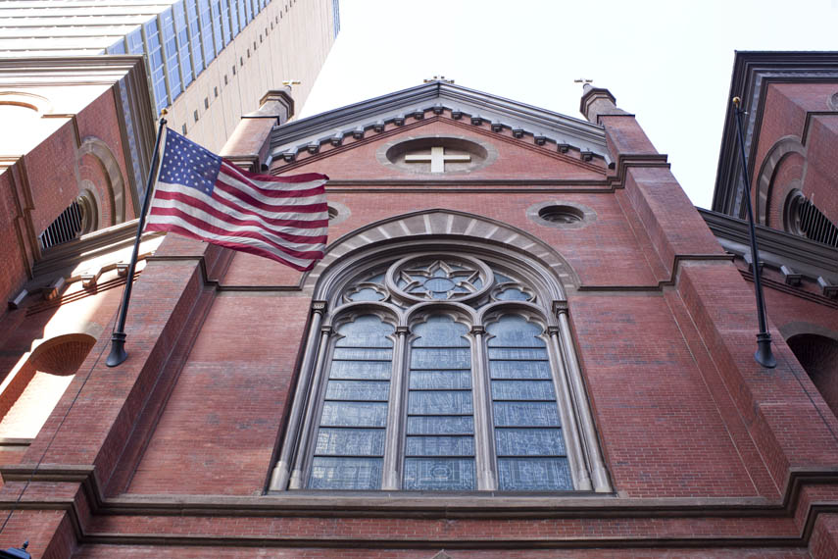
SITE DOCUMENTATION (photos/sketches)

Write description of sketch or photo here, explaining why it is important and what it shows

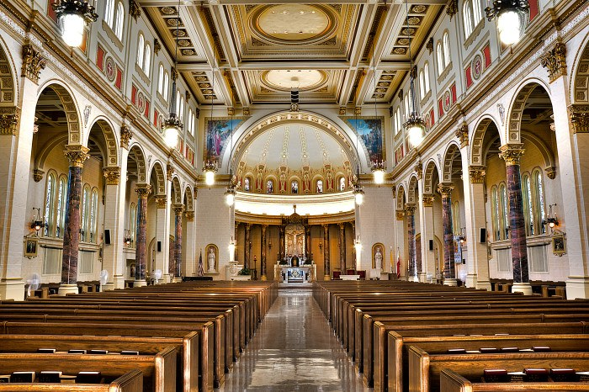
This is the interior of the Holy Cross Church, it is beautiful inside. It can fit about 500 people for the service

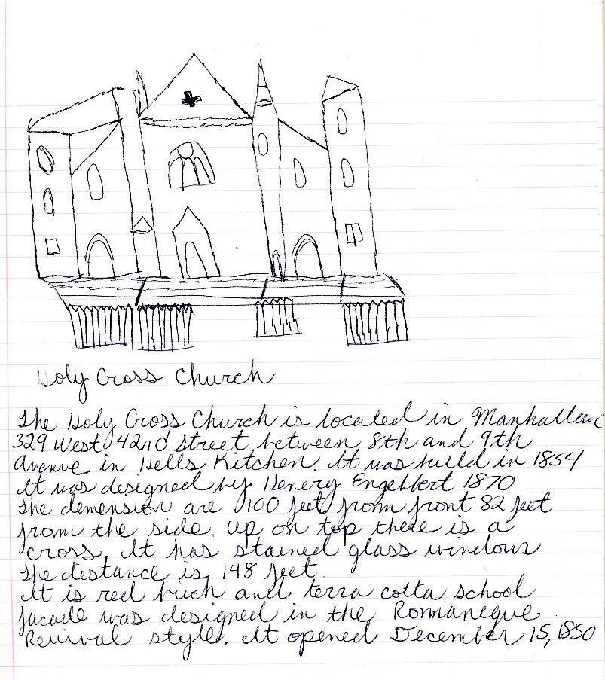
This is sketch of the church almost exactly the way it looks

QUALITATIVE SITE OBSERVATIONS
- Neighborhood / Street Character
  - 329 west 42nd street
  - It is located between Hells Kitchen and Time Square
- Vitality of Place
  - It gives you description how way 42nd Street how it used to be
People around the city and tourists come to this church and worship
  - Pedestrian Activity
It can be crowded on a Sunday morning
  - Vehicular Traffic
It can hold a lot of traffic
- Age of Buildings (provide evidence for prediction)
  - It is 160 years old
  - It was built in 1854
  - Years later they put a school additional to the church
- Relationship Between Buildings (urbeme)
  - It combines with other local stores, offices and apartments
  - xx
- Building Details (historical/architectural styles, morphemes)
Romancque Revival Style
  - Red brick and terra cotta school
  - xx
- Building Uses
  - worship
  - studying and learning
- Other Observations
  - It is across the street of the Port Authority
  - It is is in the heart of 42nd
  - xx

QUANTITATIVE DATA for Area of Study
Subject | Data
Street Names | 329 west 42nd street
Street Width
Pavement Type
Building Heights
Building Widths (Window Bays)
Building Types/Uses
Empty Lots / Gardens
Shops / Restaurants
Industrial Shops
Other Data
Other Data

QUESTIONS TO RESEARCH FURTHER
QUESTIONS:

RESEARCH METHOD/SOURCE FOR EACH QUESTION ABOVE:
- Question 1
  - xx
  - xx
  - xx
- Question 2
  - xx
  - xx
  - xx
- Question 3
  - xx
  - xx
  - xx

SUMMARY / POST VISIT REFLECTION

