A Multi-Sensory Experience at Carmine’s
Cheyenne N. Darcy
New York City College of Technology

A. How were you addressed when you entered into the restaurant? Did you need to make reservations? How long was the wait before you were seated?
Upon entering Carmine’s, one was addressed in a very welcoming and professional manner by the restaurant's hostesses. Temperature checks were taken in light of the Covid-19 pandemic, to ensure safety of both team members of the restaurant and guests who enter the premises. The hostess asked if reservations were made and yes, they were made prior to arrival. Reservations were advised because the restaurant is typically busy. However, there was no wait before one was seated, as the restaurant wasn't very busy on the bright Friday afternoon. When seated, the tables were very clean, laid with bright white table cloths, and freshly cleaned eating utensils were wrapped in linen napkins.

B. What are the cultural differences you notice? (Use class notes) Using your five senses of taste, touch, sight, smell, & sound describe some of the cultural differences that you are not accustomed to in comparison to All-American restaurant or restaurant chains. For example, one can describe but not limited to the sights in the restaurant décor, odors from unusual foods, and sounds from music. One should use all five-senses in this cultural experience.
With respect to cultural differences, Carmine’s is a unicultural restaurant, predominantly of Italian cuisine. Guests at Carmine’s are wowed with large sized, sharable portions of food, which is to be shared by friends and family (About: Carmine’s Italian Restaurant, n.d.). In Italian culture an emphasis is placed on family and love, and this restaurant provides such a dining style that one may not be accustomed to in an All-American restaurant (Family Style Dining, 2017). At Carmine’s, employees, waitresses, and hostesses carry themselves with elegance in terms of interacting with customers. A luxury feel of service is provided, which feels different than an All-American restaurant. One received great hospitality from the waitress as they were very knowledgeable about the dishes and drinks on the menu.
One can use their five senses to assess the restaurant. Jazz and showtime music filled the dining room, accompanying the luxury feel that the restaurant had. While listening closely to Jazz music, one could hear the saxophone, trumpet, bass guitar, piano, violin, and drums. As the showtime music played one could gracefully hear instruments such as the trumpet, bass guitar, piano, drums and the violin being played. There was no particular scent in the restaurant, and the taste of the food differentiated itself from that of an All-American establishment. Down to the classical dining room with chandeliers, walnut wood seating chairs and classical architectural styles featured along the wall, it was a pleasant to view. Figure 1 displays a great angle of the beautiful dining room at Carmine’s.
Figure 1: Italian Restaurant Upper West Side
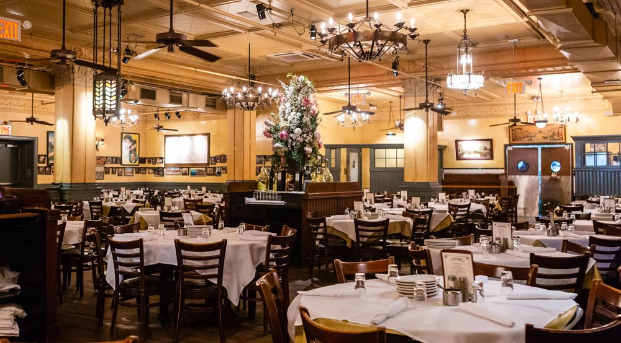
C. Look at the menu. What are the types of foods they offer? What are some unusual items? Do they describe the ingredients in the food? List various food items from the menu. What menu items did you order? Is there more than one language used to describe the foods on the menu?
The menu at Carmine’s offers a variety of foods including but not limited to steak, pasta, seafood, and chicken. Some unusual items on the menu include clams and mussels. The paper menu in the restaurant doesn't describe the ingredients in the food; however, one can use their smartphone to scan a Quick Response code to view a digital menu with full food descriptions. Numerous foods on the menu include broiled porterhouse steak, penne alla vodka, shrimp marinara, chicken marsala, chicken parmigiana and ravioli with cheese. Almost everything on the menu is in English, however there were a few dishes written in Italian such as zuppa di clams and zuppa di mussels.
One ordered the chicken scarpariello which consisted of a whole chicken cut on the bone and was delightfully marinated in garlic, lemon, and rosemary. This dish was pan fried and topped off with an excellent lemon butter sauce, layed in a bed of penne style pasta (Carmines: Order delivery & Take-out Now, n.d.). From the freshly tasting chicken, down to the tasty lemon sauce, this dish was amazing. The dish was very delicious and the chefs use quality ingredients to make each dish on their menu different from the other. The menu featured a wide variety of dishes which were priced affordably. The chicken scarpariello was the perfect meal one should order at Carmine’s. Figures 2 displays an image of the freshy tasting meal.
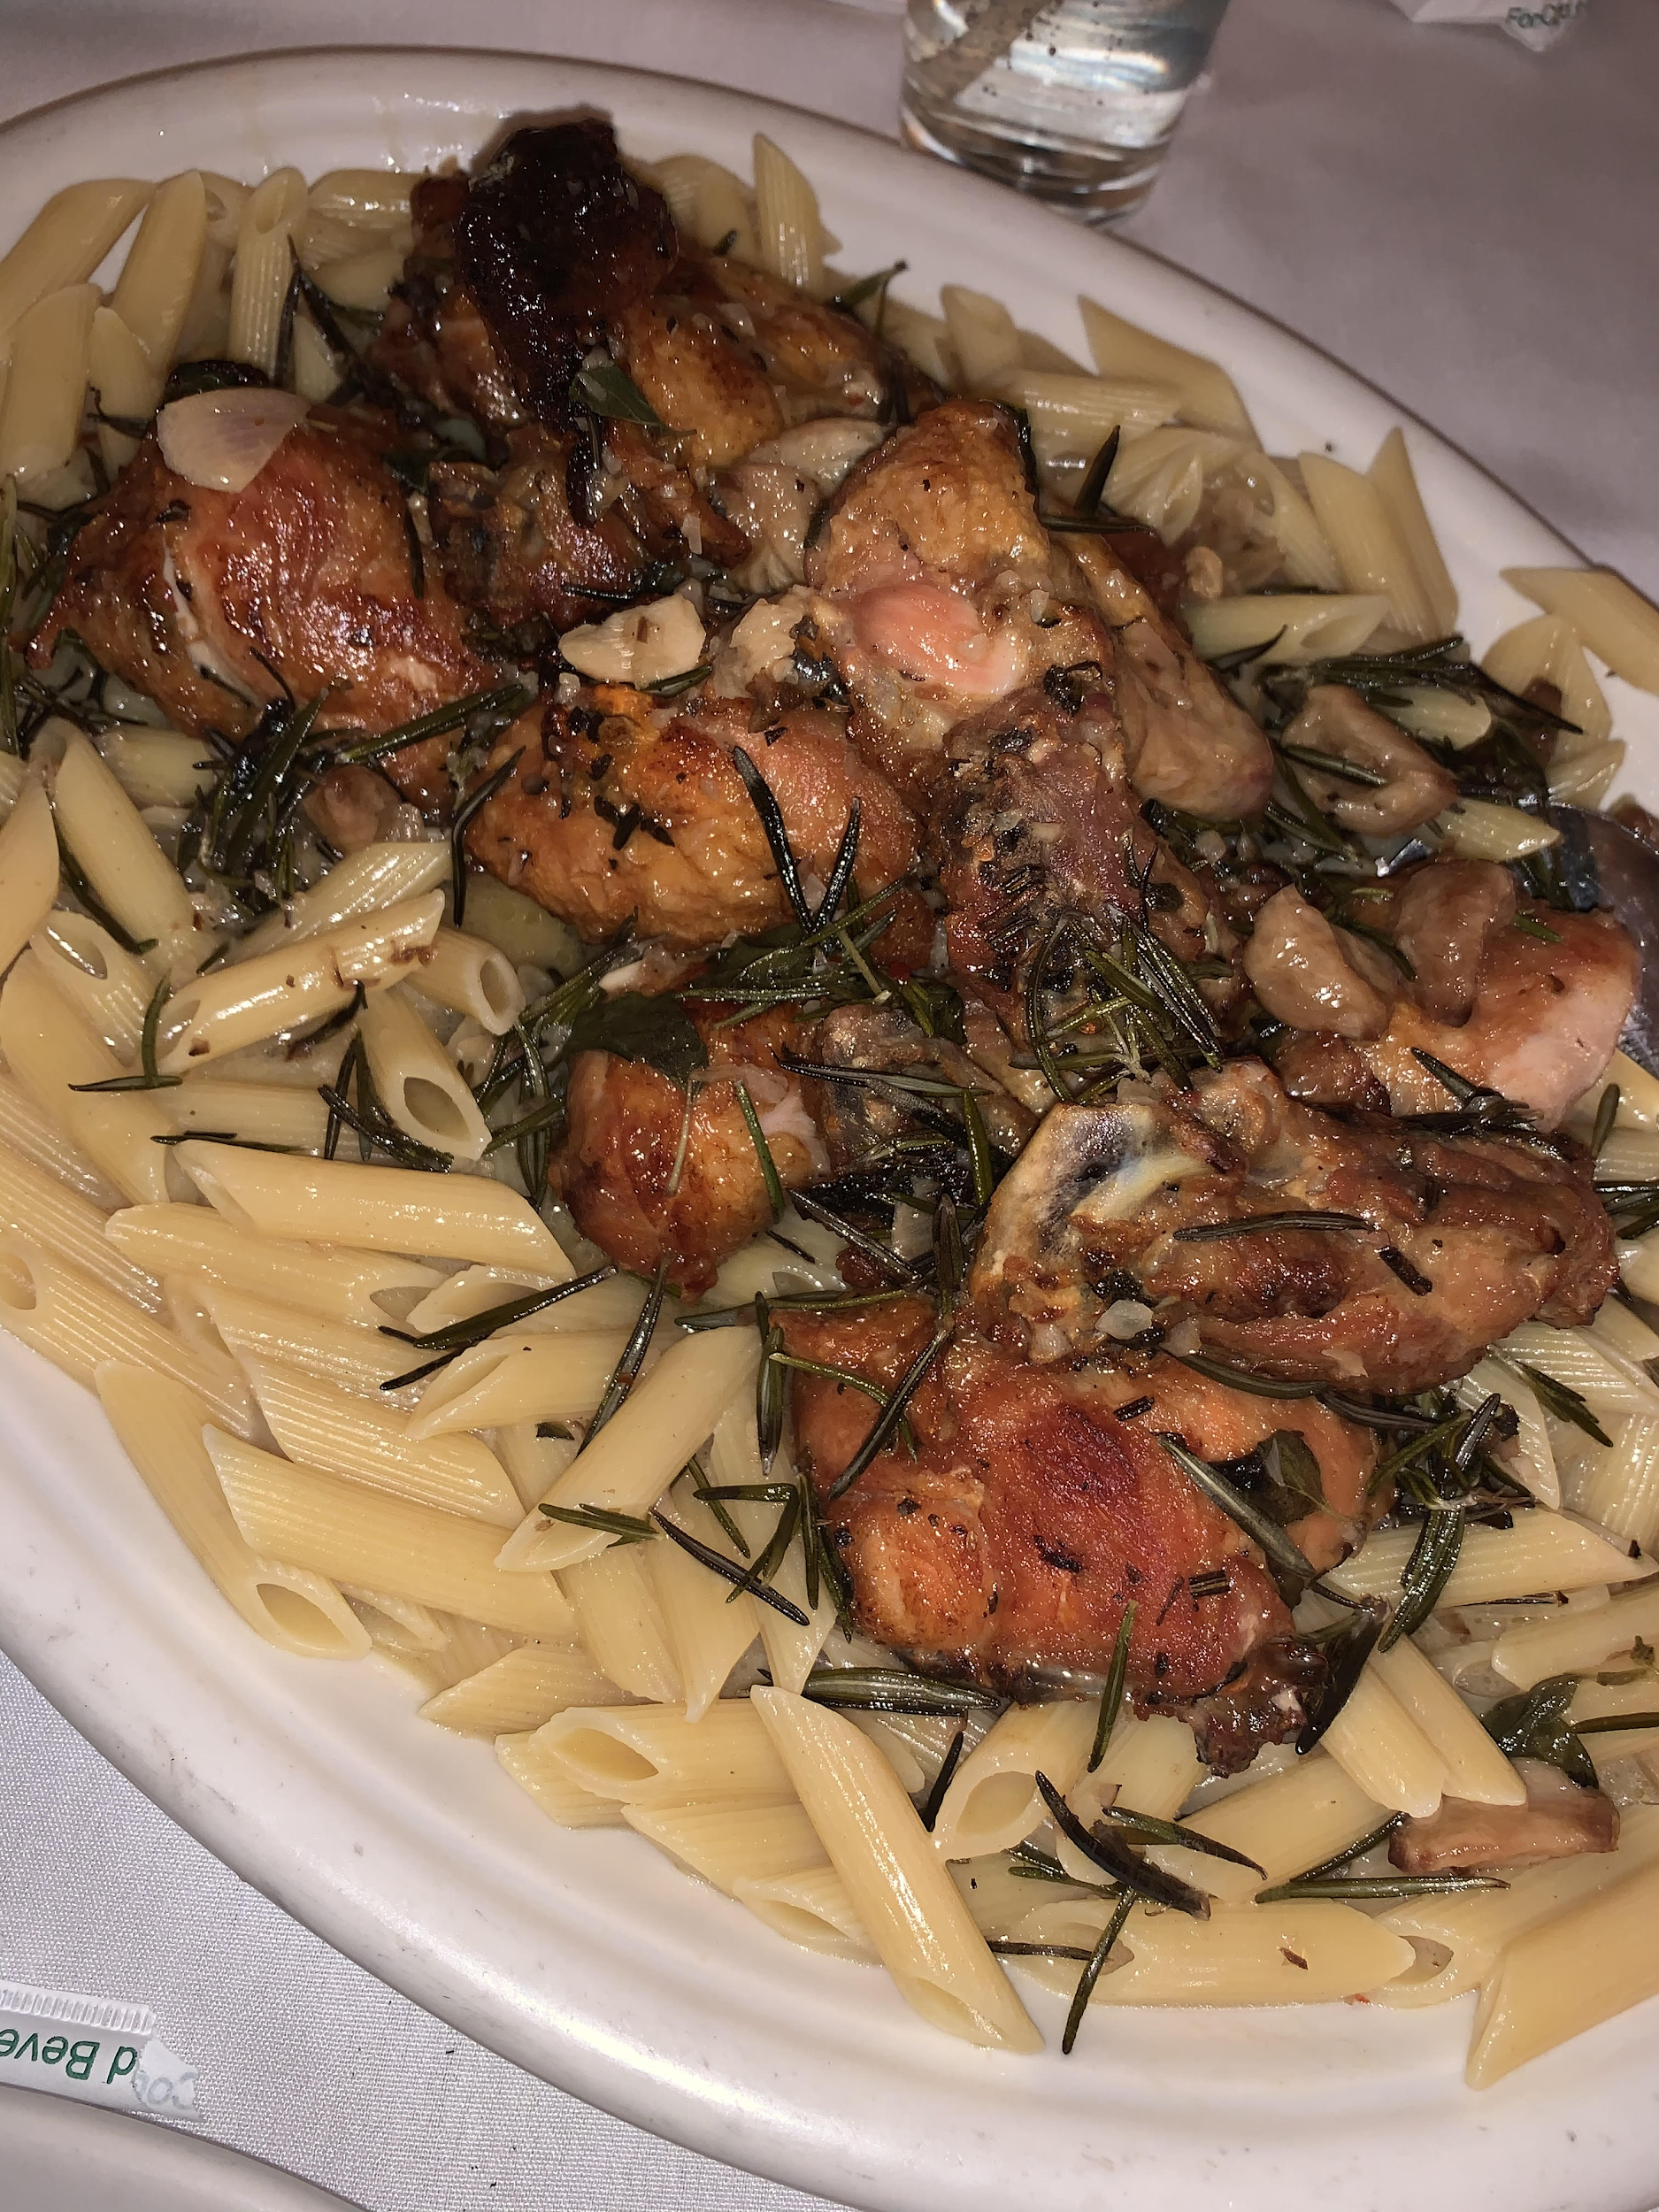
Figure 2: Chicken Scarpariello with Penne Pasta (Taken by Iphone Xs)
D. Is a traditional salad offered? If not, describe what is offered. What types of breads are offered (flat, pita, tortilla chips)? What type of desserts (cheesecake, fortune cookie, coffee)? What are they like?
A traditional salad isn't on the menu, however cesar salad, mixed green salad, and Carmine’s salad are present. Each salad takes its own spin on the traditional salad offered at All-American restaurants. For example, the cesar salad features homemade garlic croutons, romaine lettuce, parmesan romano cheese, and is served with homemade caesar dressing. There is one type of bread offered on the menu which is a garlic bread consisting of thick slices, and is completed with garlic and herb butter. Additionally, there are a variety of deserts on the menu such as chocolate cannoli, Italian cheesecake, tartfui, and a fresh fruit platter. The tarfui seems like the tastiest dessert on the menu, which includes chocolate and vanilla ice cream, almonds in a hard chocolate shell with whipped cream, grazed with shaved chocolate on the top.
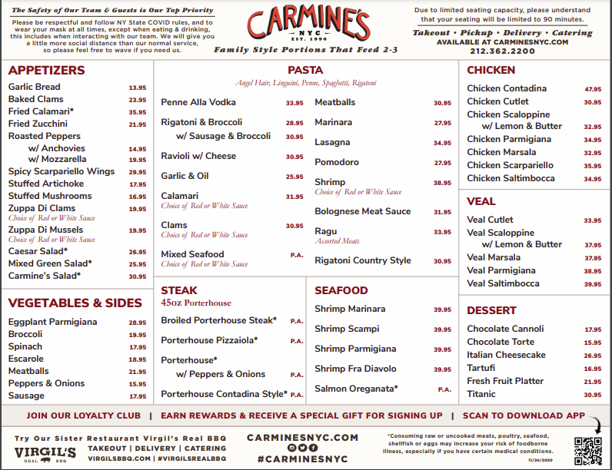
Figure 3: Front of Carmine’s Menu
As seen above, Figure 3 displays the front of Carmine’s menu.

E. What types of beverages are offered? Do they have an alcohol menu? What is not typically offered in an American chain restaurant?
A variety of drinks are on the menu such as Carmine’s martinis, spirits, beer bottles among other drinks. Yes, an alcohol menu is offered as well. In an American restaurant, wines by the quartino and bottle aren’t offered. Regular drinks like sodas aren't listed on the menu, but the restaurant carries sprite, ginger ale, seltzer water among others. American restaurants typically have soft drinks on their menu as the main beverage, however the main beverage at Carmine’s appears to be wine. As one looks around the restaurant, they see customers sipping wine rather than sipping soft drinks, nonetheless if one was in an American restaurant it would be the other way around. When one looks at the menu, they can tell that cultural differences are present between what Americans typically drink versus what Italians typically drink. As seen below, Figure 4 presents the drinks menu.
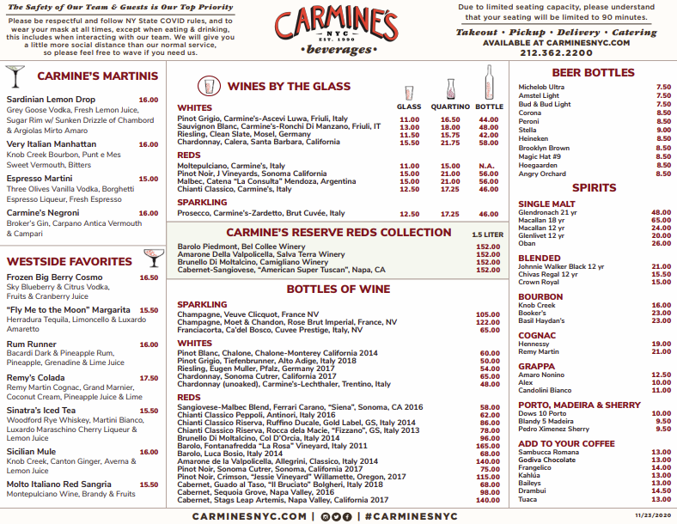
Figure 4: Back of Carmine’s Menu
F. How is the food reflective of the cultural geography and the economic geography (Use class lecture notes)? (i.e. spices are abundant in India which is rich in spices & fish (sushi) is popular in Japan & it is part of the G8). Describe approximately where in the world (continent & location) and from country this culture’s food is best known.
The food at Carmines is reflective of the cultural geography and economic geography of Italy. Italy is a country located in southern Europe, and has the world's 8th largest economy. Being apart of the G7, Italy is one of seven most developed countries in the world. The country is one of the worlds most industrialized nations, also being one of the top exporters. Italy has an abundance of natural resources and is one of the world's dominant nations in olive oil production, wine, and a variety of fruits like grapes, cherries and oranges (Sawe, 2019). Considering that Italy is abundant in these resources, it explains why Carmine’s features many wines on their menu and olive oil is likely used in various dishes on their menu as well.

G. Describe the dress? (Dress is inclusive of all five senses – you smell perfume, hear jewelry, see make-up, etc.…) What are the employees, such as hostesses or wait staff wearing? Please use Eicher-Roacher-Higgins (1992) article to define dress and answer appropriately.
The waitress was a male, wearing a white collared button down shirt, white apron, black dress pants, black shoes, and a black mask. He wasn’t wearing jewelry or makeup, but wore gloves when he handled one's meal. The wait staff who greeted one as they entered the restaurant were wearing black button up shirts, with black slacks and black shoes. “Dress is the total arrangement of all outwardly detectable modifications of the body and all material objects added to it. Dress used as a noun is defined as the assemblage of body modifications and body supplements worn by an individual at a specific moment in time (Eicher, Roacher, Higgins, 1992). The employees in the restaurant were dressed very neutrally with limited modifications to their body.

H. Rate your experience as a food critic (as in the LA Times or Houston Chronicle). Ratings should be dependent on taste, service, décor, cleanliness, authenticity, quality and price and should range from A-F (“A” being the best). Explain why you chose this rating. Be thorough and detailed in your explanations.
One would give Carmine's Italian restaurant an A rating. The ambiance in the dining room was a delight to view and the service was spot on. Carmine’s serves food in family sized portions and one should dine with another person, friends or family perhaps. Realistically, one plate is huge for one person to delve into, explaining why the plates should be split between two to four people. For the serving size of the meal, one may say that Carmine’s is very affordable. The soft drinks came back to one's tables very quickly as well as the food. The food look, tasted, and smelled absolutely amazing. Very hot, fresh, and just a delight to enjoy. It’s very likely that one may have leftovers to go, but that’s alright. That just means there’s more tasty food to enjoy the next day. One’s waitress was very jovial and helpful throughout the dining experience. The hospitality that one receives from employees, wait staff, and hostesses is amazing from the moment one walks in the establishment, to the moment they leave. Excited to return to Carmine’s very soon!

I. What did you learn from this experience that you could contribute to a multi-cultural experience in a class discussion.
From one's experience at Carmine’s, one may learn that Italians represent high context culture. They take pride in the bonds that they have with others, and an emphasis is made on physical cues. They are curious to know more about a person and tend to ask about one's life story. Italians are open to giving their opinions, in efforts to help or provide benefit to the other person. Italians are very jovial, and seek to bring light to any conversation. One’s waitress fulfilled each of these characteristics, which made dining at Carmines such a great experience. Not only being that Italians represent high context culture, Italy is a country with an abundance of olive oil and wine, both commonly seen among dishes at Carmine’s.

References
About: Carmine's Italian restaurant. (n.d.). Retrieved March 07, 2021, from https://www.carminesnyc.com/about
Carmine's Italian Restaurant: Order delivery & Take-out Now. (n.d.). Retrieved March 07, 2021, from https://www.carminesnyc.com/menus/menus-upper-west-side-dining-q420
Carmine's Menu [Carmine's Menu]. (n.d.). Retrieved March 06, 2021, from https://www.carminesnyc.com/assets/uploads/general/C91_Menu_Limited-Dinner-20201124-and-Beverage-20201123_8.5x11_.pdf
Family style dining - sacramento. (2017, October 18). Retrieved March 07, 2021, from https://espanol-italian.com/2017/10/family-style-dining/
Italian Restaurant Upper West Side I Make a Reservation Now [Italian Restaurant Upper West Side I Make a Reservation Now]. (n.d.). Retrieved March 06, 2021, from https://www.google.com/url?q=https://images.app.goo.gl/3gfCbyR4KB5D8iQKA&sa=D&source=editors&ust=1615075685708000&usg=AOvVaw0TDquvnuIdcuHCPYwsyyho
Lennon, S. J., P., J. K., & Rudd, N. A. (2017). Social Psychology of Dress. New York: Fairchild Books.
Sawe, B. (2019, July 29). What are the major natural resources of italy? Retrieved March 07, 2021, from https://www.worldatlas.com/articles/what-are-the-major-natural-resources-of-italy.html

