

A Good Smoking Cessation Tool???

* E cigarettes are not regulated by Tobacco Laws, or the Food and Drug Administration. Not only do they lack any health warnings comparable to FDA-approved nicotine replacement products or conventional cigarettes, but any minor can easily purchase an

E-cigarette.

* With flavors such as chocolate, strawberry, cherry, caramel, bubblegum, mint, and chocolate, e-cigarettes can lure teens and kids.

* They promote smoking in non-smoke areas since they produce a ‘smokeless’ vapor. This makes smoking anywhere easier than ever.
* This “virtual form of a cigarette” can easily fit into our technologically advanced world.

**E-CIGARETTES: SMOKING**

**CESSATION TOOL, OR JUST**

**ANOTHER ADDICTION?**

By: Asfiya Afsar

Catriona Hagley

Alma Shehu

References:

Alpar, B., Leyhausen, G., Sapotnick, A.,Gunay, H., & Geutsen, W. (1998). Nicotine-induced alterations in human primary periodontal ligament and gingival fibroblast cultures. *Clinical Oral Investigations*, 2, 400-46. Retrieved from <http://link.springer.com/article/10.1007/s007840050042>

(2013) Untitled. [online] Available at <http://www.cancer.org/ocs/groups/cid/documents/webcontent/002974-pdf.pdf> [Accessed: 23 Apr 2013]

Choi, K., & Forster, J.(2013), Characteristics associated with awareness, perceptions, and use of electronic nicotine delivery systems among young US Midwestern adults. *American Journal of Public Health, 103* (3), 556-561. doi: <http://dx.doi.org/10.2105/AJPH.2012.300947>

Hecht, S. S., & Hoffmann, D. (1988). Tobacco-specific nitrosamines, an important group of carcinogens in tobacco and tobacco smoke. *Carcinogenesis, 9* (6), 875-884. Retrieved from <http://carcin.oxfordjournals.org/content/9/6/875.long>

Hua M, Alfi M, Talbot P. (2013). Health-related effects reported by electronic cigarette users in online forums. *J Med Internet Res* 2013; 15 (4):59. Retrieved from: <http://www.ncbi.nlm.nih.gov/pubmed/23567935>

Malhotra, R. Kapoor, A., Grover, V., & Kaushal, S. (2010). Nicotine and periodontal tissues, *Journal of Indian Society of Periodontology,* 14(1), 72-79. Retrieved from <http://www.ncbi.nlm.nih.gov/pmc/articles/PMC2933534>

Nationalkidneycenter.org (2013). Kidney Disease Symptoms | National Kidney Center. [online] Retrieved from: <http://www.nationalkidneycenter.org/chronic-kidney-diseases/symptoms/> [Accessed: 23 April 2013]

Pearson, J. L., Richardson, A., Niaura, R.S., Vallone, D. M., & Abrams, D. B. (2012). E-cigarette awareness, use, and harm perceptions in US adults. *American Journal of Public Health, 102*(9), 1758-1766. Doi: <http://dx.doi.org/10.2105/AJPH.2011.300526>

Trtchounian, A., Williams, M., & Tablot, P.(2010). Conventional and electronic cigarettes have different smoking characteristics. *Nicotine & Tobacco Research,* 12(9), 905-912.doi: <http://dx.doi.org/10.1093/ntr/ntq114>

US Department of Health & Human Services, US Food & Drug Administration. (2009*). Fda warns of health risks posed by e-cigarettes.* Retrieved from <http://www.fda.gov/forconsumers/consumerupdates/ucm173401.htm>





**Nitrosamines-** Another substance found in electronic cigarettes. They are groups of carcinogens that can induce tumors both locally and systemically.



**What are e-cigarettes?**

An e-cigarette is an electronic vaporizing nicotine delivery system that consists of a battery, an atomizer (charger), and a nicotine-containing cartridge. Electronic cigarettes are the most recent nicotine replacement therapy used for smoking cessation.

**Can you become addicted to it?**

YES. Individuals who use e-cigarettes in order to help with smoking cessation develop an addiction to it. They contain as much nicotine, if not more, than regular cigarettes. Therefore, it replaces one addiction with another. Studies have shown that even non-smokers can develop an addiction to it.

**Is it safe?**

NO. The Food and Drug Administration has joined other health experts to warn consumers about potential health risks associated with e-cigarettes. The U.S. FDA showed that e-cigarettes contained toxic substances, which may lead to oral diseases, kidney failure, and even cancer.

**Ethylene Glycol**- A component of antifreeze which can cause kidney failure resulting in dry mouth, halitosis, and a metallic taste in the mouth.

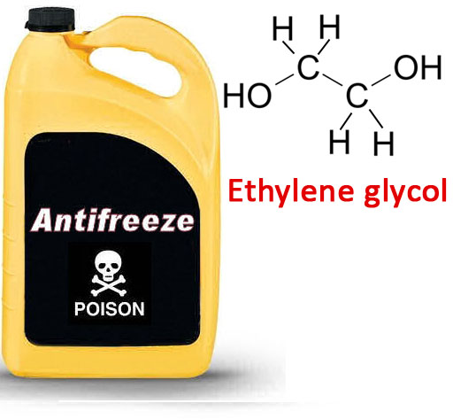

CAUSED BY:

**Nicotine**- This addictive substance may not be different compared to nicotine obtained from smoking conventional cigarettes. Nicotine is known to cause adverse effects such as mouth sores, irritated throat, and red, swollen tongue. 

It also negatively impacts bone healing, and can also be an important risk factor for the development and severity of inflammatory periodontal disease.

E-cigarettes are shown to have short and long term effects on the oral cavity, as well as the body.

Side Effects of Electronic Cigarettes