TCET 2220 12/19/13
Carlos Garcia
Prof. Viviana V.

HomeWork 5
Smith Chart

Questions
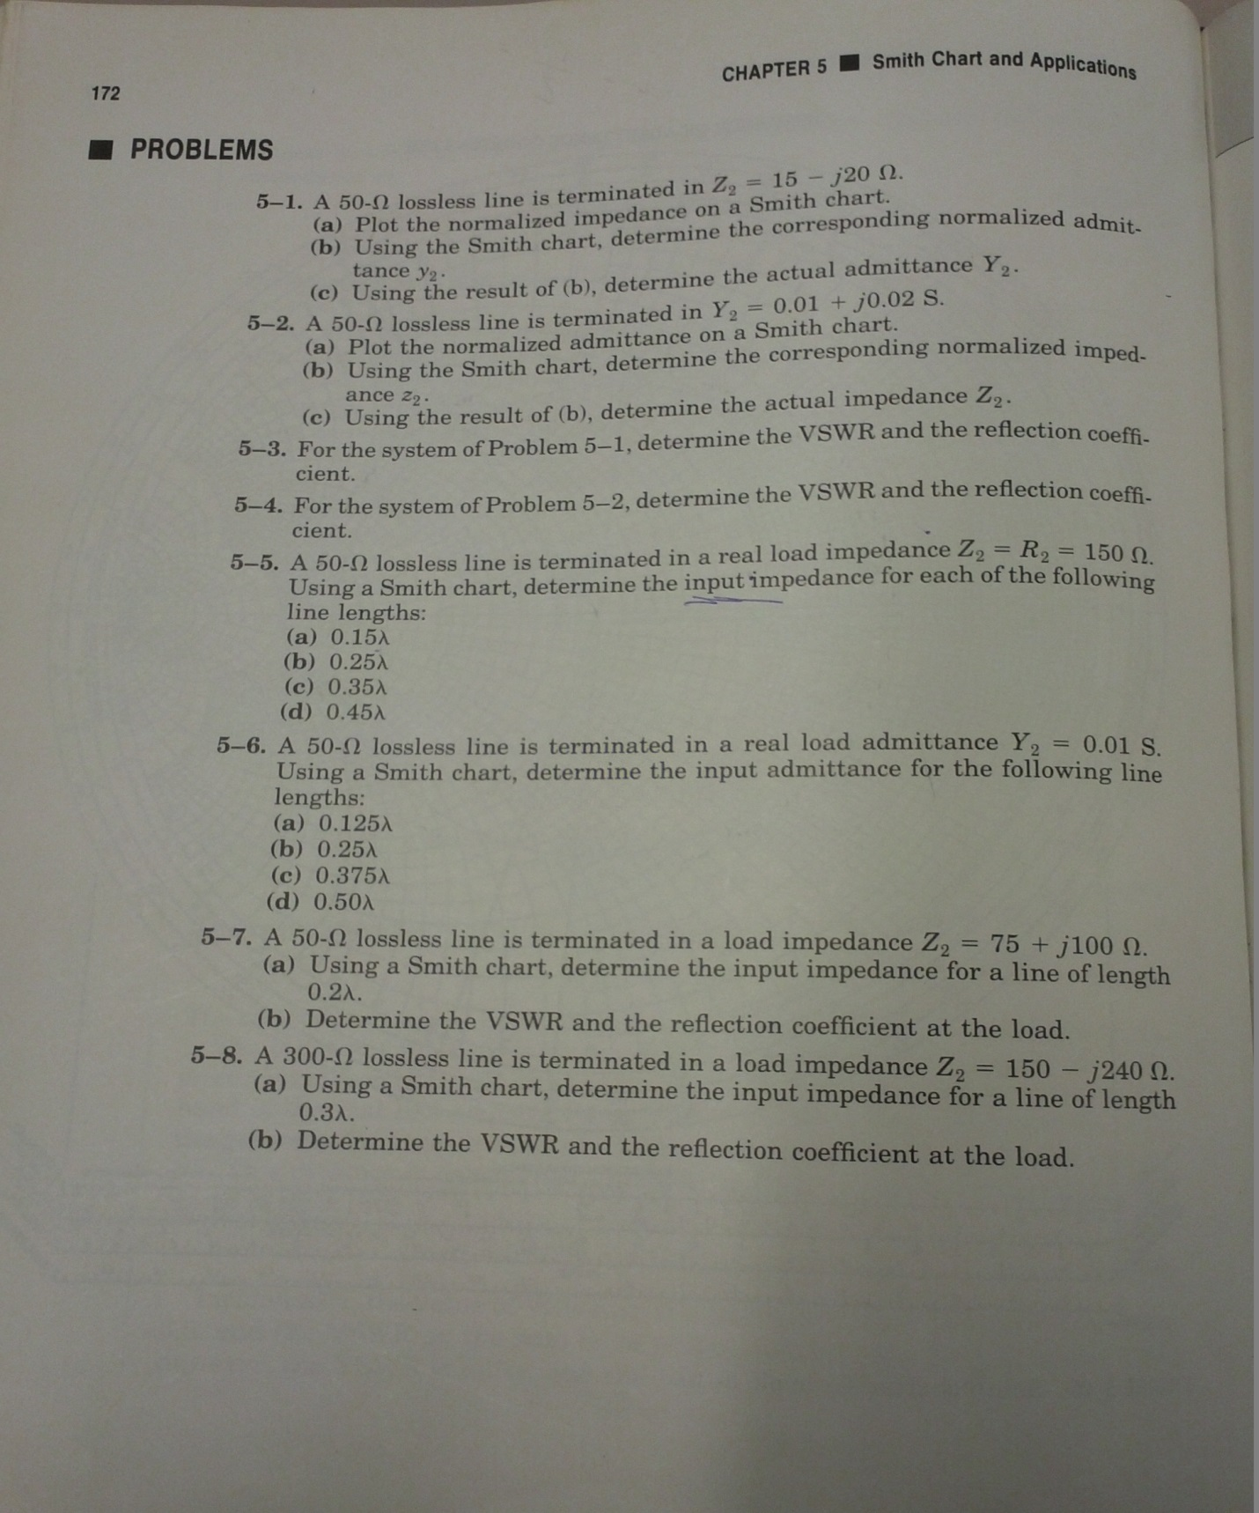

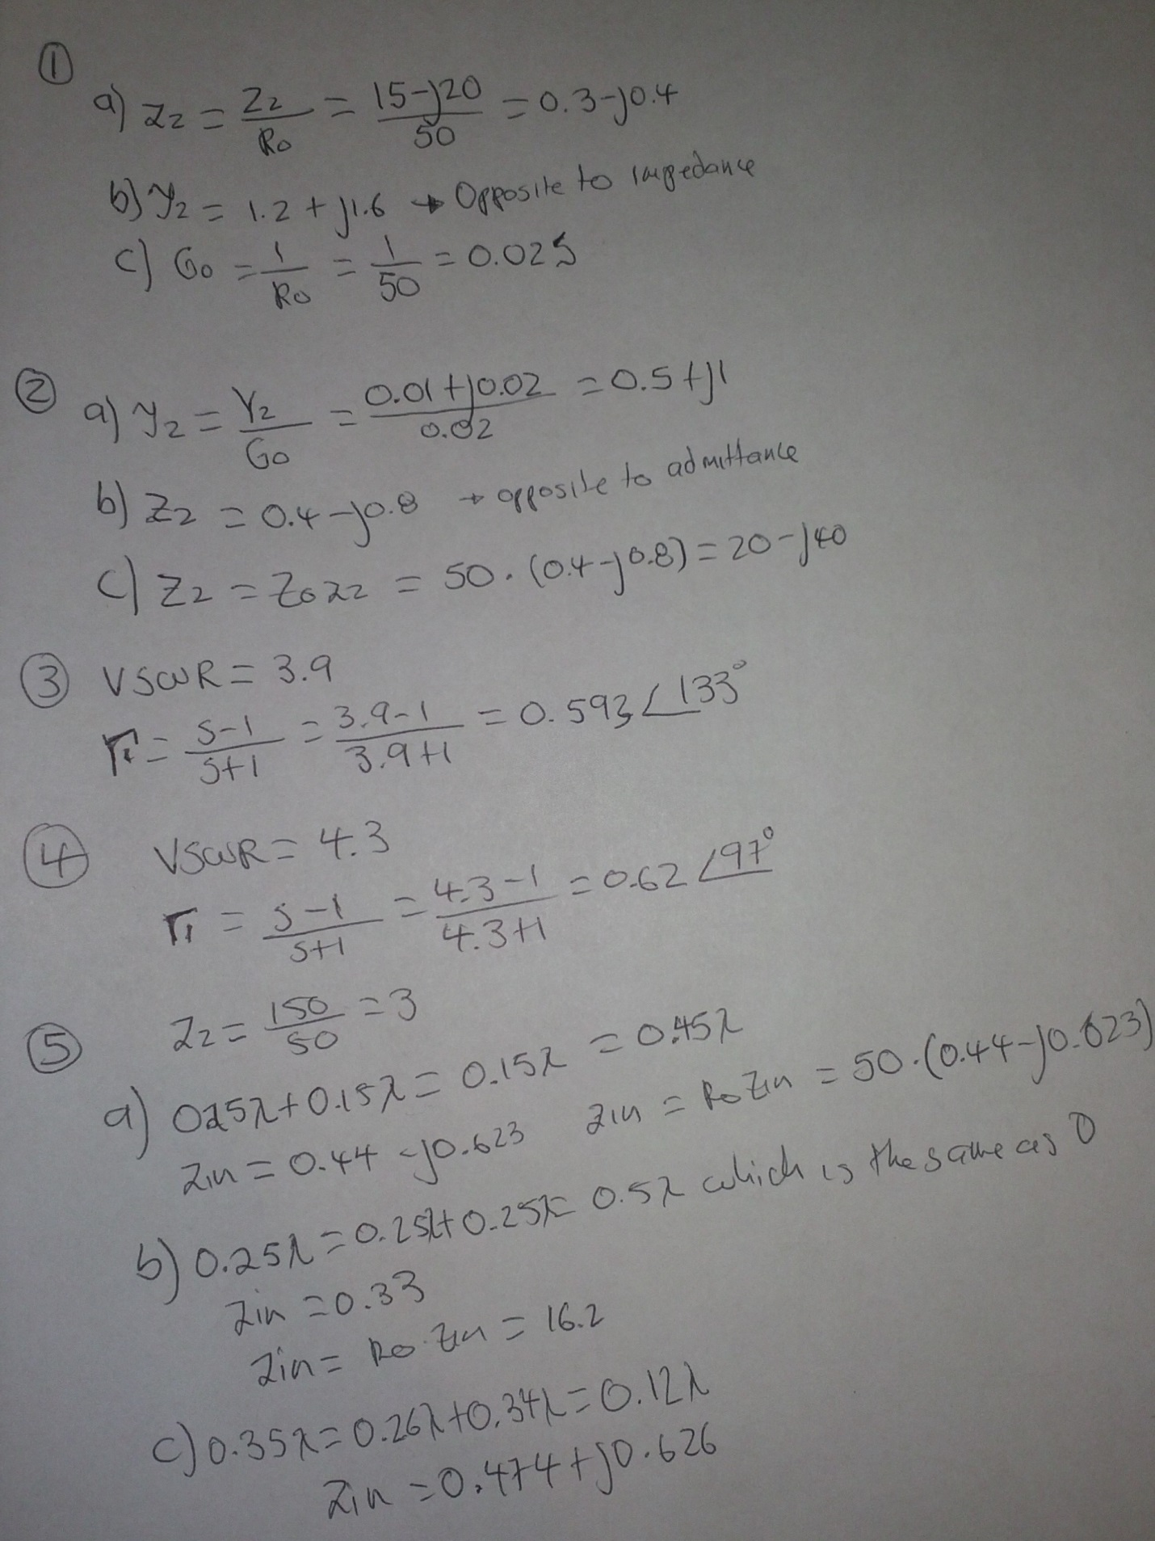
Solutions 1-5

Solutions 6-8
