Communication between ChipkitMax32 and PMODACL
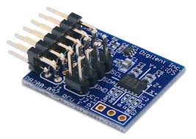
Summary:
The PmodACL is a digital accelerometer that is able to sense 3-axis using the accelerations of the position it is in. The module powered by this Analog Device is ADXL345. The Pmod ACL comes with various features such as: [1]
- SPI and I²C interfaces
- Free fall detection
- Activity/inactivity monitoring
- Single-tap/Doulple-tap detection
- User-selectable resolution

SPI interface communication:
SPI which stands for Serial Peripheral Interface is a synchronous serial data link that operates in full duplex move meaning one can receive and send simultaneously. The communication this device communicates in is master/slave mode where the master devices initiates the data frame, and with individual slave select lines, multiple slave devices are allowed.
The PMOD-ACL SPI interface has 12 pins, but uses 10 to communicate with the ChipkitMax32. These pins are:
- SS: Slave Select
- MOSI: Master output, Slave input
- MISO: Master input, Slave output
- SCK: Serial Clock
- GND: Ground
- VCC: +3.3V
- INT2: Interrupt 1
- INT1: Interrupt 2
- NC: Not connected
- NC: Not connected
- GND: Ground
- VCC: +3.3V
Interrupts may not be the standards of SPI however they are sometimes needed to be used by various sensors such as this one, touchscreen sensors, and temperature sensors.
The provides serial advantages such as, a high success rate of message delivery, full dublex communication, protocol flexibility because we are not limited to 8-bit words, simple hardware interfacing, and no limitations to any mac clock speed. On the other hand, it requires more pins on IC packages, it only supports one master device, and they are no error-checking protocol. [2]

I²C interface communication:
I²C which stands for Inter-Integrated Circuit is a multimaster serial sign-ended computer bus. This protocol is used to attach low-speed peripheral devices (sensors) to a digital electronic device such as computers and microcontrollers and with this protocol they are able to communicate with each other. I²C uses two bidirectional open-drain lines, Serial Data Line (SDA) and Serial Clock (SCL). These lines are pulled up with resistors. I²C uses a 7-bit or a 10-bit reference design. The PMOD-ACL I²C interface has 8 pins, but uses 4 to communicate with the ChipkitMax32. These pins are:
- SCK: Serial Clock
- SCK: Serial Clock
- SDA: Serial Data Line
- SDA: Serial Data Line
- GND: Ground
- GND: Ground
- VCC: +3.3V
- VCC: +3.3V
The advantages of using I²C is that it is more well known, requires less pins, allows user multiple masters, is adopted by many devices, and is used in many applications. The disadvantage is that it does not provide full duplex communication, it requires more knowledge of hardware because a pull-up resistor is needed, and it has a restrictions of 7-bit or 10-bit addresses.

Schematic of SPI interface with ChipkitMax32:
tr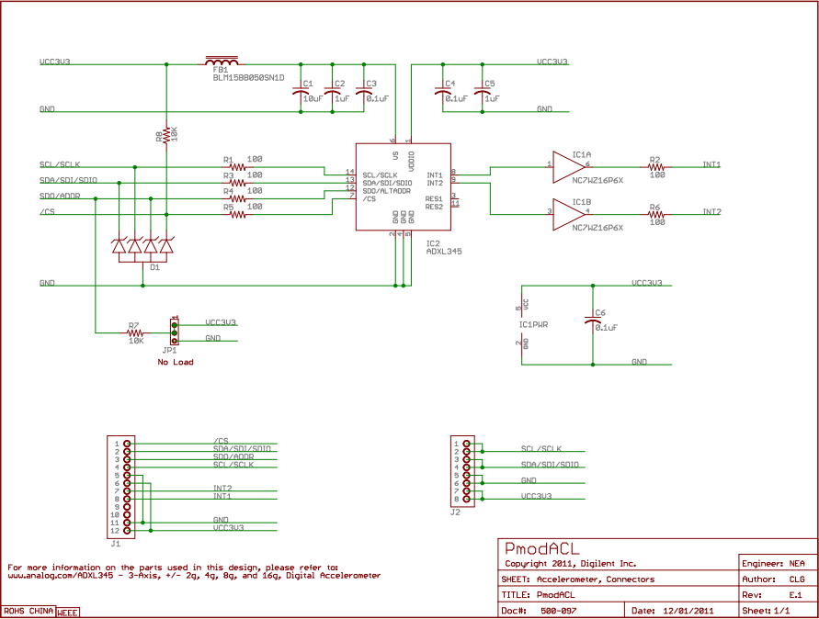 [1]
Accelerometer Theory:
Acceleration is defined by the time rate of change of velocity. (a=dv/dt) Thus, acceleration is the time rate of change of the time rate of change of distance making the unit of acceleration ft/s² or m/s². (a=d²x/dt²) When using an accelerometers the main acceleration it deals with is the earth’s gravity g where g = 32.2ft/ s² or 9.78 m/ s².
Using the ACL library given by digilent, I am able to observe how the sensor works. Below is a table that’s shows the outputs at various positions.

Position | X | Y | Z
Facing Up | 0 | 0 | 1
Facing Down | 0 | 0 | -1
Facing Left | 0 | 1 | 0
Facing Right | 0 | -1 | 0
Pointed Up | 1 | 0 | 0
Pointed Down | -1 | 0 | 0

Calibration:
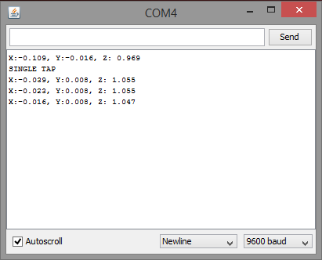
When the program first run it needs to calibrate the sensor so it send a fixed position of 0, 0, 1 which is what the sensors supposed to be when it is lying flat. Thus, one needs to make sure that the sensor is lying flat when it is running for the first time.

References:
[1] http://digilentinc.com/Products/Detail.cfm?NavPath=2,401,899&Prod=PMOD-ACL
[2] http://en.wikipedia.org/wiki/Serial_Peripheral_Interface_Bus
[3] http://en.wikipedia.org/wiki/I%C2%B2C
[4] http://www2.usfirst.org/2005comp/Manuals/Acceler1.pdf

