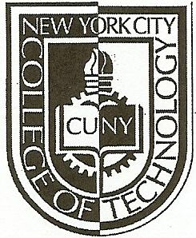NEW YORK CITY COLLEGE OF TECHNOLOGY
THE CITY UNIVERSITY OF NEW YORK
Department of Computer Engineering Technology
300 Jay Street, Brooklyn, NY 11201-1909

CET 3640 – Software for Computer Control
Lab #7
Instructions:
- Download and install the Android SDK. Instructions here http://developer.android.com/sdk/index.html
- Complete the tutorial Getting Started with Android here http://developer.android.com/training/index.html

Lab Report:
On your OpenLab portfolio create a new page and post the following items:
- Description of the lab in your own words (5 points).
- Screenshots of your app (5 points).
- Show to the professor your app running in the emulator (20 points).

Deadline: April 19, 2013 @ 2:15 PM.

