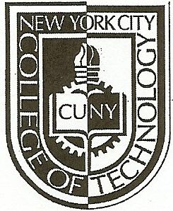NEW YORK CITY COLLEGE OF TECHNOLOGY
THE CITY UNIVERSITY OF NEW YORK
Department of Computer Engineering Technology
300 Jay Street, Brooklyn, NY 11201-1909

CET 3640 – Software for Computer Control
Lab #6
Instructions:
You are give the following interface Movable():

public interface Movable {
public void moveForward();
public void moveBackward();
public void stop();
public void moveLeft();
public void moveRight();
}

Base on the Movable interface create three classes: Car(), Plane(), and Ship() that implement it. After that, create a program that will polymorphically process an array of Movable by calling each of the interface methods, after creating an object for each one of the classes. Implement the classes in such a way that the output is:

Plane flying forward
Plane taxiing backward
Plane landed
Plane flying left
Plane flying right
---------------------
Car drives forward
Car drives backward
Car parked
Car turns left
Car turns right
---------------------
Ship navigates forward
Ship navigates backward
Ship docked
Ship navigates left
Ship navigates right
---------------------

Lab Report:
On your OpenLab portfolio create a new page and post the following items:
- Description of the lab in your own words (10 points).
- Source Code (10 points).
- Screenshots of you program running and results (10 points).

Deadline: April 05, 2013 @ 2:15 PM.

