NEW YORK CITY COLLEGE OF TECHNOLOGY
THE CITY UNIVERSITY OF NEW YORK
Department of Computer Engineering Technology
300 Jay Street, Brooklyn, NY 11201-1909

CET3640 – Software for Computer Control
Lab #3

Instructions:
- Create a class called MobileDevice with a private field deviceType that will be initialized to the string “Mobile Device” in the constructor. Include the corresponding setter and getter methods.
- Create another class SmartPhone that will inherit MobileDevice, with a private field deviceType initialized to the string “Smart Phone” in the constructor, and override the getter method by returning the string:
“Mobile Device -> Smart Phone”. (Hint: To obtain this result make a call to the super class getter method).
- Create three more classes: Android, iPhone, and WindowsPhone that will inherit SmartPhone, have a private field deviceType initialized to the string “Android”, “iPhone”, or “Windows Phones” correspondingly in the constructor, and override the getter method returning the corresponding string
“Mobile Device -> Smart Phone -> iPhone” for iPhone,
“Mobile Device -> Smart Phone -> Android” for Android”, or
“Mobile Device -> Smart Phone -> Windows Phone” for Windows Phone.

Your classes must follow this hierarchy:

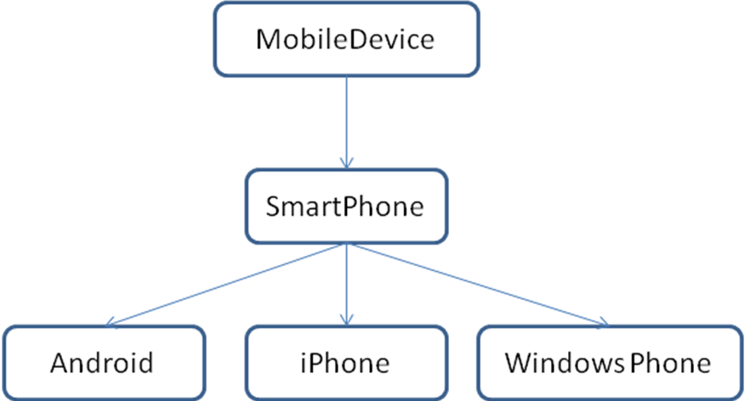

Once you create the classes, run the following client code and report your output.

public class MobileDeviceClient {
public static void main(String[] args) {
// TODO Auto-generated method stub
MobileDevice myMobileDevice = new MobileDevice();
SmartPhone mySmartPhone = new SmartPhone();
iPhone myiPhone = new iPhone();
Android myAndroid = new Android();
WindowsPhone myWindowsPhone = new WindowsPhone();
System.out.println(myMobileDevice.getDeviceType());
System.out.println(mySmartPhone.getDeviceType());
System.out.println(myiPhone.getDeviceType());
System.out.println(myAndroid.getDeviceType());
System.out.println(myWindowsPhone.getDeviceType());
}
}

Lab Report:
On your OpenLab portfolio create a new page and post the following items:
- Description of the lab in your own words.
- Source Code
- Screenshots of you program running and results.

Deadline: March 15, 2013 @ 2:00 P.M.

