NEW YORK CITY COLLEGE OF TECHNOLOGY
THE CITY UNIVERSITY OF NEW YORK
Department of Computer Engineering Technology
300 Jay Street, Brooklyn, NY 11201-1909

CET CET3510 – Microcomputer Systems Technology
Lab #6
Instructions:
Write a program C++ with two options that are the inverse of each other:
- Packing 4 characters into an unsigned long int. The 4 characters should be entered individually and the result should be content of the long variable.
- Unpack an unsigned long int into 4 characters. A single long value is entered and this should be parsed into 4 characters and these be displayed.

You can accomplish these two tasks by using shift and bitwise operators with the appropriate masks. At the end you should end up with output similar to the screen below:
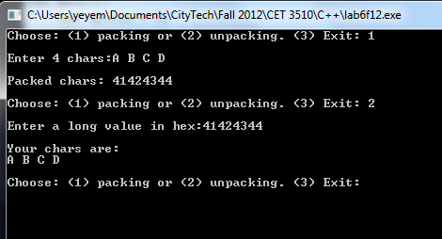
HINTS:
- Accept the input in hexadecimal instead of decimal. To do that use:
cin >> hex >> variable
- Display output in hexadecimal format instead of decimal. To do that use:
cout << hex << OUTPUT STAMENTS
- For the mask use hexadecimal numbers instead of decimal. To do place 0x in front of the hexadecimal number (i.e. 8 0x8, 10 0xA, 20 0x14)

Lab Report:
On your OpenLab portfolio create a new page and post the following items:
- Lab description.
- Source Code.
- Screenshots of you program running.

Deadline: December 13, 2013

