Cooking Techniques
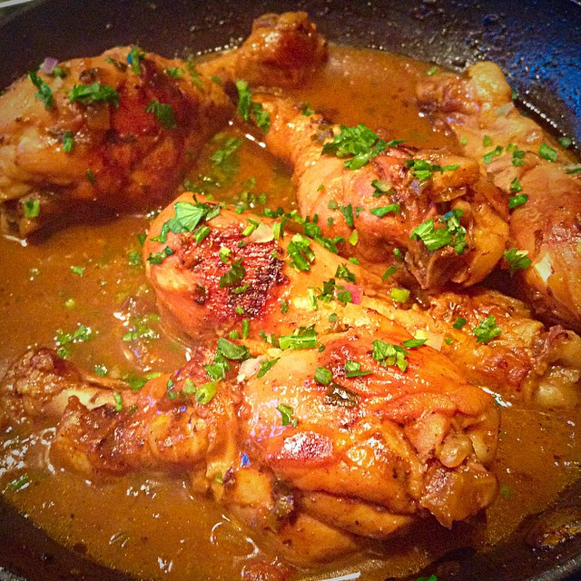

Caroline Carreño

