COMD 1112_FALL 2021_HD05
Designer Research Paper
Carl Cabrall
11-14-2021

Featuring: Brian Skerry – Renowned National Geographic Photographer
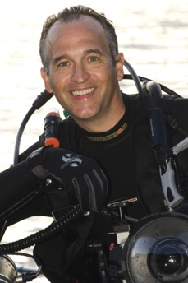
Figure 1- Brian Skerry
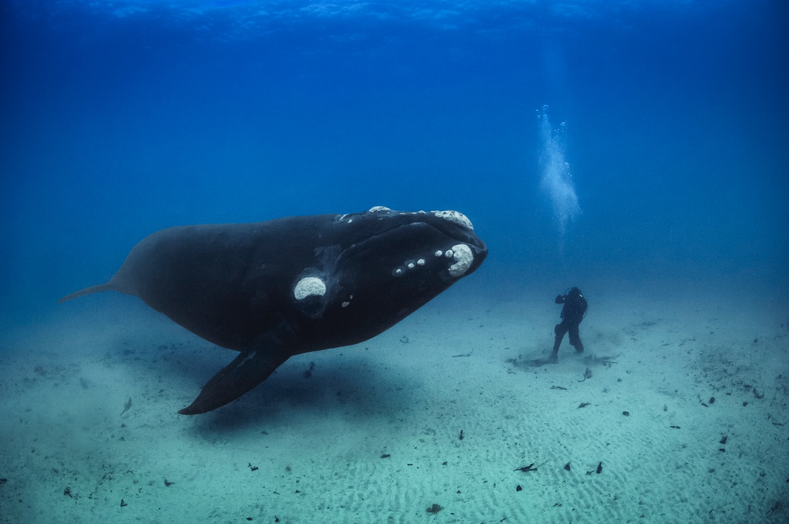
Figure 2 Wright Whale and Diver Face to Face.

Why I chose Brian Skerry

When I first saw the photo in Figure 2 above, I was transfixed immediately. What kind of man could this be that he would be found worthy by a 70 ton whale to have a face to face conversation 70ft below the surface of the ocean as if it were a normal everyday thing. I was inspired being a photographer in training myself.

How he became a photographer

In his YouTube interview with the online blog “Alive Photo,” Brian happily gives a ‘window’ into the genesis of his life as a photographer. He shares, “From a very early age, I was inspired by the ocean. I used to watch Jeac Cousteau documentaries, I read National Geographic Magazine, and I knew that I wanted to explore the ocean. It’s very rewarding to be a photographer. It has added layers to my life—to who I am—that I never could have imagined” He began scuba diving at the age of 15 years old after completing a certification course. His first experience diving was off the coast of his native New England. However it was not until a year later that when he attended the Boston Sea Rover’s Conference and saw under water explorers presenting their research and photography that he had what he called his personal epiphany and new that underwater photography was his path forward in life. However, it was not enough for him just to take world class pictures. Something was missing.

Becoming a journalist and an activist

Skerry appeared at The Connecticut Forum's "Photo Wonders" on May 11, 2019 along with Pete Souza, Lynsey Addario and moderator Lucy Nalpathanchil. He talks about becoming eventually depressed while working on a project after seeing the consequences of environmental destruction. Over and over, it bothered him deeply when he saw injured or dead animals – needlessly decimated by the hands of man. It was the first time he had an Epiphany in his understanding which caused him to see that he could make a difference using his photography to change the way people thought about caring for the ocean. His work began to take on iterations that were subject-based; artfully using photography to amplify known atrocities that governments and populations around the world were turning a blind eye to. Figures 4 to 17 represent an insight into his work. There are several YouTube links to interviews and documentaries as well as photographs showing some of his conservation activities. Figures 4 and 17 stand out the most.

Interviews / Documentaries and Photography
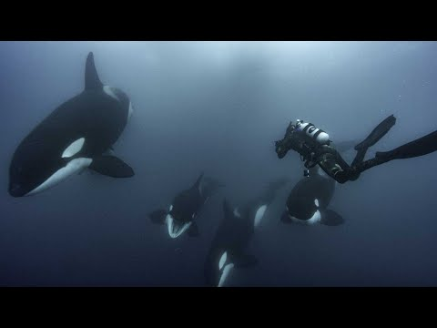
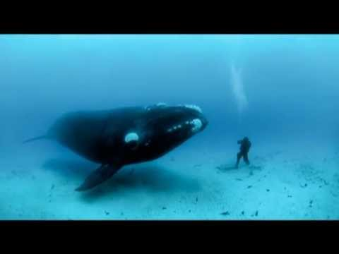
Figure 3 Meet the Man Who Swims With Whales.
Figure 4 - Brian Skerry: National Geographic Underwater Photographer

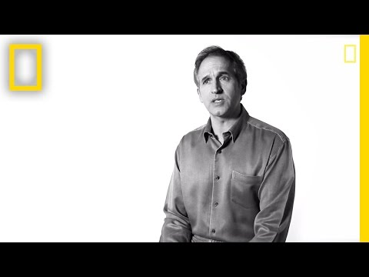
Figure 5 Brian Skerry - Capturing the Soul of the Sea
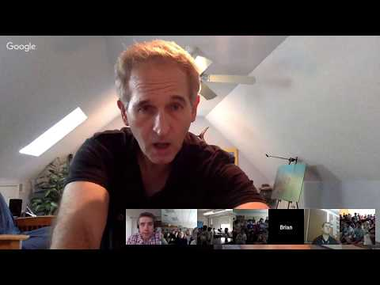
Figure 6 Explorer Classroom - Underwater Photography

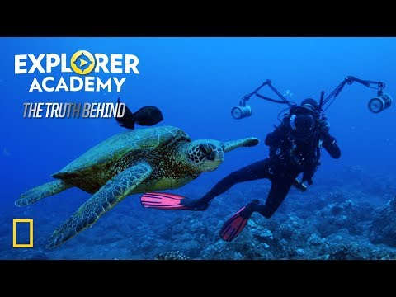
Figure 7 Explorer Academy- The Truth Behind Swimming With Giants

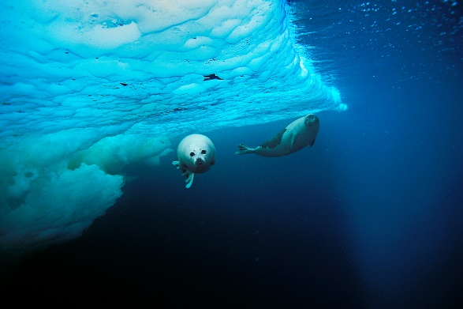
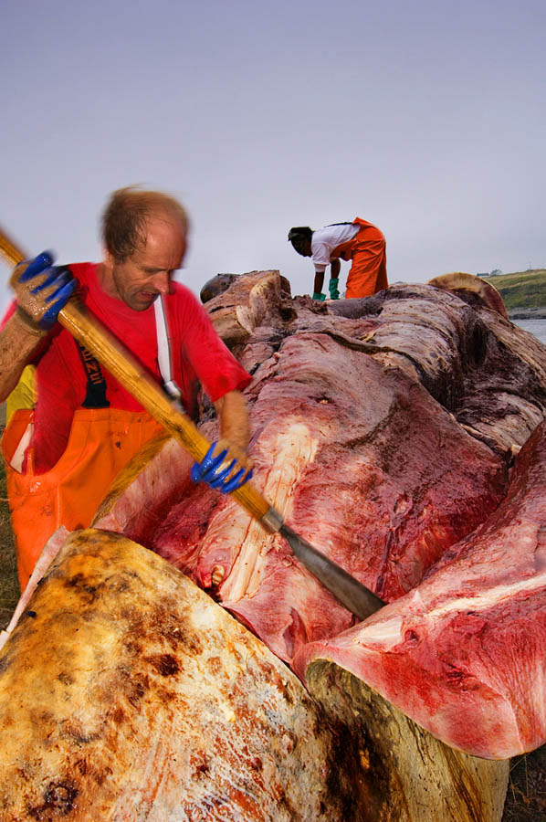
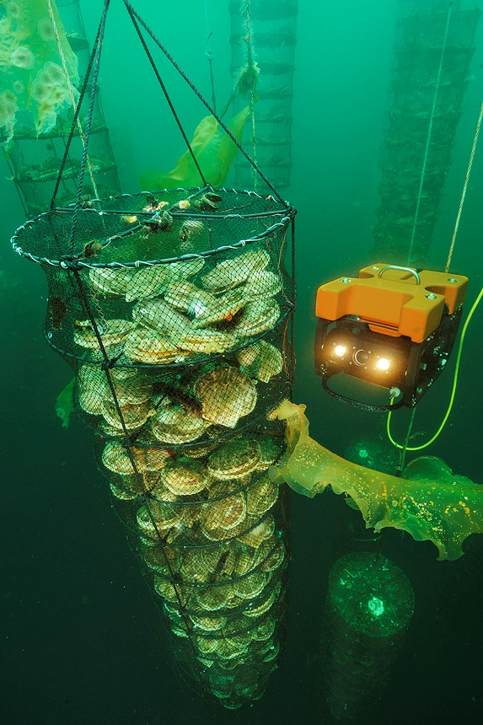
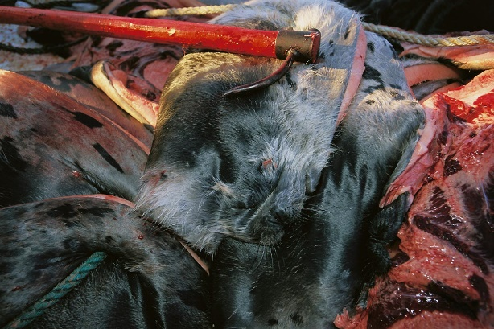
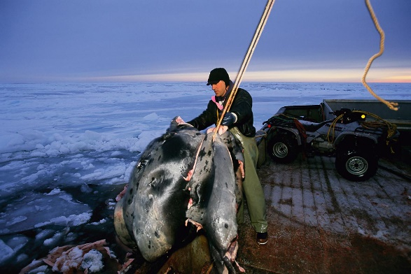
Photo Gallery
Figure 12 - Dr. Michael Moore Performing Necropsy on White Whale.
Figure 11 - Aquaculture
Figure 9 - Seal Hunter
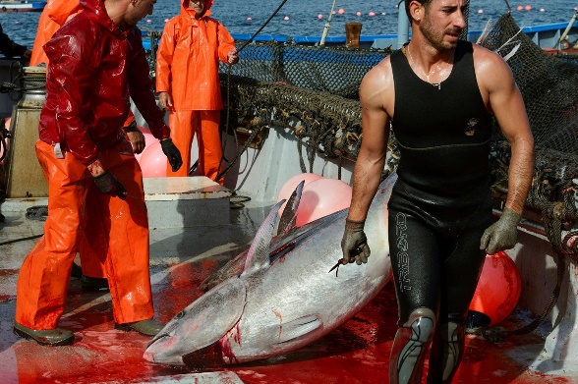

Figure 7 - Harper Seals
Figure 8 - Atlantic Blue Fin Tuna

Figure 10 - Hakapic - The Club used to Kill Seals lies on Top of Hides

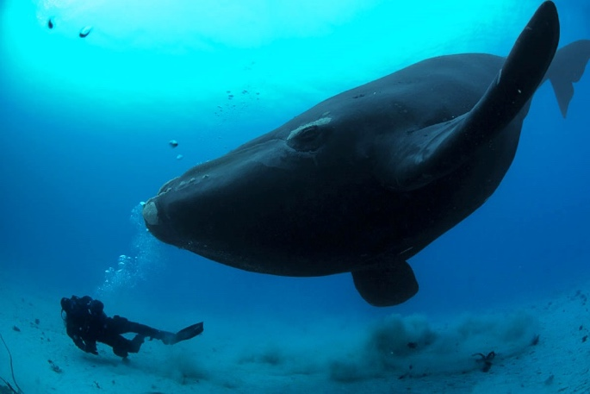
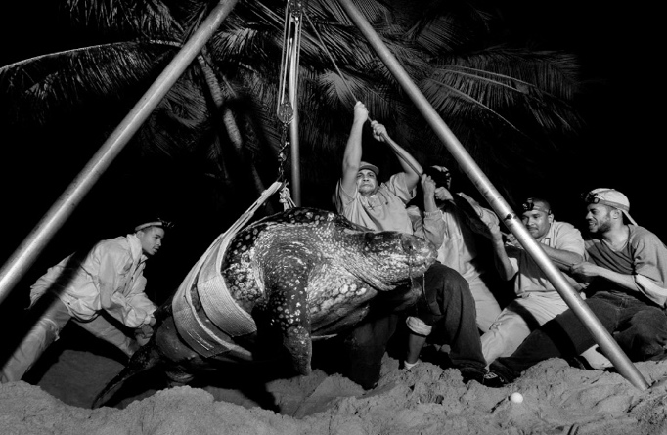
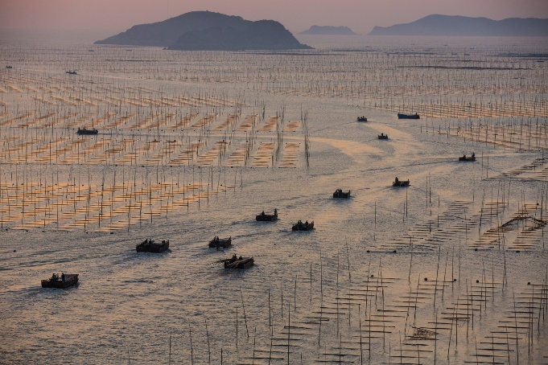
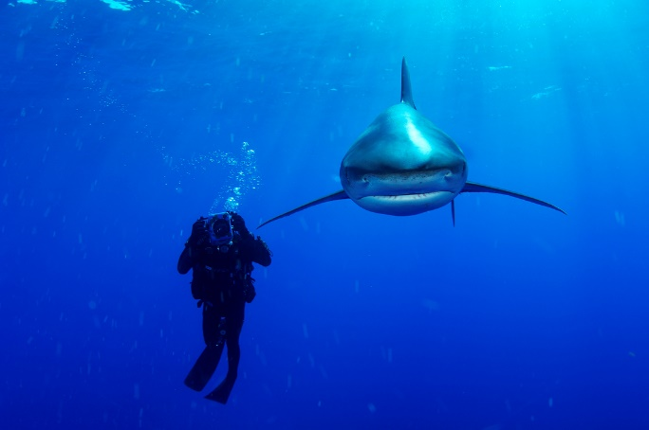
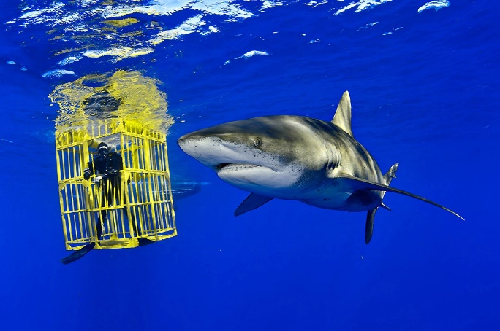
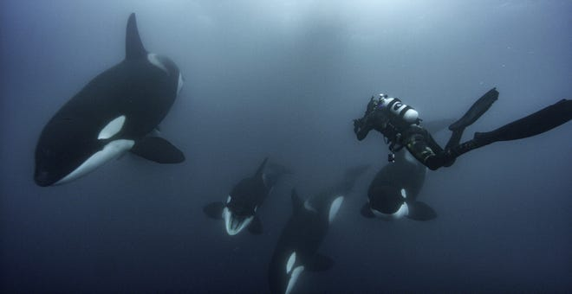
Figure 17 Turtle Conservation
Figure 16 Industrial Fish Farming In China
Figure 15 Whale Sharks
Figure 13 Shark Photography
Figure 14 Photographing Killer Whale Families

Figure 17 Encountering a Curious Wright Whale

Becoming a master teacher

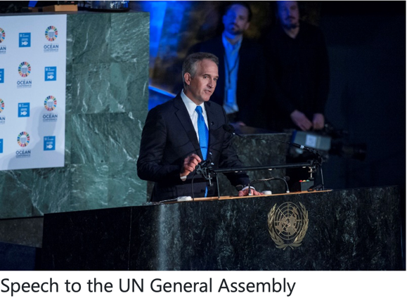
In his career that has spanned 40 years he has spent over 10,000 hours beneath the oceans of the world photographing marine life. The last 20 of those years has been as a National Geographic photographer. Working with National Geographic Magazine (NGM) give Brian an unimaginable platformed filled with priceless opportunities to influence the world. He took this opportunity very seriously. The work that he has produced has brought the world knocking on his door over and over asking for help while bringing even more opportunity. One of Brian’s most rewarding activities is being able to teach the children of the world through NGM’s Explorer Academy. Despite the ongoing pandemic, there has been numerous occasions where he has streamed interviews simultaneously with classes stretched across North America. At the end of sharing about his work children often jump at the opportunity to ask him question. One of the ‘nuggets’ of inspiration that he often shares is the fact that as young as five years old, his favorite activity was swimming in the family pool in the backyard. Even then he dreamt of becoming like Jaques Cousteau. Not only is the education of our children strategic priority for Brian, but so is the opportunity to change the minds of the leaders of the world. Figure 18 shows Brian addressing the United Nations General Assembly shedding light on men’s activities which harm endangered species of marine life.
Figure 18

Of equal urgency is the need for more young people to choose marine biology and underwater photography as a viable career. To achieve this, Brian has so far published at least 12 books some of which are shown in the bibliography at the end. One such book is shown in Figure 19.

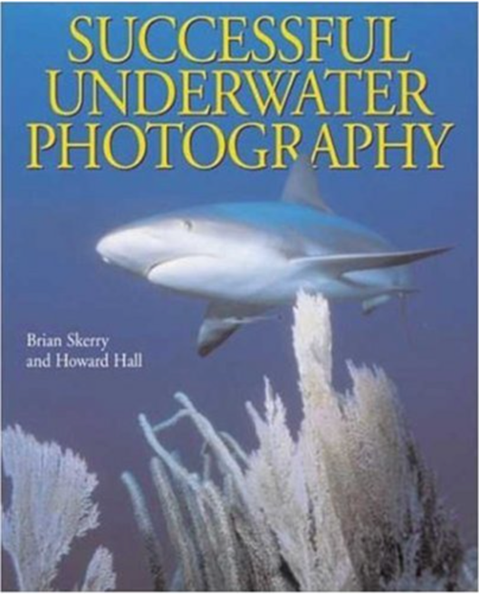
According to Brian and his Co-Author Howard Hall, Successful Underwater Photography shares in depth a range of topics. It examines everything from “…fundamental principles of photographing marine life to making a living selling underwater photographs, provides an unlimited wealth of practical advice, surefire strategies, and tested tips for taking extraordinary photos of elusive underwater subjects.” It deals with “… such topics as taking available-light photographs, silhouettes, marine wildlife portraits, close-focus wide angle photographs, and extension tube photographs to name just a few.” The authors also provide “proven guidance for purchasing underwater photographic equipment, taking photos of shipwrecks, and repairing and maintaining field equipment. It contains 150 stunning, full-color photos to demonstrate the authors successful techniques in action.” His passion for spreading sensitivity towards the environment has afforded him frequent opportunities to:
Figure 19 Successful Underwater Photography
- lecture “on photography, exploration and conservation issues. Speak at the The World Economic Forum in Davos, Switzerland, TED Talks, The National Press Club in Washington, DC, The Royal Geographical Society in London and the Sydney Opera House in Australia.”
- He has appeared as a guest on television programs across the United States and Canada and further afield.

Earned Professional Awards

Reading through the list of professional awards and commendations given to Brian reads like a ‘pleasant marathon.’ They are indeed substantial. The following list is a summary of some of his achievements paraphrased from his website:

Awards
- 1998 - contract photographer for National Geographic Magazine
- 2014 - National Geographic Photography Fellow
- 2017 - named a National Geographic Society Storytelling Fellow
- 2017 - awarded the title of Rolex NGM Explorer of the Year.
- 11-time award winner in the prestigious Wildlife Photographer of the Year competition.
- He received awards from Pictures of the Year International, Nature’s Best, Communication Arts
- The only photographer to win the coveted Peter Benchley Award for Excellence in Media.
- 2010 - one of Brian’s images named among their 50 Greatest Photographs Of All Time
- 2016 - National Geographic Photographer’s Photographer Award, this is an honor bestowed by his colleagues.

Conservation Work.

- He brought attention to the harp seal’s struggle to survive in frozen waters.
- He brought attention to the alarming decrease in the world’s fisheries.
- He increased public sensitivity to dolphin intelligence.
- 2016 - NGM published three consecutive feature stories by Brian about predatory sharks.
- 2017 – Published article in NGM, focuses on protecting special underwater ecosystems in US waters.
- 2017 - Brian produced the first images of a US President underwater.

Prestigious Publications which carried his work

From his own archives, Brian reports that he has been featured in the following mainstream publications.
  - Sports Illustrated, The New York Times, BBC Wildlife, Paris Match, GEO, The Washington Post, The Wall Street Journal, Smithsonian, Esquire, Audubon and Men’s Journal.
  - Brian has either authored or co-authored 12 books.

Exhibitions

As a global icon in the photography world, his pictures have been exhibited in:
- Visa Pour l’Image in Perpignan, France
- In cities such as Geneva, Barcelona, Lisbon and Shanghai and at the Smithsonian National Museum of Natural History in Washington, DC and many more.

Conclusion

Brian’s goal is to leave the world a better place by showing people how rich and beautiful the world beneath the ocean truly is. In a ‘bittersweet’ sort of way, beauty cannot be appreciated without showing ugliness. With a sense of mission and vision for a better tomorrow (and the cleaner and healthier ocean), Brian continues to photograph the nasty side of man’s disrespect to the oceans and its wildlife around the world. If our children can be made to develop healthy attitudes towards our oceans, then the world will be a better place. Many endangered species will thrive instead of die. Such will be the legacy of Brian Skerry.

Works Cited

All American Speakers. allamericanspeakers.com. 01 01 2002. Speaker Biography. 10 12 2021. <https://www.allamericanspeakers.com/celebritytalentbios/Brian+Skerry/386821>.
Bourne, Joel K. How to Farm a Better Fish. 01 01 1996. National Geographic Society. Article. 10 12 2021. <https://www.nationalgeographic.com/foodfeatures/aquaculture/>.
Skerry Brian, Hull Howard. Successful Underwater Photography. 14 12 2021. December 2021. <https://www.amazon.com/Successful-Underwater-Photography-Brian-Skerry/dp/0817459278/ref=sr_1_5?keywords=brian+skerry&qid=1639500486&sr=8-5>.
natgeo. Brian Skerry's Iconic Photo | Mission Critical. 14 12 2021. December 2021. <https://www.youtube.com/watch?v=rFV4pRlw5Lw>.
National Geographic. n.d. Whittney Negabower. December 2021. <https://www.youtube.com/watch?v=ChyIGJE2gzg>.
National Geographic . Youtube. n.d. December 12-14-2021. <d. https://www.nationalgeographic.com/foodfeatures/aquaculture/>.
Skerry, Brian. https://brianskerry.com/. 01 01 2017. Gallery. 10 12 2021. <https://brianskerry.com/bio/>.
TED TALK. Brian Skerry reveals ocean's glory -- and horror. 14 12 2021. TED. December 2021. <https://www.youtube.com/watch?v=0HEXx3-P8kk>.

