COMD 1112_FALL 2021_HD05
Virtual Field Trip
Carl Cabrall
11-10-2021

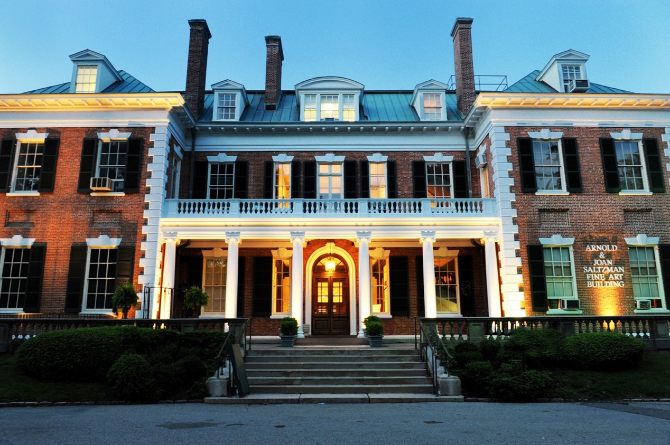

Figure 1 – Nassau County Museum Of Fine Art: The Arnold and Joan Saltzman Fine Arts Building

Being one of the more prominent museums on Long Island, according to their website, the museum has a very clear mission that guides it’s existence. “The Nassau County Museum of Art (Figure 1) is dedicated to fostering a deeper understanding of art and culture through exhibition and education programs for people of all ages and backgrounds. In practice, the Museum pursues the mission by enhancing its permanent collections, sculpture park, historic property and natural setting.” The museum’s 145 acre property and it’s facilities have a long and illustrious history of attracting many of the prominent thinkers in the north east when it was a private home of wealthy patrons who understood the power of art and research and the necessity to preserve it. It is therefore no surprise that it’s exhibit on the history of the color blue would be nothing less than profoundly eye-opening.
This week’s virtual field trip to the Nassau County Museum Exhibit Blue was a most interesting experience. Under normal circumstances, one would not stop to think that the color blue had such amazing history having undergone an evolution spanning thousands of years. It was somewhat therapeutic to see the various hues of blue unfold from the pigments of both Ancient Egypt and South America, to the chemical based experiments of Western European artists. Following hand-in-hand with an increased understanding of the evolutionary journey behind the various levels of meaning ascribed to blue from its aura of tranquility to its radiation of divinity and immortality. Consequently, three works of art would be highlighted.

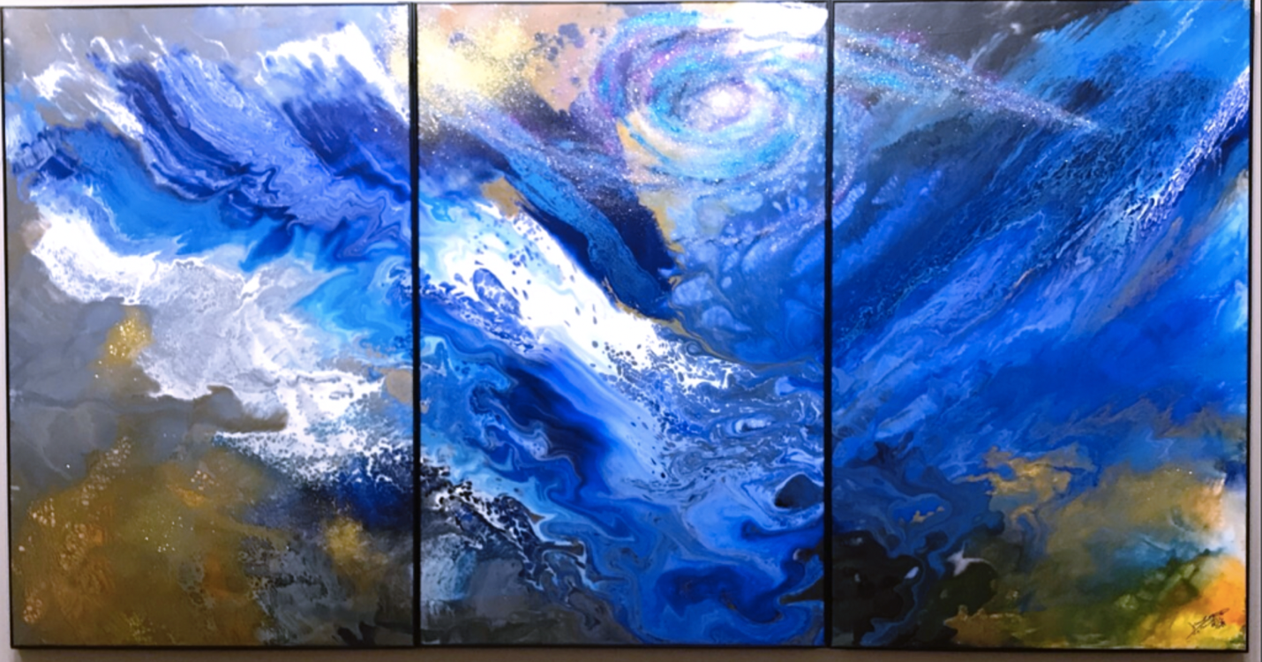
Figure 2 - Cao Jun’s Symphony, 2020

The first work of art is the peace ‘Symphony’, created by one of the long island’s resident artists; the Japanese born Cao Jun. His painting gives the appearance of millions stars and planets in a galaxy swirling in the sky as if you are looking at them from beneath the surface of the ocean. Not only does it appear as if you are looking from beneath the surface of deep water but there is a distinct appearance of glass like ice above you as you look through to the light on the other side. The painting seems to be an oil-based painting and gives the effect of a colorful sludge-like effect of blue, white and brown oil mixing with water. Several blue hues are visibly mixing seemingly creating the perfect extra planetary experience. Cao Jun’s painting is both calming, transfixing as well as beautiful to look at. The piece is fittingly called ‘Symphony’.
Equally inspiring among the exhibit what is the work of Antonio Santín was born in Madrid, Spain in 1978. Educated in Spain, “he received his Degree in Fine Arts from Universidad Complutense de Madrid in 2005.” His technique from the very beginning has set him apart opening doors for many exhibits worldwide.

Figure 4 The Tree of Life –‘El Arbol de la Vidilla 2020.
Oil on Canvas 49X79 inches (124.5X200.7CM)
By Antonio Santin

According to the Marc Straus Gallery in New York, “Santín constructs eerie, arresting compositions that simultaneously attract and unsettle in their evocative depictions of sublimated desire. He orchestrates elaborate still-lifes, manipulating both objects and the human form to construct a space he describes as “more real than reality itself.” … Deeply rooted in the tradition of Spanish Tenebrism as well as his own training as a sculptor, Santín juxtaposes flattened planes with tangible forms carved by light and shadow to create a continuous perceptual dialogue in each work. The rug series evolved from his ongoing interest in the opacity of fabric as a device to obscure with abstract patterns and textures. Each of these works brings the background into the foreground while a discernible shape hovers beneath the surface.”
My favorite piece out of all of the exhibits is the one below in figure 5 – it is Christopher Winter’s, “The Huxley Guide to Switzerland 2011.” This acrylic work of art done on canvas evokes the sense of freedom, power, confidence, and dominion and reminds me of the common phenomena that we experience in the deep realms of sleep when dreaming of ourselves flying - completely unhindered by any natural law. It is a work of tranquility with excellent use of perspective balancing the foreground in the background while placing two figures flying in space. The vivid and the careful use I have several shades of blue to create a sense of perspective and the vanishing point with reflected light over a glass like water is definitely the work of a master artist.

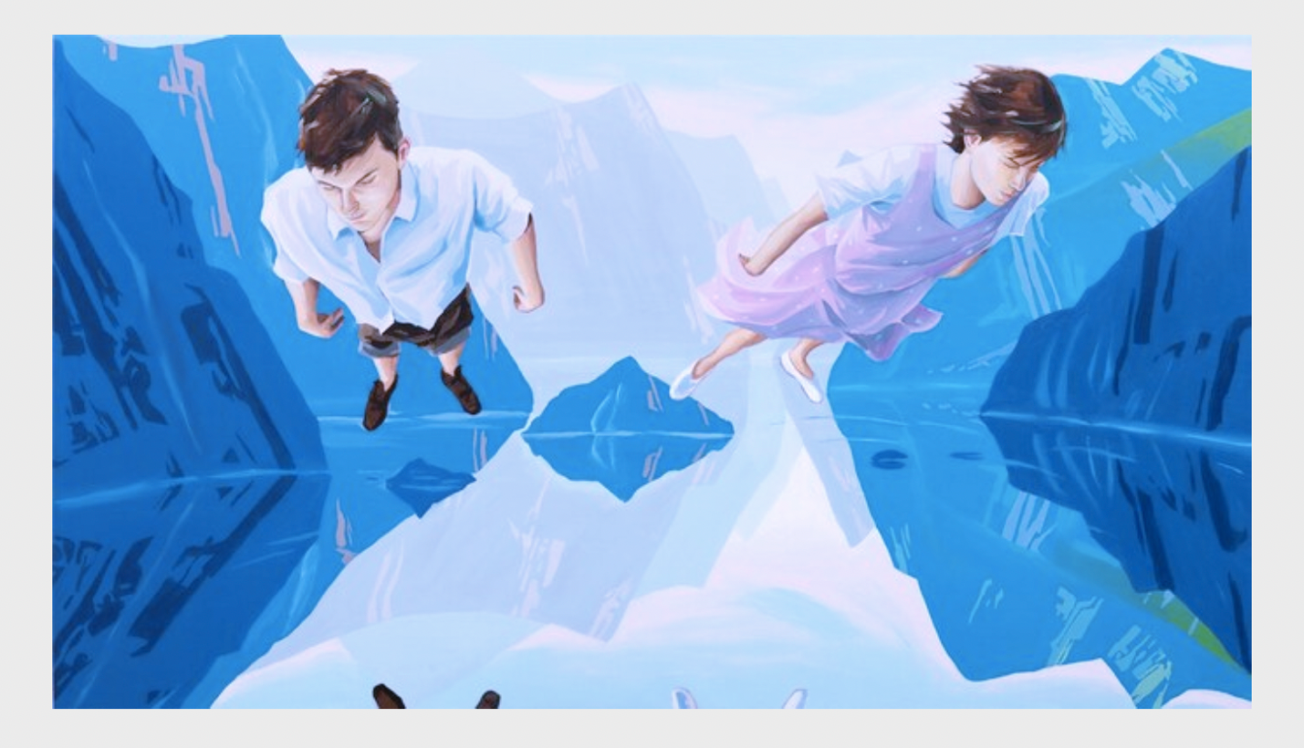
Figure 5 - Christopher Winter, The Huxley Guide to Switzerland 2011. Acrylics on Canvas 35.5 X 27.5 inches Courtesy of Edelman Arts.

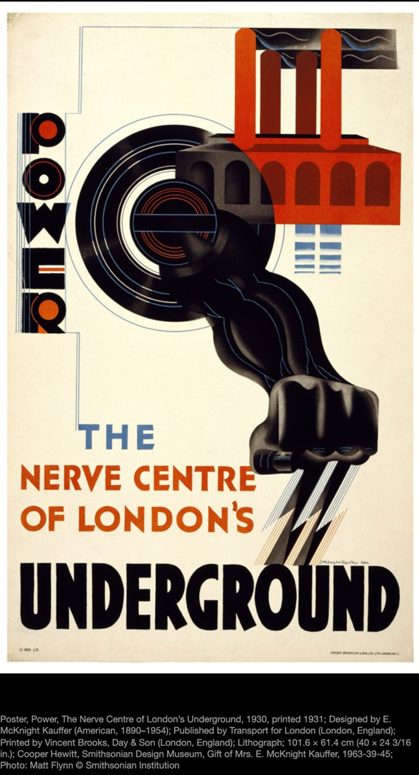
On our my virtual trip to the Digital Museum at the Cooper Hewitt, the art work called ‘Power – The Nerve Center of London’s Underground 1930,’ stood out. According to the Cooper Hewitt Museum, “This is a Poster. It was designed by E. McKnight Kauffer and printed by Vincent Brooks, Day & Son and made for (as the client) Transport for London. It is dated 1930, printed 1931 and we acquired it in 1963. Its medium is lithograph. It is a part of the Drawings, Prints, and Graphic Design department. For 15 years, Kauffer had promoted the Underground as a way to reach a destination. But here, he celebrated the raw energy that powered the system. Kauffer fused man and machine, drawing on images he had seen in Soviet propaganda posters. Electric bolts emanate from a muscular arm and clenched fist, which punches through a spinning turbine that doubles as the Underground logo. Blue currents of energy are drawn from a simplified yet recognizable Battersea power station.” Although the preceding quote represents the official description of the Cooper Hewitt museum, the meaning I took away from the posters initial impression was a bit different. It forced me to imagine the struggle for black civil rights in the 1930s in Britain. There was no shortage of volatility in the world at that time period between the Great depression, the rising tree in unionism, racial inequality, and the impending second world war 15 years later, there’s definitely a lot of social energy that needed to be expressed. For me this is what the image of this poster evoked.

Sources

https://nassaumuseum.org/about/#our-mission
https://www.cooperhewitt.org/channel/kauffer/#jp-carousel-40693
https://collection.cooperhewitt.org/objects/18448065/
https://www.marcstraus.com/artists/antonio-santin/

