Carl Cabrall
COMD 1112 -HD05
10-25-2021
The Design History Of The Boeing Company’s Logo

Introduction
As an aircraft enthusiast, I’ve always followed the mini technological advancements in aircraft production as produced by the Boeing company. This past August 24, I had the opportunity to visit the Boeing Museum located in Seattle Washington. It is for this reason why I choose their company logo for this project and share my photo of the new 747-8. It features the newest iteration of the Boeing company’s logo on the left side. Having said this, how did this company begin its journey and develop its internationally known logo?

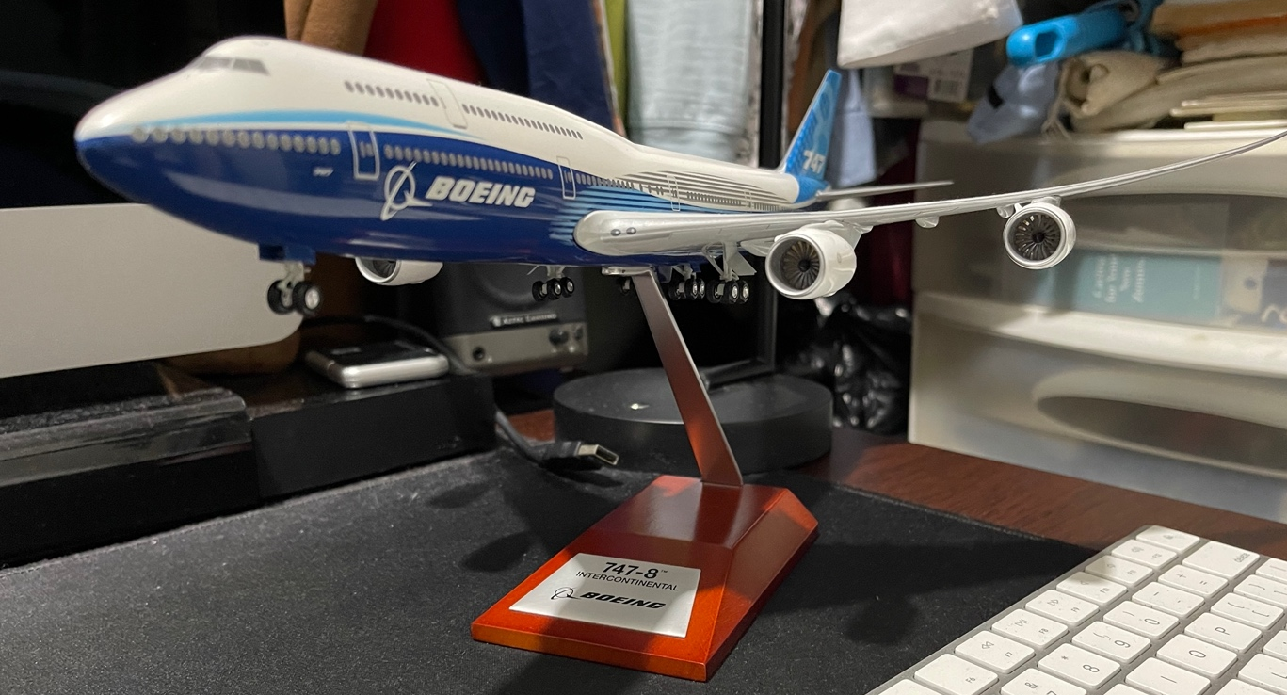
Figure 1: Original Photo by Carl Cabrall of Model 747-8 Aircraft.

Origin of the Boeing Company
The company had its genesis in 1916 in Seattle Washington by its founder Mr. William Boeing. According to the Encyclopedia Britannica, “the Boeing Company is the world’s largest manufacturer of commercial jet transports and is the world’s leading producer of military, aircraft, helicopters, space vehicles and missiles.” Contributing to its global position in the industry is its acquisition of the Rockwell International Corporation and its 1997 merger with the McDonnell Douglas Corporation. These acquisitions and mergers were influences on the official logo which we see today shown on the jet in Fig 1 above.

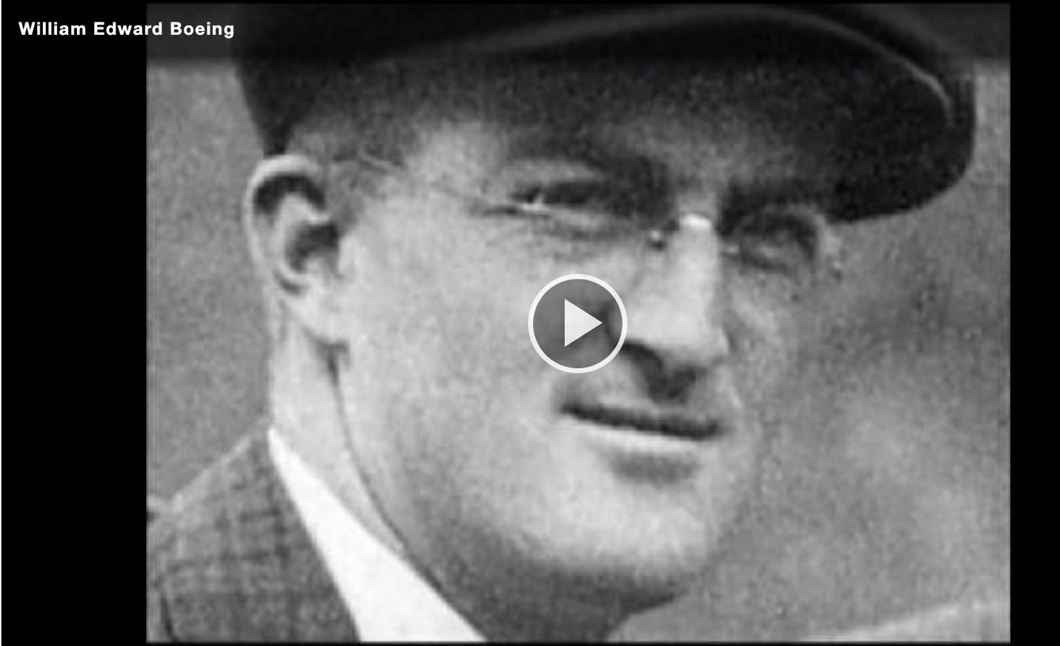
Figure 2 How the Boeing Company began. (Source: Boeing.com_founder’s videos)

How did the logos’ design change over time?
In describing the iterations of the company’s logo over time, a chronological approach will be used as much as possible throughout the duration of this paper. However, the company on a whole historically has been very deliberate in its selection of the elements used in the creation of the many iterations of its logo over the decades. According to their posted article dated July 14, 2021, the online blog 1000logos.net reports that the Boeing Company’s logo has gone through at least 4 redesigns in its history. It is conceivable that more than four design changes were in fact made given the historical record of iterations (seen in Figure 3 below).

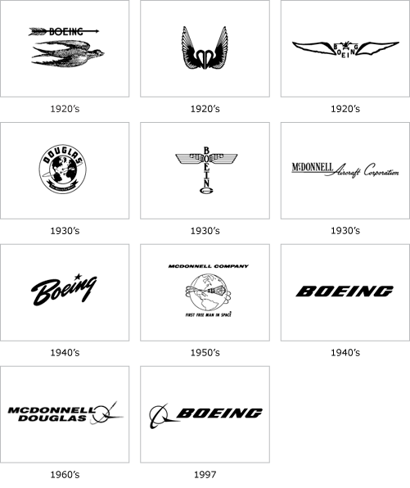
The reality is that the Boeing company has gone to great lengths to document the history of its logo. What a beautiful history it is! Michael Lombardi FRAeS (Fellowship of the Royal Aeronautics Society) and current Senior Historian at the Boeing Company based in Seattle is a direct contributor of the historical data provided in this research paper (see Pdf link in citations). The historical records report that in 1918 the “first logo was a detailed drawing of a bird flying below the name Boeing which was pierced through by an arrow (Fig. 3).” However, the company was challenged in court with a trademark infringement lawsuit from 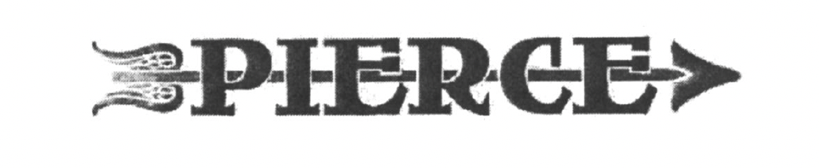
Figure 3 - Famous Logos - Content & Imagery © 2012
Figure 4 PIERCE Automobile Company Trademark Symbol
the PIERCE luxury automobile company in New York. That company’s logo (Fig. 4) also used the company name pierced through with an arrow. Boeing had to drop this aspect from its logo. At that time the company was called Boeing Airplane Company and by 1921 it was clear that they needed a new official logo. General manager Edgar Gott in his January 13 memo (see pdf in citations) of that year wrote to William Boeing presenting three possible designs for a new company logo. All three designs Incorporated versions of the Boeing name surrounded by wings are seen in Fig. 5 below. Design 2 of the three was chosen.
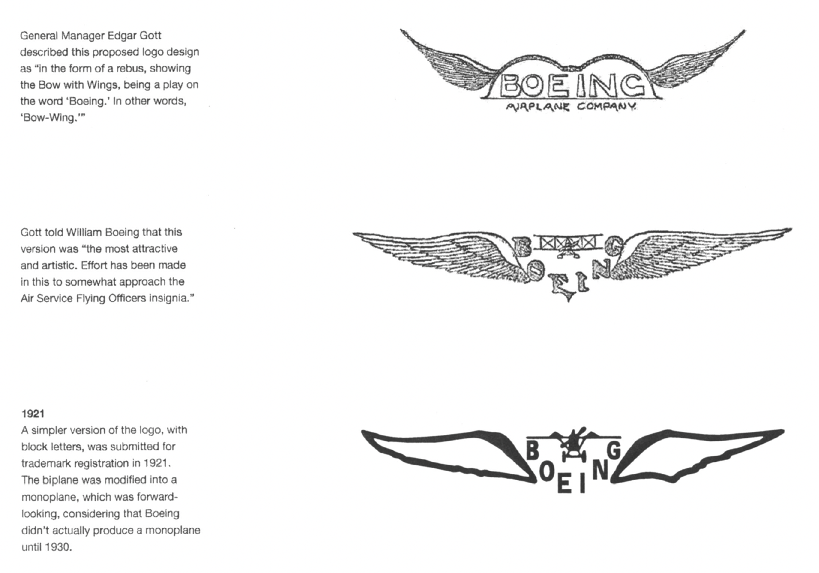
Figure 5 Three designs in Edgar Gott memo to William Boeing - January 13, 1921 Source: Michael Lombardi

According to Boeing Company records, five years after that Edgar Gott memo the new design iteration was proposed and adopted in 1926. The logo was both designed and proposed by Boeing Chief Engineer C.N Montieth and artist Rogger Sult respectively. “Sult created a logo in the shape of a (Totem) pole echoing the traditional arts of the pacific northwest Indian tribes. The letters of the company name formed the vertical pole and the two birdwings extended from the “O”. The “G” was widened to resemble the horizontal stabilizer of an airplane so that the entire shape is similar to that of an airplane in plan view (viewed from above).” Michael Lumbardy in the archival records is noted as describing this particular iteration of the logo as a defining event in the company’s public branding and corporate identity. He writes, “This was one of the first disciplined uses of corporate identity in the history of Boeing. The Boeing Airplane Company logo is placed inside a double circle, and between the outer circle was the name of the company or subsidiary.” Images are very powerful when they represent the goals and purposes of a group of people sharing a common set of values and objectives. For these reasons, this particular iteration of the logo was extremely popular within the Boeing company itself. It was used on Leatherheads, signage, pins, the sides of Aircraft as well as on embroidered patches on the uniforms of company employees. The companies staff lovingly called it, “the bug.”
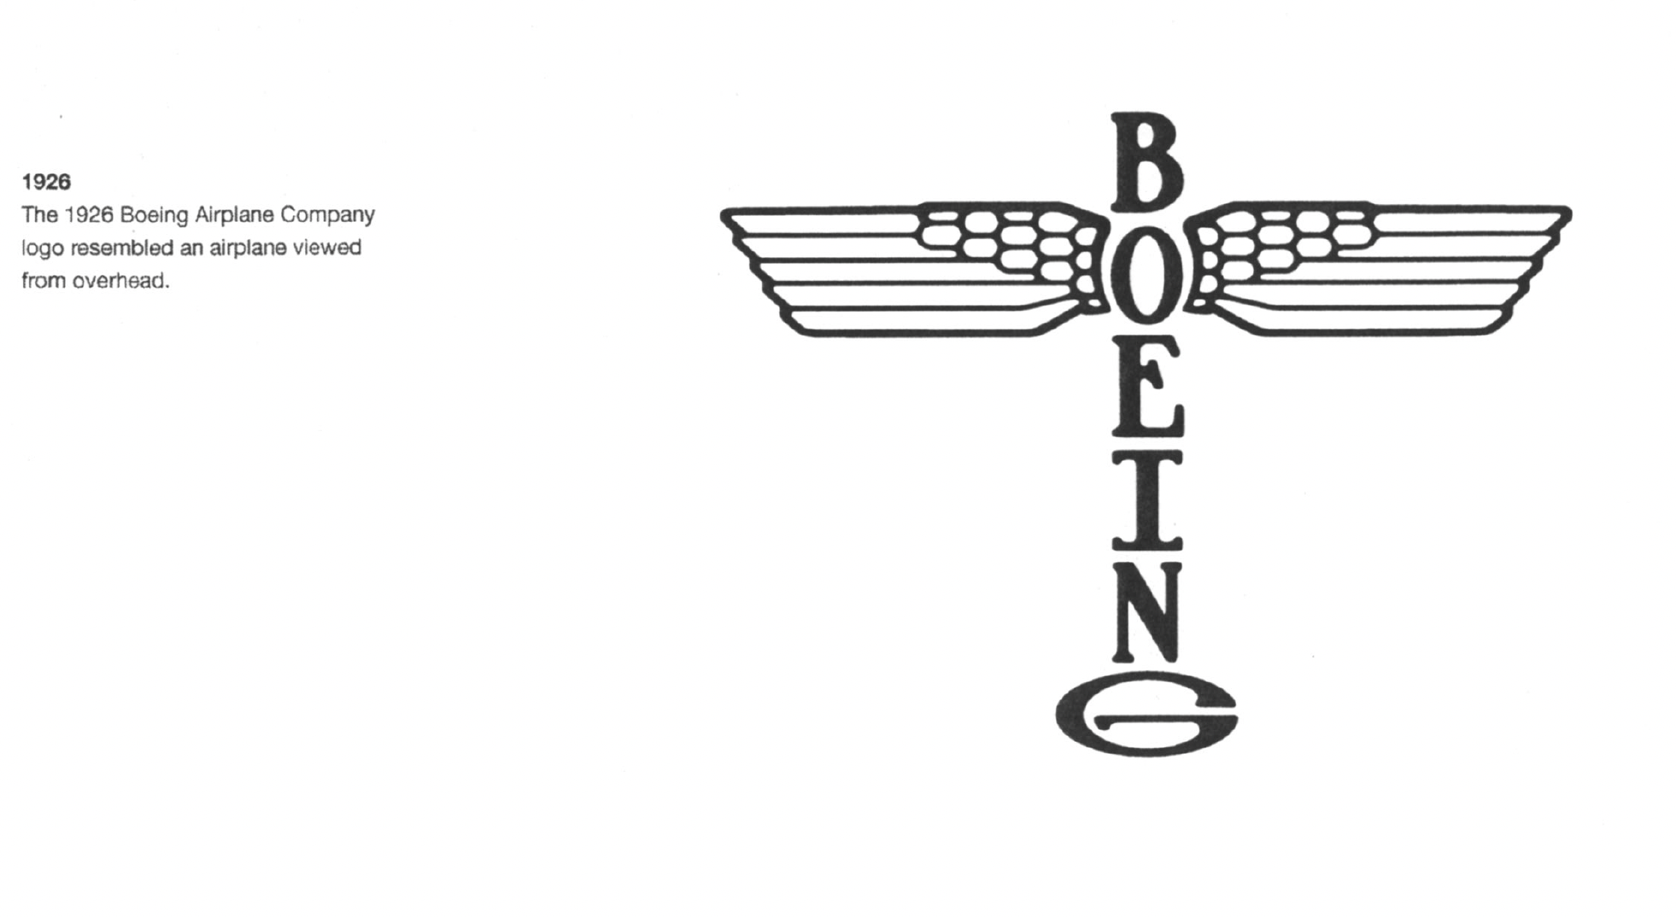
Figure 6 Boeing Airplane Company Logo -"The Bug" 1926 - Designed by Rogger Sult

At the time, the general manager PHILLIP Johnson suggested that the 1921 logo needed to be replaced and that the company be represented by a single image. On November 26^{th,} 1926, he wrote a memo to William bowling expressing his preference for the use of the new design on the company’s letterhead. To emphasize his point, in attaching the new design to the memo which is presented on the usual company letterhead, he was deliberate in drawing an X through the 1921 logo on the very top of the page as he presented the new design.

By the arrival of the 1930s, America and the world at large were undergoing a major transformation. The company had to adapt and grow in the areas in which it was able to dominate the industry. The company is now called the United Aircraft and Transport Company. This company included aircraft manufacturers, engine and propeller manufacturers, and facilities that train the flight and maintenance personnel. A key part of the company’s business was mail delivery across the United States. It is conceivable that the US Congress became nervous of a company of Boeing’s magnitude having such levels of dominance in the US marketplace. It’s past the 1934 Airmail Act. Archival records report that to comply with the regulations the company had to split itself into three entities. “The first was United Airlines, secondly United Aircraft (later United Technologies, the parent company of aircraft engine manufacturer Pratt and Whitney), and last, the Boeing Airplane Company.” Apart from triggering the departure of William Boeing from his own company, it triggered a search for a redefining of the company’s logo once again. In 1937 Boeing’s designers began experimenting with a brush script typeface that was tilted at an angle to simulate a rising aircraft. It had a star over the “I” to signify the US Air Force star. The script was already popular in use across the United States and was used by American iconic sports teams such as the Brooklyn Dodgers and the New York Yankees on their team jerseys seen in Fig 7 below. They even experimented briefly with the serif typeface Beton. By 1940 the star was replaced with a dot with the launching of its new Boeing Stratocruiser aircraft.
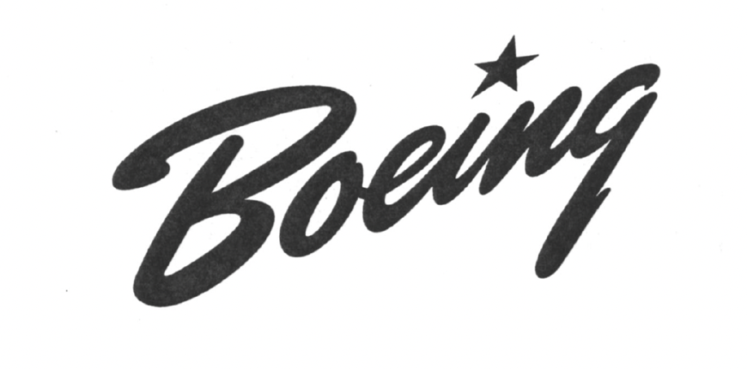
Figure 7 Brush Script typeface used in 1937 design iteration.

Company records suggest that one of the design hindrances was that the Boeing logo has faced from its inception what is its ability to be used in all areas of the company’s activity as well as its user-friendliness in being applied on all types of materials such as plastic, wood, metal, company letterheads and on the sides of Aircraft. It still needed to be legible, photogenic, versatile, dignified in its originality and it’s a representation of comfort, luxury, speed, and dependability. These were the ideals that framed the proposal submitted by Boeing artists Keith Kinsman and Bob Lally in 1947, for a new logo that would take the Boeing company into the jet age with has just begun. Their proposal was 10 pages in length and included sketches, and paint studies which ultimately culminated in them creating a new typeface unique to the company. It was a bold, oblique, sans serif-type face which they eventually gave the name Stratotype (Fig 8). This design was an immense success across the entire company and globally. Many design systems that required the use of a logo where deliberately designed with the stratotype logo design in mind.
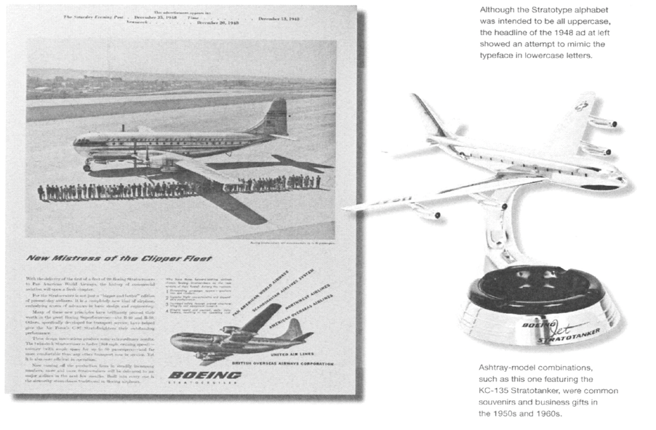
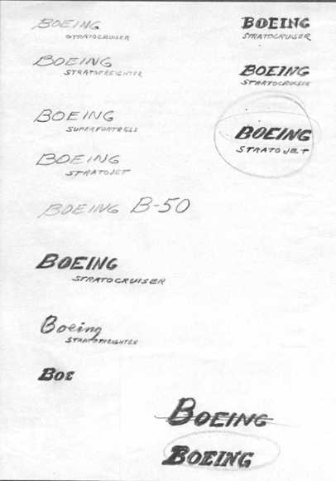
Figure 8 Boeing Stratotype original Design Sketches by Keith Kinsman and Bob Lally in 1947. - Boeing Stratotype

Many design systems that required the use of a logo were deliberately designed with the stratotype logo design in mind. This design was so successful it survived up until 1996 when American corporate logo designer Rick Eiber what is contracted to develop a series of design studies that would lead to a modernized version of the logo. It’s so happened that concurrent to this, Company executives had successfully negotiated a merge with McDonald Douglas. The designer seized upon this opportunity and they proceeded to merge the logos of these two American iconic companies. 40 different iterations of potential designs were proposed before a conclusion was reached shown in figure 9 below.

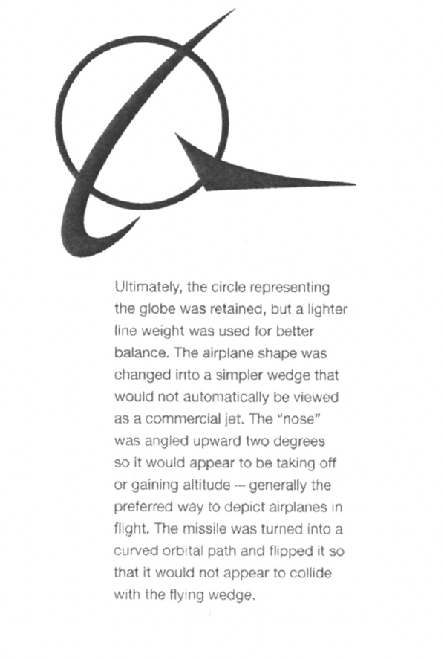
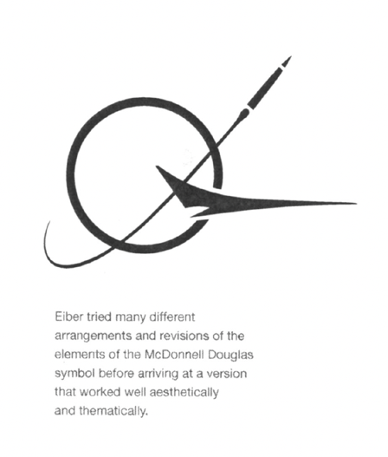
Figure 9 Design iteration of the Mc Donald Douglas Logo By Rick Eiber

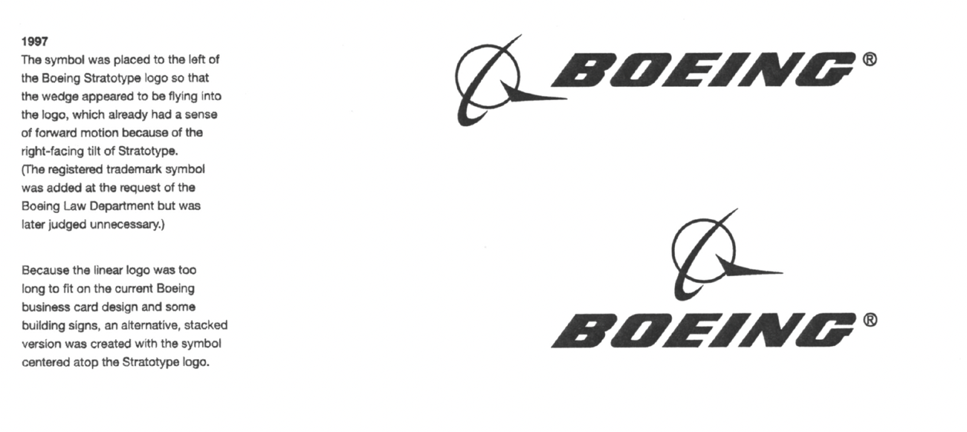
Figure 10 The merging of the Mc Donald Douglas and Boeing Company Logos in 1997

What does the current logo mean?
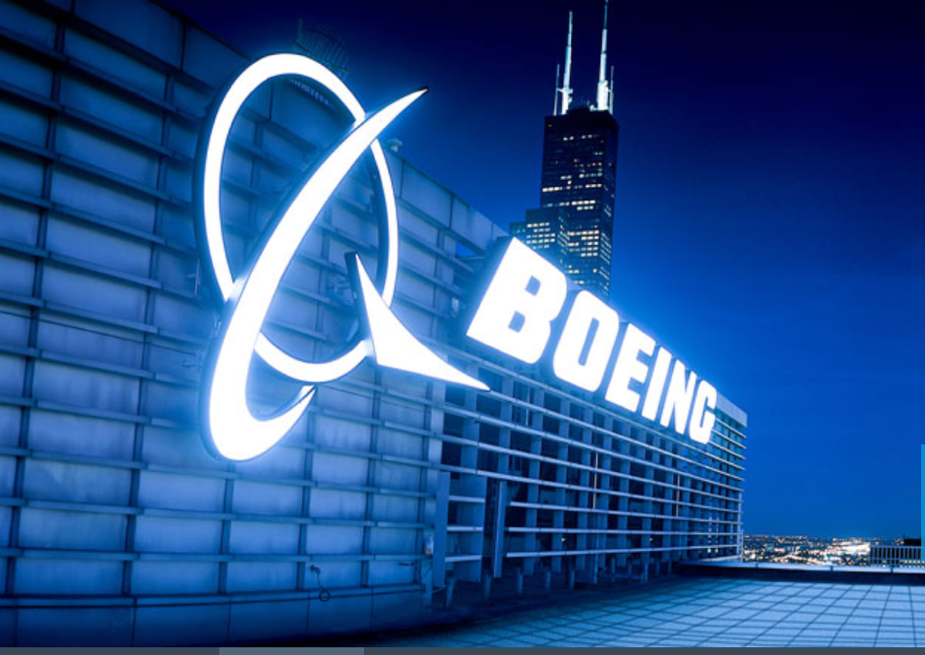
In 1997, Rick Eiber completed his final design of the company’s logo which is still used to this day (Fig 10). According to the Boeing Company, their logo is an iconic international symbol of American dominance of civilian, military, and space aviation technology. He drew his inspiration from the penultimate symbolisms found in the historical design elements which strongly defined the company’s image globally as well as the Mc Donald Douglas Logo. The blue color represents the sky, supremacy, strength, and success of the brand. He kept the powerful symbolism and significance of the use of the Stratotype Type Face previously introduced in 1947. To many, this may simply be just another typeface, however, it mirrors Boeing’s workplace environment and the products it creates. Consider the following words, stratosphere, strato-cumulous, nimbostratus (types of high-level clouds), Model 377 Strato-Cruiser, and lastly the B52 Strato Fortress. All these words suggest that the company’s main workplace environment is in the highest regions of the earth’s atmosphere. For over 100 years, they have built products that have made these altitudes normal places for men to traverse. It is an innovative company that has stood the test of time and has adapted to the very difficult economic environments in world history. Single-handedly it can be argued that the existence of the Boeing company has fast-tracked human civilization through its contribution in air transportation, keeping the peace through the production of military hardware and advancement in satellite and space technology, and much more. It is a company that arguably has survived because of a legacy of celebrating its employees who have built products that have changed the world.
Figure 11 Current Boeing Logo

Citations

Amir, A. R., and Weiss, Stanley I. (2021, April 19). Boeing Company. Encyclopedia Britannica. https://www.britannica.com/topic/Boeing-Company

Brown, David Parker, The Boeing Archives Part 3a: Interview With Boeing Historian Michael Lombardi, May 4, 2011, Airline Reporter, https://www.airlinereporter.com/2011/05/the-boeing-archives-part-3a-interview-with-boeing-historian-michael-lombardi/

Lombardi, Michael FRAeS. Senior Corporate Historian. The Boeing Brand Trademark History PDF. The Boeing Company. 2021 https://drive.google.com/file/d/1tnIyAghepFmIhaGX-fJzOPKGBmpurUn4/view?usp=sharing

Boeing logo and symbol, meaning, history, 1000logos.net, 2016-2021, Boeing logo and symbol, meaning, history, PNG (1000logos.net) Fig 2

Boeing Logo, Famouslogos.us, Boeing Logo - Design and History of Boeing Logo

Boeing Brief, General Information, Boeing, September, 30, 2021, Boeing: The Boeing Company: General Information

Boeing History, Boeing, Boeing History:

Founders Videos , Boeing- https://www.boeing.com/history/#/founders-videos/william-edward-boeing?playlistVideoId=1213225988001

