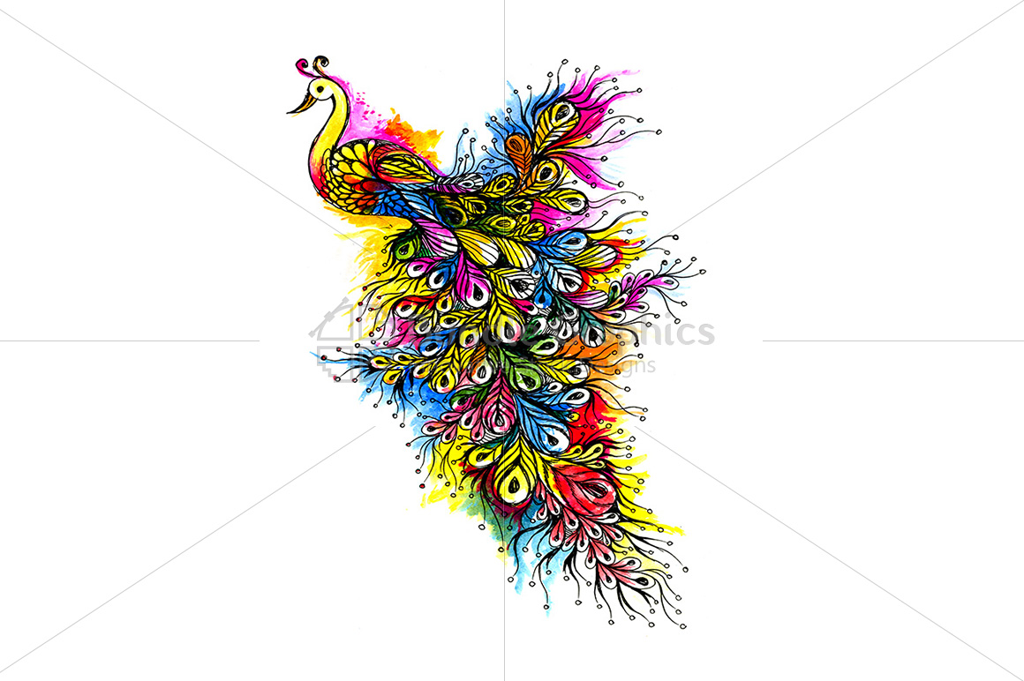

Carlos Ortega

TABLE OF CONTENTS

Definitions ……………………………………………………………………………………………………………2
Department Store…………………………………………………………………………………………………………………….3
Don Quijote……………………………………………………………………………………………………………………………3
Chain or small special store………………………………………………………………………………………………………6
Debenhams…………………………………………………………………………………………………………………………...6
Electronic Store…………………………………………………………………………………………………………………….....9
PCRichard&son………………………………………………………………………………………………………………………9
Gifts Shop…………………………………………………………………………………………………………………………………12
I love NY………………………………………………………………………………………………………………………………12
Display with mannequin……………………………………………………………………………………………………….....15
Forever21……………………………………………………………………………………………………………………………15
Display without mannequin………………………………………………………………………………………………….....18
Mini Mioche…………………………………………………………………………………………………………………….....18
End of Aisle Display…………………………………………………………………………………………………………………..21
North Caroline Market…………………………………………………………………………………………………………21
Point of Purchase Display………………………………………………………………………………………………………….24
Mcdonald’s………………………………………………………………………………………………………………………….24
Citations……………………………………………………………………………………………………………………………………28

DEFINITIONS

Visual merchandising is a set of tools and graphics strategies that uses creativity to raise customers' awareness about products and services offered by a company. The purpose of visual merchandising is to pursue customers to buy the products. Throughout the use of windows displays, a company can establish a unique brand image.
Visual merchandising, besides being a selling power tool, it characterizes the company's mission and values. When selecting a displayed windows theme, the creative team must pay close attention to details. For example, the tone used in the graphics, letter size, form, and the conditions mannequins are displayed. Any wrong message could negatively impact the brand's reputation.
Besides increasing revenue, visual merchandising allows stores to support and give back to the community. Selecting the right outfits to show on displays, portraying photos of models with different backgrounds, skin tones, and body measurements, it can help end discrimination towards minority groups, LGBTQ community, racism, and women salary gap. Store windows can show their sympathy during national events.

DON QUIJOTE

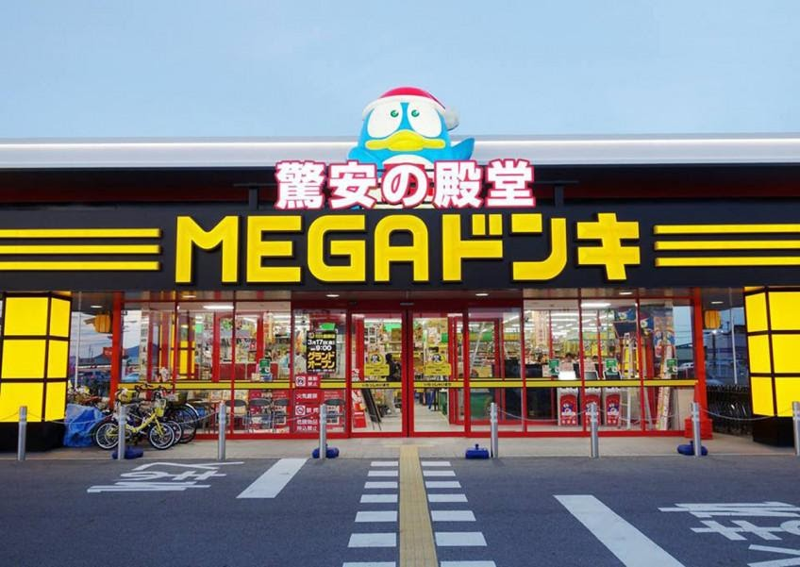

I was planning on going on vacation this summer, but due to the coronavirus, I had to postpone it. I wanted to explore Japan's most famous tourist attraction, but since I can't go this year, I will explore Japan through the visual merchandising final project." Don Quijote is a popular Japanese discount chain store that opened in 1989. What makes the business different from the competition is the number of items, toys, food, and products that are available under the same roof. The picture that I chose, according to the article " 5 things to know about Don Quijote," written by May Ong, shows the first Don Quijote store in Singapore.
As you can see in the picture, the windows set up in this particular location is a "Parallel to sidewalk windows." From a prospective customer point of view, the yellow line on the pavement caught my attention. It functions rhythmically, directing customers right into the store. The store has an open-back window, which allows customers to have a clear view of which products the store offers inside the stores. The name of the store is written in big letters that can be read from a distance. The tone used in the graphics and letters incorporated in the displays illustrates a stores personality and ways to gather the attention of customers. The purpose in Upper letters and the animal image in the store's name describes the business proposals. It helps promotes store capacity, variety, and merchandise discount. Moreover, Lighting is crucial. It helps direct customers to view specifics items and objects managements wants to show. It can also transmit information about a store carrying a well-known brand, new merchandise, and sale signs. After the store is closed, with the help of light, the stores' windows are pursuing customers into buying the products. In Don Quijotes'case, the bright neon colors and the lights on the storefront, maintain the store visible to customers after closed. The horizontal yellow lines adjacent to the store name transmits to the customers a calm and resting feeling while the vertical red lines give the impression of strong supportive poles.
Now let's talk about the attention-getting devices shown outside of the windows. Since it's a chain store that has a large variety of products and services, the selling power of the store can be seen through the parallel windows with open-back windows, which reflects how family-oriented the store is. The purpose of the products shown in the windows is to attract children and their parents by placing minibikes and toys. ATMS for the adults and chairs in the waiting area. The store is showing the demographic area of the target market group that it wants to attract.
After reading about Don Quijote online and informed myself about the type of products and services offered by the chain company, I was surprised to see how symmetric the store windows of this location were set up. The store doesn't seem to be projecting any particular theme or celebration; instead, it is harmoniously showing a serious side of a discount store. It is not expected for chain store windows to display any mannequins, but they usually use the store windows to show anything that the store carries inside, but this store location was the exception. The open-windows approach allows the customers' eyes to flow into the store, encouraging them to walk in. There is a fantastic balance between colors, designs, and props on the store windows; it doesn't hurt looking at the window. Instead, it gives the impression that the store’s staff are respectful, organized, and clean.
It’s time to discuss the colors used in Don Quijote's windows. Colors are very crucial when you are making a sale. There are two primary colors used on the windows; yellow and red. Yellow gives a bright intensity while red has dark orange shape, which gives the impression that yellow was added to the red to create a yellow hue. In my honest opinion, if I have the opportunity to work for the visual merchandising team at Don Quijote, I wouldn't change anything to the windows. I think the store looks stunning! The proportions and the balance of the items located around the windows harmoniously fit with each other.
BEBENHAMS

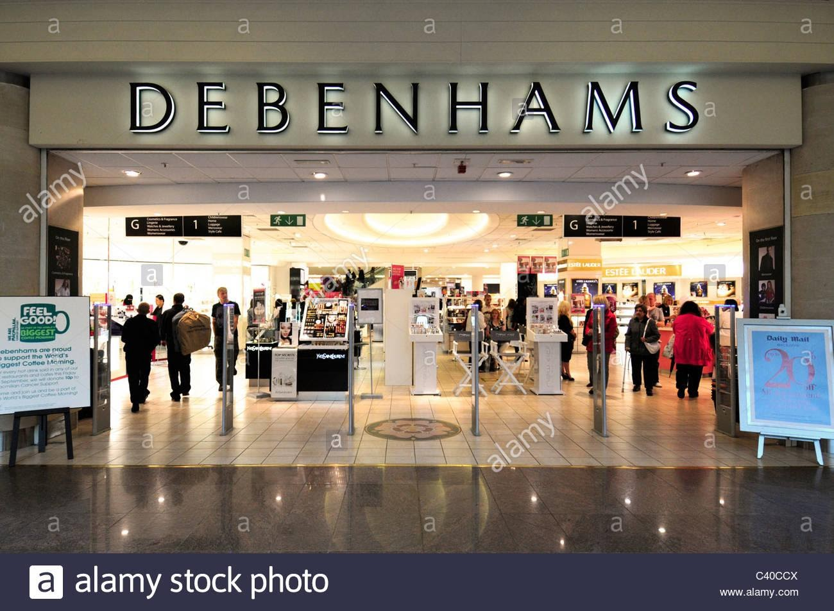

According to Debenhams’s website, the European department store opened its doors in 1778 by William Clark. The picture that I am using for the project was posted on a website called Alarmy.com. The first thing that comes to mind is that the store's setup has a "Windowless Window Display." When you walk through the doors, you will get through the metal detectors that prevent people from taking unpaid merchandising or attached metal tags.
I think the purpose behind a Windowless Window Display is to drive customers into the stores. They are inviting customers into the store by eliminating barriers, for example, windows and doors. I think it is brilliant to have such a display while establishing the beauty department in the front view. As some of us know, women spend more money than men. Using those makeup displays is tempting women to walk in, and if she is not alone, you could have a whole group of prospective buyers into the store.
When you walk into the store, besides the beauty department, there are directional signs that can direct other shoppers into their perspective departments. If a couple steps into the store, while the lady is checking some beauty products, her partner should take a chance and browse other departments in the store. There is a high chance that both but definitely one makes a purchase. The store displays are beautiful; the color, the lighting, and the products produce a luxury texture that may prevent you from touching. However, as I mentioned before, the store has a welcoming environment, which allows customers to touch, feel, and smell the store. People want to have contact with the product before purchasing it. Customers want to know how it feels when it is on their hands if the material feels good. If you notice, in the pictures, customers are walking freely around the store.
The store doesn't seem to decorate or display props around the store with a theme. Everything is exceptionally modern and sophisticated. The front of the store carries a fair balance between controlling displays tension and store layout. Customers are able to walk around the store without being close to one another. The vertical layout of the displays allows customers to continue their journey into the store. Since there are no windows, the colors beige on the walls harmoniously consolidate with the yellow lights, creating a creamy, achromatic color hue.
The purpose of a store window displays is to increase customers driven, established brand identity, and inform customers about the products and services the company offers. Pretending not to know that DEBENHAMS is a department store, the store's image seems very gender exclusive. Since the store doesn't have windows, it is possible to admire the storefront layout from the outside and noticed that the main attraction to customers is the beauty departments. From a male perspective, I wouldn't walk into the store if I didn't know it was a department store, which means the store can lose money. I would suggest the store could enhance the store image adding billboards, signs, or pictures illustrating the type of products and services they have. Moreover, it's not a male or female situation, it’s a department store, they offer a large variety of products that are being hidden due to the store image.

PCRICHARDS & SON

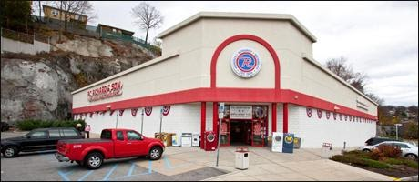

To me, one of the most visited electronics companies in America is PC Richards & Son. The company not only sells electronics but cell phone plans and home furniture. According to their websites, the company has "110 Years of Honesty • Integrity • Reliability" on the market.
The store’s window photo that I will discuss for the project is from one of the PC Richards' locations in Yonkers, NY. First, the store does not have windows, and one reason can be that the store was built that way. The building structure has a corner walk window shape. A corner walk window is a beneficial structure for the business because it enables customers to see the windows from different angles outside of the store.
I think the structure of the building has a suburban design, where it should be modern but simple. As a visual merchandising student, I would have suggested that the store could add billboards outside of the stores, with family-oriented content, teenagers enjoying their cellphones and home furniture pictures. By creating a visual merchandising strategy, the store could increase the number of customers driven into the store. Depending on who’s the target that they are trying to attract, the store could use some colors or designs. After all, colors do help make sales.
The store is located in a bustling avenue in Yonkers, NY which means that thousands of customers are exposed to the store daily. The company may be losing customers because it is only advertising washing machines and stoves. What would happen if customers are looking to get a new computer or home-furniture, but the store doesn't provide enough information in regard to the products it sells. They will not stop to explore the store; they will drive somewhere else. I think visual merchandising is not just designing pretty windows; it's about informing and helping customers identify themselves with the stores and the products and services it offers. The location in Yonkers doesn't have any representation ads that notify customers about the products they could find in the store. As time has gone by, consumer behaviors have become hard to forecast. For a business to increase customer-driven, it must adapt and innovate the visual merchandising strategies if the company wants to make a profit. The store at that particular location doesn't stimulate or persuade a large number of customers to come inside.

I LOVE NY GIFT SHOP

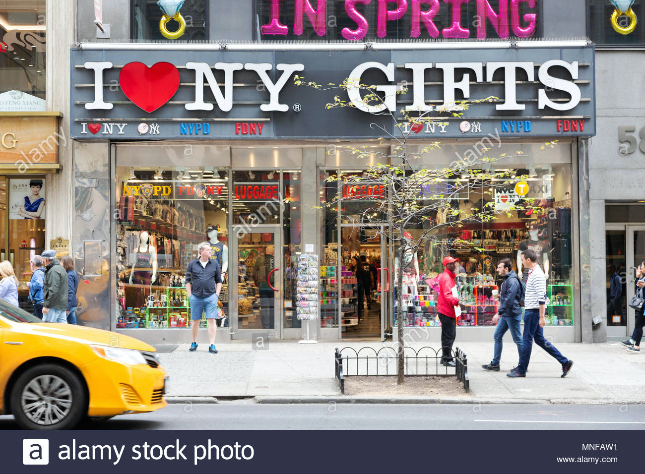

The "I Love NY " Gift shop photo I will be using is from a website called Alarmy.com. The store location is on Fifth Ave in New York City. I have to admit, the view of the store is nice and neat. The store windows feature a parallel window setting that connects the windows to the sidewalk. The open-back windows allow customers to have a better view of the store when they walk by the store. The window designs are very well organized, consolidating props, lighting, and mannequins harmoniously.
The store windows were expertly designed to maintain a level of unity between each piece. From the smallest signs to items and mannequins that compose the windows, everything goes well together. There is a balance of colors, side, and repetition between both windows, allowing the customers to understand the type of merchandise that could be found at the Gift shop. The hue color combination that is incorporated in the windows do not negatively contrast each other. Everything blends together, the primary colors are Yellow and Red, and if you notice, these two colors are hue to different colors that are used in the windows—for example, some Neon colors, hot pink, and Lemon Yellow. They also used some dark shades of grey to control the vision.
I want to say that the tone used in the store's windows letters, contribute to the store identity. The different colors, size, and shape provides first-hand information regards the store's management, for example, customer services, quality, and pricing. The neon colors incorporated in the layout suggest that you can find convenient, engaging, and exciting merchandise on the shelfs.
When it comes to the theme, the store portrays a truly relaxing summertime in NYC. The mannequins are wearing comfortable, casual clothes. The environment in the store is tourist-friendly, where they can find any gifts to take as souvenirs, T-shirts, hats, personal care products, keychains, luggage, and bags. The store knows what kind of customers to attract. Themes are significant when it comes to design windows displays because it helps customers identify themselves with the products. The store's windows focus on traveling consumers and athletic merchandising. The use of casual mannequins in the display helps communicate fashion trends and customers preferences. The store is screaming through the mannequins the merchandising it has in stock. It seems like the store offers casual, low-quality athletic, sporting items of clothing in case of someone looking for a gift or a last-minute shop. The impression given by the mannequins is that they are standing on a supportive rob. The use of males and females’ mannequins shows the diversity of the merchandise carry by the store.
The store lighting can help direct customers to new products. In addition to that, the ambient lighting equipment demonstrates the transparency and honest perspective of the business towards consumers. As a safety concern, the store looks clean, organized; customers can also have a better view of items, colors, details, and textures.
I think the store has a very nice window displays, but a lot is going on. Some customers may not take the store very seriously and believe that the store only sells low quality. The colors, the mannequins, and the items located everywhere around the windows creates chaos. I would suggest reducing the number of items on the windows will allow customers to understand what is being offered. Placing the mannequins on it owns, enables the display to tell a story while showing the merchandise. This way, the customer will be aware that its a gift shop but also carries convenience products.

FOREVER21

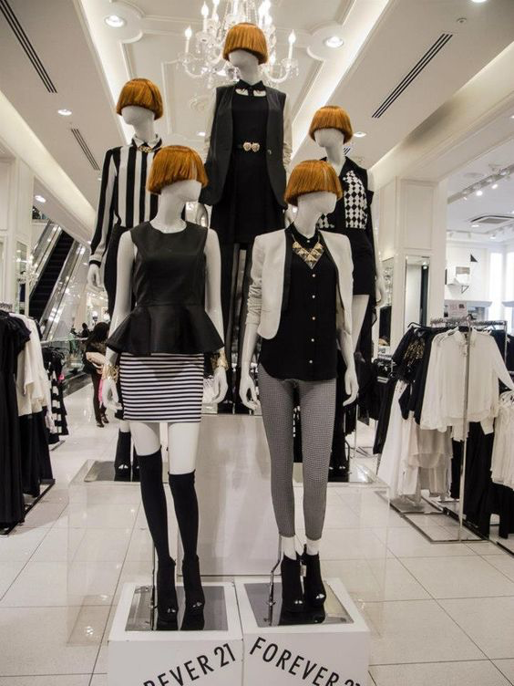

For the fashion display mannequin report, I will be using a photo posted on Pinterest.com by Karin Vriese. The photo was taken at a Forever21 store. Forever21 is a fast-fashion family-oriented retail store that started in California. Forever21 is a trendy retail store among teenagers and young female adults.
Mannequins are very important, and it helps deliver a valid message to an audience, in this case, information about brands exclusively, fashion trends and customers self-image. The mannequins on the picture are standing on a supportive rob to display a more elegant look while keeping customers safe. Mannequin displays help customers visualized how clothing will look and fit since the garments must be adjusted to the mannequin. Since the mannequin in this display is the focal point, everything has to be perfect; any mistake can distract the customer from the display purpose, losing the sale or damaging the store reputation.
The display is formed of five vertical standing female mannequins between clothing sections in the store. The purpose of the mannequins is to help customers visualize themselves by dressing the mannequins with trending outfits while incorporating a mix-match environment. Customers want to feel and touch the garments before buying them, with the display, they will have the chance to see how the garments will fit, touch the fabric, see if stretches, and how soft they feel on your skin.
In addition to that, vertical lines have been used in the displays to amplify heights and strengths. The main goal of the presentation is to attract middle-class young professionals, female employees. The mannequin is dressed in casual, elegant, and comfortable chic clothing at affordable prices. The location of the display gives the impression that those garments are trending, and customers are going to be looking for them, they wanted the display to be in a visible area where customers can see what the store has in stock.
There are two complementary scheme colors on display; black and white. Black, though usually related to evil, here is transmitting confidence and individuality while white is adding its softness and purity to the show. I think the message behind the colors of the season is about being strong. Black is a very dark shape color that has a lot of strength. Color can not only sell products but allow people to express themselves, emotionally.
By adding Accessories like necklaces and belts to the display, the store is promoting additional products that increase sales.
The displays look quite stunning, but I think society would want the display to be more diverse. Human beings come in every size and shapes and it’s time for retails to incorporate new fashion strategies that allows customers to identify themselves with the products that they buy.

MINI MIOCHE
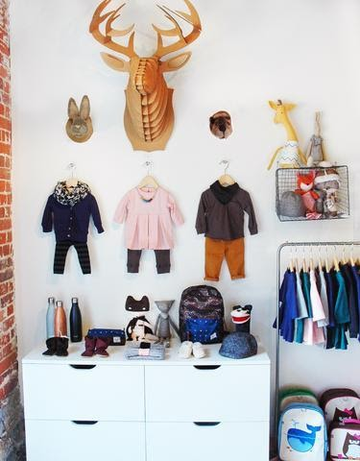
The next display picture is from an online article" How This Kids Clothing Company Uses Personal Touches to Double Online Sales" written by Nicole Clark. The display demonstrates the economic and social impact that merchandising has on customers due to the capacity to sell itself on its own.
The display illustrates the connection between childhood and nature, the secure attachment of adventure, and innocence among children and animals. The purpose of the presentation is to pursue the curiosity of parents and their children to explore the new merchandising. The props used on display are stuffed animals and hanger outfits. The use of these props helps children, and their parents visualize their children wearing their clothes without discriminating against anyone in particular. The no mannequin strategy in the display can increase customers' drives because customers will buy out of feelings toward their children. To the children, going shopping will feel like going to a playground to play with toys. The majority of children enjoy the company of animals, which could turn the store into a destination spot for tourists and locals.
Color is an excellent way to motivate customers into buying merchandise, such as cars, toys, and clothing, to name a few. Since the display we are discussing is from a children's clothing department, colors play a crucial aspect between the relationship between customers and the retail stores. Moreover, colors bring joy and the desire to explore, and retailers know that. The display in this case is stuffed animals against the wall, showing analogous schemes of colors from blue to yellow. Even though there are different variations of colors in the same area, the combination of shapes and values in those colors harmoniously blend, maintaining a balance, and reducing the tension among garments.
I think having the dog in the store is very convenient for the business and the stressed parents. It will help reduce parents' stress; the children are going to be distracted admiring the dog. It will give them time to browse, select, and purchase what was needed.

NORTH CAROLINE MOREHEAD

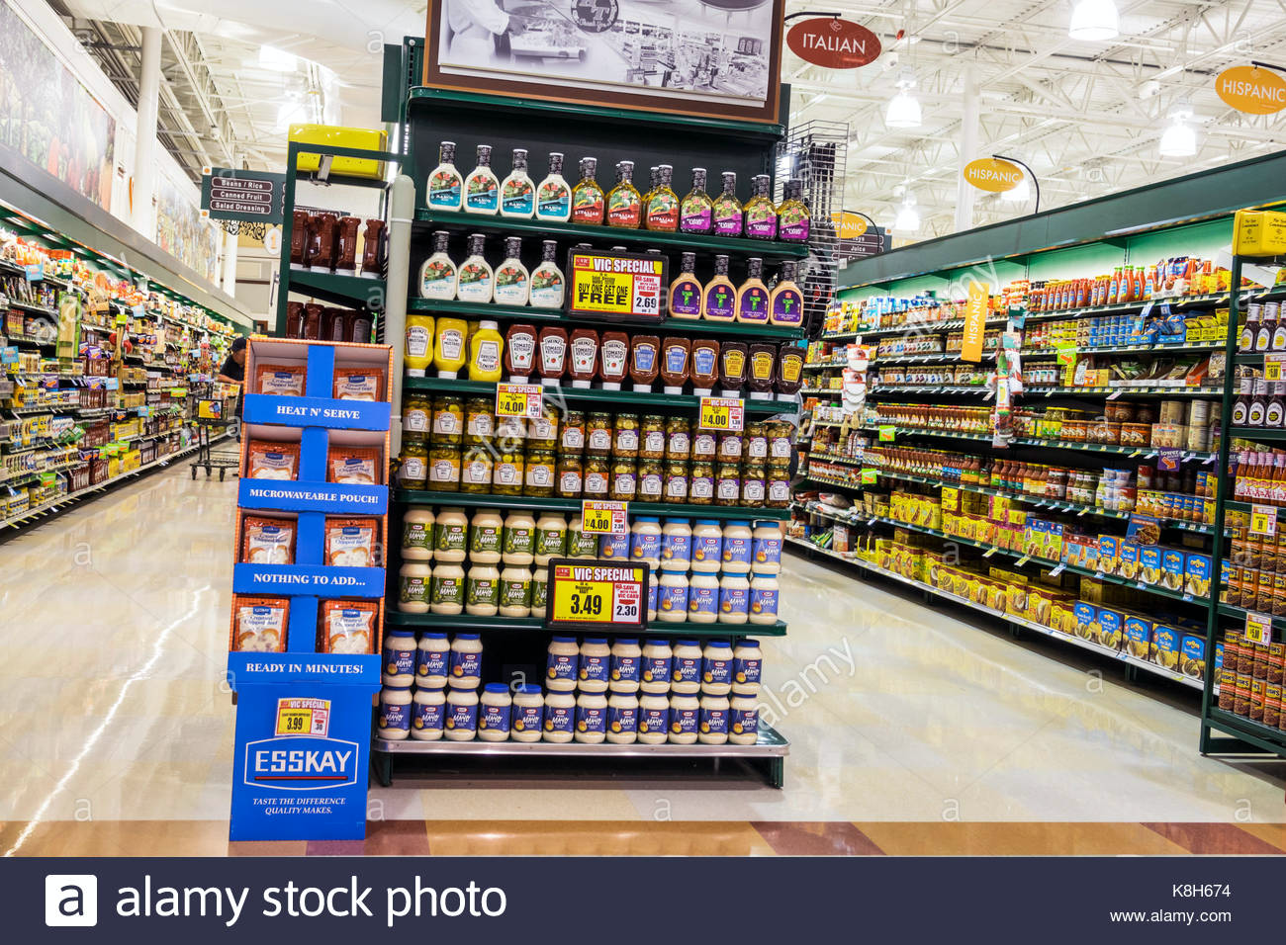

The end of the aisle at the supermarket or any retail store is usually reserved for product offers, discounts, and brand presentations since some brands pay slotting fees to place their products in selected areas on the shelf.
The following picture is from a North Carolina Morehead city Harris supermarket and the image posted by Alarmy.com.
The attraction from the display illustrates summertime, a time when the majority of Americans spend quality time with family and friends barbecuing; It’s the perfect season to increase the sale flow of the products on the image. The way the shelf is organized, it helps direct customers to buy the products that are at the eye level of the customers. Horizontal lines are used to show product values and popularity among customers. Placing salad dressing at the top of the shelf, gives those who are concerned about their weights a choice to pick that brand. As it follows, there are bottles of ketchup and other barbecue essentials.
The sale signs purpose is to motivate customers to purchase these products, avoiding other brands to be exposed. The repetition or sequence of the bottler's brand name causes customers to consider that the product is better, accessible, with a higher demand within customers. It also shows the power that big names in the industry have over the supermarket shelf positions.
Since we are observing plastic bottles on the shelf, colors are significant. Still, shapes and designs can help customers identify their products and brands to differentiate themselves from the competition. Moreover, it is noticeable that the shelf is organized from tints to shades scheme colors, left to right. The shelf displays a unique symmetric balance among the products, size, shapes, and logos.
In my honest opinion, what if someone doesn't walk through that side of the store and goes directly to the aisle, wouldn't they miss those products at the end of the aisle? Some supermarkets do not have the same products in two different places. If customers can't see your products, they won't buy it, and the brand will be losing money. Some customers believe that the end of the aisle is for products that are on sale due to expiration dates and final sales products.

MCDONALDS

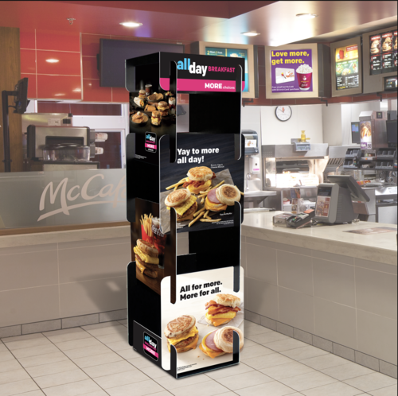
According to the website s2kgraphics.com, point-of-purchase are displays that gather attention from customers as they walk by the stores to inform about additional sales and promotions. The point-of-purchase display I will be discussing is a kiosk sample posted on the same website.
The kiosk features an "all day" menu from McDonalds. It shows pictures and details explaining seasonal promotions. Since the advertisements are not permanent, it allows management to relocate the displays depending on the store setups. For example, placing the kiosk next to the waiting line directing customers to see additional promotions on the menu. The location of the displays plays important roles since customers could end up adding items, they were not thinking of buying, for example, a new summer drink or a 2 for $1 apple pie!
The design and structure of any display is very important; you have to produce a display that communicates and represents the company's sales strategies. The color hue used on the displays demonstrate the purpose behind the advertising display. The design delivers a unique balance and unity among the chosen analogous scheme’s colors; red, yellow, brown, and beige. The combinations strongly create a customer desire to taste the flavor. As some of us know, customers like to touch and feel the products, for the food chain, the purpose is to pursue the customer to taste it. The displays show the perfect texture. However, the black colors stand for the commitment of the company, while white is the finest services the store provides.
During the designing process of displays, management should be aware that not every store has the same structure as the prototype store. Some stores are smaller than the others, while the store has two floors. The point-of-purchase display on the picture is quite large and takes space on the floor, which is inconveniences to the customers while they are waiting for an order. I suggest that depending on the store, billboards, and pictures should place instead of the display, it saves space and can be changed or taken down anytime.

CITATIONS:
- Don Quijote
ONG, MAY. (June 06, 2017). “5 things to know about Don Quijote, Japan's popular discount chain store”. Singapore. Asianone. Retrieved https://www.asiaone.com/singapore/5-things-know-about-don-quijote-japans-popular-discount-chain-store

Photo: Facebook/Don Quijote.

- Benhams
King, Alan.( 2010). “Debenhams store department”. Manchester. Alarmy.com.
Retrieved https://www.alamy.com/stock-photo-debenhams-store-department
Mhttps://ir.debenhams.com/history

- PCRICHARD & SON
Retrieved https://www.pcrichard.com/Stores/New-York/Westchester/Yonkers-Scarsdale

- I Love NY
Sriskandan. Kumar.( may 6,2018). New York City, USA.
Retrieved https://www.alamy.com/i-love-new-york-gifts-gift-shop-fifth-avenue-new-york-city-usa-image185349277.html

- FOREVER21
Vriese. Karin. Pinterest.
Retrieved https://www.pinterest.com/pin/428827195746708420/

- Mini Mioche.
Clark. Nicole.( Sep 1, 2016). How This Kids Clothing Company Uses Personal Touches to Double Online Sales”. Retrieved https://www.shopify.com/retail/how-a-children-s-clothing-company-is-doubling-its-online-sales-every-year

- North Carolina Morehead
Issac,Jeffrey. (17 may, 2017). USA.
Retrieved https://www.alamy.com/stock-image-north-carolina-nc-morehead-city-harris-teeter-grocery-store-supermarket-

- McDonalds.
Puzzle Kiosk. S2Kgraphics.com
RETRIEVED http://www.s2kgraphics.com/puzzle-kiosk

- Peacock photo. Peacock-Handmade Ink Graphics.
https://designbundles.net/bundlegraphics/20890-peacock-handmade-ink-graphics

