*“Back to The Future” movie, directed and produced by Robert Zemecris and Bod Gale Nail.*

*Carlos.Ortega1@mail.citytech.cuny.edu*

*Textiles BUF 2246 0l35*

*Prof. Kelly Valladares.*

Outline Page

1. Photo…………………………………………………………………… 2
2. Introduction……………………………………………………………...3
3. Costume Designer……………………………………………………….5
4. Garment’s Performance…………………………………………………6
5. Garment’s History and Materials……………………………………….8
6. Reference………………………………………………………………. 10

BACK TO THE FUTURE

Figure 1. “On How would they get the DeLorean to 88mph on stage?”.

BACK TO THE FUTURE

1. Introduction

The 1985 "Back to The Future" is the first of a series of different sequences about an ordinary teenage kid in the 1980s named Marty McFly, who played by Michael J. Fox. According to the article “Back to the Future” (FANDOM). The story takes place in Hill Valley, California. The adolescent has a girlfriend named Jennifer, who is seeing through the movie from time to time. Marty lives with his family, his father named George McFly, who is bullied by his boss, his mother is a housewife who doesn't tell the story of how she and his father met while waiting for her brother to come out of jail (IMDbtv). Marty has two siblings, an older brother who works at a fast-food chain and a sister who goes to school.

Marty has a friend name Emmet Brown, but he calls him Doc. Doc is a scientist who is trying to invent a time travel machine. The movie starts when Marty meets Doc at a parking lot, where Doc showed the boy the time travel car machine, DeLorean’s. The car uses Plutonium, which enables the vehicle to travel through time. Doc stole the product from a group of Libyan terrorists, who later showed up to kill Doc (IMDbtv). Marty tries to save his life by getting in the car, driving 90 miles per hour while setting the date back to 1955. Back in 1955, Marty had the chance to meet the younger version of both of his parents. By accident, Marty saved his father from being hit by a car but interfered with his parents' chance to meet. As a consequence, he notices that his siblings are disappearing if their parents don't meet (Ebert, 1985). While he is planning on getting his parents to fall in love at the school dance, Doc sets up everything at the clock tower to use the historical lighting strike to send Marty back to the future. George, the father of Marty, seems that the bullied is trying to force himself into Loreane, Marty's mother. He punches the bullied in the face and fall in love with the mother. Marty tries to get back to the future a few minutes before the terrorist killed Doc (IMDbtv). When he gets back, he watches Doc got shot and himself driving the DeLorean back to the past. Doc survived by wearing a bulletproof vest, takes Marty back home where he found out his family's life has improved while Doc goes back to the future 2015. The end of the movie is when Doc comes back from the future to warned Marty and his girlfriends about their children's future.

COSTUME DESIGN

1. Designer’s background

According to a small article published online, Deborah Lynn Scott was born on January 01, 1956 (HOWOLD). She is an American costume designer, who graduated from California State University, Northridge, California. Her first job as a movie costume designer was “Don’t Answer the Phone 1979", following many more essential films such as " Titanic" for which she won an award, E.T the extra-terrestrial (1982), "Back to the Future (1985)" and "Legends of the Fall(1994)" and among others (IMDb). She is married to Tim Suhrstedt.

Figure 2. “Back to The Future US 1985”.

GARMENT’S PERFOMANCE

1. Clothing development

One of the garments in the movie" Back to The Future," written by Zemeckis and Bod Gale, selected by the group, was a 1950s outfit that was inspired by the male fashion of that time (Ebert, 1985). The designer in charge was Deborah Lynn Scott. The Character is wearing a maroon two-tone color jacket, with a leather tan centerpiece, as the sleeves made of satin lining, dyed red. Underneath the jacket, he is wearing a red/blue shirt with a unique design (collections). According to Petal Signature cotton’s website, the shirt's fabric name is Amoeba. A quilting-weight, 100% natural cotton fabric". The website offers an eco-friendly printer if you order the fabric from the website. He is also wearing straight-cut blue jeans, which are not too tight with a cuff as an end (Wong). The shoes that he is wearing are a pair of what is seems like conserve sneakers (Corsillo, 2015). The whole outfit together has a retro appearance.

The movie's most crucial scene where the garment's performance is put in perspective starts with Martyn arriving at the Dinner, alongside his father's younger version. The scene gives the audience a sense of young, fresh, sexy, "casual look" that any man could wear while the dark colors chosen in the outfits blend well together, adding masculinity to the garment. The exciting part is when a group of teens is chasing Marty. Each piece of the outfits plays a significant part in the scene. Watching Marty running wearing denim was very surprising since wearing jeans can be uncomfortable and very painful, but it was the opposite in Marty's case. He was running at full capacity, jumping and bending all around the community.

When it comes to the sneakers, the costume designer crew decided that a pair of black and white high-top canvas would not only complement the look but would perform smoothly on the run. At one point, the character had to jump on a skateboard while holding to the back of a moving car. The sneakers are light and comfortable, allowing him to maintain his balance while not sliding off the board. In addition to that, the Jacket and the t-shirt were very smooth also, allowing him to be flexible to wrap the skateboard from the kids, swing his arms around to push himself to run faster, and hold himself to the car without a problem. The scene ends as if he was the heroes of the movie. He did not get caught, his clothes were intact, and the smile of victory on his face would give the audience the experience that anything is possible even with the type of clothes he was wearing.

Moreover, coming from my perspective, I was thinking about the scene and the outfit together. I wondered why the garments were to consolidate sports, fashion, and adventures together or if they wanted the younger generation to feel related to the character through the type of clothes used. Many people would say that they had were similar outfits and had been chase before.

GARMENT’S MATERIALS

1. History of garments

One of the garments in the movie" Back To The Future," written by Zemeckis and Bod Gale, selected by the group, was a 1950s outfit that was inspired by the male fashion of that time. The designer in charge was Deborah Lynn Scott. The Character is wearing a maroon two-tone color jacket, with a leather tan centerpiece, as the sleeves made of satin lining, dyed red (Collections). Underneath the jacket, he is wearing a red/blue shirt with a unique design. According to Petal Signature cotton, the shirt's fabric name is Amoeba, a quilting-weight, 100% natural cotton fabric". The website offers an eco-friendly printer if you order the fabric from the website. He is also wearing straight-cut blue jeans, which are not too tight with a cuff as an end. The shoes that he is wearing are a pair of what is seems like conserve sneakers. The whole outfit together has a retro appearance.

The 1050s were a decade where young men dressed similarly to their father. what these teenagers wore during free time, gave meaning to the fashion trend of the 1950s (“Debbie”). Blue Jeans, gap jackets, and varsity sweaters were some of the most popular trends. Many young boys had the opportunity to dress as their father. An elegant and stylish suit was perfect for social occasions. Simultaneously, Varsity sweaters were alternative to gap jackets, since it was acceptable by the schools, giving teenagers different fashion profile options (“Corsillo, 2015”). The relationship between the outfit discussed in the project and the one used in the movie describes the movie's Character and the reality of such time.

Moreover, Denim was introduced to the country in the 1880s. According to the article "What is Denim? A Guide to the History of Denim”, the Different Types of Denim, and what to Look for When Buying a Denim Jeans"(MasterClass, 2020), two men were responsible for such a creative act. Levi Strauss moved to the United States from Germany in 1851 to helped in his brother's business, while Jacob W. Davis was a tailor from Reno, Nevada.

It also mentioned that David was Levi's customer and one day purchased a pair of sturdy pants made of Denim. Both men became partners and opened a factory together. Their vision was to create sustainable, resistant, functional appeals that will be wear in challenging working conditions (MasterClass, 2020). During that time, there was no kind of Jacket in the market that was functional enough to be ready-to-wear. Their marketing strategy was to manufacture a robust Denim jacket that was not just fancy and delicate.

The article explains that Denim is made of cotton fabric using twill weave, which "creates a subtle diagonal pattern (MasterClass, 2020). During the process, the weft threads go under two or more warp threads while the yarns take the right position.

MANUFACTURING

1. Fashion Development

The word Denim comes from Serge de Nimes, France. The materials and fiber used to make denim were made from wool before cotton fiber. In today's' world, jeans are made 100% of cotton("DeninConstruction"). Before synthetic indigo was invented, The dyeing materials used to make Jeans blue come from India's indigo Fera Tintoria plant. "Denim is from rugged tightly woven twill" in the process, weft goes below two or more warp threads, making the horizontal yarn stronger and durable"("BlueJeans"). Since denim is the first dye before weaving, the yarn side does not get dyed and remains white, which corresponds to the inside, while the blue-dyed part is the outside.

Some Characteristics denim weave.

Left-hand Twills, also known as S'twill, which consist of the yarn lines run from the top-left hand corner of the fabric towards the fabric's bottom right("DenimConstruction"). The left side weaves tend to get softer after wash, but it is more difficult to procedure due to the attention needed.

Preparing the cotton yarn:

There are two steps during the manufacturing.

A- Carding.

B- Spinning

When the cotton balls are collected, the fibers go through a machine with bent wire brushes, which will clean, disentangle, straighten and make slivers out of cotton before starting the process("BlueJeans"). The second step to follow is the spinning; its purpose is to have the yarn twist to stretch the cotton yarn. ("DenimConstruction”) Keeping in mind that Denim jeans are categorized by High rise, Regular rise, low rice, super or ultra-low rise to fit different sizes while it cut are, Skinny, Straight, Boots-cut, Flare, and TrouserDiagram

Figure 3. Carding and Spinning

The Evolution of teenager’s clothing in the 1950s

1. 1950s in the United States

T After the end of WW2, pop culture and the economic boom of the 50s contributed to creating a specific market for teenagers and young adults. Department stores and catalogs were advertising heavily to females, teenagers, and young adults, showing new silhouettes and fabrics to the public("FashionThrougTheDecades"). The idea of rebelling among teenagers gain much popularity. 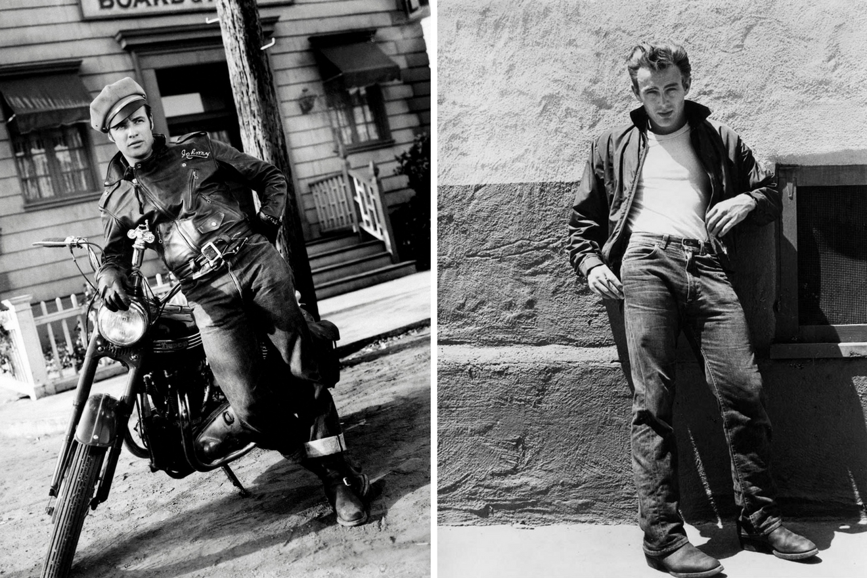

Figure 4. Denimhunters, “Marlon and James wearing jeans in 1950s”.

The entertainment and music industry played a very important for influencing teenagers to dress differently from their parents("Dudbridge"). The goal was to be original and rebel at such a young age. While some teenagers were receiving money from their parents, others were working part-time to buy new clothes. Teenagers social life started to develop, as well. Dinners and cafes were the place young people were hanging out("Dudbridge"). As you can see on figure 3 and 4, among the most iconic styles of the 50s were inspired by music legends like Elvis Presley and his Rock and Roll, movie actors like Marlon Brando dark denim and leather jacket' style, and James Dean's garments on "Rebellion without a cause" were the popular looks. 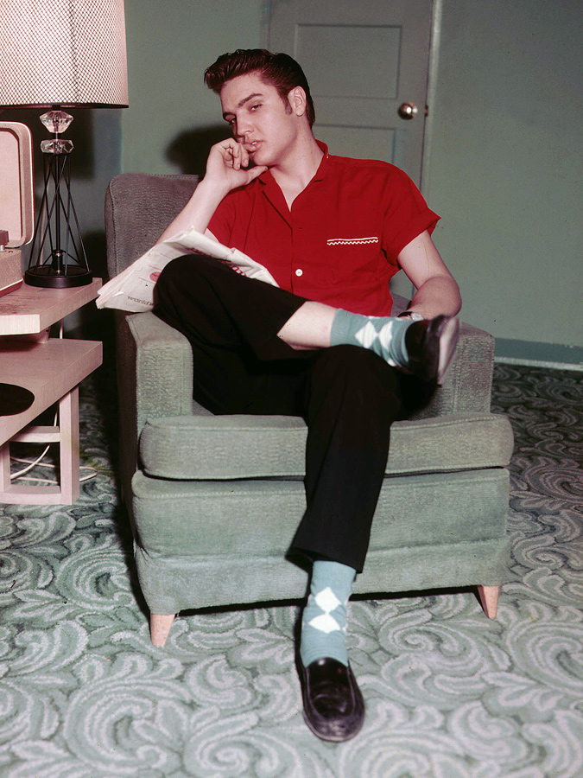

Figure 5. “Why Elvis Presley Is Your New (Old) Style Icon”.

Designers of Time

1. Fashion sense of 1950s

While teenagers were trying to find their own identity and fashion senses, designers in the 1950s innovated their creations to another level (“Dudbridge"). For example, famous designers such as Christian Dior introduced the public new silhouette couture with his famous "New Look," and Cristóbal Balenciaga was consolidating and adding new patterns, mixing and using many different kinds of fabric and brighter colors. Meanwhile, the House of Chanel made a comeback with the famous" Little Black Dress." Chanel wanted to focus on mass production while other designers wanted to work on Luxury and Couture.

Reference:

Back to the Future(1985)”Plot”. IMDb

Retrieved from:

<https://www.imdb.com/title/tt0088763/plotsummary>

Blue Jeans. “How Products are Made”. Volume 1.

Retrieved from:

http://www.madehow.com/Volume-1/Blue-Jeans.html

Corsillo, Liza(October 21,2015)”Why Martyn McFly’s Clothes Were Cooler in the First Back to The Furute”.

Retrieved from

### <https://www.gq.com/story/why-the-first-back-to-the-future-had-better-clothes>

Denim Construction. “Denim-Construction and Common Terminology”. Basic Knowledge.

Retrieved from:

https://onefamily.lfapps.net/sites/default/files/learning/merchandising/Denim%20and%20washes.pdf

Ebert, Roger (July 03, 1985). “Back to The Future”.

<https://www.rogerebert.com/reviews/back-to-the-future-1985>

Dudbridge, Saxony. “History of Fashion 1950’s-1960’s”.

Retrieved from:

http://www.catwalkyourself.com/fashion-history/1950s-1960s/

### “Marty McFly 1955 Original Vest (Michael J. Fox)” Retrieved from http://www.sciencefictionarchives.com/en/collections/309/marty-mcfly-1955-original-vest-michael-j-fox

(September 10, 2019) “1950s Teen Boy’s Clothing” Vintage Dancer, Fashion History.

Retrieved from:

https://vintagedancer.com/1950s/1950s-teen-boys-clothing/

SpoonFlower. FabricMarty McCfly 1955 Shirt 2: Amoeba” theoncomingstorm”.Retrieved from

www.spoonflower.com

“Fashion Through The Decades”.The People History

Retrieved from:

http://www.thepeoplehistory.com/50sclothes.html

Wong, Ethan M. (June 21) The Menswear in Back To The Future, Film Style, Show Notes.

Retrieved from:

<https://streetxsprezza.wordpress.com/2020/06/21/the-menswear-in-back-to-the-future-1985/>

“What Is Denim Fabric? A Guide to the History of Denim, the Different Types of Denim, and What to Look for When Buying Denim Jeans”. Design&Style.Massterclas, Oct 2, 2020. Retrieved from:

https://www.masterclass.com/articles/what-is-denim-fabric-a-guide-to-the-history-of-denim

Wong, Ethan (June 21).” The Menswear in Back to the Future(1985). Retrieved from:

<https://streetxsprezza.wordpress.com/2020/06/21/the-menswear-in-back-to-the-future-1985/>

Photo

Blue Jeans. “How Products are Made”. Volume 1.

Retrieved from:

http://www.madehow.com/Volume-1/Blue-Jeans.html

Bojer, Thomas. “How Denim Went from Workwear to Fashion Statement”, Marlon Brando and James Dean wearing jeans in the 1050s. History of Jeans.

Retrieved from:

<https://denimhunters>.com/history-of-jeans-1/

Campbell,Lucy(February 23,2020).”allstarPictureLibrary”,“This is the new standard for spectacle’: fans react to the Back to the Future musical”

Retrieved from:

<https://www>.theguardian.com/stage/2020/feb/23/fans-react-back-to-the-future-musical-manchester-opera-house

Corsillo, Liza(October 21,2015)”Why Martyn McFly’s Clothes Were Cooler in the First Back to The Furute”.

Evans, Mary/Amblinentertainment/UniversalePictures/RonaldGrant/Everret.

Retrieved from:

<https://www.gq.com/story/why-the-first-back-to-the-future-had-better-clothes>

VreelandHill, George. “Elvis Presley, 1950s”.

Retrieved from:

https://www.pinterest.com/pin/843228730205651834/