2017
Associate Prof. Sue Brandt
Production Manager
Entertainment Technology
NYCCT
03/01/2017

YOUR CHARACTER, NAME, POSITION, DIALOGUE, DUTIES,
IN MAKE UP AND COSTUME

Gravesend Inn Haunted Hotel Actors Manual
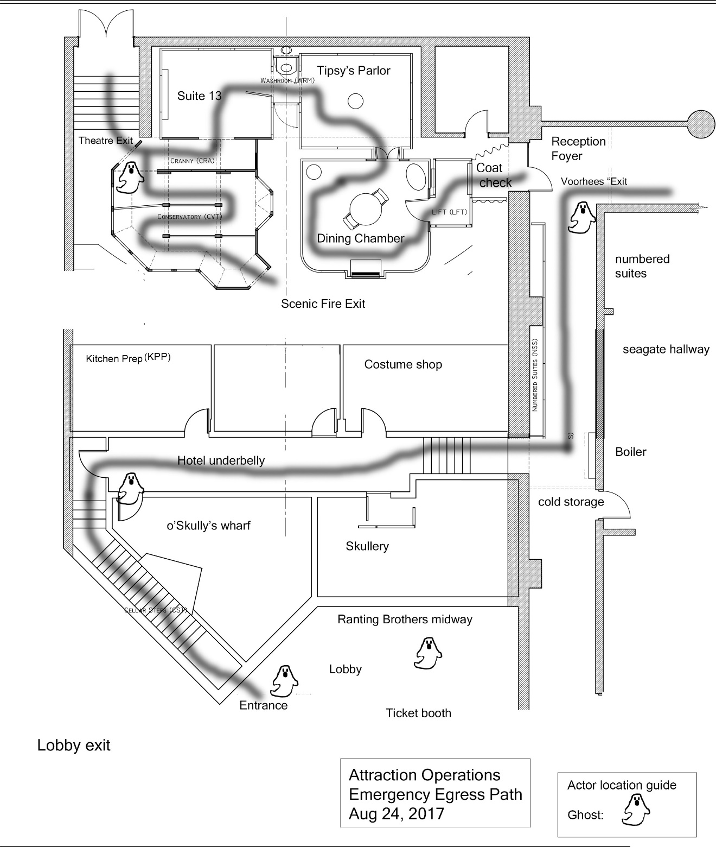

Contents
General Operations information 5
Identification 5
Attendance policy 5
No show 5
On call 5
Schedule 5
Professional demeanor 5
Guidelines for guest services 6
Attire 6
General standards 6
Clothing 6
Shoes 6
Rules of conduct 6
Tips for dealing with guests 7
Guest complaints 7
Guest with disabilities 7
Areas Defined/Ranting Bros. Midway 7
Lobby 7
Preload 7
Service Entrance (Entrance Door, left of lobby entrance doors) 8
Queue 8
Cellar Steps 8
Hotel Underbelly 8
O’Skully’s Wharf (pirate room) 8
Service Hall 8
Kitchen Prep 8
Scullery 8
Boiler 8
Seagate Passage and Numbered Suites 9
Reception and Foyer 9
Coat Check 9
Dining Chamber 9
Tipsy’s Parlor (upside down room) 9
Washroom to Suite 13 9
Cranny to Conservatory to Check-Out 9
Exit into Patchen’s Picture Palace 10
Actors 10
Position 1: DEREK VAN SICKLEY, Doorman/Concierge 10
Position 2: LAWRENCE LACKEY, Bellhop 10
Position 3: DANIEL DINGEY or SOPHIE SWEEPER, Housekeeper 10
Position 4: LILY LACKLUSTER, Maid, or MAXWELL PORTER, Steward 10
Position 5: TINA TERMINAL, Unwedded bride 10
Ride restrictions 11
Guests 11
Guests with disabilities 11
Actors 11
Scenes and Effects 11
Important phone numbers: 11
Operations Procedures 12
Evacuation Procedures 12
Level 1 Evacuation 12
Level 2 Evacuation 12
Level 3 Evacuation 12
Important Notes 12
Agreement Signature Page…………………………………………………………… 13

General Operations Information

The Acting Crew provides entertainment inside and outside of the attraction. Your goal is to provide our guests with a safe and enjoyable experience.

Identification
Each Attraction Operator will be wearing an Attraction Operations T-shirt. Once you put the shirt on you are on duty.

Attendance Policy
All actors are expected to be on time for the assigned call. Make-up can take up to one hour to apply. Remember poor attendance creates a hardship for your fellow students.
Actors who know they will be late must notify the Stage Manager prior to their schedule call time.

No Show
Failure to report to work or notify your supervisor of your expected absence before the call time will be consider a no-show.

On Call
If you would like to be “on call” to cover for a missing crew member, please let your Stage Manager know during the attraction training. To be “on call” you must be able to arrive at the venue within 30 minutes of being called.

Schedule
No schedule changes without prior approval of supervisor.
Schedules are prepared before opening day of the attraction.

Professional Demeanor
All actors are required to be courteous, congenial, helpful, and must present a positive professional image to our guests. No eating, drinking or gum chewing inside the attraction or in guest areas. When on break, the best place to eat is in the crew room. There are lockers, microwave and refrigerator for your use. See an Entertainment CLT to obtain a locker.

Guidelines for Guest Services
Remember: all patrons of our attraction are considered our guests. From the time they enter the front doors of Voorhees and finally exit, each patron is our guest.
As an actor you are visible to all the guests whether or not they attend the attraction. You are now a front line employee; you are the first contact of the guest to the attraction.

Each time a guest asks you a question, stay in character, and point them in the correct direction. If the guest is young or under stress, you may answer in a positive enthusiastic manner. Courtesy and kindness can go a long way with a frustrated, stressed-out guest. A guest should never feel they are a burden when you are helping them solve a problem. It is not easy to continuously answer the same question in a patient friendly manner. But you must remember that the guest is asking the question for the first time. Generally, guests do not read signs; they are officially on vacation when they walk through the front door. It is our responsibility to make sure their vacation is fun while we are providing the entertainment.

Attire
As a cast member you are expected to maintain a neat appearance. Remember you are representing City Tech and the Entertainment Technology Department. Good grooming demonstrates pride in City Tech and yourself. Wear black clothing without any logos visible.

General Standards
Personal hygiene: all crew members must be clean and practice healthy hygiene. Avoid perfumes, colognes and cosmetics with scents. You are working in an environment in close proximity to the audience.

Clothing
Wear clean comfortable underwear and black shoes. A costume will be provided.

Shoes
Please wear closed-toed shoes that are comfortable to navigate crowds and stairs. Please wear socks.

Rules of Conduct

- Never touch a guest.
- If you see a guest acting inappropriately notify your team leader.
- Never approach an unruly guest alone.
- If you see a crew member acting inappropriately notify a faculty member.

Tips for Dealing with Guests
- Remain in character; stay in your assigned area.
- Call for assistance when it is a problem you cannot handle. Do not use the statement “I don’t know”. This tells the guest they are not important; instead tell them “I do not have that information, but I will attempt to find out for you”. You are always being observed while in the attraction. Your supervisor or a faculty member is your support team.

Guest Complaints
- Ensure you understand the problem before you attempt to solve it.
- Privacy: move the guest away from the crowded area; you will hear better and they can explain in privacy.
- Wait until the guest has finished with their entire complaint before responding.
- Empathize with the guest- put yourself in their shoes.
- Remain calm, do not get in a shouting match with the guest; tempers can escalate. Your attitude can set the tone. By remaining calm you are in control of the conversation.
- Apologize for the inconvenience.
- Be confident.
- Refer the guest to a faculty member in the lobby if they seek more compensation than the apology.
- Do not be afraid to ask for assistance from your team leader or faculty member.
Situations that require support:
- Abusive language.
- Personal property damage or theft.
- Irate guests.
- Do not offer free tickets, reimbursement or rain checks--these can only be authorized by a faculty member.

Guest with Disabilities
Guide guest to the house manager who is trained to support all guests with disabilities.

The Areas of our Haunted Hotel, relating to it’s Backstory, are:

“Ranting Bros. Midway”:

Lobby
Guests go to box office tables to purchase tickets.

Queue
Guests enter the line across the lobby into the queue.

Preload
Guests are preloaded into groups of 4 or 6 in preload area. Lawrence Lackey, the bellhop, answers questions and entertains the line of guests.

“Service Entrance” (Entrance Door, left of lobby entrance doors)
Guests move as a load group to the loading area in front of the entrance.
They are greeted by the Derek Van Sickley, the doorman. He opens the door when he gets a green cue light. The door must be closed behind the load group after they enter the attraction.

“Cellar Steps”
Guests walk down a decorated stairway leading to the basement level of the building.

“Hotel Underbelly”
Hallway leading to sensor cued effects.

“O’Skully’s Wharf” (pirate room)
The guests are invited into the pirate room by a housekeeper, Sophie Sweeper or Daniel Dingey, to hear the Pirate Captain’s story. The story is approximately 2 minutes long. It is the actor’s job to make sure the guests trigger the sensor to start the animated scene.

“Service Hall”
Lights and sound effects in hallway.

“Kitchen Prep”
Sensor triggers when guest leans into the room on the left. While viewing tonight’s dinner “Chekhov”, they experience a rumble floor effect. Guests can enter but must exit out the same door back to the service hall.

“Scullery”
Sensor triggered when guest walks along right-hand side of the hallway. A corpse, Bonnie Haggard, drops down from above inside a doorway. Guests cannot enter the room.

“Boiler”
Guests continue down hallway, up a short set of stairs. At the end they see the boiler. When they reach the boiler they will trigger the boiler effects and continue left.

“Seagate Passage” and “Numbered Suites”
Guests then turn left and proceed down Seagate Passage. A series of doors are on the left hand side. The first doorway is a fake door. The second doorway will contain the telephone booth props and sound effects. The third doorway will contain the latex wall and hands. The fourth doorway can be a hiding place for an actor or remain shut.

“Reception Area/Foyer” (event continues to entrance on left)
At this end of Seagate Passage, there may be a live actor, Lily Lackluster, maid, or Maxell Porter, steward, at this location.

“Coat Check”
Guests turn left and enter a propped “Check-in” room. They will set off a sensor for an animated “bear head” trophy hanging on the wall.

“Dining Chamber”
Guests will proceed through a door and into the dining chamber. They will set off a sensor that starts a series of effects including a portrait with a journal below it, that tells a story of the original hotel owner, Lord Jasper deGore, and invites them to continue to the next room.

“Tipsy’s Parlor” (upside down room)
No sensor effects, but the room is upside down. Guests must walk across a mirrored floor to enter the next room.

“Washroom”
There is a mirror effect triggered in this small area.

“Suite 13”
Opening the door triggers a series of effects. Sliding candle, lighting and sound effects, dresser drawers opening, and a cadaver, (wife of Lord Jasper de Gore), Lady Virginia Ghostly de Gore, jumps up in the bed.

“Cranny” with Gardener
A gardener, Bartholomew Rash, pops up on the left when guests trigger a sensor.

“Conservatory”
Guests enter the conservatory. The unwedded bride, Tina Terminal, is lurking at the fire exit door. Video effect in three panes of a bay window. Guests are to follow the attraction route through the conservatory.

“Check-Out”
Air blow effect on ankles and a pop-up trashcan, Howard Stump, effect.

Exit into “Patchen’s Picture Palace”
Guests exit the maze through the center aisle of the theatre. They are given a program and encouraged to take a seat and watch the movie screens stage right and left.

Actors:

The Gravesend Inn, A Haunted Hotel casts five actors who live within the attraction. They add important ambiance to the attraction. Students from City Tech are cast as character actors for the attraction. These volunteers love Halloween.

Management Notes:
Please learn and use the following personal names, titles and position numbers for all live actors. This will help the actor, especially the one “thrown in” at the last minute, to easily become and relate to the backstory, even if they know nothing of the attraction’s background. Giving them a personal name, rather than just “maid” will help benefit their performance. Making sure they have their props will help them stay in character and give them something to do aka “their business.” If there is a shortage of actors, it is essential to run the hotel event with Position #1 and Position #3 always filled at the very least. It is always preferable to have all 5 positions filled, for ease of moving the guests through, as well as providing the best experience for them.

POSITION #1 DEREK (Van Sickley) is a doorman/once a concierge for the hotel. Derek opens the Service Entrance door on-cue to let our guests in. It could be cast male or female. Not a friendly character. Derek could sit on a stool. Prop: pet rat or similar.

POSITION #2 LAWRENCE aka “LARRY” (Lackey) is a bellhop. A very friendly character, who entertains guests while they wait in line. A bellhop can be cast male or female. Prop: a small suitcase

POSITION #3 SOPHIE (Sweeper) if female, or DANIEL (Dingey) if male. Both are called housekeepers for this position at the bottom of the Cellar Steps, to encourage guests into O’Skully’s Wharf and The Kitchen Prep.
Prop: a broom and rags

POSITION #4 LILY (Lackluster) a maid if female, or MAXWELL (Porter) a
steward if male. MAID or STEWARD for this position at the end of Seagate Passage, aka Reception /Foyer to help direct guests. Prop: a broom and rags

POSITION #5 TINA (Terminal) unwedded bride if female, GUNTHER (Graves) unwedded groom if male, at entrance of The Conservatory. She and her groom died on their wedding day due to a freak storm. Prop: handkerchief to cry into, dried wedding bouquet, wedding invitation

Ride restrictions

Guests
- Main entrance: must be strong enough to walk down a flight of stairs.
- Be able to walk for 15 minutes.
- Disabled guests will be assisted by house management and enter the basement through an elevator and join the tour at the Reception/Foyer area. The guest will be accompanied throughout the attraction by house management.
- Children must be accompanied by an adult.

Guests with disabilities
- Our house manager is trained to assist guests with disabilities.
- Ushers will lead guests utilizing a wheel chair or any other assistive mobility device to an elevator taking them to the lower level to enjoy the experience.
- If any guest needs extra guidance, please let your team leader know so he or she can accommodate them to the best of our abilities.

Actors
- We cast CityTech students as character actors who are deployed throughout the attraction.
- Their job is to help guide and entertain the guests traveling through the attraction.
- They will never touch a guest.
- Please advise guests “do not touch the actors, they will not touch you”.

Scenes and Effects
- Guests will enjoy all the scenery and effects throughout the event.
- Guests and actors do not touch scenery, props, or climb on furniture or effects.

Important phone numbers:
Production Manager: Professor Sue Brandt 718-260-5595
Theatreworks Information Line: 718-260-5592
Security: Lobby desk Voorhees: 718-260-6573

Operations Procedures
Be aware of the crew working to support the attraction in guest services.
The following is the evacuation procedures the attraction crew will do if needed.
You will get instructions from the Stage Manager if an evacuation is occurring.

Evacuation Procedures

Good communications between Attraction Operations, House Management and the Technical Control Team is essential for smooth and safe evacuations.

The Lead Attraction Operator is in contact with the show control booth and house manager via a wireless headset system. The Lead Attraction Operator will instruct you as to the type and level of the evacuation.

Level 1 Evacuation
The event is having technical difficulties. All guests inside the attraction are evacuated out of the show area and taken back to the front of the queue area to get a fresh tour of the attraction. During this level guests will be permitted to wait in the queue area for the attraction restart.
Actors with remain in the attraction.

Level 2 Evacuation
Evacuation of the event for safety or medical reasons. All patrons are evacuated from the show area to a designated exit area. During this level guests will be permitted to wait in the queue area for the attraction restart.
Actors will be guilded to the wardrobe area.

Level 3 Evacuation
Complete evacuation of all guest areas. All guests will also be escorted out of the attraction, queue line, Voorhees audience/house area, and lobby. They cannot return
until security designates the building is safe.
Actors will exit outside. You will be instructed where to go by the attraction staff.

Important Notes
- All delays and evacuations are considered “technical difficulties”. Never state a problem or use the words “evacuation”, “accident”, and “fire” to any guests or in any guest areas.
- Only the lead operator will give the guests readmission passes to bypass the queue line for that day or any other day the attraction is running.
The Gravesend Inn, A Haunted Hotel

ATTRACTION OPERATIONS
ACTOR MANUAL

Fall 2017

I have attended an attraction actors training session. I have read and understood the actor’s manual.

Name_________________________________ Date:___________________________

Signature______________________________

Stage Manager__________________________________________

Attractions Operations Manager_____________________________

