2016
Associate Prof. Sue Brandt
Production Manager
Entertainment Technology
NYCCT
08/29/2016
BRING THIS MANUAL, FLASHLIGHT AND MULTI-TOOL WITH YOU TO YOUR WORK SHIFT

ATTIRE IS STAGE BLACKS
Gravesend Inn Haunted Hotel Attraction Operations Manual
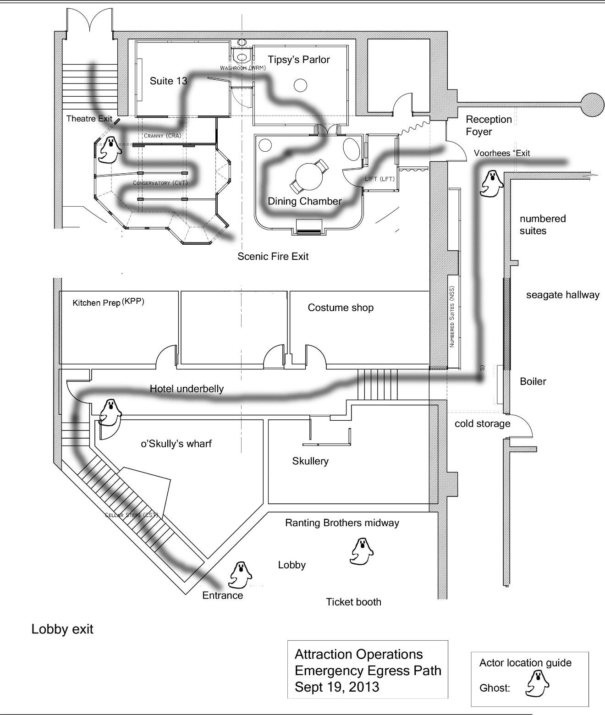

Contents
General Operations information 5
Identification 5
Attendance policy 5
No show 5
On call 5
Schedule 5
Professional demeanor 5
Guidelines for guest services 6
Attire 6
General standards 6
Clothing 6
Shoes 6
Rules of conduct 7
Tips for dealing with guests 7
Guest complaints 7
Guest with disabilities 8
The Gravesend Inn A Haunted Hotel scene breakdown 9
Ranting Bros. Midway 9
Lobby 9
Queue 9
Preload 9
Service Entrance (Entrance Door, left of lobby entrance doors) 9
Cellar steps 9
Hotel underbelly 9
O’Skully’s Wharf (pirate room) 9
Service Hall 9
Kitchen Prep 10
Scullery 10
Boiler 10
Seagate passage and Numbered suites 10
Reception and Foyer 10
Coat Check 10
Dining Chamber 10
Tipsy’s parlor (Upside down room) 10
Suite 13 11
Conservatory 11
Exit 11
Actors 12
TOBIAS TICKETTS AND OR BONITA BANCHOR 12
DEREK VAN SICKLEY, CONCIERGE 12
LAWRENCE LACKEY, Bellhop 12
DANIEL DINGEY AND OR SOPHIE SWEEPER 12
LILY LACKLUSTER, MAID AND OR MAXWELL PORTER 12
TINA TERMINAL, bride 12
Ride restrictions 13
Guests 13
Guests with disabilities 13
Actors 13
Scenes and Effects 13
Operations Procedures 14
Opening procedures 14
Attraction cleaning 14
Show area walk through 14
Queue Attendant 14
Pre-load 14
Load 15
Closing procedures 15
Evacuation Procedures 15
Level 1 Evacuation 15
Level 2 Evacuation 15
Level 3 Evacuation 16
Important Notes 16
Evacuation assignments 16
Lead Operator: 16
Level 1 16
Level 2 16
Level 3 16
Queue line attendant 17
Levels 1 and 2 17
Level 3 17
Pre-load operator 17
Levels 1 and 2 17
Level 3 17
Load operator 17
Levels 1 and 2 17
Level 3 18
Floater 18
Levels 1 and 2 18
Level 3 18
Thank you 18
Attraction Operations quiz 19
General information 19
Guest Relations 19
Ride Evacuation 20

General Operations information

The Attraction Operations crew oversees the daily operation of The Gravesend Inn A Haunted Hotel attraction. Your goal as an Attraction Operator is to provide our guests with a safe and enjoyable experience.

Identification
Each Attraction Operator will be wearing an Attraction Operations T-shirt. Once you put the shirt on you are on duty.

Attendance policy
All operators are expected to be dressed and ready to work at the beginning of their show call. Remember poor attendance creates a hardship for your fellow operators and will result in a lower grade for you.
Operators will be considered tardy if they are not at their assigned position at the scheduled time. Operators who know they will be late must notify their supervisor prior to their schedule call time. Advanced notice does not excuse a tardy.

No show
Failure to report to work or notify your supervisor of your expected absence before the call time will be consider a no show.

On call
If you would like to be on call to cover for a missing crew member please let your supervisor know during the attraction training. To be on call you must be able to arrive at the venue within 30 minutes of being called.

Schedule
No schedule changes without prior approval of supervisor.
Schedules are prepared before opening day of the attraction.

Professional demeanor
All crew members are required to be courteous, congenial, helpful, and must present a positive professional image to our guests. No eating, drinking or gum chewing inside the attraction or in guest areas. When on break, the best place to eat is in the crew room. There are lockers, microwave and refrigerator for your use. See an Entertainment CLT to obtain a locker.

Guidelines for guest services
Remember: all patrons of our attraction are considered our guests. From the time they enter the front doors of Voorhees and finally exit, each patron is our guest.
As an Attraction Operator you are visible to all the guests whether or not they attend the attraction. You are now a front line employee; you are the first contact of the guest to the attraction.

Each time a guest asks you a question; answer in a positive enthusiastic manner. Courtesy and kindness can go a long way with a frustrated, stressed out guest. A guest should never feel they are a burden when you are helping them solve a problem. It is not easy to continuously answer the same questions in a patient friendly manner. But you must remember that the guest is asking the question for the first time. Generally guests do not read signs; they are officially on vacation when they walk through the front doors. It is our responsibility to make sure the vacation is fun while we are providing the entertainment.

Attire
As an operations team member you are expected to maintain a neat appearance. Remember you are representing CityTech and the Entertainment Technology Department. Good grooming demonstrates pride in CityTech and yourself. Wear black clothing without any logos visible.

General standards
Personal hygiene; all crew members must be clean and practice healthy hygiene. Avoid perfumes, colognes and cosmetics with scents. You are working in an environment in close proximity to the audience.

Clothing
Wear loose fitting comfortable clothes that allow you to work in comfort. Proper under garments are required. Black clothing is best. No identification of other productions or events.

Shoes
Please wear closed toed shoes that are comfortable to navigate crowds and stairs. Please wear socks.

Rules of conduct

- Never touch a guest.
- If you see a guest acting inappropriately notify your team leader.
- Never approach an unruly guest alone.
- If you see a crew member acting inappropriately notify a faculty member.

Tips for dealing with guests
- Always initiate contact with a guest. Welcome them to the attraction.
- Smile
- Greet the guest
- Be helpful; “How may I assist you?
- Remain available; stay in your assigned area.
- Become the information expert; know the location of the ATM, restrooms, lounge area, food service, security, water fountain and exits in your area.
- Be understanding
- Use good language such as: please and thank you.
- Call for assistance when it is a problem you cannot handle. Do not use the statement “I don’t know”. This tells the guest they are not important, instead tell them “I do not have that information, but I will attempt to find out for you”. Find your supervisor or a faculty member to be your support team.

Guest complaints
- Ensure you understand the problem before you attempt to solve it.
- Privacy, move the guest away from the crowded area, you can hear better and they can explain in privacy.
- Wait until the guest has finished with their entire complaint before responding.
- Empathize with the guest, put yourself in their shoes.
- Remain calm, do not get in a shouting match with the guest, tempers can escalate. Your attitude can set the tone. By remaining calm you are in control of the conversation.
- Apologize for the inconvenience.
- Be confident
- Refer the guest to a faculty member in the lobby if they seek more compensation than the apology.
- Do not be afraid to ask for assistance from your team leader or faculty member.
Situations that require support:
- Abusive language
- Personal property damage or theft.
- Irate guests
- Do not offer free tickets, reimbursement or rain checks--these can only be authorized by a faculty member.

Guest with disabilities
Guide guest to the house manager who is trained to support all guests with disabilities.

Important phone numbers:
Production Manager: Professor Sue Brandt 718-260-5595
Theatreworks Information Line: 718-260-5592
Security: Lobby desk Voorhees: 718-260-6573

The Gravesend Inn A Haunted Hotel scene breakdown

Ranting Bros. Midway

Lobby
Guests go to box office to purchase tickets

Queue
Guests enter the line across the lobby into the queue.

Preload
Guests are preloaded into groups of 4 or 6 in preload area.

Service Entrance (Entrance Door, left of lobby entrance doors)
Guests move as a load group to the loading area in front of the entrance.
They are greeted by the doorman. He opens the door when he gets a green cue light.
The door must be closed behind the load group after they enter the attraction.

Cellar steps
Guests walk down a decorated stairway leading to the basement level of the building.

Hotel underbelly
Hallway leading to sensor cued effects

O’Skully’s Wharf (pirate room)
The guests are invited into the pirate room by a house keeper to hear the story of the pirate. The story is approximately 2 minutes long. It is the actor’s job to make sure the guests trigger the sensor to start the animated scene.

Service Hall
Lights and sound effects in hallway

Kitchen Prep
Sensor trigger when guest leans into the room on the left. A new effect the rumble floor will occur in this area. Guests can enter but must exit out the same door back to the service hall.

Scullery
Sensor triggered when guest walks along right-hand side of the hallway. A ghost drops down from above inside a doorway. Guests cannot enter the room.

Boiler
Guests continue down hallway, up a short set of stairs. At the dead end they see the boiler. When they reach the boiler they will trigger the boiler effects.

Seagate passage and Numbered suites
Guests then turn left and proceed down Seagate passage. A series of doors are on the left hand side. The first doorway is a Faux Door. The second doorway will contain the telephone booth props and effects. The third doorway will contain the latex wall and hands. The fourth doorway can be a hide for an actor or remain shut.

Reception and Foyer
Propped area with desk. There may be a live actor the housekeeper at this location.

Coat Check
Guests turn left and enter the lift room. They will set off a sensor; a mounted bear head will tell them a short story.

Dining Chamber
Guests will proceed through a door and into the dining chamber. They will set-off a sensor that starts a series of effects including a portrait that tells a story and invites them to continue to the next room.

Tipsy’s parlor (Upside down room)
No sensor effects, but the room is upside down. Guests must walk across a mirrored floor to enter the next room

Washroom
Mirror effect

Suite 13
Opening the door triggers the series of effects. Sliding candle, lighting and sound effects, a cadaver sits up in bed.

Gardener
A gardener props up on the left when guests trigger a sensor.

Conservatory
Guests enter the conservatory. Tina Terminal is lurking at the fire exit door. Video effect in three panes of a bay window. Guests are to follow the attraction route through the conservatory.

Check-out
Air blow effect on angles and Trashcan effect.

Exit
Guests exit the maze through the center aisle of the theatre. They are given a program and encouraged to take a seat and watch the movie screens stage right and left.

Actors
The Gravesend Inn A Haunted Hotel casts fives actors and ticket sellers who wander throughout the attraction. They add important ambiance to the attraction. Students from CityTech are cast as character actors for the attraction. These are volunteers who love Halloween. It is important we are eyes and ears for them as they work throughout the attraction.

TOBIAS TICKETTS AND OR BONITA BANCHOR
She or he stays in the box office and sells tickets for entrance to the attraction.

DEREK VAN SICKLEY, CONCIERGE
He stands at the main entrance to the attraction and on cue opens the door for the guest entrance to the attraction. He may sit on a stool and play with his pet rat.

LAWRENCE LACKEY, Bellhop
He wanders through out the lobby entertaining the queue line as well as covering for other actor positions inside the attraction. He carries a small suitcase.

DANIEL DINGEY AND OR SOPHIE SWEEPER
He/she Stands at the bottom of the cellar steps and invites guests into O’Skully’s wharf. The house keeper hand prop is a broom.

LILY LACKLUSTER, MAID AND OR MAXWELL PORTER
He/she stands at reception desk. She can also work upstairs at the queue line.
The house keeper hand prop is a broom.

TINA TERMINAL, bride
Tina dies on her wedding day due to a freak storm. She is looking for her dead husband IN THE CONSERVATORY

Ride restrictions

Guests
- Main entrance: must be strong enough to walk down a flight of stairs.
- Be able to walk for 15 minutes.
- Disabled guests will be assisted by house management and enter the basement through an elevator and join the tour at the reception/Foyer area. The guest will be accompanied throughout the attraction by house management.
- Children must be accompanied by an adult.

Guests with disabilities
- Our house manager is trained to assist guests with disabilities.
- Ushers will lead guests utilizing a wheel chair or any other assistive mobility device to an elevator taking them to the lower level to enjoy the experience.
- If any guest needs extra guidance please let your team leader know so her or she can accommodate them to the best of our abilities.

Actors
- We cast CityTech students as character actors who are deployed throughout the attraction.
- Their job is to help guide and entertain the guests traveling through the attraction.
- They will never touch a guest.
- Please advise guests “do not touch the actors, they will not touch you”.

Scenes and Effects
- Please advise guests to enjoy all the scenery and effects throughout the ride.
- Please advise guests to not touch or climb on the attraction.
- Please advise guests this is a safe family environment, be aware of the people around you who are also having fun.

Operations Procedures

Opening procedures

Attraction cleaning
Inspect lobby, queue area, load area and exit. Be sure queue stanchions are in place.

Show area walk through
Before opening and after closing two Attraction Operators will be assigned to inspect the entire length of the show area. The operators will pick up all trash and items not related to the production. At the end of the walk through deliver all found items to the Attraction Operations team leader.

Queue Attendant
This is a mobile position. This operator is continuously circulating throughout the assigned queue area. Responsibilities include:
- Greeting guests
- Screening guests for appropriateness to go through the attraction.
- General set-up of main queue area and overflow areas.
- Communicating with team leader.
- Ensuring guests have no food or drink prior to entering the load area.
- Maintain cleanliness of the queue area.
- Overall safety of guests and fellow employees.
- Length of time guests will be in line is noted on signs along the wall of the queue line.
- Reassure guests the ghost character actors will not touch them and are part of the ambiance of the attraction.

Pre-load
This is not a mobile position. This operator is assigned to the front 15 feet of the queue area. Responsibilities include:
- Inform guests of ride restrictions.
- Screening guests for appropriateness to go through the attraction.
- Communicating with team leader.
- Ensuring guests have no food or drink prior to entering the load area.
- Maintain cleanliness of the queue area.
- Overall safety of guests and fellow employees.
- Advise guest of ride warnings and restrictions.
- Assign groups of 4 or 6.
- Load groups to pre-load area.
- Keep entrance to the Voorhees Theatre clear of guests for safe fire egress.

Load
This is not mobile position. This operator is assigned to the load portion of the queue area. Responsibilities include:
- Greeting guests
- Screening guests for appropriateness to go through the attraction.
- Advise guest of ride warnings and restrictions.
- Load group onto load area.
- Communicating with team leader.
- Ensuring guests have no food or drink prior to entering the attraction.
- Maintain cleanliness of the queue area.
- Overall safety of guests and fellow employees.
- Encourage group to enter the attraction.
- Ensure attraction entrance door is shut between groups.

Closing procedures
Inspect lobby, queue area, load area and exit. Be sure queue stanchions are in place.

Evacuation Procedures

Good communications between Attraction Operations, house management and the technical control team is essential for smooth and safe evacuations.

The lead Attraction Operator is in contact with the show control booth and house manager via a wireless headset system. The lead Attraction Operator will instruct you as to the type and level of the evacuation.

Level 1 Evacuation
The ride is having technical difficulties. All guests inside the attraction are to be evacuated out of the show area and taken back to the front of the queue area to get a fresh tour of the attraction. During this level guests will be permitted to wait in the queue area for the attraction restart.

Level 2 Evacuation
Evacuation of the ride for safety or medical reasons. Evacuate all patrons from the show area to a designated exit area. During this level guests will be permitted to wait in the queue area for the attraction restart.

Level 3 Evacuation
Complete evacuation of all guest areas. All guests will also be escorted out of the attraction, queue line, Voorhees audience area and lobby. They cannot return until security designates the building is safe.

Important Notes
- All delays and evacuations are considered “technical difficulties” Never state a problem or use the words “evacuation”, “accident”, and “fire” to any guests or in any guest areas.
- Only the lead operator will give the guests readmission passes to bypass the queue line for that day or any other day the attraction is running.

Evacuation assignments
Position Assignment
- Lead operator lobby
- Queue line attendant onstage maze
- Pre-load onstage maze
- Load entrance through Seagate hallway
- Floater entrance through Seagate hallway

Lead Operator:
All levels
- Notify all operators of evacuation level and assignment
- Stay in lobby and coordinate with house manager and show control.

Level 1
- No guest entrance into Voorhees theatre or attraction area.

Level 2
- No guest entrance into Voorhees theatre or attraction area.

Level 3
- No guest entrance into Voorhees theatre or attraction area.
- Assign Attraction Operators their attraction area to evacuate and the designated meeting area.
- Coordinate with house manager; ushers to direct guest out of Voorhees building.
Typical Order of evacuation
- Lobby
- Queue line
- Voorhees Theatre

Queue line attendant

Levels 1 and 2
- Stay in position
- Reassure guests: “Technical difficulties”
- Do tasks assigned by lead operator.

Level 3
When instructed by lead operator:
- Enter the attraction at the reception foyer; near the stairwell below the scene shop. Walk through the basement area to the lift room entrance.
- Proceed to lift room entrance, with one other Attraction Operator walk the entire ride area from the lift room to the exit.
- Evacuate the guest out of the upstage left emergency exit.
- Guide the guests around the building back to the lobby entrance.
- Go to designated area to check in with the Attraction Operations lead.

Pre-load operator

Levels 1 and 2
- Stay in position
- Reassure guests; “Technical difficulties”
- Do tasks assigned by lead operator.

Level 3
When instructed by lead operator:
- Enter Voorhees theatre through main entrance
- Proceed to lift room entrance, with one other Attraction Operator walk the entire ride area from the lift room to the exit.
- Evacuate the guest out of the upstage left emergency exit.
- Guide the guests around the building back to the lobby entrance.
- Go to designated area to check in with the Attraction Operations lead.

Load operator

Levels 1 and 2
- Stay in position
- Reassure guests; “Technical difficulties”
- Do tasks assigned by lead operator.

Level 3
When instructed by lead operator:
- Proceed to the main entrance, with one other Attraction Operator walk the entire ride area from the main entrance to the lift room.
- Evacuate the guests out of the closest emergency exit.
- Guide the guests around the building back to the lobby entrance.
- Go to designated area to check in with the Attraction Operations lead.

Floater

Levels 1 and 2
- Stay in position
- Reassure guests; “Technical difficulties”
- Do tasks assigned by lead operator.

Level 3
When instructed by lead operator:
- Proceed to the main entrance, with one other Attraction Operator walk the entire ride area from the main entrance to the lift room.
- Evacuate the guest out of the closest emergency exit.
- Guide the guests around the building back to the lobby entrance.
- Go to designated area to check in with the Attraction Operations lead.

Thank you
Thank you for your interest in being an Attraction Operator. In order to qualify you must complete the quiz on the last page and attend one session of Attraction Operator training.

Attraction Operations quiz

Name_______________________

General information

- All Attraction Operators will be identified by
- Wearing all black
- Wearing all black with a ride operation t-shirt
- Wearing brightly colored clothing
- Wearing a Halloween costume.

- To be considered on time a Attraction Operations crew member must be:
- On time, with their t shirt on at assigned work area.
- In the lobby door
- Call in he or she is on the way
- Have a friend cover the shift.

Guest Relations
- Is it never appropriate to touch a guest.
True or false_________________

- You have an unruly guest in line. They push another guest.
You should:
- Notify your supervisor
- Step into the middle of the fight
- Through a towel
- Yell at them to stop.

- You are approached by an unhappy guest. He is disrupting the queue line.
You should:
- Invite him to step away from the crowd and listen to his problem.
- Give him a pass to the front of the line.
- Tell him to leave
- Ignore him.

- The guest asks you a question you do not know the answer to your reply is:
- “I do not know”.
- “I do not have that information, but I will attempt to find out for you”. Find your supervisor or a faculty member to be your support team.
- “I can find it in my manual”.
- Walk away.

- A disabled guest arrives in the lobby in a walker, you should:
- Notify the house manager and discreetly direct him/her to the guest.
- Identify yourself and roll the guest to the elevator.
- Give the guest a free ticket
- Walk away

Ride Evacuation
- The ride has shut down at level 1, you should:
- Stay in position and wait for further instructions.
- Evacuate everyone in eyesight
- Yell “emergency”
- Leave

- It is a level 2 evacuation. A guest in line asks you what the problem is. You answer:
- We are experiencing technical difficulties.
- A patron had a heart attack.
- I do not know.
- Leave the building.

- The power has gone out. You team supervisor tells you we are having a level 3 evacuation. You are working the load position. What are your two responsibilities?
- Evacuate the guests from the attraction area from the entrance to the lift room.
- Go to designated area to check in with the Attraction Operations lead.
- Evacuate the lobby.
- Evacuate the queue line.

The Gravesend Inn A Haunted Hotel

ATTRACTION OPERATIONS
MANUAL

Fall 2016

I have attended an attraction operations training session. I have read and understand the ride operations manual.

Name_________________________________ Date:___________________________

Signature______________________________

Stage Manager__________________________________________

Attractions Operations Manager_____________________________

