Baraquiel Tapia Jr. 2/1/2013
GRA 1111 Prof. Goetz
CBS (Columbia Broadcasting System) has been a long standing and successful long standing television network for generations. In 1951, CBS President Frank Stanton told his creative director Bill Golden to design a new symbol for the network. A companies’ logo is perhaps the most important asset especially when reaching out to new customers. For anyone looking at your logo it is the first sign of your companies’ presence, and we all know you only get one first impression. Apparently, Golden had seen symbols that inspired him while in the Pennsylvania Dutch and Shaker regions and variations of their “all-seeing” “Eye of the Providence” barn paintings. Kurt Weiss, while working with Golden, drew the first CBS eye logo on October 17, 1951, the logo was first broadcasted shortly after on October 20th of the same year.
The CBS logo is usually shown in a clear and transparent symbol on the lower right hand side of the screen at any given time on their network. The company is the most watched television show on television taking a lot of television awards in 2012 with no signs of letting up.
"It was originally conceived as a symbol in motion. It consisted of several concentric 'eyes.' The camera dollies in to reveal the 'pupil' as an iris diaphragm shutter which clicked open to show the network identification and clicked shut.” said Weiss of the original design and use of the logo on television.
Weiss has created other logos that have since been inactive but nothing has stood the test of time like the CBS logo of a company that celebrated their 50th year anniversary in 2001. A logo is put on literally everything your company produces and defines you as a whole, making it the best it can be is essential and the reason so many have been changed throughout the decades.
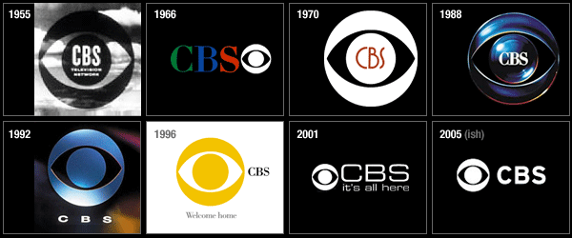

Supporting Links/ References:
http://www.closinglogos.com/page/CBS+Productions
http://www.cbs.com/info/user_services/info_eye_50th.shtml
http://madamepickwickartblog.com/2011/03/man-with-the-golden-eye/

