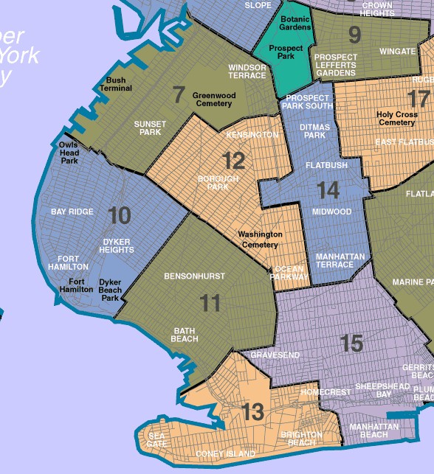

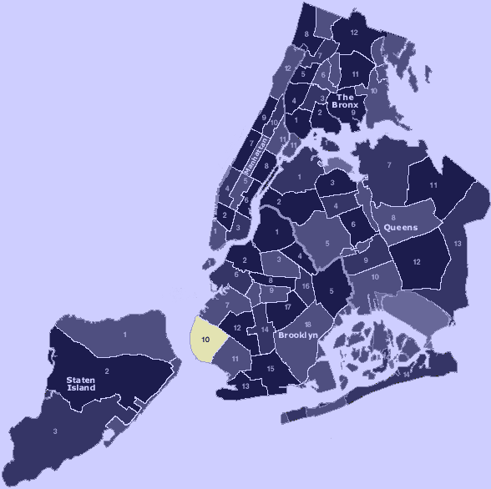

Summary statement of community

**Part 2.** B. Bay Ridge Community is located along the southwest tip of Brooklyn.

|  |  |
| --- | --- |
| Defining the southern and western borders of the community are the waters of the Verrazano Narrows. To the North, the L.I.R.R./MTA railroad cut from the shoreline at 65th Street, proceeds eastward to 62nd Street, where our district mergers with our eastern border at 14th Avenue. The Fort Hamilton area, which follows the southern shoreline, is comprised of historic Fort Hamilton, located near the magnificent span of the Verrazano Bridge and overlooking New York Harbor. Bay Ridge Community known primarily as a residential community, the stability of the district depends greatly on the viability of its commercial sectors and housing stock. Dissecting the geographic district, the commercial corridors of 3rd Avenue, 4th Avenue, 5th Avenue, Fort Hamilton Parkway, 11th Avenue, 13th Avenue and the bustling 86th Street strip, provide the goods, services and employment opportunities for the community. One and two family homes comprise the major portion of the housing composition and aging multiple dwellings together with some new structures.  Senior citizen population continues to rise; the ethnic and racial mix of the district’s population continues to shift with the out-migration of earlier established ethnic groups and the influx of Middle Eastern and Asian settlers and more recently, Eastern European. The overall population consists primarily of middle income, blue-collar and white-collar workers, who contribute significantly toward our district’s low unemployment statistics. Consequently, our district continues to serve as a vital tax resource base for New York City. The stable demographic indicators limit the availability of public funding programs for this community. Fortunately we are endowed with concerned, energetic, civil minded citizens who work and actively participate in self-help programs through local community organizations. Accordingly, these efforts have impacted positively on the vitality and stability of our district and our Community Board has supported, assisted, participated and championed many of these activities.  Transportation ARTERIAL HIGHWAYS The maintenance work conducted by the Bureau of Bridges and Arterial Highways is the vital function that sustains the viability of our roadways and overpasses. This Bureau is responsible for maintaining the curb area alongside the BQE that runs from on the south side of 7th Avenue from 65th Street to 86th Street and on the north side of 7th Avenue from 65th Street to 78th Street. This area is constantly filled with debris and strewn garbage. Due to budget limitations this area as well as the service roads of Dahlgren and Gatling Place cannot be adequately maintained. This Bureau is also responsible to maintain the Shore Road bicycle path and maintain overgrowth along the Belt Parkway and BQE within Community Board Ten area. It is necessary to provide additional funds for routine weekly maintenance with sufficient manpower and equipment needed to meet maintenance commitments.  **VERRAZANO NARROWS BRIDGE**  Traffic on the Verrazano Bridge and its approaches has reached the saturation point, not only during the rush hour but also frequently at off-hours. The approach ramp of the Verrazano Narrows Bridge has reached its life expectancy and is currently undergoing and extensive rehabilitation which is expected to last for approximately two years.  Traffic flowing from Brooklyn enters from multiple access points exceeding the capacity of the bridge. The 6 lanes on the bridge then reduce to 3 on the Staten Island Expressway, exacerbating the problem because the bridge traffic has nowhere to go.  Community Boards 10 and 11, together with Council Member Vincent Gentile formed a task force to discuss traffic issues in 2005. Local elected officials continue to work together to address mounting traffic issues plaguing the communities of Bay Ridge, Dyker Heights and Fort Hamilton spurred by the approach ramp rehabilitation project.  Better traffic management is needed in Bay Ridge, Dyker Heights and Bensonhurst, particularly during normal rush hour, as well as summer related backups caused by sharp volume increases. Greater capacity is needed on the Staten Island Expressway. Moreover, other pathways in and out of New York City, particularly the Hudson River tunnels must be made accessible to all trucks to reduce the pressure on the Verrazano bridge. verrazano-bridge-evelina-kremsdorf.jpg  **SENIOR CITIZENS HOUSING**  Elderly citizens in the Bay Ridge have access to many housing programs. Majority of housing programs are subsiding by government and department of aging, while some of them are getting financial help from religious or private organizations. One of the largest housing programs in the community for senior citizens is Lutheran Health Care. Lutheran Health Care provides affordable housing programs s well as medical help to eligible seniors in the community. **Shore Hill** is a 558-unit private apartment complex built by **Lutheran Medical Center** to accommodate the housing needs of low income elderly persons. Completed in 1977, the complex consists of two fourteen-story towers and a separate community building situated on a three-acre site. The construction of Shore Hill was financed by New York State Housing Finance Agency with the cooperation of the State Division of Housing and Community Renewal. The architectural firm of Gruzan and Partners created the award winning design. Shore_Hill.107171210_std.jpg  To help support elderly citizens throughout all stages of life, [Lutheran Family HealthCenters](http://www.lutheranhealthcare.org/Main/LutheranFamilyHealthCenters.aspx) has developed a full array of services for older adults that includes wellness activities and health education; supportive services; access to medical and rehabilitative care; social adult day programs; providing meals to those who need them; and long-term care. These services are a part of **Lutheran HealthCare's** commitment to helping community members stay healthy and active as they age.  **Criteria and Eligibility for Residence at Shore Hill**  A person must be a United States Citizen, be at least 62 years of age, income not to exceed HUD’s limit and must pass other screening criteria per the **Tenant Selection**. In order to be eligible for an apartment a person must have an active application number on the **Waitlist**. The waitlist is closed at this time; applications are not being distributed or accepted.  Philosophy of the Shore Hill Housing is to provide equal medical and spiritual help to all members of the community. In keeping with its faith-based mission, values-centered, Lutheran HealthCare remains committed to: Fostering the understanding in our staff that we are all moral agents, responsible for compassionately identifying ethical realities in health, healing and organizational life.        iPHONE pictures 001.JPG  iPHONE pictures 002.JPG    iPHONE pictures 003.JPG  unnamed.jpg  References:  The City of New York. Community Board 10. (2008). Retrieved from  http://www.bkcb10.org/neighborhoods/    Community Health Profile. Southwest Brooklyn. (2006). Retrieved from  http://nyc.gov/communityprofile  Shore Hill Housing. (2013). Retrieved from http://www.lutheranhealthcare.org/Main/ShoreHillHousing.aspx | |
|  |  |