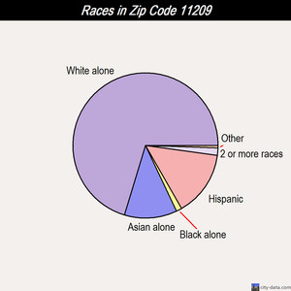
If you are looking for a fine neighborhood to live in and raise a strong family, you may take in consideration zip code area of 11209. 11209 zip code is a wonderful place with many positive feedback from people who live there for more than five or ten years. As a city data demographics shows that the number of men and women are almost equal and that increases a chance to find a sole mate and not be alone. There are 47 .2% (33,831) men 52.8% are (37,873) women. The median age of women is 38 years, and 37 for men. Many young families work and live by the side of those who retired. People who are 85 years and older consist of only 2.02% of that area population relating to 5.83% who are under 5 years old. Most people are white ethnicity (not Hispanic origin) about 77%, and 66% was born in the United States.

Fort Hamilton High School is well over 150 percent capacity and in need of modernization especially electrical upgrades to meet the challenges of the increased capacity and to keep up with technological equipment necessary for proper learning.
But it doesn’t stop students to attempt a higher education, so the average educational level of this neighborhood is a bachelor degree 42.8% and 17.9% has graduated or professional degree as well. Those who is in school 87% of high school graduates or college attenders combine to the average income of the zip code, $56,000 in average per person. Due to a large number of private houses and small multifamily houses for 2-3 family, economical position of this area shows that people can afford paying mortgages and bank interest rate in time. There are multifamily buildings and the cost of the rent is higher than in other neighborhoods. 11209 is also known for a shopping and night out area. It has numerous bars and restaurants, along with shopping stores that attracts people from other zip codes, which benefit local commuters.
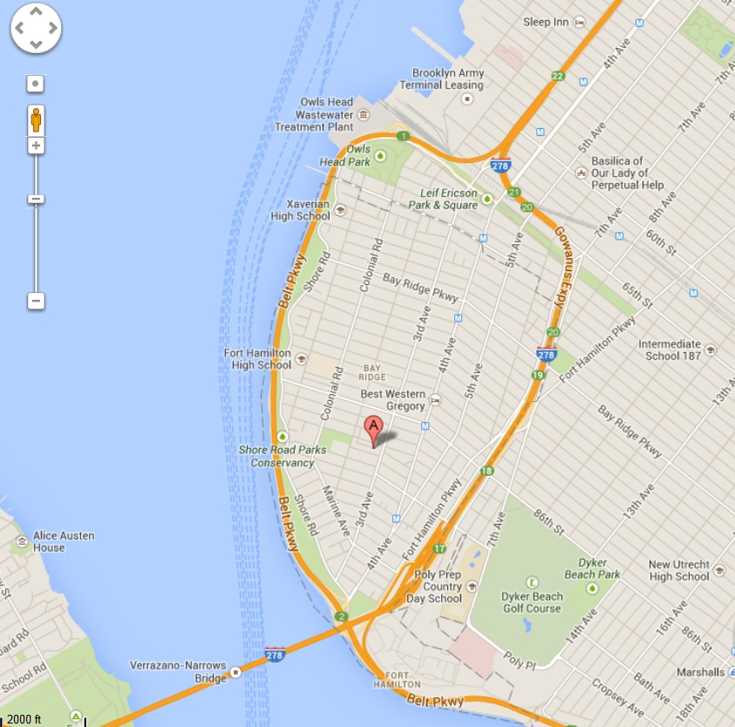
Either it’s a holiday, personal vacation or usual weekends with a family, residents of the 11209 zip code can find themselves playing in the parks or getting healthy by jugging, walking, cycling or rolling on the 2 mile bay rode just under the Verrazano Bridge, which is one of the greatest bridges in the New York City. Famous Owl’s head park, which consist of several blocks of green paradise is the place for lonely souls to meet or for some families to have a small picnic time, get some sun and relax from busy work schedule. Other point of interests that attracts bay ridge commuters and others include 69th Street Pier at 69th St. and Shore Road, is the community's key seaside recreation spot. Sports fishermen travel across the borough and from other boroughs to fish the waters of "The Bay Ridge Anchorage" and along the seawall promenade that runs south from the pier to the Verrazano Narrows Bridge and east along Gravesend Bay. Years prior to the construction of the bridge, commuter ferry service was operated between this Bay Ridge pier and the St. George Ferry Terminal in Staten Island. Farrell House, which has been at 125 95th St. since the early twentieth century, is one of many old mansions in Bay Ridge, and it is now an official landmark. An accompanying structure, thought to have been used as a barn, was unable to be saved and was demolished. By legend the house was turned so that its "widow's walk," a balcony that traditionally faces the sea so women left at home could watch for their husbands' ships, would no longer face “The Narrows”.
If you think that it is time for you to get in shape, 11209 zip code area provides many fitness centers, where you can get professional training and after a while to fit into desirable jeans size. After an extensive workout you can please your body with any kind of healthy spa salons, which provides mental and physical healing to your soul and the body. Massages, dirt or oil therapies will make you feel younger and full of life. 11209 zip code is a concentration of positive energy flow from the first moment you move here or making a visit. However the negative aspect of this area would be an existence of the Owls Head Wastewater Treatment Plant” which is located on the distance from houses and businesses. None of any toxic or industrial wastes are present in this area and in overall people who live there don’t complain on the environmental status, more than that they like spending time outside their houses, finding themselves in the parks or on the bay road.
There are some concerns about street undermining and street collapses what may be caused by underground water leaks is an ongoing problem most evident on 86th Street between Shore Road and Fort Hamilton Parkway, which is scheduled to be repaired this Fiscal Year and 6th Avenue between 84th Street to 65th Street which is currently being studied for capital improvements. Other capital commitments included in the 10-year plan involves the replacement and extension of trunk and distribution mains, upgrading cement pipe sewers, and refurbishing the sewer and waste water systems.
These infrastructure initiatives provide a long range forecast for improving the systems viability. However it neglects to address the immediate crucial need for ongoing, cyclical preventive maintenance programs for catch basins that will ultimately provide adequate drainage for the prevention of overflow and flooding on streets and roadways. Department of Environment Protection protects the quality of drinking water, continues water conservation initiatives and improves maintenance of the complex infrastructures that protect environmental concerns.
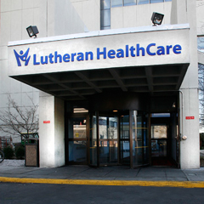
Retired workers or older adults in case of emergency will be brought to the nearest hospital or medical center where they can get professional treatment. And the closest Medical Center is right next door, less than a mile away, the Lutheran Medical Center.
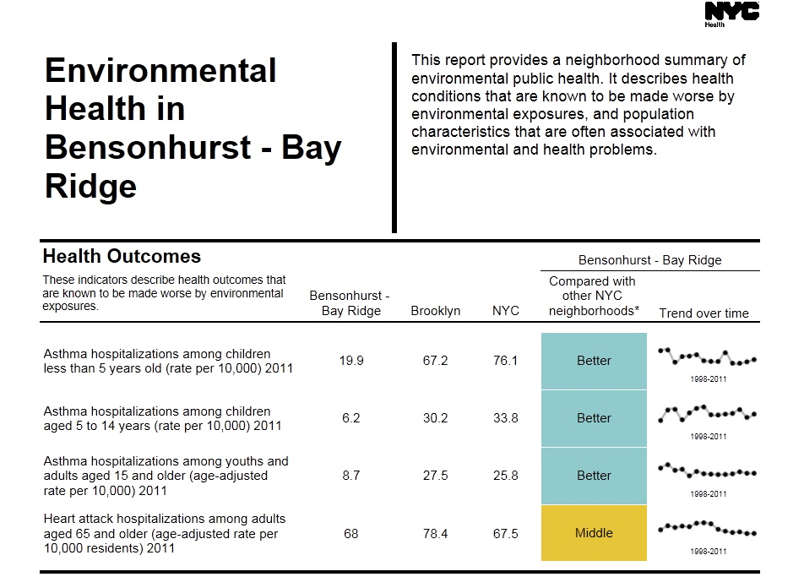
If it is not an emergency situation, but a regular medical checkup, number of doctors and their clinics or offices will provide quality health care. Nursing homes, rehabilitation centers are working hard to meet quality care of their older adults. 11209 zip code provide public services as well, if someone seek professional help from alcohol or sexual abuse, he can find a place and be there anonymously. Shelters for homeless are not listed in this area but pet adoption shelters are the most common thing.

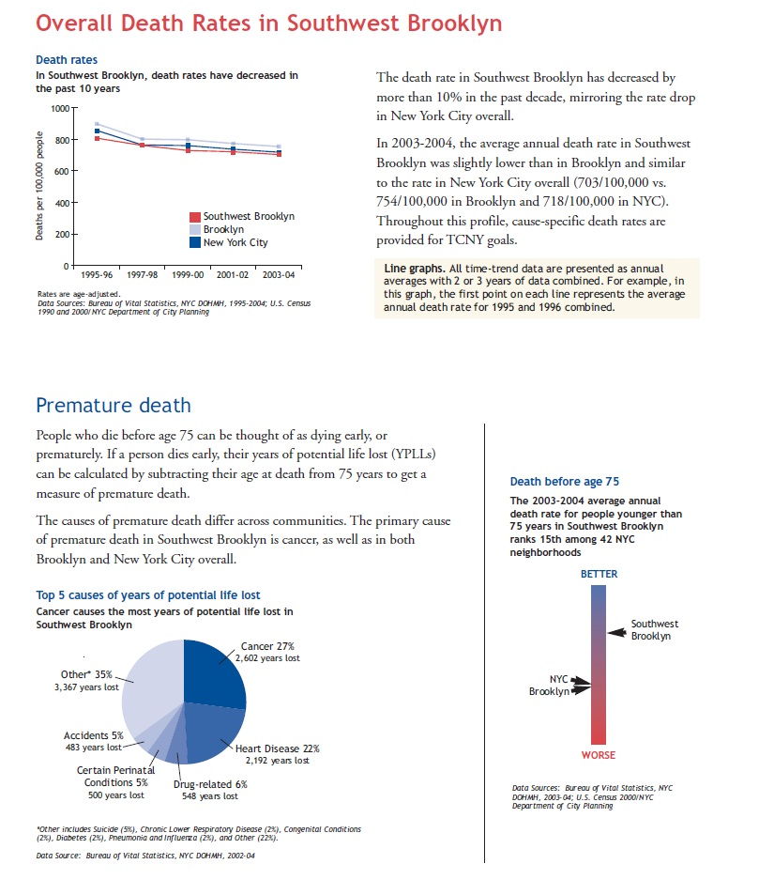
Street undermining and street collapses caused by underground water leaks is an ongoing problem most evident on 86th Street between Shore Road and Fort Hamilton Parkway, which is scheduled to be repaired this Fiscal Year and 6th Avenue between 84th Street to 65th Street which is currently being studied for capital improvements. Other capital commitments included in the 10-year plan involves the replacement and extension of trunk and distribution mains, upgrading cement pipe sewers, and refurbishing the sewer and waste water systems.
These infrastructure initiatives provide a long range forecast for improving the systems viability. However it neglects to address the immediate crucial need for ongoing, cyclical preventive maintenance programs for catch basins that will ultimately provide adequate drainage for the prevention of overflow and flooding on our streets and roadways. This program is an essential mechanism in relieving conditions and its implementation must not be overlooked or delayed. Support is needed to provide resource gains to the Department of Environment Protection to enhance the agency’s capabilities to protect the quality of our drinking water, to continue water conservation initiatives, fulfill major capital improvement program commitments, and improve the maintenance of the complex infrastructures that protect our environmental concerns. To improve quality of water for NYC including bay ridge community NYC green infrastructure plan is in progress with good effects. Green infrastructure encompasses cost-effective measures that collect and treat storm water using natural and passive systems. These measures include blue roofs and green roofs, which use mechanical devices. In addition to being cost effective, many of these infrastructure strategies provide benefits that traditional grey infrastructure does not, such as cooling the city, reducing energy use, cleaning the air, and increasing the property values.

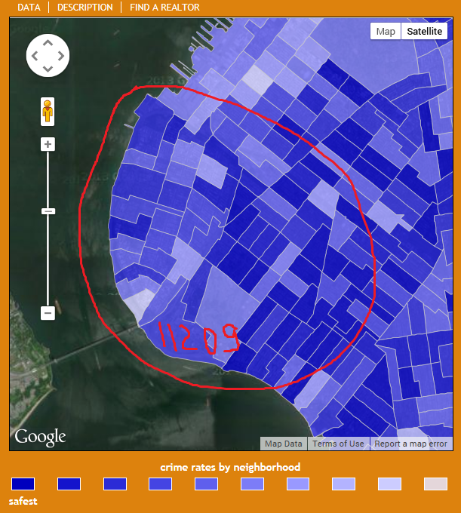
The low crime rates make this zip code area desirable to live in, but not everyone can afford buying a house or renting an apartment. According to this scale 11209 is a safe place to raise children and meet your retired years.

The 68th Precinct provides police service to the Brooklyn neighborhoods of Bay Ridge, Dyker Heights and Fort Hamilton. These middle-class neighborhoods are culturally and ethnically diverse. Over recent years there has been a significant influx of people of Middle-Eastern and Asian descent into the area. The statistics shows that crime rate goes significantly down in number by 2014. As it is demonstrated on the graph below there are total of 11 crimes noted in 2014 as opposed to 947 crimes in 2013.
Community Board Ten fully supports activities for youth that includes recreational, tutorial and community based counseling. The service what this neighborhood requires is not always can be met, but more of additional needs are being addressed by offering a myriad of programs for zip code youth. There is a broad range of human needs service providers located within this district. These services are available through government agencies, not-for-profit or volunteer groups and the private sector, that offers their assistance to fulfill the needs of the community. As public awareness of the availability of these services is limited, the agencies involved must expand their outreach and communications network to arouse public awareness from the affected population groups that include the frail elderly, the home bound, the handicapped, youth, single parents and the economically disadvantaged. It has become apparent that the Community Board’s role has broadened. Community Boards have greater responsibilities and serve as an essential component of city government. Combined with their charter-mandated responsibilities, they act as a catalyst between agencies and the community. Community Board budgets have not increased by any substantial way and therefore there is a minimum staffing used to the volume of work and need. Adequate funding should be made available for community Boards so that they can fulfill their charter-mandated responsibilities.
Bay Ridge community offers care management techniques such as mammography diagnostics and breast cancer prevention. BRMI care is one pf the programs at Bay Ridge medical imaging that offers caring solutions to address and help improve population health. Mammography is a specific type of imaging that uses a low-dose x-ray system to examine breasts. A mammography exam, called a mammogram, is used to aid in the early detection and diagnosis of breast diseases in women. Three recent advances in mammography include digital mammography, computer-aided detection and breast tomosynthesis. Digital mammography, also called full-field digital mammography (FFDM), is a mammography system in which the x-ray film is replaced by solid-state detectors that convert x-rays into electrical signals. These detectors are similar to those found in digital cameras. The electrical signals are used to produce images of the breast that can be seen on a computer screen or printed on special film similar to conventional mammograms. From the patient's point of view, having a digital mammogram is essentially the same as having a conventional film mammogram. Computer-aided detection (CAD) systems use a digitized mammographic image that can be obtained from either a conventional film mammogram or a digitally acquired mammogram. The computer software then searches for abnormal areas of density, mass, or calcification that may indicate the presence of cancer. The CAD system highlights these areas on the images, alerting the radiologist to the need for further analysis. Breast tomosynthesis, also called three-dimensional (3-D) breast imaging, is a mammography system where the x-ray tube moves in an arc over the breast during the exposure. It creates a series of thin slices through the breast that allow for improved detection of cancer and fewer patients recalled for additional imaging.
Mammography plays a central part in early detection of breast cancers because it can show changes in the breast up to two years before a patient or physician can feel them. Current guidelines from the U.S. Department of Health and Human Services (HHS), the American Cancer Society (ACS), the American Medical Association (AMA) and the American College of Radiology (ACR) recommend screening mammography every year for women, beginning at age 40. Research has shown that annual mammograms lead to early detection of breast cancers, when they are most curable and breast-conservation therapies are available. The National Cancer Institute (NCI) adds that women who have had breast cancer and those who are at increased risk due to a genetic history of breast cancer should seek expert medical advice about whether they should begin screening before age 40 and about the frequency of screening.
Bay Ridge community is also known for its great senior citizen housing opportunities and services provided for seniors. There are programs and services that help to optimize seniors’ health, well-being and ability to live independently at home. Senior Centers offer a variety of cultural, creative, recreational and fitness activities in addition to nutritious meals. All these wonderful and helpful programs are supported and funded by New York Department for the Aging.
After my assessment of Bay Ridge community I have analyzed that it is a nice area to live in. Based on crime statistic rates it is safe area and close by pricing, which is available 24 hours and 7 days a week, there are many recreational activities for all age groups, useful community services, close and varied transportation, which would definitely benefit for our busy everyday life, and strong health related facilities, like Lutheran Medical Center.

Reference:
Improve Water Quality (January, 2014). Vision 2020: New York City Comprehensive Waterfront Plan, pp 60-70. Retrieved from http://www.nyc.gov/html/dcp/pdf/cwp/vision2020/chapter3_goal4.pdf

Neighborhood Scout Reports (2014). Crime Rates in Brooklyn, NY. Retrieved from http://www.neighborhoodscout.com/ny/brooklyn/crime/

Carey, M (2011). Annual reports for Lutheran Medical Center. Putting People First. Retrieved from http://www.lutheranhealthcare.org/Main/Home.aspx

New York City department of Health and Mental Hygiene (2006). Community Health Profile. Pp 1-16. Retrieved from nyc.gov/health

Rasinya, D., & Beckmann, J., (2009). District Needs Statement: Fiscal Year. Senior Citizen Housing.

U.S. Department of Health and Human Services (2014). Breast Cancer. Retrieved from http://www.cancer.gov/cancertopics/types/breast

NYC Department for the Aging (2014). Senior Services and Programs. Retrieved from http://www.nyc.gov/html/dfta/html/health/health.shtml

