Bin Rinekso
Proposal Project
5/2/18

Sound Designing for “AVY” Pilot

Executive Summary

During my time at City Tech, I developed my skills in sound designing and in video editing. For my culmination project, I will be designing sound for a Miniseries called AVY, which will be directed and shot by my colleague Lukasz Pypec. Sound designing is the process of recording, developing, and generating audio elements. As a sound designer, it is my responsibility to obtain all sound effects for this production. My job is also to sync the audio and the clips together, and my job is also to mix the sounds on the project. I will be doing some outdoor recording for the most part, and some indoor recordings as well.

Drawings and diagrams are not needed for this project.

Deliverables

- Sound files
- Screen shot of the project
- Behind The scenes pictures

Methods

During the shooting, I plan on recording the dialogues with the Zoom H6 recorder. After we finished shooting, I plan on using an SM58 microphone to record outdoor and indoor sounds while its being recorded onto Logic Pro X on my MacBook. For the editing process, I will sync the recorded audio with the actions on Avid Media Composer.

Calendar

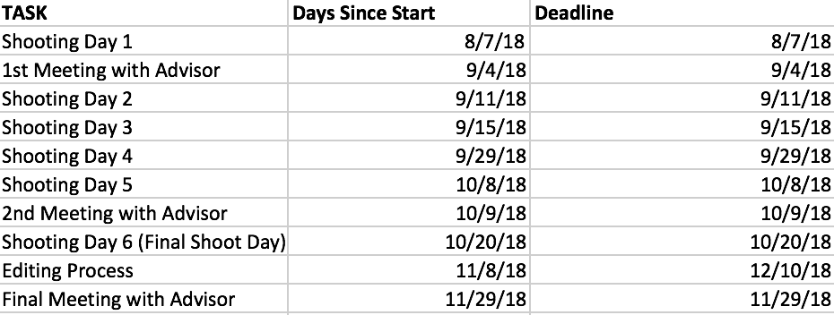

Budget

Avid Media Composer ($10/month) x4 | $40.00 | Owned
Zoom H6 | $200.00 | Borrowed
Logic Pro X | $199.99 | Owned
Lavalier Mics | $40.00 | Borrowed
Avid MBox Mini Audio Interface | $99.00 | Borrowed
Shure SM58 Mic | $99.00 | Owned
XLR Cable | $19.99 | Owned
MacBook Pro | $1,799.00 | Owned

Total: $2,496 .98

