Bryan Ramirez

Professor Tanya Goetz

Digital Media Foundations COMD 1112

12 April 2020

Claude Garamond

Claude Garamond was a French type designer, publisher and punch-cutter based in Paris. Garamond started out his career as an apprentice for the Parisian punch-cutter and printer. Antoine Augereau in 1510. It was during this early part of the 61th century that Garamond and his peers found that the typography industry required unique multi-talented people. This way they could produce fine books. Many of the printers during that time period were able to master all or most of the artistic and technical skills of book production from the type design to bookbinding. Claude Garamond was first to specialize in type design, punch cutting, and type-founding in Paris as a service to many famous publishers.

In 1545, Garamond became his own publisher, featuring his own types including a new italic. His first book published was Pia et religiosa Meditatio of David Chambellan. As publisher, Claude Garamond relied on his creativity harnessed by reasoned discipline to produce superbly well crafted products. He modeled his book publishing style after the classic works of the Venetian printers who catered to the absolute elites of high society. He admired and emulated the works of Aldus Manutius. Garamond insisted on clarity in design, generous page margins, quality composition, paper and printing, which was always accentuated with superb binding.

The soundness of Garamond’s designs in his typefaces have historical staying power, and they are likely to remain the day-to-day tools of professional typographers, as long as western civilization survives. Reading a well set Garamond text page is almost effortless, a fact that has been well known to book designers for over 450 years. He has worked in the tradition now called old-style serif design, which produced letters with a relatively organic structure resembling handwriting with a pen but with a slightly more structured and upright design. Garamond is considered one of the leading designers of all time, being recognized to this day for the elegance of his typefaces. Many old-style serif typefaces are collectively known as Garamond, named after him.

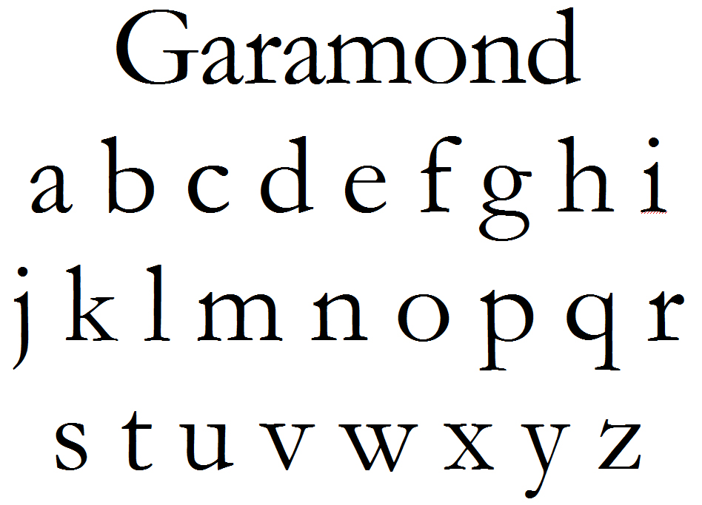

Here is a look at the Garamond typeface.

Garamond was the first to deviate from a purely handwritten-style to make letters that would read better when printed. These letterforms were thinner and more delicate than those before it, which both allowed the ink to bleed on the page without overly distorting the words and used less ink. They also were more decorative than those modeled directly from the hand. The capital T is a beautiful example of a letterform that is far more ornate than a scribe would write but Claude styled with unique semi-parallel angled serifs. Other key characteristics include the way the top serifs of the lower-case letters curve back into the letter, the feeling of airyness from the generous openings in the letters, known as counters, and the tall ascenders. But when in doubt, you can always look for the tell-tale crossed capital W.

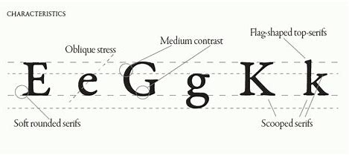

We can see how the way the top serifs of the lower-case letters curve back into the letter, a feeling of airness rom the generous openings in the letters, known as counters, and the tall ascenders.

Are you wondering where Garamond typeface can be found? Some of the most popular books have been set in a form of Garamnond including the books of Dr.Seuss and all of the Harry Potter novels. In addition, it can be found in many book covers. A few notable uses included Google’s original logo, Abercrombie & Fitch’s logo, and Apple’s logo Think Different campaign. Furthermore, the Adobe Garamond design is considered one of the most versatile fonts available today and certainly one of the most attractive, graceful print. It is also one of the most eco-friendly types to print because the letterforms use less ink than other similar faces.



These are examples of logos, books, and book covers with great use of Garamond typeface

After a decade of success with his types all over Europe, King Francois I of France demanded that Garamond produce a Greek typeface, which later became known as “Grecs du Roi”. The three fonts were modeled after the handwriting of Angelos Vergetios, and cut the largest size first, on a 16 point body. All three original sets of Royal Greek punches are preserved at the Imprimerie Nationale in Paris, France.

Works Cited

“Adobe Garamond from Adobe Originals.” *Adobe Fonts,* fonts.adobe.com/fonts/adobe-garamond#about-section.

Chheath, Carolyn. “Typeface: Garamond.” *Medium*, Medium, 23 Oct. 2017, [medium.com/@thelittlereina/typeface-garamond-be1b8b01add8](mailto:medium.com/@thelittlereina/typeface-garamond-be1b8b01add8).

“Claude Garamond.” *Wikipedia,* Wikimedia Foundation, 14 Nov, 2019, en.wikipedia.org/wiki/Claude_Garamond.

Fiddlerat. “The Garamond Font: 30 Typeface's Look, History and Usage at Prepressure.com.” *Prepressure*, www.prepressure.com/fonts/interesting/garamond.

“Garamond.” *Sitewide ATOM*, meaningfultype.com/garamond.html.

*The Biography of Claude Garamond*, [www.pointlessart.com/education/loyalist/typeTalk/garamond/biography.html](http://www.pointlessart.com/education/loyalist/typeTalk/garamond/biography.html).

Monotype GmbH, info@linotype.com. “Just What Makes a ‘Garamond’ a Garamond?” *Garamond - Linotype Font Feature*, www.linotype.com/3474/garamond-font-feature.html.

The Editors of Encyclopaedia Britannica. “Claude Garamond.” *Encyclopædia Britannica*, Encyclopædia Britannica, Inc., 1 Jan. 2020, www.britannica.com/biography/Claude-Garamond.