Buenaventura Nunez

Easy Wine and Food pairing

Courtesy of iStockphoto/Thinkstock

Table of Contents

- Ordering Wine With Food………………………………1-2
- How to order wine……………………………………...3-4
- Quick easy way to taste wine…………………………...5-6

- White Wines……………………………………………...6-9
- Chardonnay……………………………………………..6
- Pinot Grigio……………………………………………..7
- Sauvignon Blanc………………………………………..7
- Riesling…………………………………………………8
- Sparkling Wines………………………………………...9

- Rose Wines………………………………………………..10
- Rosé sparkling…………………………………………..10
- Dry Rosé……………………………………………….10

- Reds……………………………………………………….11-14
- Pinot Noir…………………………………………………11
- Cabernet Sauvignon ………………………………………12
- Malbec…………………………………………………..13
- Syrah…………………………………………………….14

- Fortified Wines…………………………………………….15-17
- Porto………………………………………………………15
- Sherry……………………………………………………..16
- Madeira……………………………………………………17

INTRODUCTION

Ordering or buying wine can be intimidating when one does not know how to. All the wine experts in the world will tell you that the most they learn about wine, the less they know; Good to know that we are not the only one. Wine can be a wonderful experience if is matched well, but it can be a disaster if is not. In this booklet you will learn some basics that most wine experts in the world agree. However Wine tasting and matching is a very subjective experience, meaning that you are the final judge in deciding what you like and how to match them. Each one of us have a different palate and in a world of different background and rich culinary tradition we have preference to food and smell that we have been accustomed to. Learning about wine should be fun, exciting but more importantly a humbly experience. That is how you find out more about wine, by experimenting what you like and dislike. Like the old saying goes “Wine makes the beauty of life more enjoyable and the sorrows of life more bearable.” So let’s enjoy ourselves and drink wine.

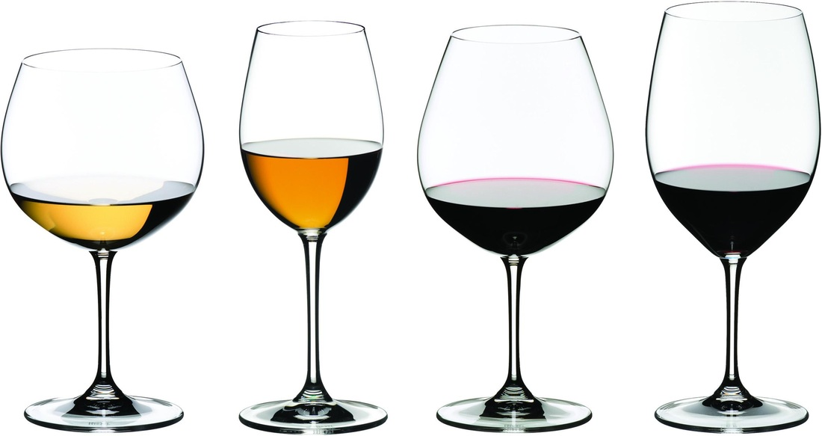
Courtesy of WineGlasses.com

Wine matching should be simple and enjoyable, so I will keep simple and hopefully you will find it enjoyable. We grew up with the idea that one matches white wine with chicken and fish, and Red wine for meat. This idea although simple works most of the time, but if one wants to be more adventurous it can be rewarding to be a little bit more daring. According to the Wine Bible by Karen McNeill, when it comes to food matching “Pair great with great, humble with humble.” Meaning that if you are eating a chicken burrito from the local food truck, is not ideal to eat it with a $750 Cabernet Sauvignon. It makes more sense to match it with a reasonable $10 bottle. And hopefully leave that $750 for your wedding toast or more realistic to your divorce toast… Just joking. Remember my introduction about wine and sorrows. McNeill also emphasizes that you should have an idea of what you want to achieve. Whether if you want to “mirror a given flavor or set up a contrast.”
Flexibility is also a big factor in wine matching pairing. It is important to understand that some wines are not very flexible such as toasty or oaky white wines like a California chardonnay. “Sauvignon blanc or dry German or Alsace Riesling due to the cleansing acidity” according to McNeill.
Saltiness Salty food contrast with acidity in wine. If you are looking to set up a contrast. Smoked salmon goes well with Champagne and for Asian dishes with soy sauce, American Riesling- because of the sweetness- are ideal for the contrast.
High Fat food-. According to Exploring Wine by Stan Kolpen, food with high-fat content calls out for an “equally rich, intense, structured, and concentrated wine” such as a California cabernet sauvignon if you are looking for a mirror effect.
Sweetness- for Sweet foods and dessert matching can be a little tricky. It is ideal to get a wine that is slightly sweeter than the dessert. McNeill claims that desserts that are sweeter than the wine they accompany make the wine taste dull and blank. In effect, the sweetness of the dessert can knock out the character of the wine.
Below there are a list of wines that match perfect with food that we eat every day and how we can pair them.

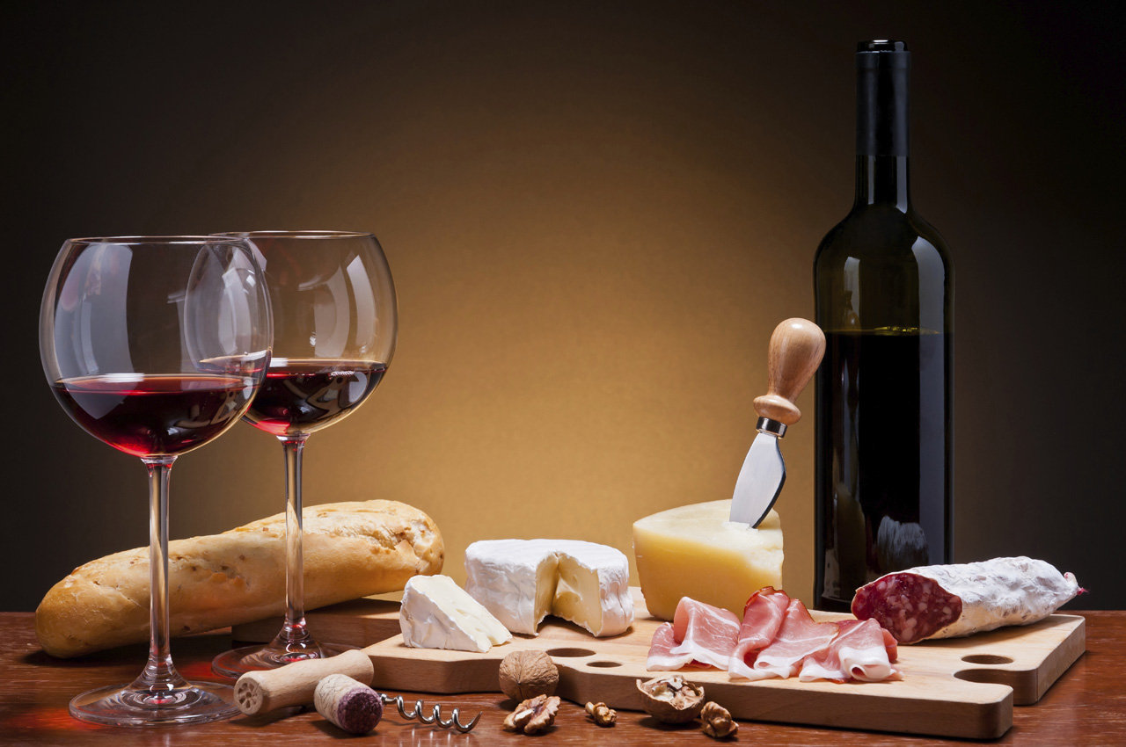
© iStockphoto/Thinkstock

White Wines
In general white wine is consumed by most people without any food. But in the list below there are a few selections of white wines that would make the experience of pairing food and wine a wonderful experience

- Chardonnay-The most famous “green-skinned grape variety used to make white wine. The basic flavors of chardonnay are: vanilla, butter, butterscotch, buttered toast, custard, green apples, tropical fruit, lemon and pineapple Chardonnay due to its crisp, oaky and elegant style match perfectly with fatty fish or fish in a rich sauce. Fishes like Salmon are perfect with chardonnays from California, Chile or Australia—. Thanks to its rich and complex texture Chardonnay has become one of the most sought after white wine in the United States.
Lifestyle and food
Courtesy
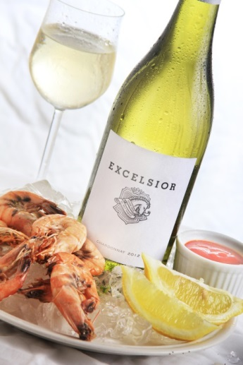
- Pinot Grigio. Is the most sold white wine in the United States. Pinot Grigio consist of aromas of “pear, apple, lemon and mineral.” Pinot Grigio could be light-bodied or medium-bodied and they pair well with light fishes or with chickena and white meat. Also because of its “ Crispy and complex fruit flavors”, Pinot Grigio has become America’s most drank wine, to
which many prefer drinking without food. 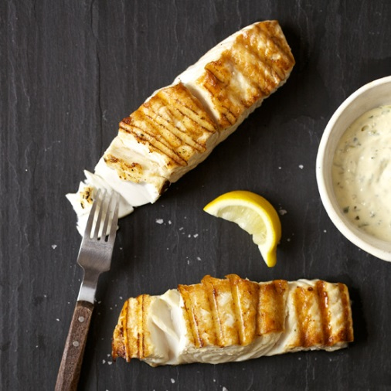
Lifestyleandfood.com

- Sauvingnon Blanc-in contrast to the chardonnay, sauvignon blanc according to MacNeill is “a taut, lithe, and herbal with a keen stilettoof acidity that vibrates through the center of the wine. a sauvignon blanc goes well with tart dressings and sauces. Tangy foods won't overwhelm zippy wines like sauvignon blanc. 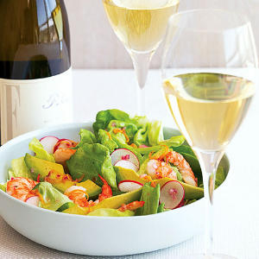
Sunset.com Li
- Riesling- Considered by many experts as the most noble and unique white grape variety in the world.. There are three types of Riesling- Sweet, Semi-Sweet and Dry. Thanks to its low alcohol content- about 8%- and its high acidity, Riesling pairs well with sweet & spicy dishes.From a ginger and beets shrimp salad, to some spicy asian dishes, you can not go wrong with a nice Riesling.

Enjoyingwine.com 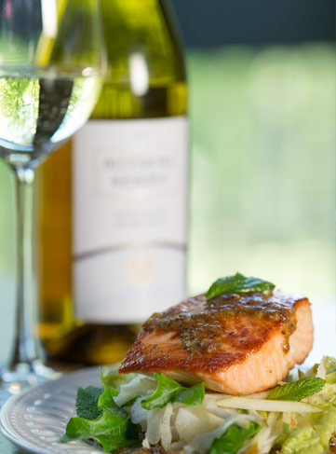
- Sparkling Wines – Most people often make the mistake of confusing Sparkling Wine with Champagne. In order for a Sparkling wine “can only be called Champagne if it comes from the region of Champagne, France, which is just outside of Paris. Further, champagne can only be made using Chardonnay, Pinot Noir, and Pinot Meunier.To clarify, all champagne is sparkling wine, but not all sparkling wine is champagne. According to Totalwine.com “Guide to Sparkling Wine,” Sparkling wine is as versatile at the dinner table as it is varied in styles. Brut or Blanc de Blancs is appropriate as an aperitif or as a reception wine, while Blanc de Noirs or Rosé Champagne pair well with full-flavored main courses and entrees. Sweeter styles may be served with dessert or just prior. Salty foods or foods fried in oil are particularly good matches for Champagne, as the bubbles provide a refreshing palate cleanser after the food. Puff pastries, cheeses, nuts, mini-sausages and other finger foods are good choicessince these foods are both salty and oily”.

Rose Wines

- Rosé sparkling- Rosé wines “have amazing red-fruit flavors that explode on the palate with lovely balance and acidity. They are the perfect wine for sipping on the deck or patio, and they pair beautifully with seafood and shellfish”. Rosé have the depth of flavor and richness to go with a wide range of main courses, perfect for aperitif, light Foods and Asian Cuisine.
.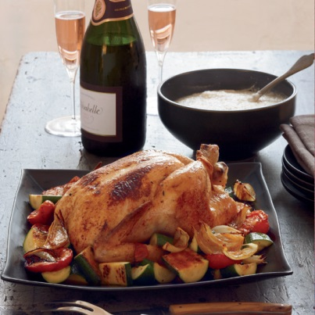
Theloveofwine.com

- White Zinfandel- One of the Wine that is rapidly growing in the United States. Its cherry and strawberry flavors have made the Zinfandel a favorite among new wine drinkers. California is exploding with great quality Zinfandel at good price ranges. Zinfandel goes well as an aperitif, pasta or light food.
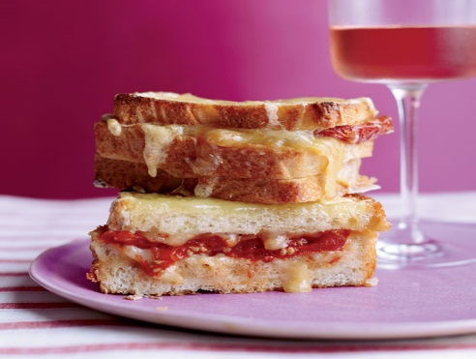
Reds
Red wine is the number one choice when people want to pair wine and food. Below there are some of the most popular red wines in the world that you may encounter.

- Pinot Noir- Described by some as “the sexy wine”. Pinot noir express baked cherries, plums, damp earth, mushrooms, cedar, cigars, chocolate, worn leather, sweat, dry leaves. According to the 15 rules for Great Wine and Food Pairing by Food & Wine, Pinot noir are great for dishes with earthy flavors. Such as herbed pork chops, pepper steaks, or chicken and mushrooms.

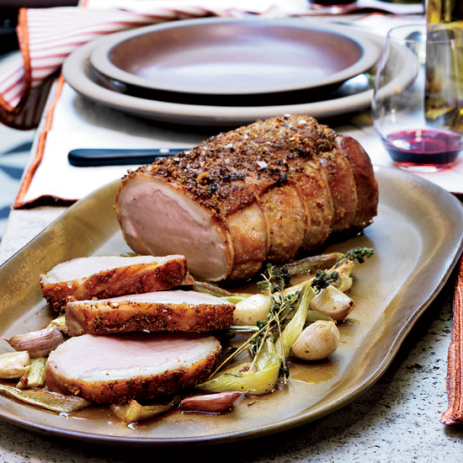
Lovingmyredwine

- Cabernet Sauvignon- The classic of the red wines, a Cabernet sauvignon have hints of: blackberry, black currant, cassis, mint, eucalyptus, cedar wood, leather, and plum. According to Winefolly.com, “Guide to Cab,” “Cabernet Sauvignon is one of the more complex and layered wines out there…Because of Cab’s traits, look for foods high in fat and umami flavors for Cabernet Sauvignon food pairing. Foods like lamb, burgers, red meat and filet of beef match cabernet sauvignon to perfection”.
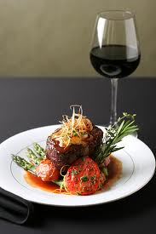

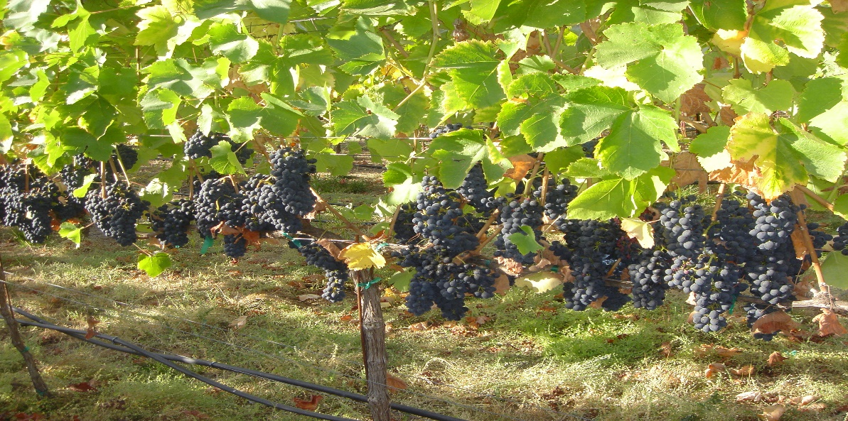

- Malbec- The most popular wine that comes from South America, especially Argentina. Malbec often is called the “black wine” due to its dark complexion. With taste of dark fruits, blueberries, blackberries and dark blackberries, like the place where it is most planted, Malbec goes perfectly with grilled meats and spicy dishes.

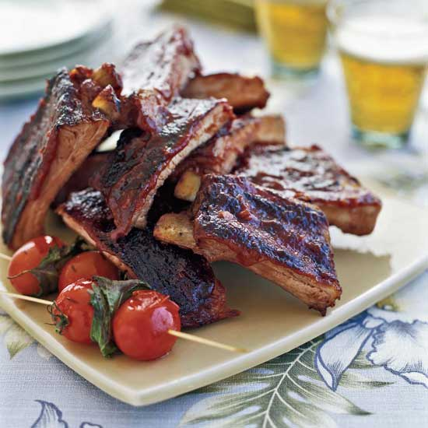

- Syrah- Syrah or Shiraz just like the cabernet sauvignon is one of the darkest color red wine in the world. Its profile are aromas of blueberries, blackberries, and other dark berries. Syrah’s palate profile are: “Olive, pepper, clove, vanilla, mint, licorice, chocolate, allspice, rosemary, cured meat, bacon fat, tobacco, herbs and smoke. Syrah is one of the most versatile wine, they go well from cheeses to steak and burgers and Asian and spicy dishes.

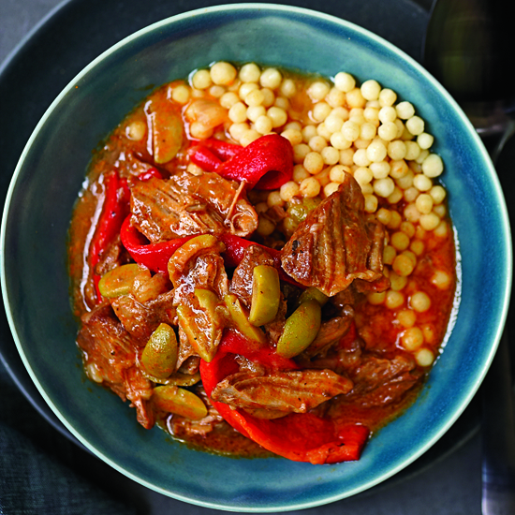

Fortified Wines
Fortified wines often have the bad reputation of being low quality wines; where in reality fortified wines can be a pleasurable and highly enjoyable wines. There are three major types of fortified wines: Porto or port, Sherry and Madeira, and each one has a different style and complexity.
- Port- Port wines come from Portugal’s Douro valley Region and is one of the oldest wine variety in the world. There are two major types of Ports- Tawny and Ruby. According to the epicculture.com in an article called “Sommelier Certification: Exploring the Dizzying World of Fortified Wine” There are some very big distinctions between the two. First of all, Tawny Port takes many vintages of wine and cask ages them for 40+ years. As they’re typically a blend of white and red grapes, Tawny Port has a lighter color and is a bit smoother. On the other hand, Ruby Port is much simpler and less expensive, bottle aged with young non-vintage wines. You’ll often find the wine is delicate with notes of red fruits. It is also worth mentioning Vintage Port, which accounts for only 1% of Port production but is very special, only made in very good years using the best grapes”. Port match well with cheddar cheeses and with nuts and dried fruits and with fruit cake and pies.
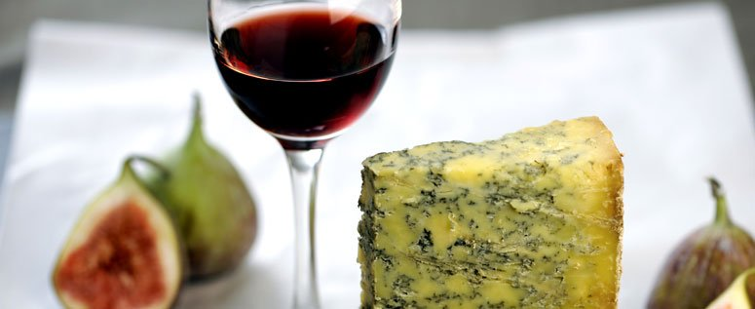

- Sherry- Sherries are known for their dryness and saltines; although there are some sweet Sherry as well. Sherry come from the Andalusia Region of Spain, and it is made with white palomino grapes, Sherry is perfect for salty snacks like peanuts and chips, as well as with Iberian Jamon or pieces of bacon.
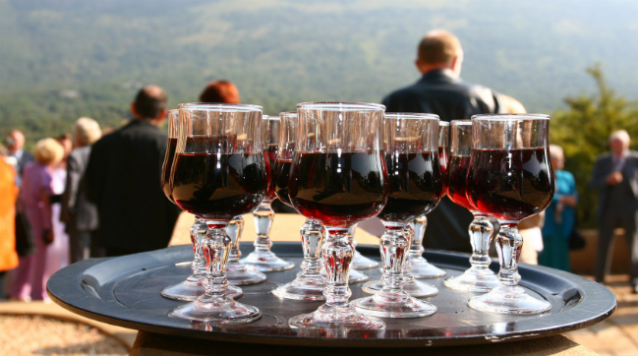

- Madeira- Another Portugal’s own and according to McNeill, Madeiras has a “pale amber with a slight green rim” appearance and has a screamingly high acidity and wildly aggressive caramel notes.” These characteristics made Madeira one of the easiest, most recognizable, and distintic wine in the world. Madeira matches well with goat chesses, almonds, Swordfish, scallop, green apple and even sushi.

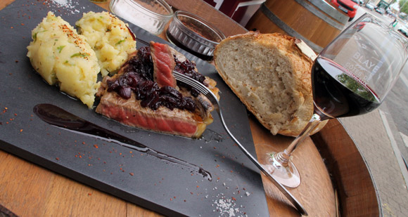

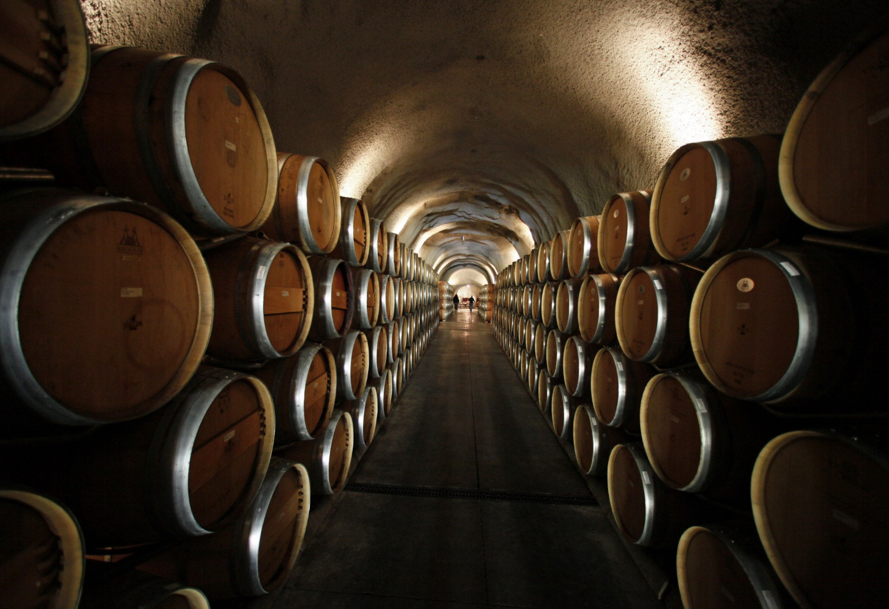

List of References:
- (oops) wine | Viña Undurraga, the world-class family owned winery producing (oops) wines. (n.d.). Retrieved April 18, 2015, from http://www.oopswines.com/in-the-vineyard.html
- Isle, R. (n.d.). 15 Rules for Great Wine and Food Pairings. Retrieved April 15, 2015, from http://www.foodandwine.com/articles/15-rules-for-great-wine-and-food-pairings
- Kolpan, S., & Smith, B. (1996). Food Matching. In Exploring wine: The Culinary Institute of America's complete guide to wines of the world (3rd ed., pp. 454-498). New York: Van Nostrand Reinhold.
- LA76 Photography - Lifestyle, Editorial, Travel, Architecture and Real Estate Photography. (n.d.). Retrieved April 20, 2015, from http://la76.photoshelter.com/image/I0000wlKTzxFU.sU
- MacNeil, K. (2001). Pairing Wine with Food. In The wine bible (1st ed., pp. 83-85). New York: Workman Pub.
- Pairing food [and] wine [Motion picture on DVD]. (2006). Millennium Interactive Inc.
- WINE GLASSES. (n.d.). Retrieved April 10, 2015, from http://www.alleneuedekoration.com/wine-glasses/
- At The Table: Food and Red Wine Pairing. (2010, March 13). Retrieved May 4, 2015, from http://www.made-in-italy.com/italian-wine/learn/food-and-red-wine-pairing

