Red wines

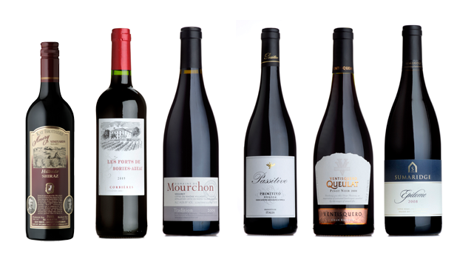
George Unwin. Enjoy The Warming Embrace Of A Rich, Autumnal Red Wine. http://www.platform505.com/enjoy-the-warming-embrace-of-a-rich-autumnal-red-wine/ Nov.22 2013

