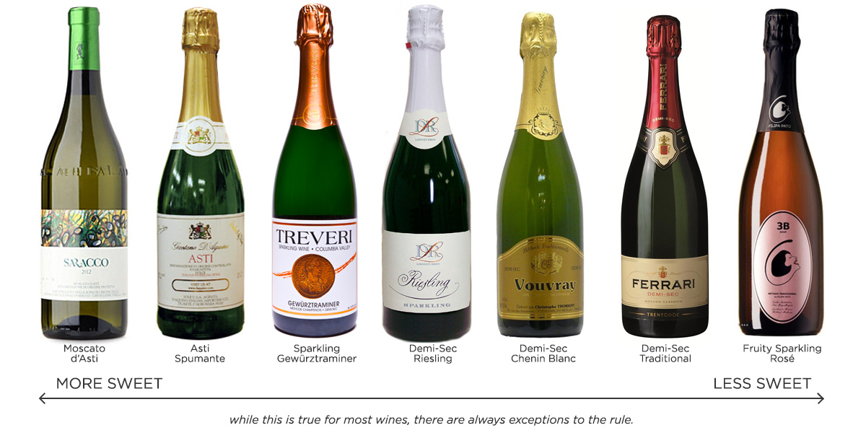 Madeline Puckette. 5 Main Types of Dessert Wine. http://winefolly.com/review/types-dessert-wine/

