Picture 6
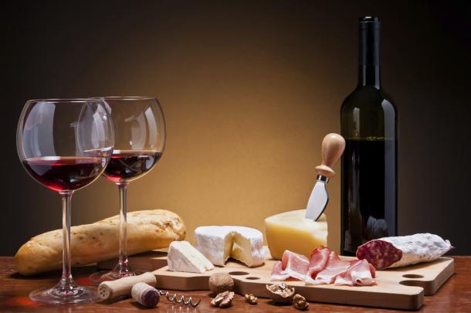

I really this picture because the background says it all, Just eat.

