Picture 5
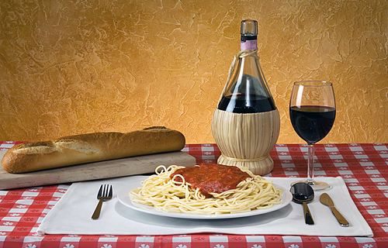

It is a very simplistic picture and yet it looks really interesting. I think this picture will open up the appetite to ANYONE reading the booklet

