Buenaventura Nunez

Easy Wine and Food pairing

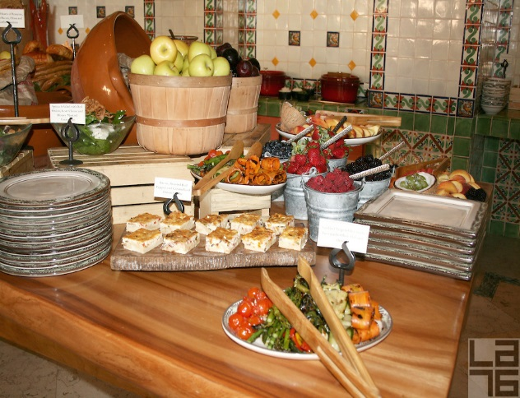
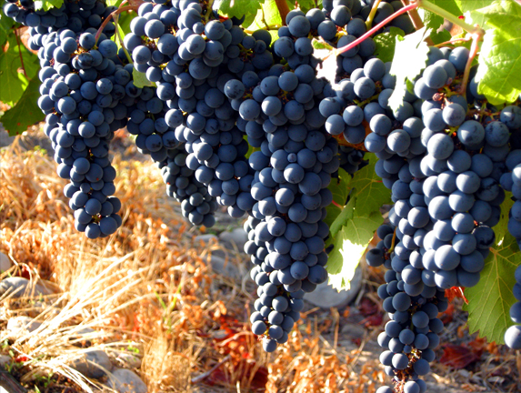
Table of Contents

- Ordering Wine With Food………………………………1-2
- How to order wine……………………………………...3-4
- Quick easy way to taste wine…………………………...5-6

- White Wines……………………………………………...5-8
- Chardonnay…………………………………………………..5
- Pinot Grigio……………………………………………..6
- Sauvignon Blanc…………………………………………7
- Riesling……………………………………………7
- Sparkling Wines…………8

- Rose Wines………………………………………………….9-10
- Rosé sparkling……………………………………………………9
- Dry Rosé……………………………………………….10

- Reds…………………………………………………..11-13
- Pinot Noir………………………………………………………11
- Cabernet Sauvignon ………………………………………………….12
- Malbec…………………………………………………..12
- Syrah…………………………………………………….13
- Old World Wines………………………………………13

INTRODUCTION

Ordering or buying wine can be intimidating when one does not know how to. All the wine experts in the world will tell you that the most they learn about wine the less they know. Good to know that we are not the only one. Wine can be a wonderful experience if is matched well, but it can be a disaster if is not. In this booklet you will learn some basics that most wine experts in the world agree. However Wine tasting and matching is a very subjective experience, meaning that you are the final judge in deciding what you like and how to match them. Each one of us have a different palate and in a world of different background and rich culinary tradition we have preference to food and smell that we have been accustomed to. Learning about wine should be fun, exciting but more importantly a humbly experience. That is how you find out more about wine, by experimenting what you like and dislike. Like the old saying goes “Wine makes the beauty of life more enjoyable and the sorrows of life more bearable.” So let’s enjoy ourselves and drink wine.

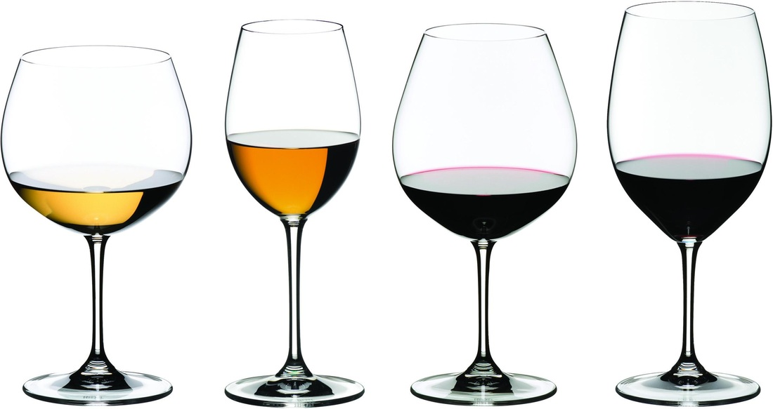

Wine matching should be simple and enjoyable, so I will keep simple and hopefully you will find it enjoyable. we grew up with the idea that one matches white wine with chicken and fish, and Red wine for meat. This idea although simple works most of the time, but if one wants to be more adventurous iit can be rewarding to be a little bit more daring. According to the Wine Bible by Karen MacNeill, when it comes to food matching “Pair great with great, humble with humble.” Meaning that if you are eating a chicken burrito from the local food truck, is not ideal to eat it with a $750 Cabernet Sauvingnon. It makes more sense to match it with a reasonbale $10 bottle. And hopefully leave that $750 for your wedding toast or more realistic to your divorce toast… Just joking. Remember my introduction about wine and sorrows. MacNeill also emphasizes that you should have and idea of what you want to achieve. Whether if you want to “mirror a given flavor or set up a contrast.”
Flexibility is also a big factor in wine matching pairing. It is important to understand that some wines are not very flexible such as toasty or oaky white wines like a California chardonnay. “Sauvignon blanc or dry German or Alsace Riesling due to the cleansing acidity” according to MacNeill.
Saltiness Salty food contrast with with acidity in wine. If you are looking to set up a contrast. Smoked salmon goes well with Champagne and for Asian dishes with soy sauce, American Riesling- because of the sweetness- are ideal for the contrast.
High Fat food-. According to Exploring Wine by Stan Kolpen, food with high-fat content calls out for an “equally rich, intense, structured, and concentrated wine” such as a California cabernet sauvignon if you are looking for a mirror effect.
Sweetness- for Sweet foods and dessert matching can be a little tricky. It is ideal to get a wine that is slightly sweeter than the dessert. MacNeill laims that desserts that are sweeter than the wine they accompany make the wine taste dull and blank. In effect, the sweetness of the dessert can knock out the character of the wine.

White Wines

- Chardonnay- for fatty fish or fish in a rich sauce. For fishes like Salmon chardonnays from California, Chile or Australia—or with any kind of seafood in a lush sauce. Thanks to its rich and complex texture Chardonnay has become one of the most sought after white wine in the United States. The basic flavors of chardonnay are: vanilla, butter, butterscotch, buttered toast, custard, green apples, tropical fruit, lemon and pineapple.

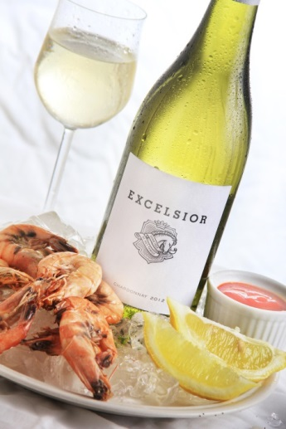
- Pinot Grigio. Is the most sold white wine in the United States. Pinot Grigio pairs well with light fish
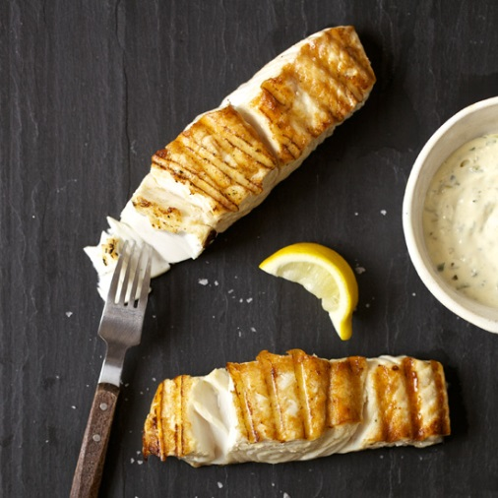

- Sauvingnon Blanc-in contrast to the chardonnay, sauvignon blanc according to MacNeill is “a taut, lithe, and herbal with a keen stilettoof acidity that vibrates through the center of the wine. a sauvignon blanc goes well with tart dressings and sauces. Tangy foods won't overwhelm zippy wines like sauvignon blanc.
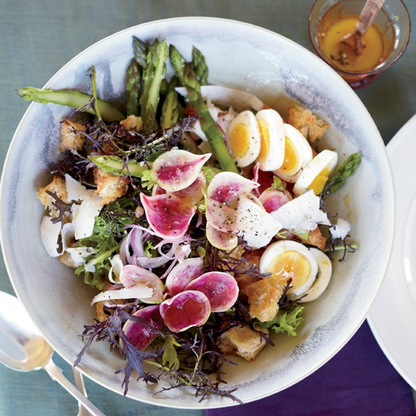

- Riesling- Considered by many experts as the most novle and unique white grape variety in the world. Thanks to the low alcohol content- about 8%- and its high acidity riesling pairs well with sweet & spicy dishes. From a ginger and beets shrimp salad, to some spicy asian dishes, you can not go wrong with a nice riesling.
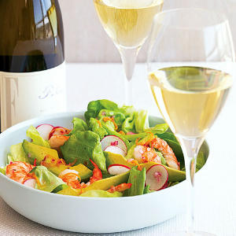

- Sparkling Wines - Perfect with anything Salty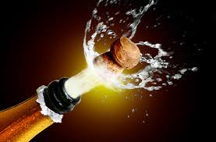

Rose Wines

- Rosé sparkling- have the depth of flavor and richness to go with a wide range of main courses
.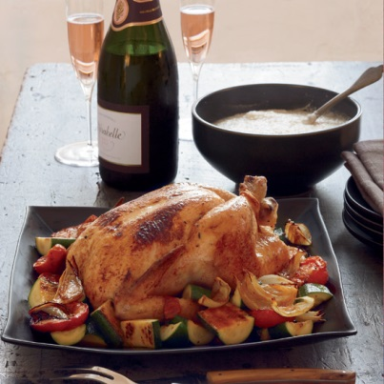

- Dry Rosé- With rich, cheesy dishes.
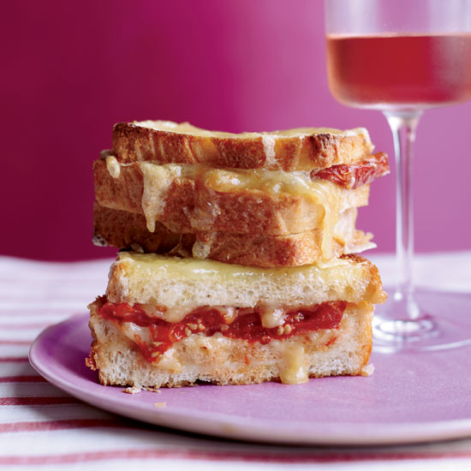

Reds

- Pinot Noir- Described by some as the sexy wine. Pinot noir express baked cherries, plums, damp earth, mushrooms, cedar, cigars, chocolate, worn leather, sweat, dry leaves. According to the 15 rules for Great Wine and Food Pairing by Food & Wine, Pinot noir are great for dishes with earthy flavors. Such as herbed pork chops, pepper steaks, or chicken and mushrooms.
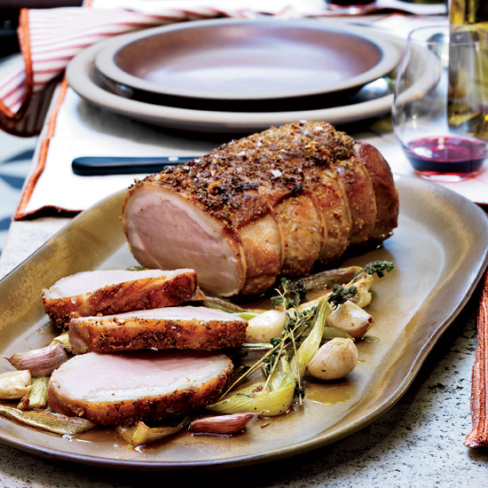

- Cabernet Sauvignon- The classic of the Red wines. A classic cabernet sauvignon will have hints of: blackberry, black currant, cassis, mint, eucalyptus, cedarwood, leather, and plum Perfect with Red meat
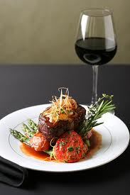

- Malbec- Perfect with food with sweet-spicy barbecue sauces.

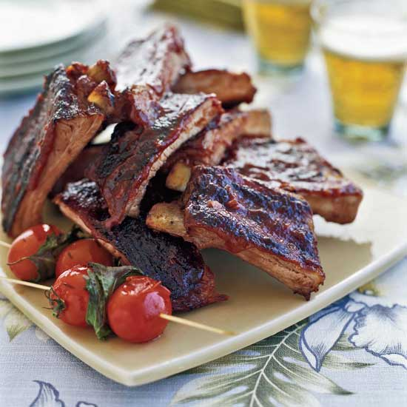

- Syrah- Perfect for highly spiced dishes
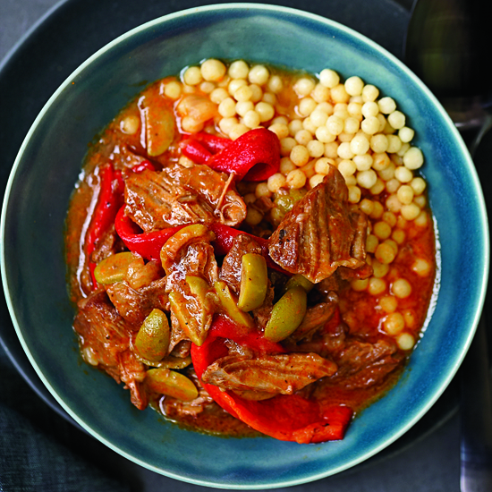

- Old World Wines- The flavors of foods and wines that have grown up together over the centuries, and are almost a natural fit.

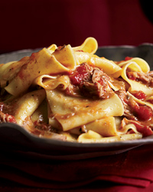

List of References:
(oops) wine | Viña Undurraga, the world-class family owned winery producing (oops) wines. (n.d.). Retrieved April 18, 2015, from http://www.oopswines.com/in-the-vineyard.html
Isle, R. (n.d.). 15 Rules for Great Wine and Food Pairings. Retrieved April 15, 2015, from http://www.foodandwine.com/articles/15-rules-for-great-wine-and-food-pairings
Kolpan, S., & Smith, B. (1996). Food Matching. In Exploring wine: The Culinary Institute of America's complete guide to wines of the world (3rd ed., pp. 454-498). New York: Van Nostrand Reinhold.
LA76 Photography - Lifestyle, Editorial, Travel, Architecture and Real Estate Photography. (n.d.). Retrieved April 20, 2015, from http://la76.photoshelter.com/image/I0000wlKTzxFU.sU
MacNeil, K. (2001). Pairing Wine with Food. In The wine bible (1st ed., pp. 83-85). New York: Workman Pub.
Pairing food [and] wine [Motion picture on DVD]. (2006). Millennium Interactive Inc.
WINE GLASSES. (n.d.). Retrieved April 10, 2015, from http://www.alleneuedekoration.com/wine-glasses/

