My Story, My Evolution with some Fashion

Brenda Mendez

Dr. Adomaitis

SBS 3201

To my beautiful mother

Sandra Mendez

Table of Contents

Introduction ……………………………………………………………... Pg 3

Just a kid ……………………….……………………………………… Pg 4-15

Mid-life ……………………….……………………………………… Pg 16-21

All grown now …………………………………………………………… Pg 17-

Introduction

My name is Brenda Yanira Mendez. I want to introduce this story to everyone, this is about my life and how I evolved to be the young women I am today. I overcame a lot of struggles, but obtained many blessings as well. The reason for the motivation that drives through my veins is all because of my Mother Sandra. And this is why I wanted to dedicate this story to her. She is the most important person in my life. She gave up all her dreams and had to sacrifice her happiness for mines most of the time. My mother had me when she was 19 years old. She had no choice but to start work and take care of me without the support of my biological father. Her support and her willing to care not just for me but for others is what makes me have such a huge heart. She always told me that I deserved to do what I loved in life. When I told her I did not want to be a fancy doctor or lawyer, but just a normal girl in the fashion industry she did nothing but smile and told me if it is what I loved, she 100% supported me all the way, economically and physically.
There are plenty of reasons why my story is being dedicated to her, but most of all is being dedicated to the women that I love the most. This is my story, my evolution in life with many more chapters to come, and of course with a lot of fashion included.

When I was only 4 years old, I remember walking down the streets of Mexico in my favorite pink crop tank top that had colorful butterflies on it. I partnered that specific top always with red corduroy skinnies. I lost count of how many times I wore this outfit. I was always excited every time my mom put this outfit on me.

I always remember my passion for clothing and how excited I would get every time I had a new shirt or dress because me and my mother was never financially stable to afford the greatest things during that time, but we were happy and grateful to have what we did. We lived in a small town Tulcingo, in Puebla where you can smell the fresh tortillas being cooked by hand from every corner of the block. We lived on block away from where my mom used to work. She would work with my godmother Malu and godfather Dago in a Parcel.

My Favorite part of the day was waking up in the morning because my mom would leave very early for work, she would leave me a note beside the bed that said “ Good morning my sweet girl, please put on some clothes and do your hair and come to the parcel.” I loved to always pick out what I wore, especially because I got to show it off to my god sister Marilyn. It’s like we was always in a competition to see who wore the best outfit of the day, its okay though. We loved each other and got a long pretty well. She was my only best friend.

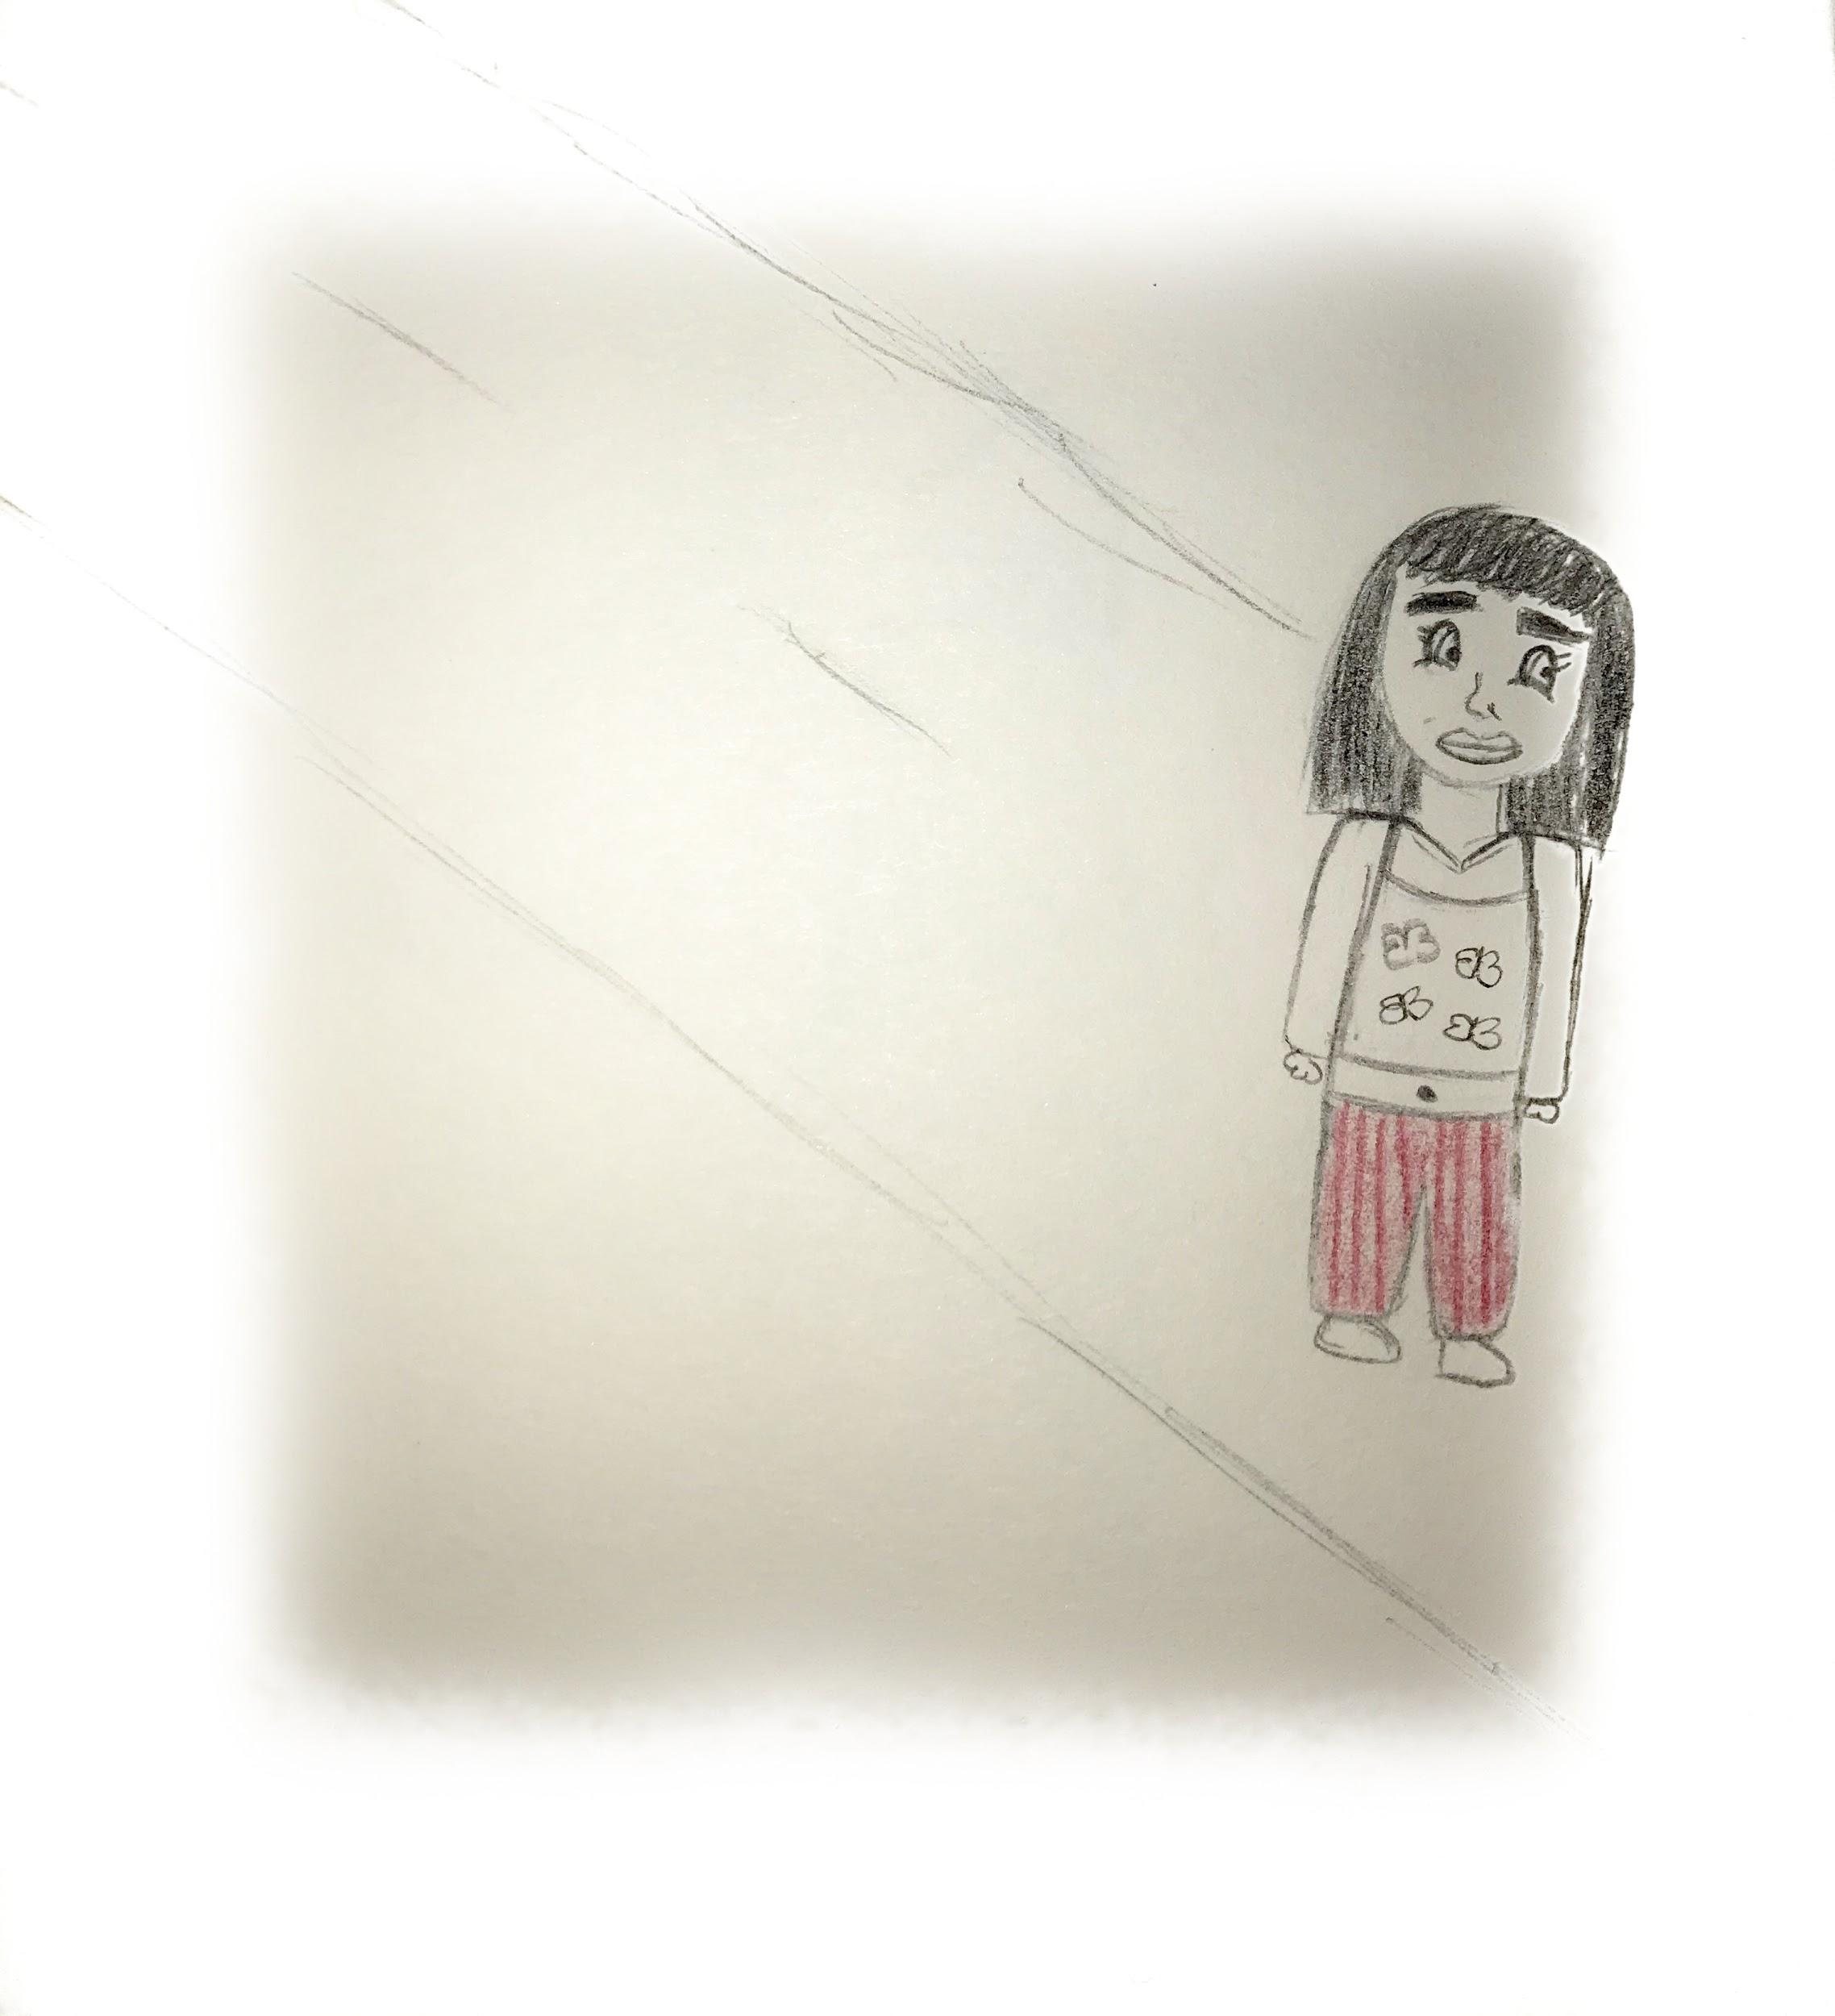

One day when I came out of Pre-School, I remember I was so upset. My Pre school was named “Echo De Colores” meaning made of colors in english. Ugh, I hated this school. All the little kids were mean to each other and rebellious. But luckily that same day that I was having a bad day my mother picked me up from school and told me she was going to put me in a beauty pageant the following week, I immediately started to tell her “ oh my god! Now i'm going to be famous!”.
Moments later while walking home, I found the most beautiful barbie doll abandoned in the street, It was my first barbie I ever had. I remember the doll had a green cheerleading outfit. With blonde hair, she also smelled so good for some reason. I weirdly felt bad for the other girl who dropped it, but I did not care, I took it home with me in a blink of an eye. It was so beautiful that I even wished I owned the outfit she had on. I added this Barbie to my collection of stuffed animals I had at home.

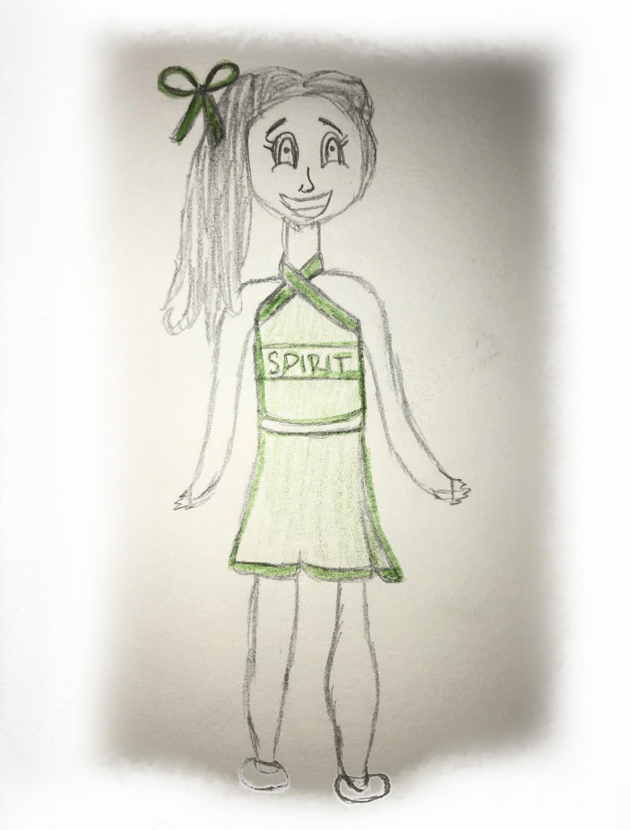

My mother got me this beautiful white dress with ruffles on the side that had satin and mesh stripes, I partnered it with high white socks that had ruffles as well with white patent leather shoes. Although I was not known in the neighborhood my mother believed in me and believed that I can win the whole pageant. My mother Sandra, man, she is the best mother anybody can ask for. She is this beautiful curly hair caramel skin women with soft skin that always smells like lotion (because she is obsessed with lotion since forever) that would always have a smile on her face. She always tried to put me into activities she knew I would love, she always tried her hardest to spend all her time doing things with me besides her hectic work schedule.
Anyways, On the weekend of the pageant over 400 people came by the plaza, they voted for the best dressed known queen. There was 2 runner ups, Me and some girl named Zimoneta. Which is such a weird name. Three hours went by and we found out who had the most votes of the night and who would win Miss little Tulcingo.
The votes went through, and it was such a close call ... but I did not make it. I did not win, how could that be I kept asking my mom? I thought I had such a better look than her! I remember not knowing whether to cry or smile but I took it as an I did not care which I did a lot. I wanted to make my mom proud. But overall my mom was proud of me and how i carried myself at such little age, without any tears and a smile on my face.
In mexico the beauty pageant winner gets to be the queen and participate in all the parades, while the runner up (me) got to be the princess next to her and also attend the parades which was pretty excited. At the end of the day, I still wanted that big pretty silver crown.
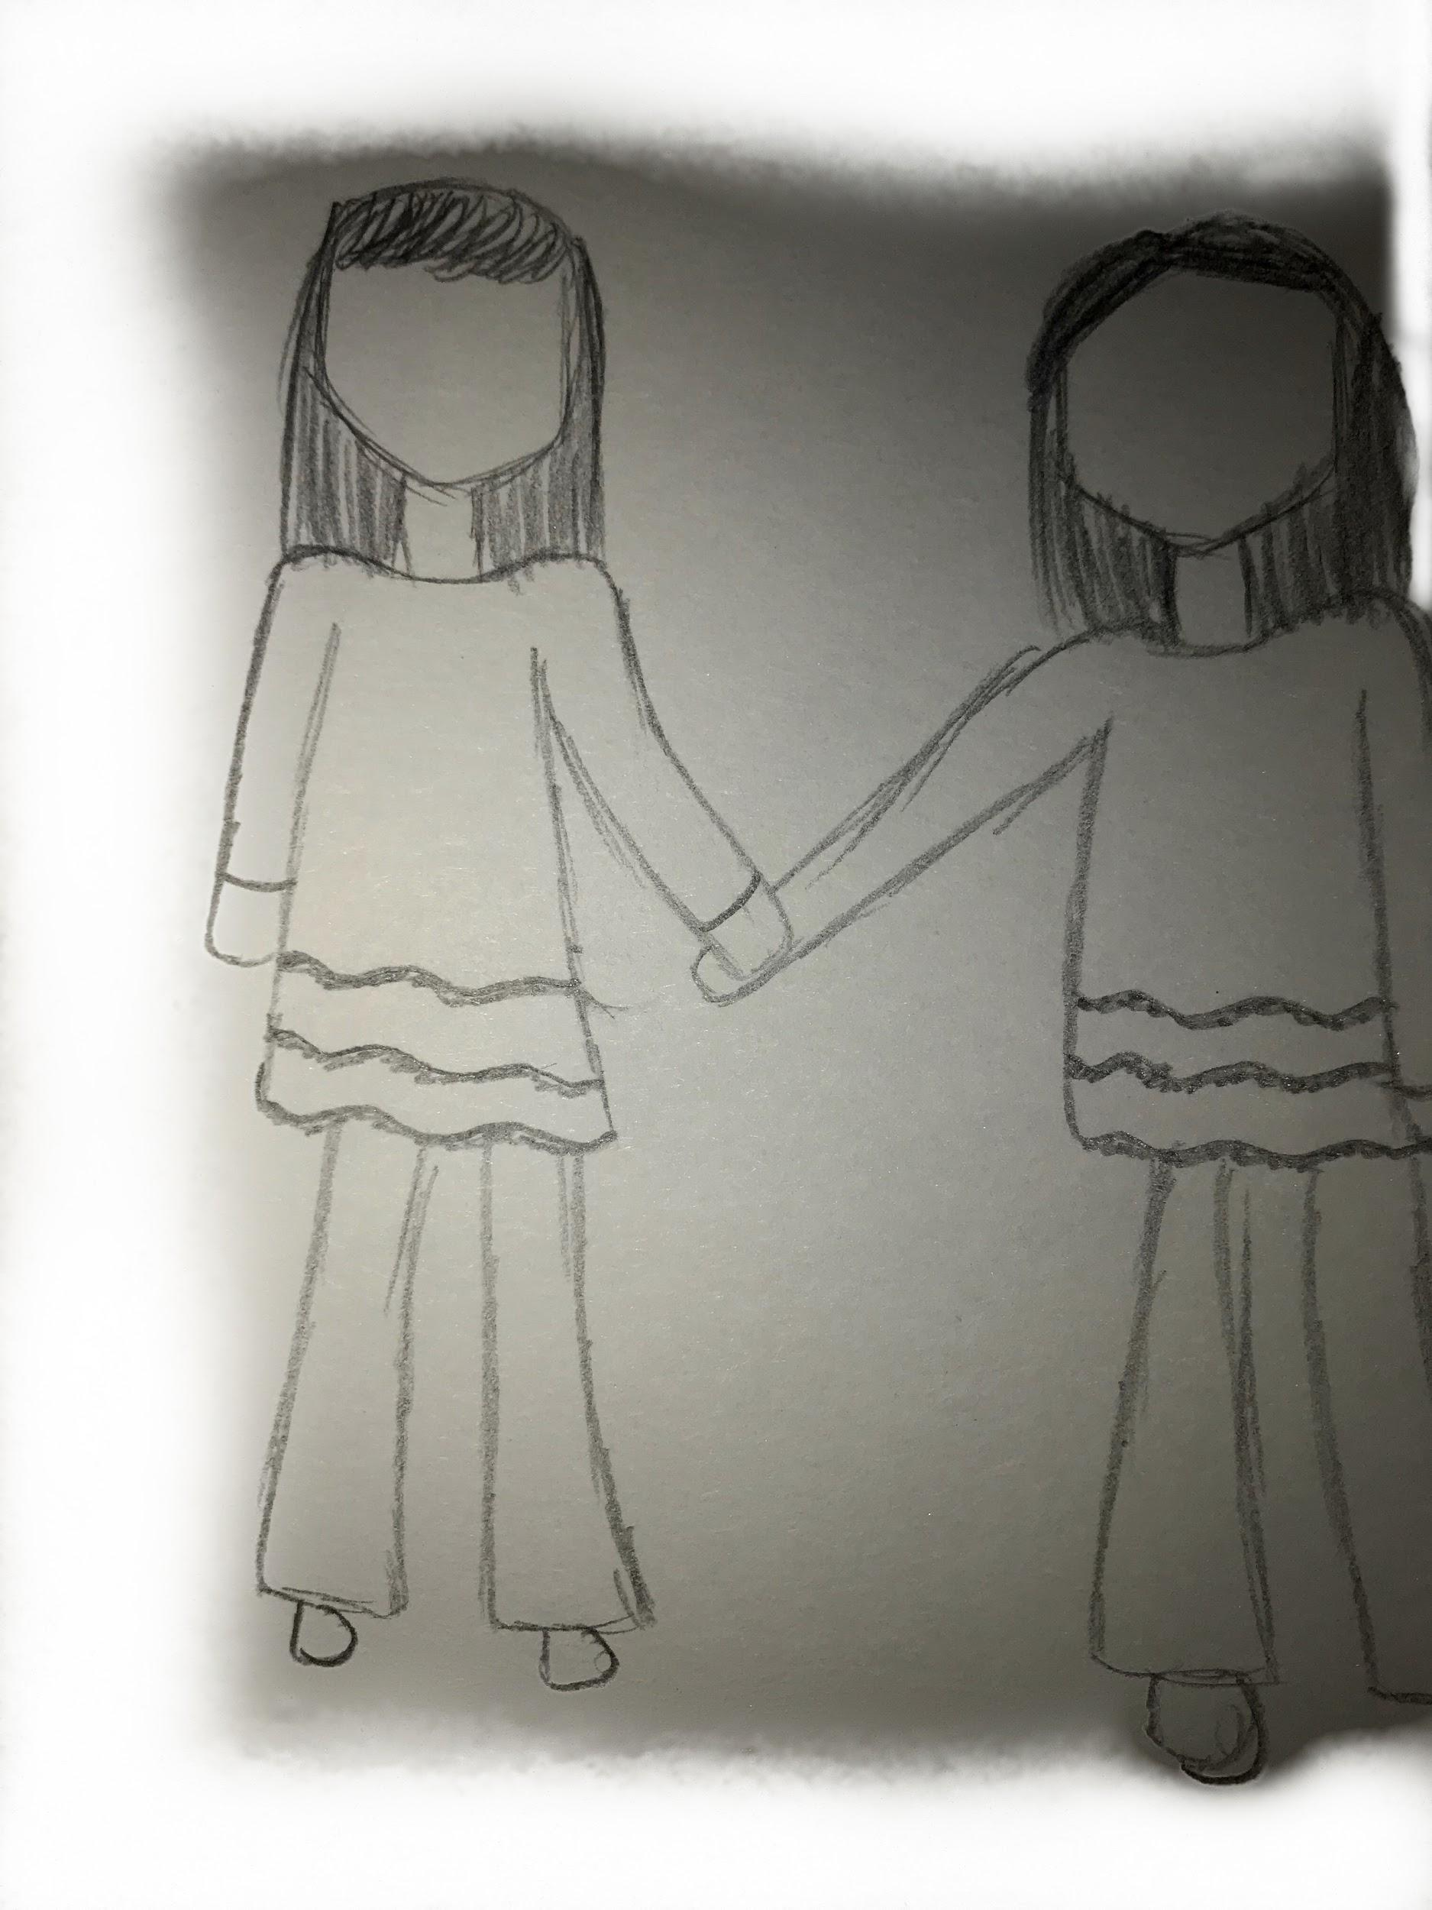
I had a photoshoot a week after the parade. I told my mom that this time I wanted to pick out my own dress. She took me to the plaza mini mall to pick out the dress I wanted.
The dress I choose was all green, like the color of the leaves. On the top of the dress it had colored butterflies. I guess I had a love for butterflies at that time. The dress flared out and it had thick straps on the top. On the waist it had a black strap separating the top and the bottom. In my mind I was thinking to myself, “I am going to look great in this photoshoot.”

I went to the beauty salon, I put my hair up in a bun with two thin curls coming down in front of my face. I never felt so beautiful. My mom allowed me to wear this rosy red lip gloss that smelled like cherries and a little bit of gold eyeshadow.

The room of the photoshoot was all white, with huge big lights facing this navy blue screen with a chair and flowers as a prop. I was nervous and excited at the same time. I did not know how to pose or what to do. At times I felt like I was going to do constipated faces without noticing. But, at the end I managed to pull through and I did great, I felt great and all because of that beautiful butterfly dress I was wearing, I felt confident. I guess when you love what you wear, your confidence gets boosted like crazy, and that is exactly what I felt that day.

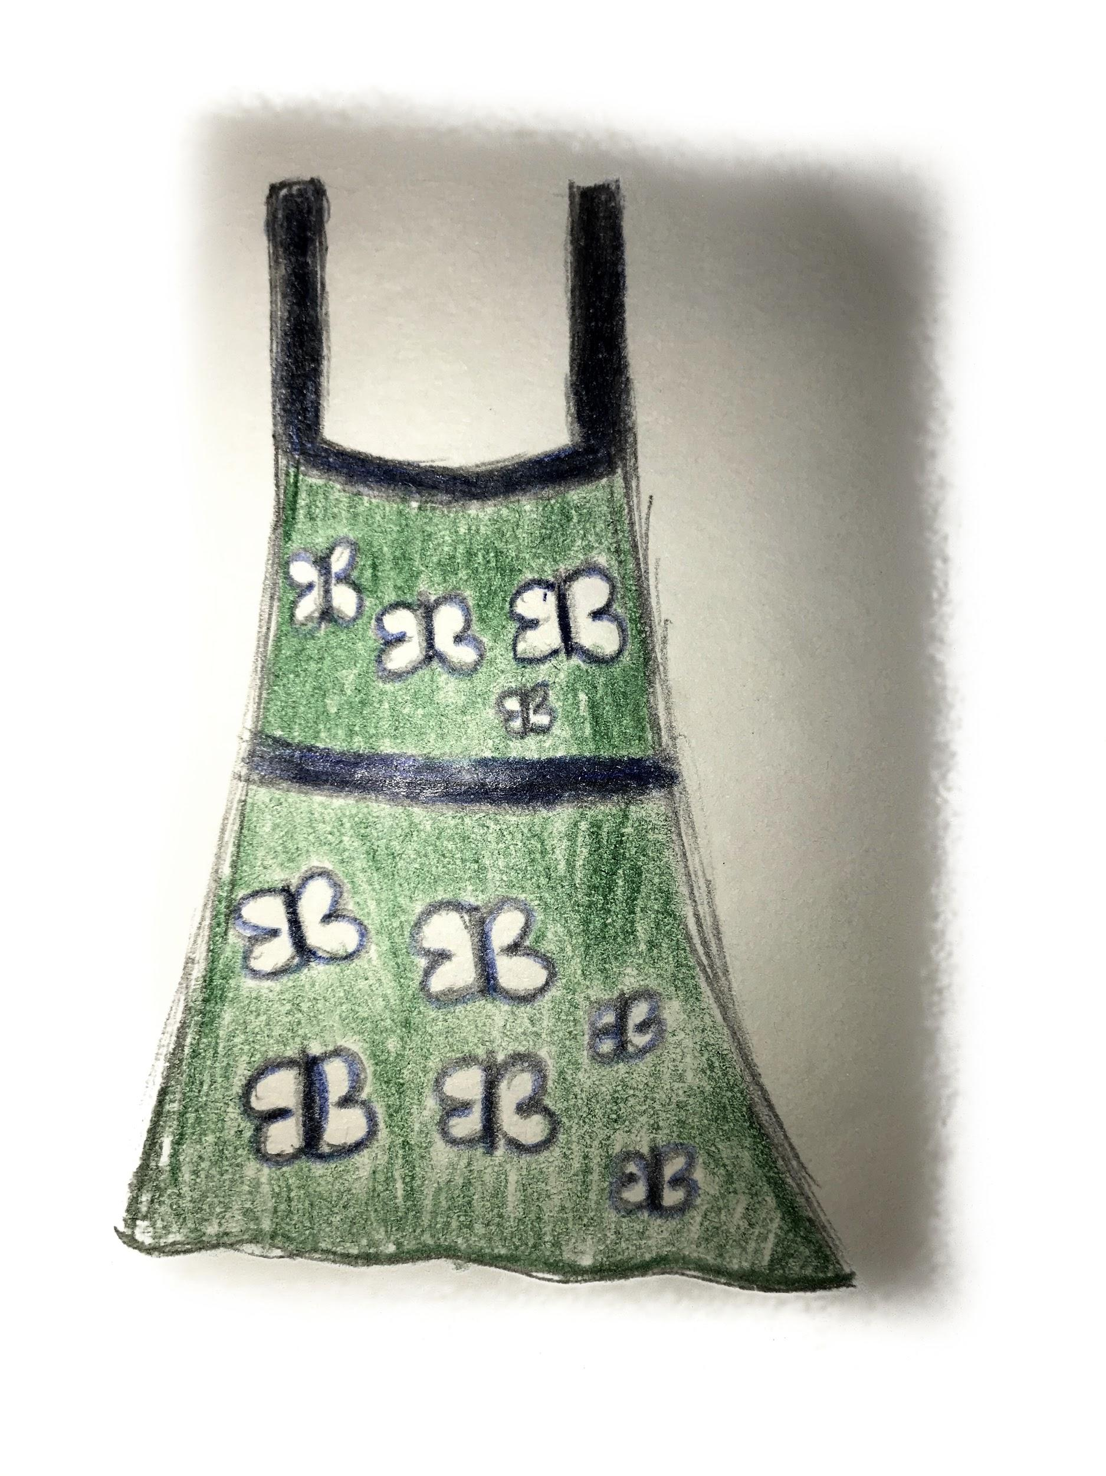

That Same Month of September, After all the things I was going through with mom,
My Papa which was my brand new stepfather, had said we were moving.. But we were moving far far away. Meaning, NYC. Miles and miles away from Mexico.
He sat me down and told me very calmly that I was going to move somewhere very cool, where I was going to have a lot of friends, a lot of activities to do but in my head I told myself but I didn’t even know what was New York City or where it was. All I can remember is that I was scared and mad at the same time. I barely know this guy? All I know is that he made my mom fall in love with him, But why does that mean we have to move where ever he wants? I have friends here, I have my pageants, I have it all here, I didn’t want to leave. I REFUSED.

My God sister Marilyn was my best friend. She was the first to know, I can't even explain how close we was. We Sometimes bought the same outfits so we can act like sisters because that is what we thought we was, sisters but from different parent. I did not want to leave her. I will miss the days where we will wear the same peach peplum shirt with the white bell bottom pants our moms bought in the plaza. It was OUR favorite outfit. We wore that outfit more than I can even recall.
So we decided to make the big move and come to NYC on october 2002. A year later after the twins tower had fallen. I remember my parents also being a little worried over that situation. They talked about it all the time. Everything in NYC was a little scary at the moment, it was a risk we was all taking. But I was over all excited. My stepfather and all my friends convinced me that were I was going was supposedly a “magical place.” I was moving into the big apple and of course where fashion lives.
Everything changed the minute I came to NYC. On the first day of New York City I remember it like it was yesterday. It was like 30 degrees. It was super cold. Before during that time October was way colder than how it is now.
I wore a big silver metallic parka that had no collar and it almost looked like a bomber. I was called myself a teletubbie every time I wore it. I felt so silly. Also because i had never wore a coat before. When we arrived it was between 11:00pm-12:00am. It was so dark, all I could spot was huge city buildings with so much lights. I thought I was in another galaxy. In mexico the tallest building was probably four floors max. I felt like a tiny seed compared to these enormous buildings. It is so beautiful. I could not help but smile so much my cheeks hurt. I kept pulling down my mom's coat saying “look mom, look!” at everything that I saw.

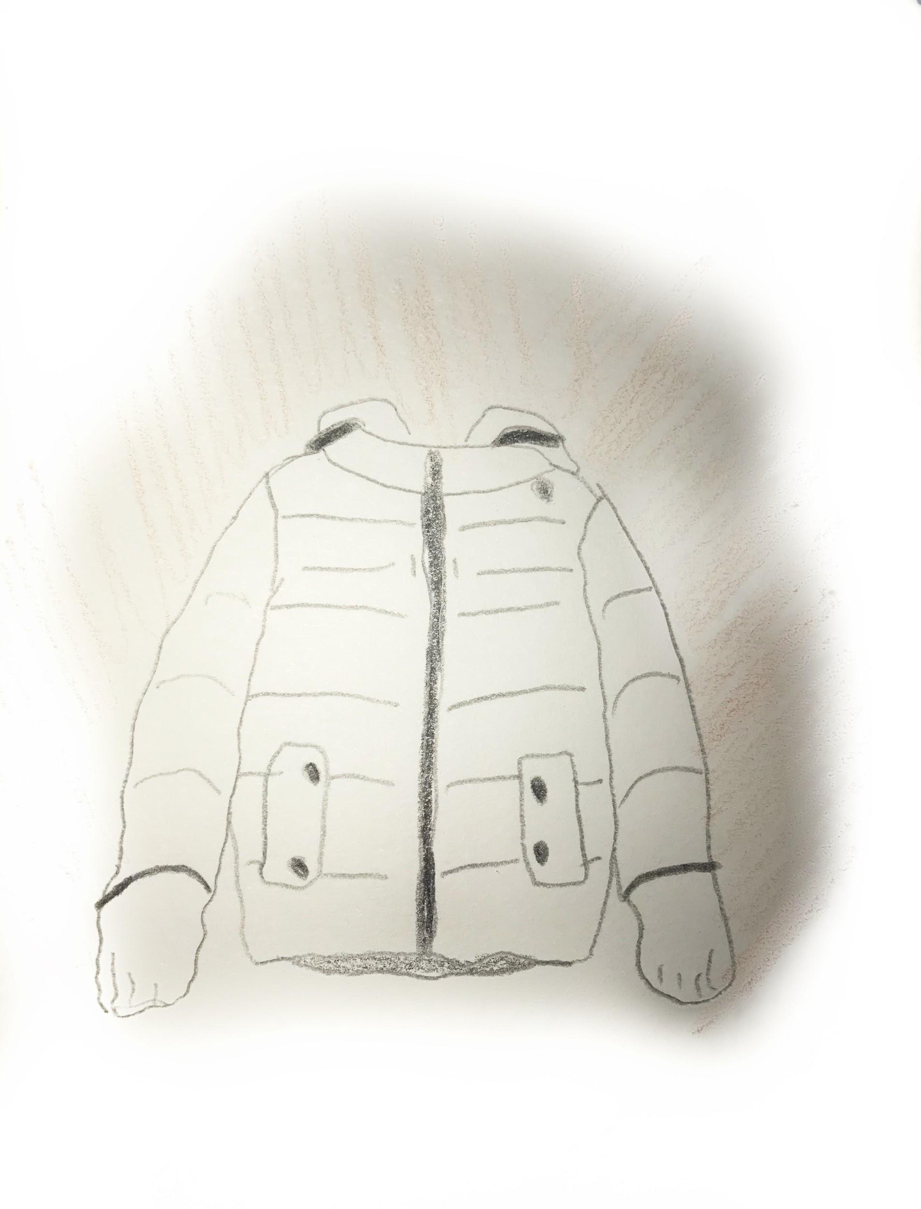
Years went by, winters and winters passed by and honestly I had never been in a place where I was forced to wear layers of clothing, if not I would freeze to death.. NYC was way too cold for me.. I still loved the city besides all the suffering from the cold.
Me and my parents first home was near the Yankee Stadium. 955 Walton Avenue, right in front was a huge park that had a really nice fountain. I made so much memories in that park. In the summer we would be in the park until 3:00am in the morning because the sprinklers activated to wet the grass, Me and my friends from the building would run into the sprinklers and have a blast. We lived on the fourth floor of the building so I can say my view wasn’t pretty bad. From my window I could see the Stadium on the inside. That was the best part. Therefore, the Yankees became my favorite. I basically watched games for free all the time. I loved their logo and outfits too. And I loved especially how the uniform looked on the guys. The players uniform was white with blue navy stripes, with the Yankees sign on the shirt. They wore these high socks with cool looking shoes. I don’t know, but to me it was super hot!

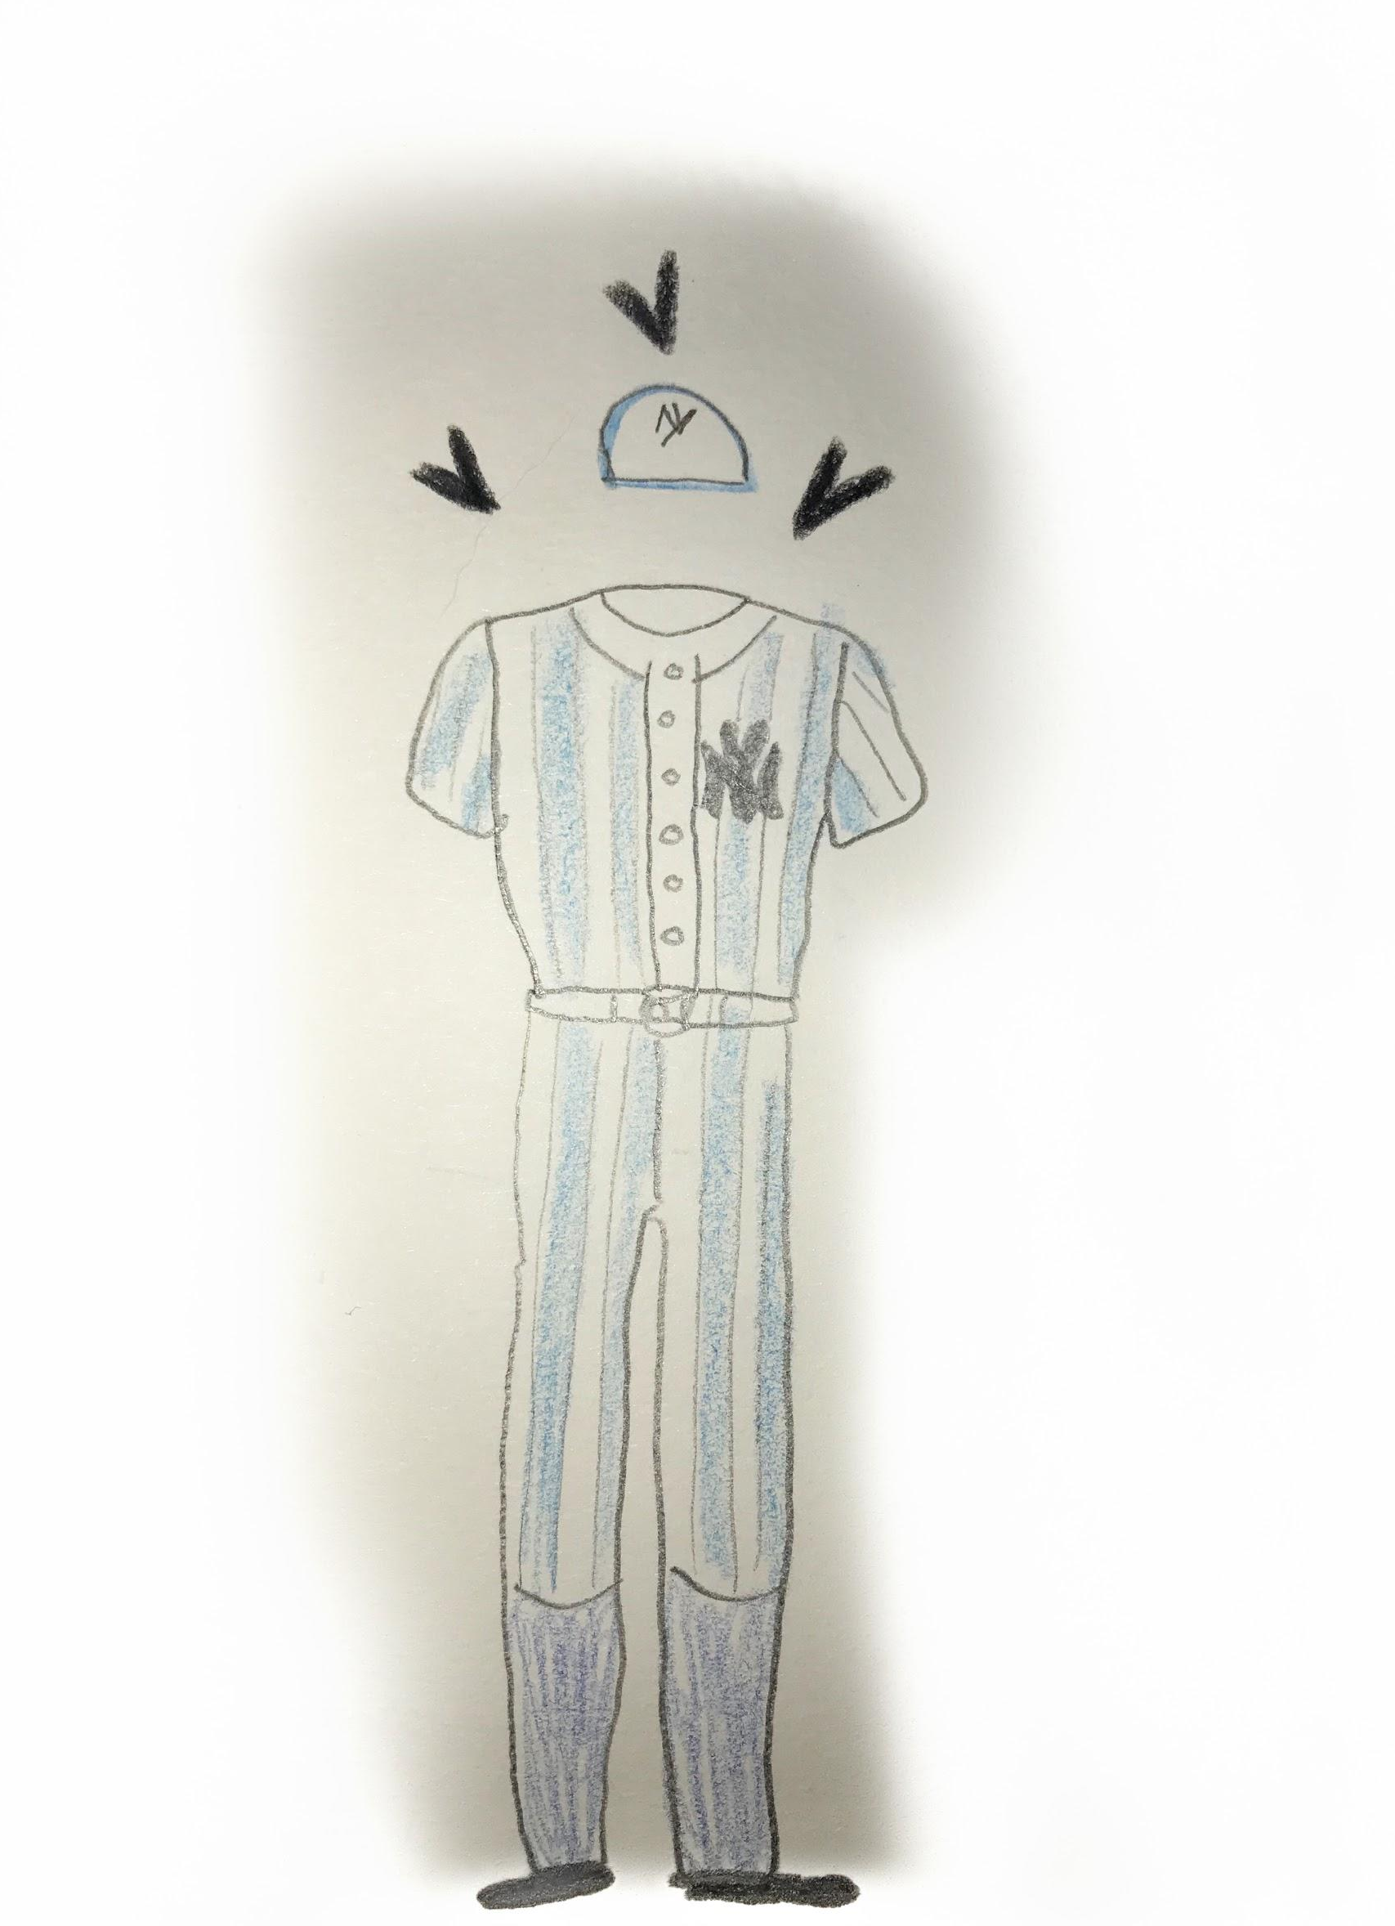

I was always a workaholic, ever since I was little. I would help my mother around the house so much. Not just at doing chores, but I just always loved being constantly busy. I miss those days. Where technology didn't take over our whole day. We actually had the chance to get things done. When I turned 16 years old I decided to tell my mom I wanted to work, even though she didn't agree to it because I was too young in her eyes, but she she accepted it. I don’t know for how long I had begged her that I wanted to work and make my own money to buy my own things. I hated to ask my mom and dad for things. I never wanted to make them feel like I was bothering.
I lived in 161st street for 7 years so why not work for the Yankees? I started to work off the books across the street from the Yankee stadium in a small gift shop. I would go to school and work like 20 hours a week. The best part was my uniform I got to wear any jersey in there that I wanted. And i got 35% to top it off! I was 16 years old making 160$ a week. I thought I was a young baller. During those days, making that amount of money was pretty good. Plus, my shifts were pretty simple and not boring whats so ever. My cousins and I all decided to work in the same place. It was like I was getting paid to just laugh all day long with them. I used to love the brand Hollister during this time. I would always wear my Hollister sweats which were so cozy to work in with my Yankee Jersey. These sweats gave me life, I know they were 100% cotton, but from the inside of the sweats? It’s like it was magical as weird as it sounds. It felt like I had clouds as pants how warm and fuzzy they were. Was I walking on clouds? But no really. I was obsessed with all of the colors it came in. I would never forget those sweats and how much I loved them.

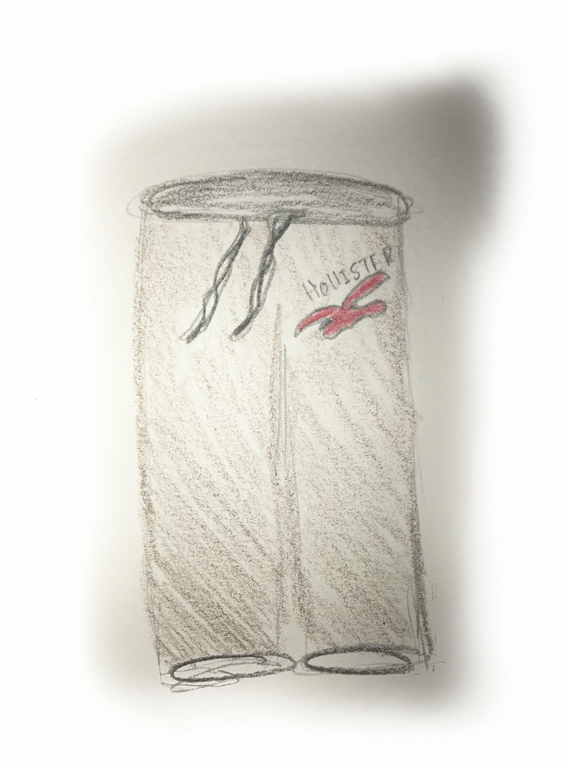

Baseball season was over, and I was not working in the gift shop anymore. I began to babysit the cutest 3 year old baby Sofia and got paid for it. I would get 50 bucks a week just by babysitting her Wednesdays and Fridays from 3:00pm to 6:00pm because I would get out from school at 2:30pm. It did not bother me, she was a quiet baby who probably spent her time coloring a book or watching Dora on Nickelodeon.
I was always the girl in school that had the latest jordans. Although kids would wonder how did I have so many shoes. They never believed me everytime I told them I worked. They easily thought my parents would buy me these things. When in reality, I would actually work for it. Babysitting Sofia was the reason why I could get most the things I desired. My favorite jordans that I had bought at the time was the Bred 11’s. They were so beautiful. They are all black with patent leather in the front and sides, and a big red Jordan logo in the back. I remember I saved those 50$ Sofias mom gave me every week. I managed to save $200 dollars in one month. The sneakers came out to 125$ dollars. Oh my god. Those sneakers were my babies. They were an accomplishment to me somehow. I bought my very own Jordans. With my own money. I wore those so much, It was like I had a romance with sneakers. It did not matter if they were funky looking or not. As long as my collection kept growing I was happy. You name it? I had it. Every jordan number you can possibly think of, I would save up all my money and just spend it on sneakers. Sneakers basically defined me and defined my outfits as well. When ever I wore my old looking jays that were beat up with scruffs on the side and creased bottoms, that meant I woke up in the worst mood and that meant, no one talk to me for the whole day. BUT if I wore my shiny, crispy clean jays, that meant I took time in order to put my outfit together and match whatever I wore that day. It’s like my shoes defined my feelings.
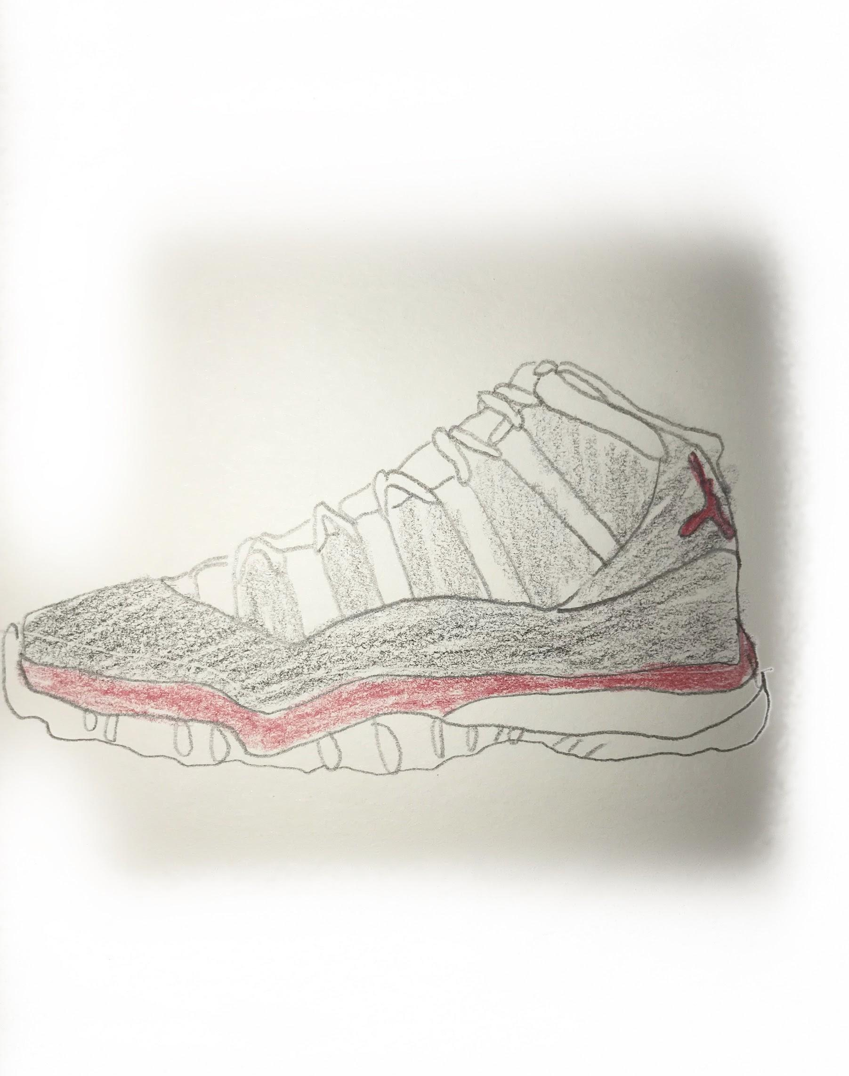
Like I stated before, My parents were never financially stable to ever afford the big things in life. Although that was not everything in life. I went through emotional depression when it came to clothes between middle school and high school, getting bullied and teased on. I would never forget it. I would get teased on for not having the best clothes. I dealt with so much bullying that it made me fall in love everything that had to do with clothes and fashion. As soon as I began to afford the things I wanted, from the latest sneakers to the Hollister Sweats that were popular at the moment, i felt so much better about myself and my identity. I was not getting picked on anymore. Instead I was an innovator to these girls. I would get asked all the time where I got my things from, it felt nice to not get picked on for having dirty shoes and the same light wash jeans I would wear 4 days a week.

This was only in Middle School, I will never forget I was forced to wear this Hideous Uniform in High School. I hated Theodore Roosevelt. I had to wear this ugly white collared shirt with black pants and black shoes. We all looked like walking oreos honestly. On top of that the school looked like prison. The only good thing that came out of this high school was meeting my Highschool Sweetheart Erick, that now being 21 I am still with up to this date. He is the only one that kept me entertained throughout the four miserable years of homework, snotty teachers and fake friends.

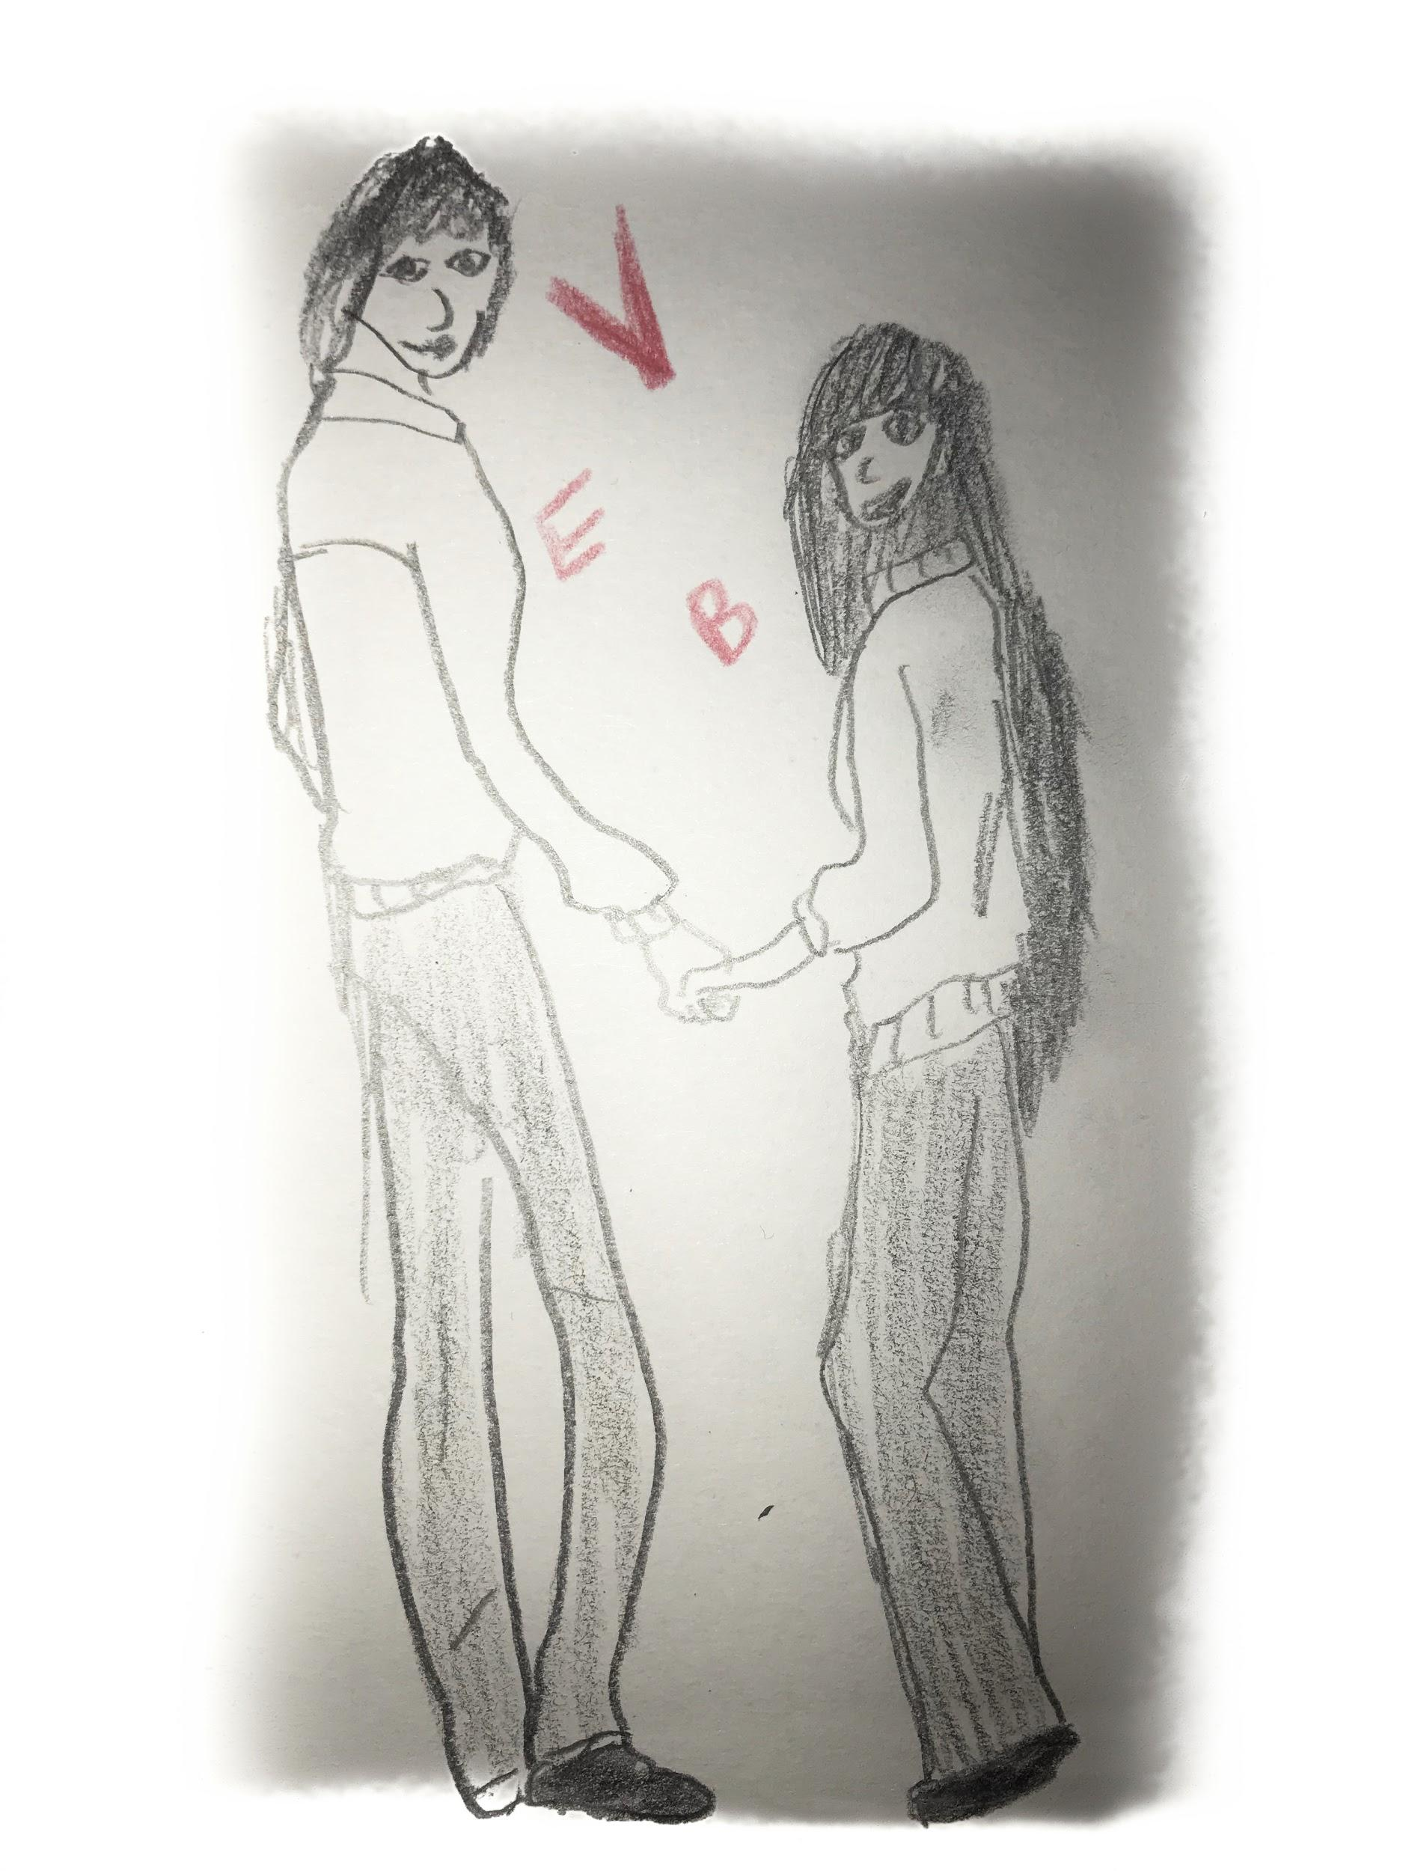
Senior year was a year to remember. It was the only year out of the four that I felt at ease knowing me and all my classmates were going to start our dream career. One day that was very special to me was my Senior Prom. It was on June 4, 2015 at 8:00pm. The day where we wouldn't have to worry about homework being due the next day, all we had to worry about was to have fun, which was the best part. I would never forget what I wore for my prom day.
My dress was a sleeveless sweetheart neckline. It was a corset top that cinched my waist so tight that sometimes I honestly could not even breath. It draped all straight down below my ankles, on the top it was all silver crystals and solid dark navy blue on the drape. I can't even explain how beautiful I felt in this dress. I remember how it took me such a long time to find the perfect prom dress, as soon as I put this one on in the boutique I immediately said “ this is the one.” My cheeks turned rosy red and my smile was from one ear to the other.
As soon as I got to prom I got compliments non stop, especially because I made the decision to cut my 30 inch long hair to my neck. It was the craziest decision I made. We partied and dance all night. Until they had to announce who was going to be prom queen and king. As they were mentioning them, I did not even bother to listen, I was in line with Erick ready to take the Prom picture. When All I hear is “Brenda Mendez” I completely spaced out. I said what? Whats that my name? Everyone turned to me and said “yes brenda, you won prom queen!” I was perplexed at this moment. I did not even think in a million years that people would vote me, me as prom queen? NO WAY!

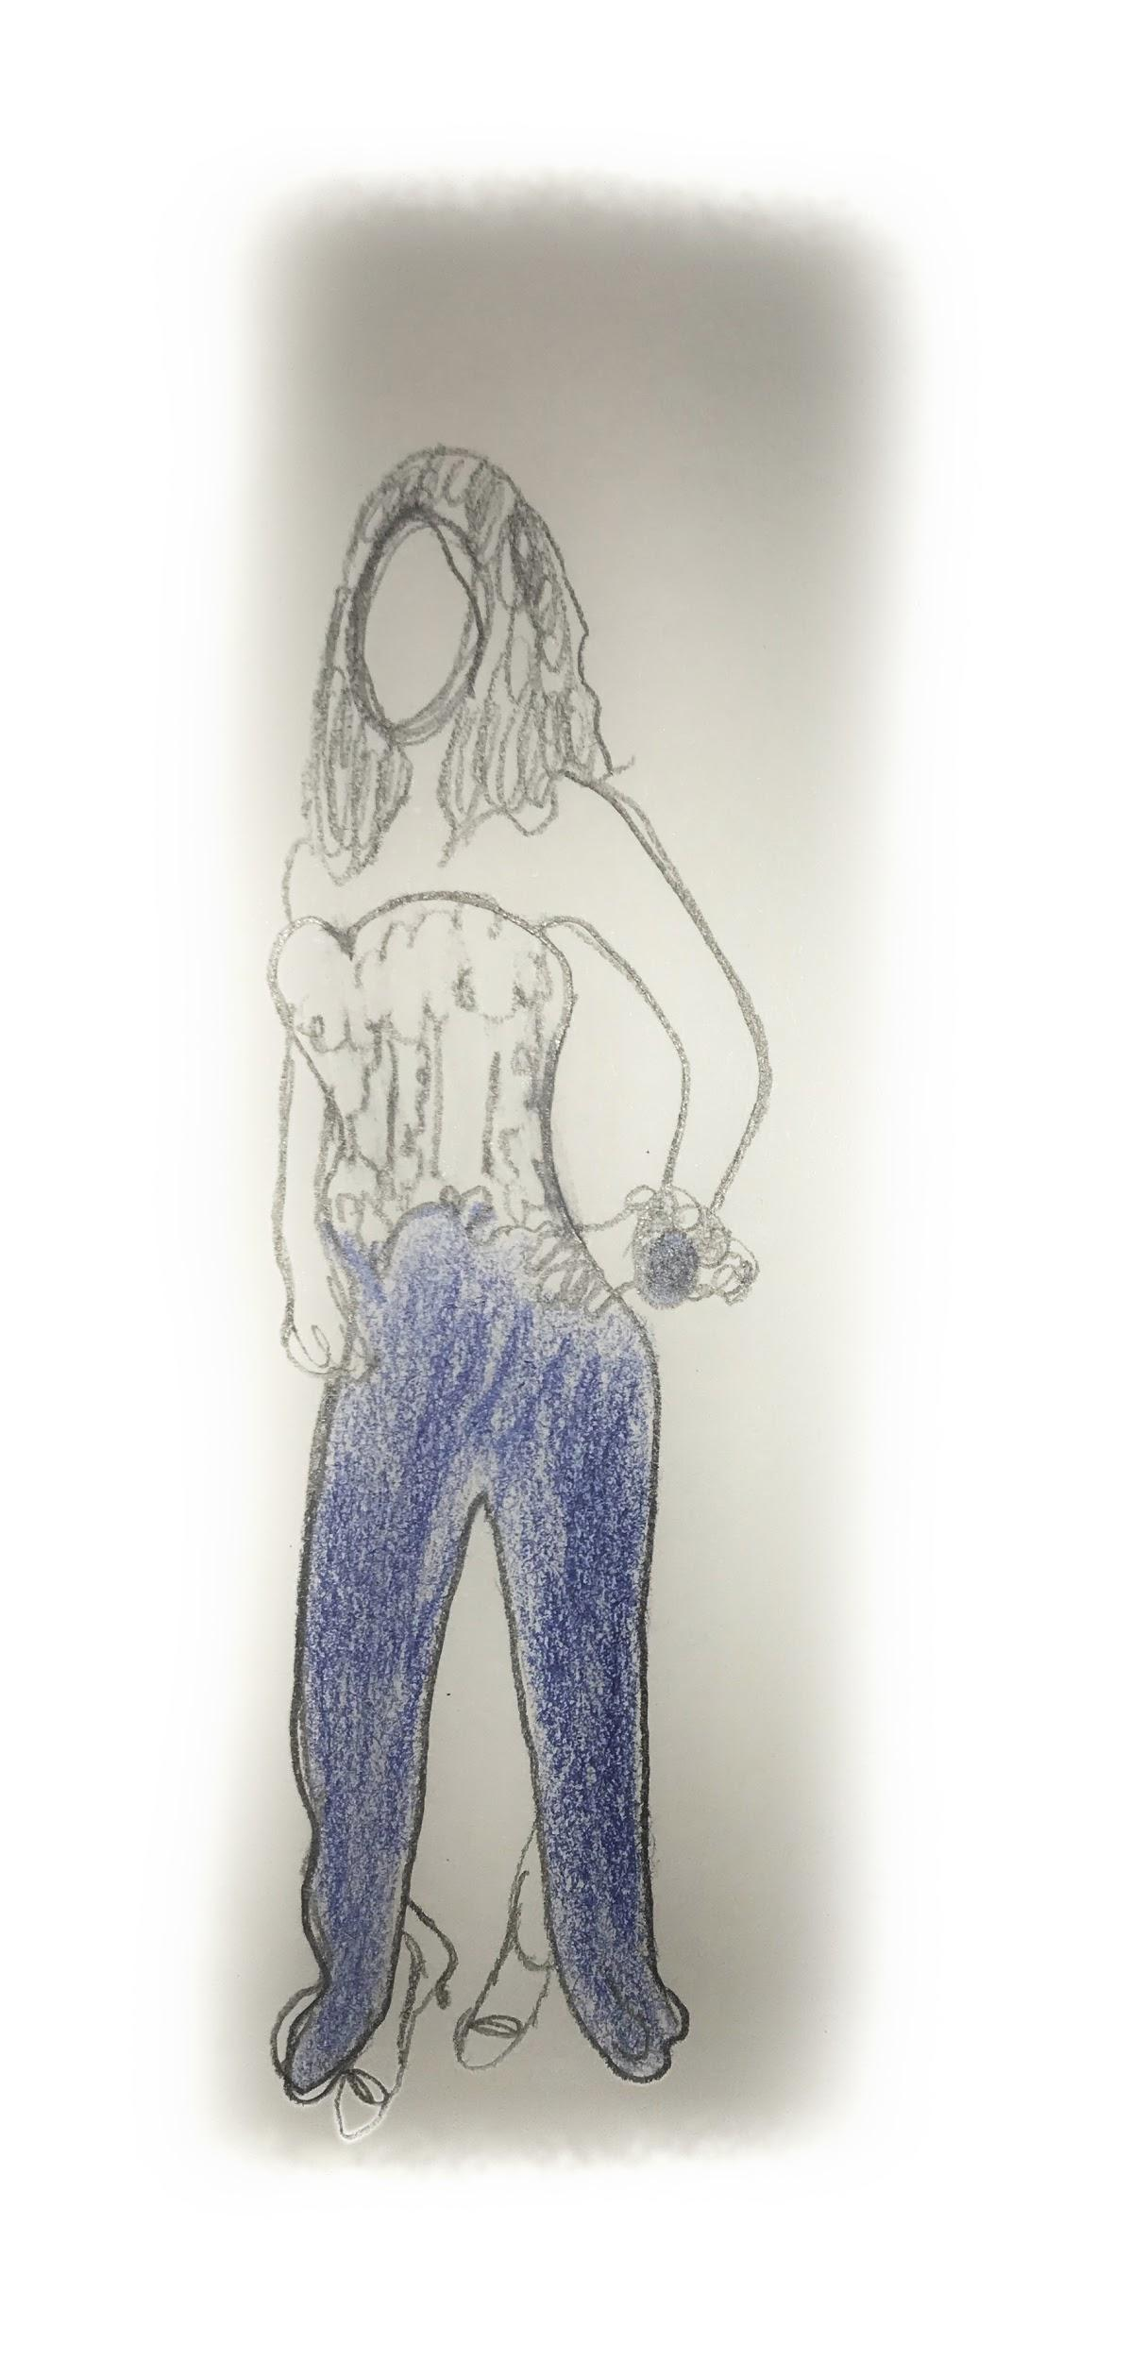
I thought prom was amazing that night, it was definitely a day to remember. But then graduation came, the day I was waiting for my whole life. My Graduation was held at Fordham University right across the street from my high school. I knew that no one would see my outfit underneath that ridiculously large white gown they gave us. But I wanted to go all out and look perfect for this special day. The sun was out, the birds was out. Nothing was going to ruin this day. On June 25th I wore this olive green scuba dress that was tight on my body. I wore these open toe strappy nude heels with it that I bought at Aldo. For some reason those shoes were highly uncomfortable to walk in, but throughout the day I was so emotional, the pain became immune on my toes. It was the most simplest solid dress ever, It was sleeveless and right below my knee.
I wore green because green to me meant freshness. A feeling of freshness, a feeling of wanting new beginnings. I got my diploma ending at a 3.8 GPA. Seeing my mother smile, the people that I love be next to me and celebrate one of the most important days of my life became the most rewarding feeling anyone can feel. I felt blessed, I felt lucky. Lucky enough to have a chance to go to college, to have a wonderful family and great friends.

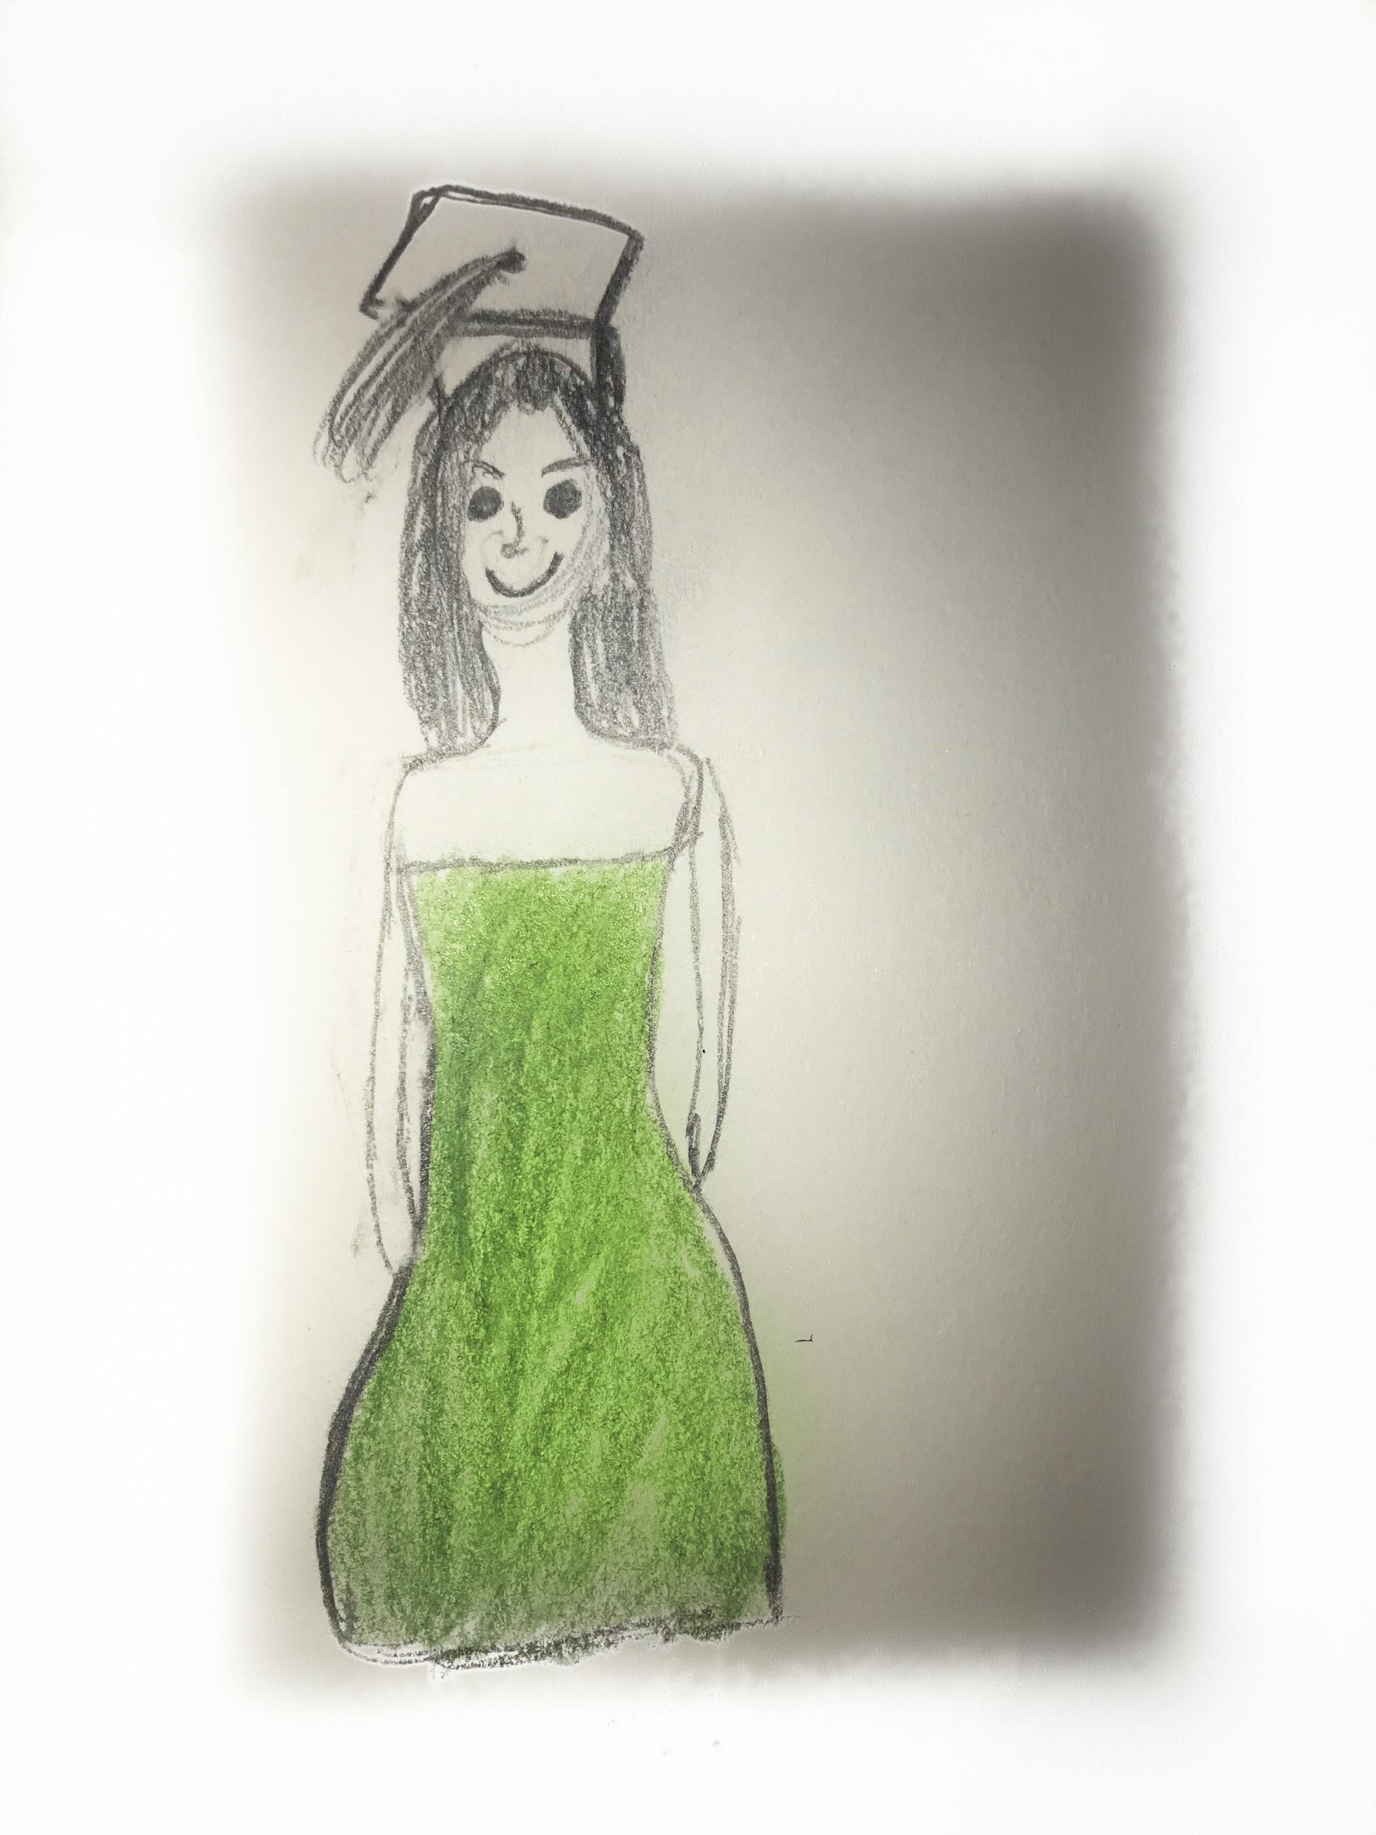

After High School, that summer I decided to get a job. I turned 18 years old on August 20, 2015. As soon as I turned 18 I got a legal job that was not off the books anymore.
I started to work at a retail store in 59th street Columbus Circle called Bebe. This may have had been probably the worst retail job I worked in my life, but the discount was worth it in that job. I got 50% in this store, meaning everytime I received my check every two weeks I would spend a good 100$ on something. Oh boy, I did love dressing up for work a lot. It was basically a requirement for this store, to look girlier than ever. I would wear fedoras hats all the time with my straight hair down, I would wear a long vest cardigan with destroyed jeans and knee high boots that clacked everytime I walked.
This job was awesome for that reason only, I got the chance to dress the way I wanted, which was girly and chic. I have a very bubbly personality so everything I wore everyday corresponded to how I am. I would buy so much merchandise from Bebe, I would basically have so much pieces I had the chance to wear something different everyday. I would make so much sales because everything I wore a client would ask to buy it.

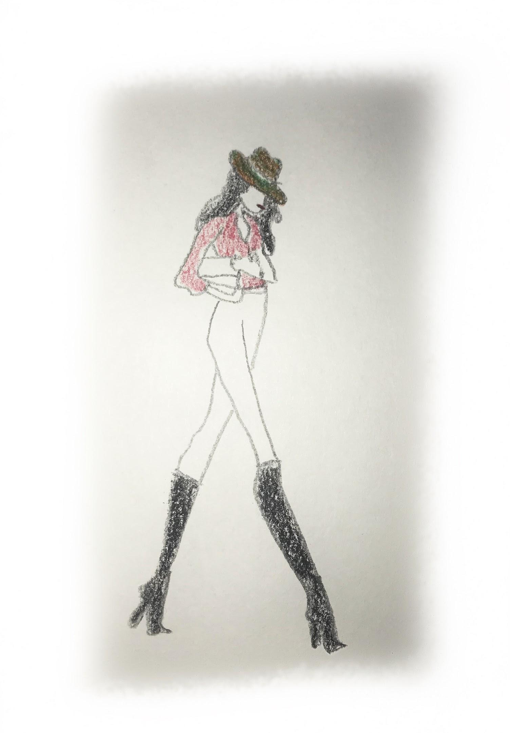

After working for 3 months, I decided to save up for a shoe that I was dreaming since high school. My first pair of Christian Louboutins. O M G. That is all I can say about the day that I was able to buy these popular shoes that every girl wished they had at my age. I remember I saved up mostly all summer long to buy these pair of heels. When I had the money I decided to walk into Saks Fifth Avenue and walk to the women’s shoe department. Walking on this floor is like a women’s heaven. Beautiful designer shoes left and right. Everything that you can think of is possibly here. But when I saw those beautiful Christian Louboutins, there was no turning back. I was determined.
The So Kate heel is a patent black leather heel that’s about 5.5 inches with a pointy toe at the front. It was Cream interior with a beautiful patent leather exterior with all solid red at the bottom. As soon as I walk over to the register and the sales lady tells me the total price, before she can even finish her sentence I hang over my debit card and decide to pay it for it as fast as possible before I regretted that huge purchase. I tried to not feel bad about it because I knew that I worked so hard for it. For any one who owns a pair of these shoes, they would know that they are very hard to walk on, but at the end of the day it was worth every penny. All those 8 hour shifts of annoying customers had finally paid off.
I first wore these heels to a dinner that me and Erick went to down in Meatpacking. I remember walking in those horrible concrete streets in those thin stilettos. Every step felt like I was going to fall how bad these shoes hurt. Was the pain worth me looking good? At this point I told myself heck yes!

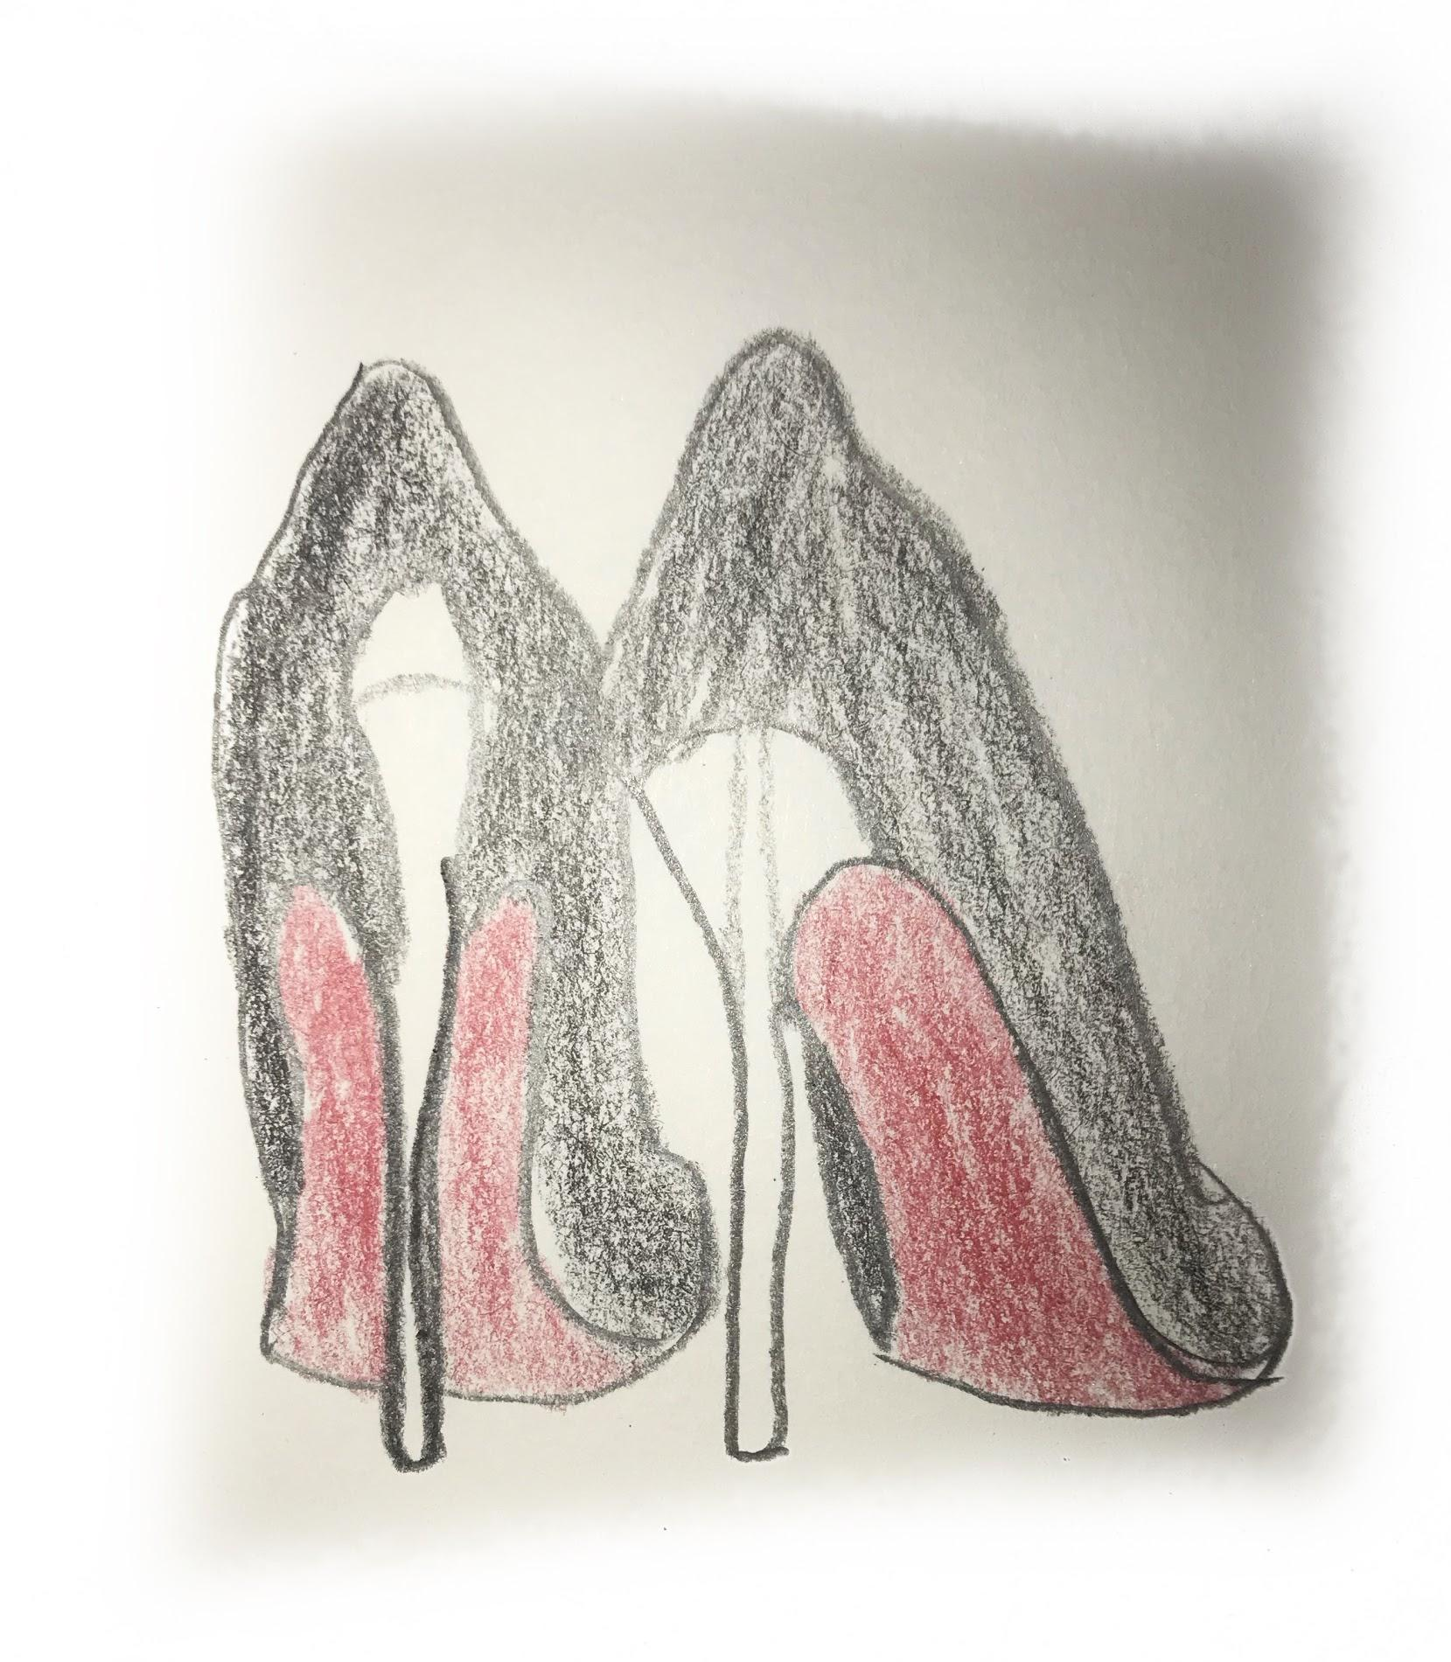

After Bebe, I decided it was time to move on, I got hired at a new retail job that I currently work in named Hugo Boss. Hugo Boss is a German brand that is known for its high quality suits. Working here turned into a complete 180. The reason why I say this is because in my previous job in bebe, I was able to wear anything I desired, In this Job I had no other choice but to wear a stupid uniform that reminded me of my high school. I have to wear a white collared shirt that had zippers on the side instead of it being a button down, I had to wear slim slacks, a black blazer and black patent leather loafers that are hard to work in on an 8 hour shift. But there is a reason why everything changed since I got here.
All of a sudden my way of dress changed. I noticed up to this date, I can switch my style up everyday. From wearings leggings with an oversized hoodie, to heels and dresses. The way I dress everyday is a part of me and how I carry myself. Fashion has become a huge passion in my life. Sometimes I would go to sleep late overthinking what I was going to wear the next morning. Even when I knew it was just a simple school day. That is how you know you have a love for dress, how I dress is my persona.
