Creating a Post using the block editor
Create a post by clicking on the + on the top of the main screen and choosing Post. You’ll be taken to the Dashboard, and the screen will look like this:
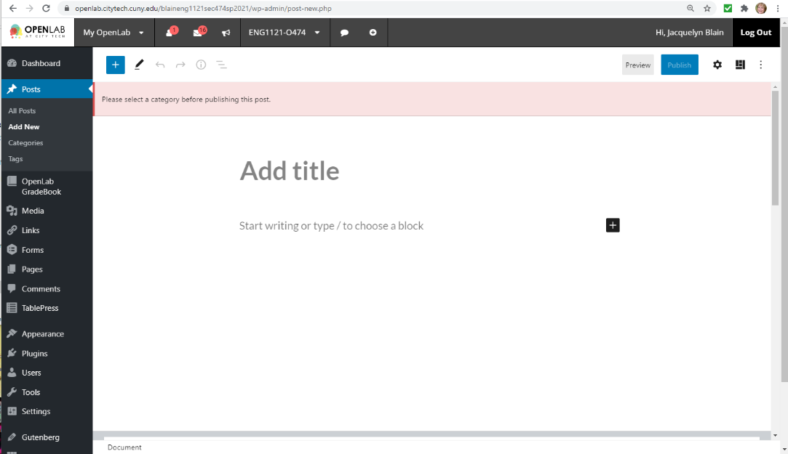
Not like the old OpenLab editor! Here are the important things to notice right now:
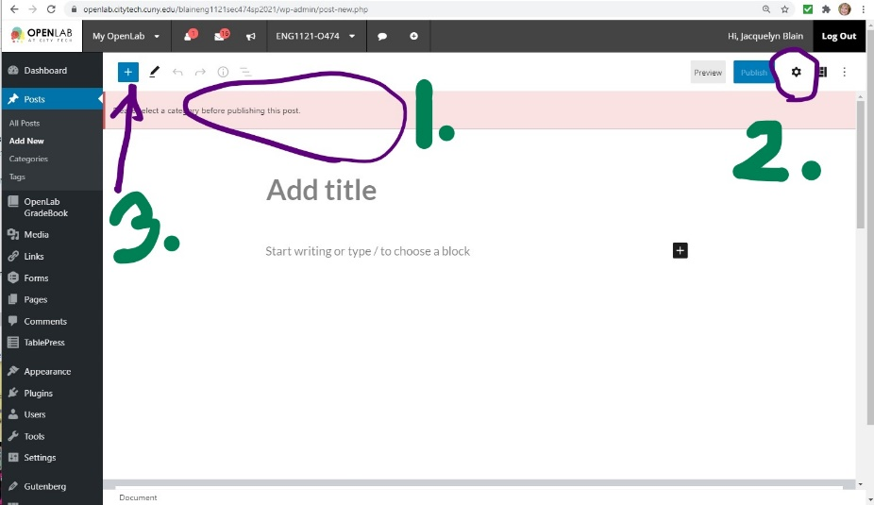 | - The pink bar says you have to choose a Category before you post. We’ll use…  - …the settings wheel to do that later.  - This big blue square with the + sign in it opens up the world of blocks! For now, just notice it’s there.

The first thing you’ll do is add a title. Then when you hit Enter, it will drop down to give you the usual text. Once you type something, you might want to add an image or a table or embed a YouTube, so click on the blue box with the + sign, and you’ll see…
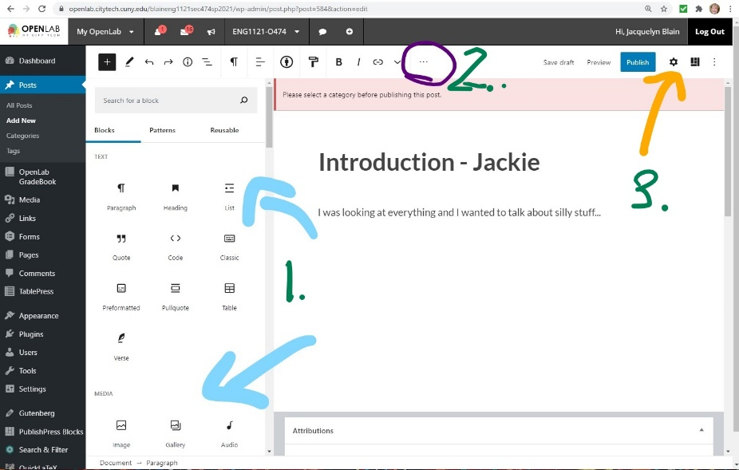 | - This sidebar menu pops open. You can scroll through all kinds of things to add – image, audio, cover, YouTube. So just click on the icon of what you want, and it will show up in the main work area.  - If you change your mind and don’t want that block, go to these three little dots, click on them, find “Delete block” and it will disappear.  - Once you’re all done, you have to go to the settings wheel before you try to Publish. If you accidentally hit Publish first, just click on “Cancel” when it shows up, and you’ll come right back here.

Once you’re ready to Publish, again, be sure to click on the Settings wheel. This is what you’ll see:
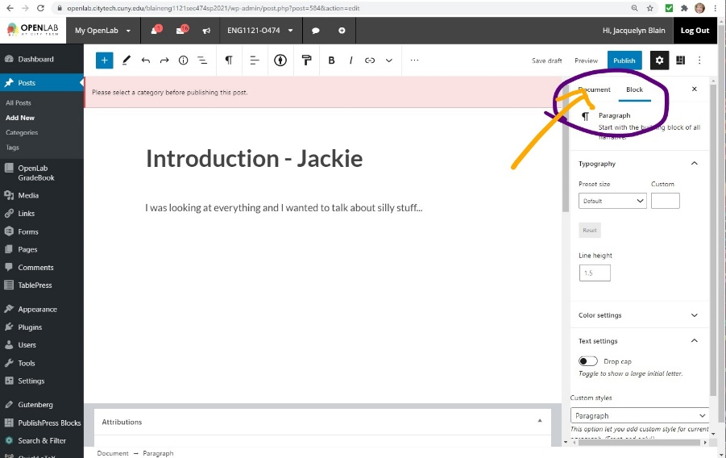 | - This sidebar will drop down.  - The purple circle shows you have two choices: Block is the default, but you want to click on Document.

The sidebar will change and you’ll see this:
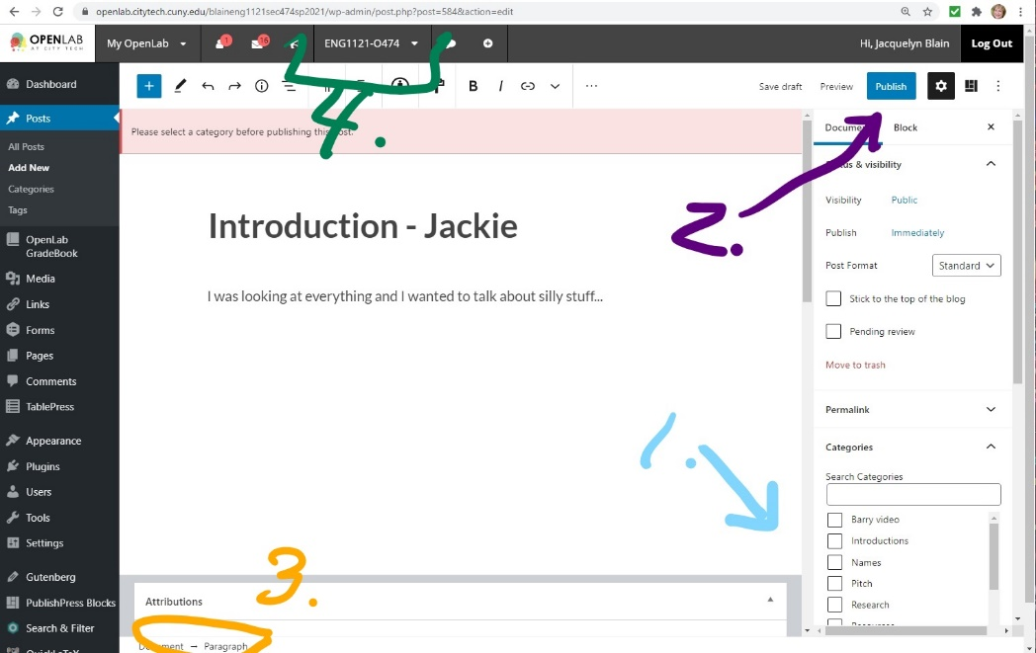 | - Scroll down to find the Category you need. Click in the box.  - Now you can hit the blue Publish box.  - Once you’ve done that, you’ll get a little message on the very bottom that says “View Page.” Click on that, and you’ll be taken back to where your post has been published.  - You can also just go back up to the top of the page and click on the course name/number. That will take you back to the Announcements page
.

