How to set up and use Slack for class

Install the Desktop and Mobile Apps
- If you don’t already have Slack installed on your computer, download the desktop app for Mac or Windows. (If you are using a computer less than 10 years old, your chip is almost guaranteed to be 64-bit. To confirm, try going to computer Settings – About – Device Specifications – System type.)
- If you use your phone or tablet for most of your work, download the mobile app for iOS or Android. You can also reach your Slack workspaces through a browser by visiting dartmouth.enterprise.slack.com.
- Installing Slack on your mobile device is a great way to keep up with important messages. You can download mobile apps for iOS or Android from the App Store or Google Play.

The Basics of Slack

A Tour of the Interface

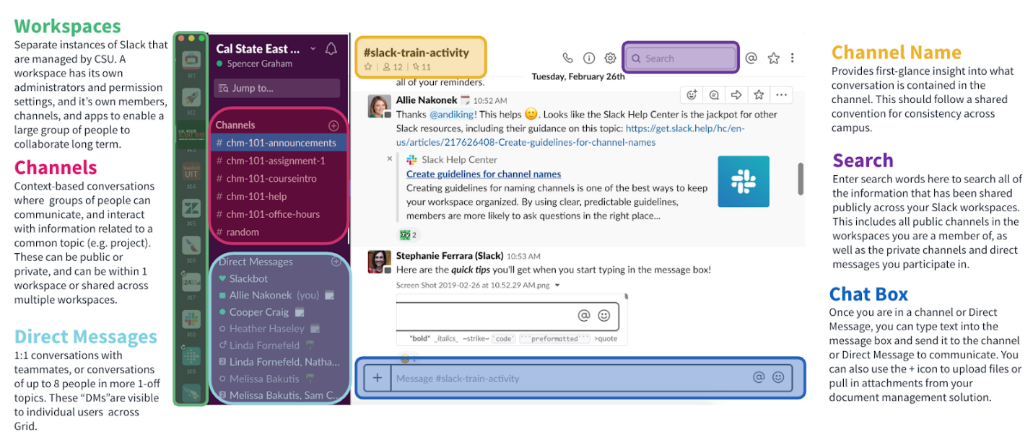

Workspaces
- The workspace sidebar shows you which workspaces you are signed into. You’ll likely have a workspace for each course you’re in, and you might have a community-wide workspace for departmental announcements, events, and day-to-day collaboration beyond your courses.

Channel Sidebar
- The channel sidebar is where you navigate into your conversations on each workspace. It is divided into sections for channels, direct messages, threads, and apps.

Messaging Area
- The messaging area is where the action happens! Here you can view and post messages, search, post files, and more.

Search Bar
- Type in the search box to quickly find messages, files, channels, and users across your workspaces.
- Tip: use “CMD+K” on a Mac or “Ctrl+K” on Windows to quickly switch to a different channel or conversation and view your unread messages.

Join Channels
- In the Channels section of the main sidebar, you will see a few channels to which you are automatically subscribed.

Posting Basic Messages in Channels
- To post a message to a channel, first select the appropriate channel in the sidebar.. Then, type something in the chat box, and hit Enter.
- If you want to mention someone to get their specific attention, begin by typing the @ symbol. Keep typing to find their name, and select it from the dropdown list that appears. You’ll know you’re about to notify someone when their name gets highlighted in blue. When you send your message, you’ll send that person a notification.
Replying to Messages
- You have some choices about how to reply to a message. The simplest is to just type something in the Chat box.
- However, if you hover over the original message if you’re on a laptop, or tap on the message if you’re on your phone, you’ll get other options.
- Laptop/desktop: On the floating bar you can: 1) click on the emoji to add reaction, 2) click on the balloon to reply in a thread about this specific topic [good for organizing things], 3) click on the arrow to Share the message with other people in the workspace [you’ll get a list of members you can click on to share with], 4) click on the bookmark to add to saved items, and 5) click on the three dots to delete your own message [don’t delete other people’s messages!!!]
- On phone: Tap on the message itself. You can find the other icons once the message moves into a new screen.

Sending Direct Messages (DMs)
- Best practices for Slack use promote the idea of first searching and/or asking questions in channels, as opposed to private messages. This approach allows other members to see your question and any knowledge shared in response. It is likely that others may have had a similar question and were not as comfortable to ask, or they may gain from hearing the question and associated answers or discussion. The more perspectives at the table, the better the discussion.
- When you need to send a message to one person instead of a group, Slack provides traditional instant messaging functionality for you to do so. To send a direct message, navigate down to the Direct Messages section of the main sidebar. If the person is not already on your list, click the + icon, search for the person you would like to message, click on their name, and click GO. Then, type something in the chat box, and press the Enter. Unlike public channels, your direct messages are private between you and the recipient(s).
- Note: While DMs are private conversations, sensitive or confidential information should not be discussed, and Personally Identifiable Information (PII) should not be uploaded to or shared on Slack. PII includes birthdates, birthplaces, Social Security numbers, credit card numbers, and other sensitive information regarding one’s identity.

Search
- Messages and files added to Slack are instantly searchable, so you can quickly come back to documents and discussions when you need them. Slack’s robust search functionality enables you to find key information quickly, even inside shared files.
- To access Search, type your query in the Search field and hit Enter or Return. Your results will appear in a panel on the right of the Messaging area. You can refine results by channel, person, date, file type and more.

Finding New Activity in Slack
- Slack informs you of activity in your channels or conversations in a variety of ways:
In the main sidebar:
- When a channel name is bold in the channel list, it means there’s new, unread messages in that channel.
- When a channel name is bold with a red badge, it means there are unread messages where you were mentioned.
On your desktop dock icon:
- A red circle with a white dot means there is some unread activity in one of your Slack teams.
- A red circle with a number indicates direct messages, mentions, or messages containing one of your highlight words.
Through desktop notifications:
- By default, Slack will send you desktop notifications only when you receive a direct message or mention. You have the option to adjust these settings to your own preferences.
- If you’re not online on your computer, Slack will send you mobile notifications when you receive a direct message or mention. You can also adjust these settings as needed.
In the Activity pane:
- The Activity pane lists out your latest mentions, highlight words, and emoji reactions. You can think of this pane as a bit like your Slack inbox. It’s generally a good place to check first when getting caught up in Slack. To access, click the @ icon in the top right corner of Slack.

Beyond the Basics

Files
- You can upload files such as images, documents, or presentations to Slack in a few easy ways:
  - Click on the button on the left hand side of the message box
  - Drag and drop your file from your device into a channel
  - Copy an image from online, then use Ctrl/Cmd + V to paste it in
  - On mobile, tap the file attachment icon in the chat box to upload a file, or tap the photo icon to upload images
- Give your files a good, descriptive title — it makes them easier to find later! Slack’s powerful search also indexes the content of all files you upload (or link via Google docs or Dropbox) so you can easily find the information you need later, making Slack a great place to share files. REMEMBER: Sensitive or confidential information should not be discussed in Slack. Personally Identifiable Information (PII) should not be uploaded to or shared on Slack. PII includes birthdates, birthplaces, Social Security numbers, credit card numbers, and other sensitive information regarding one’s identity.

Posts
- Posts are a way to share and collaborate on long-form content — like lecture notes, project plans, to-do lists, or meeting agendas — directly in Slack. To create a post, click the + button, then select ‘Create a post’. Posts are private to you until you share them to a conversation in Slack. To share your post, click the Share button at the top right and select a channel or person to share it with.

Pinning
- Pinning is a great way to highlight important files, posts, or messages in a channel so they are easily referenced later, or so that newcomers to the channel can find them right away. To pin something, hover over the message, click the [•••] icon and select “Pin to channel”. To view all the pinned items in a channel, click the “Show Channel Details” icon at the top of the channel, then expand the “Pinned Items” section.

Stars
- Stars are a great way to bookmark any Slack message or file for later. Your Starred Items can also be used as a simple to-do list: items appear in the order you star them, and you can unstar to remove a task from your list. To star a message, hover over it and click the gray star icon. To star a file, click More actions and select Star file.

Emoji
- Emoji are a great way to quickly respond to messages and can be useful for things like voting, checking off to-do items, showing excitement, or just for fun. They can also be placed in your messages to convey tone, and make your messages more impactful.
- Adding emoji “reactions” onto a message is a great way to keep the noise down in channels. To add an emoji reaction, hover over a message and select the “Add reaction” icon and choose an emoji.
- Here are a few common emojis reactions and their meanings to get you started.
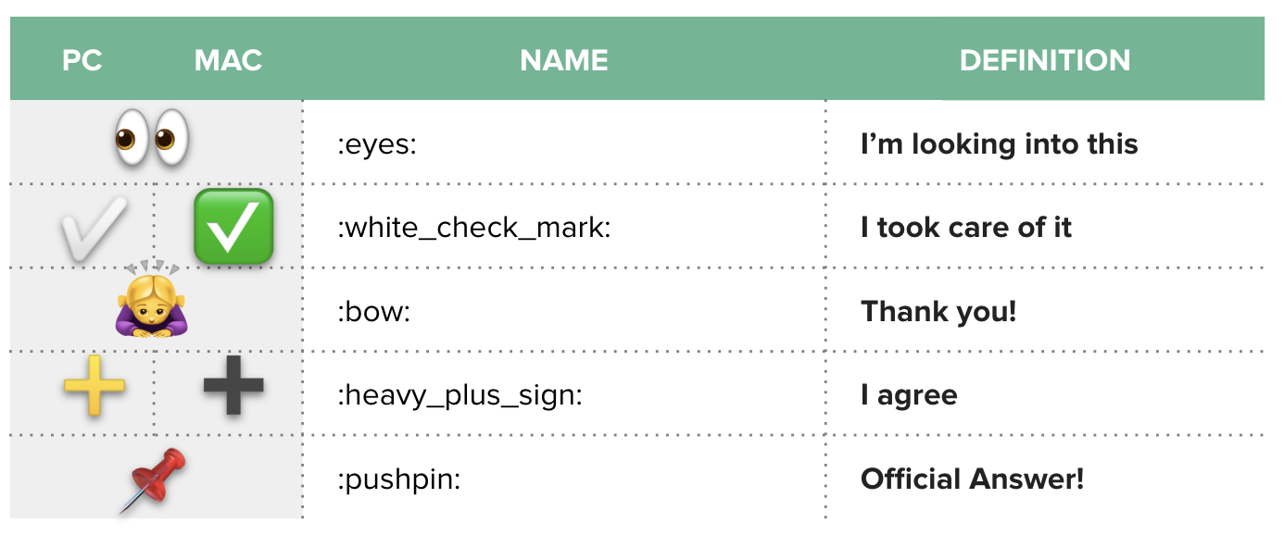

Slash Commands
- Slash commands are shortcuts you can type into the message input box to perform an action. For example, typing /mute will automatically mute whatever channel you are in. Or, typing /invite + @ username will automatically invite that person into the channel.
- To see the full list of slash commands available, just type “/” and a menu of slash commands will open.

