Instruction Manual:HOW TO CREATE AN ICE-CREAM TRUCK USING LEGOS

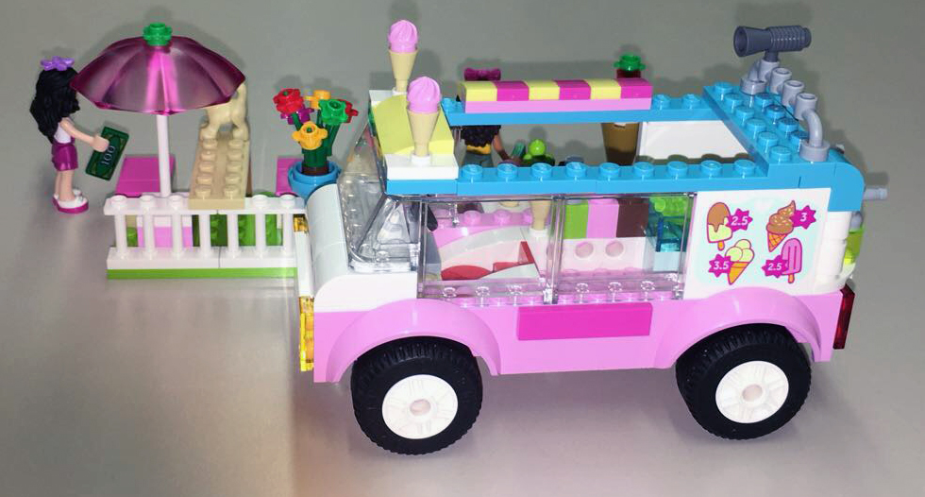BY: VALINIE ALLI

Introduction: I will be creating a very fun and colorful Ice cream truck for children ages 4 and up. Keep in mind that one of the greatest and most easily recognizable benefits of Legos is its ability to bring out the creative side of a child. Playing with Legos, being able to utilize the shapes, sizes and colors can add more educational benefits within a child’s creativity. Also for parents helping your child build something can helps create a stronger bond between both of you. I plan on using actual photos of the ice cream truck that I took while building it to include in my manual. Since my manual is targeting children ages 4 and above with or without the help of parent they may be able to build it, with the help of these actual step by step images.

10 Skills Children Learn from LEGOs
1. Fine Motor Skills
Using LEGO bricks is the perfect opportunity for building fine motor skills LEGO bricks are a great way to work the fingers as children build and even pick up LEGO pieces. Children love the thrill of building and they can do this for hours, building up strong little muscles in their hands that will help them do other skills, such as learn to write.
2. Cooperative Play
It’s so easy for LEGO building to turn to a time of imaginary bliss with adventures, heros, villians, animals, and even family members. Using LEGO minifigures and bricks with other peers gives children the same skills they would learn in dramatic play.
3. A Sense of Accomplishment
When my children have finished their amazing work of art, they are excited to show me their creations. They have made something they are incredibly proud of, which is good for their hands as well as good for their heart. Most of the time they come up with an idea in their heads, then they begin to piece it together.
4. Persistence
Building with LEGO bricks sometimes leads to heartbreak. A beautiful tower comes crumbling down with one wrong move.
Initially, this is frustrating. I’ve learned though that children who use LEGO bricks regularly are not defeated by this. Instead, they make it again. This can help make your kids more patient.
5. Solving a puzzle
It doesn’t matter whether a child uses an instruction booklet or builds completely from their own imagination. They are solving a puzzle. A bucket of LEGO bricks becomes a new opportunity!
6. Math Volume, quantity, one to one correspondence, symmetry, patterns, and more all can show up when a child plays with LEGOs or Duplo’s. Let’s not forget addition and subtraction. When you give a child a limited number of Legos to complete their entire project, they learn that each one counts. They begin to understand that each and every brick, minifigure, and piece has a value! Children can even begin the complex task of rationing their supply to complete their masterpiece.
7. Science
Science is the driving component behind all creations that a child has. The foundation of science is to come up with an idea and to prove it practically. LEGOs do this naturally through imagination. A child simply comes up with an idea then develops it.
8. Technology
Put simply, technology is using new techniques to accomplish a task. LEGOs teach children to use basic materials to complete a task. I love this idea to build a LEGO candy dispenser.
9. Engineering
This is all over LEGOs! Want to build a bridge? Then you must figure out what it takes to stand up. Children quickly learn that a tower made of a single column quickly falls. By creating a stable base, they open up a new world of possibilities.
10. Creativity
Every LEGO creation is a form of art. A child’s imagination is the only limit. Children become creators with the hundreds of tiny pieces. They can use wheels, shapes, and even “people” figures to build the ideas in their minds. It can be useful, entertaining, or even therapeutic.
As you can see there are so many important skills children learn from LEGOS !
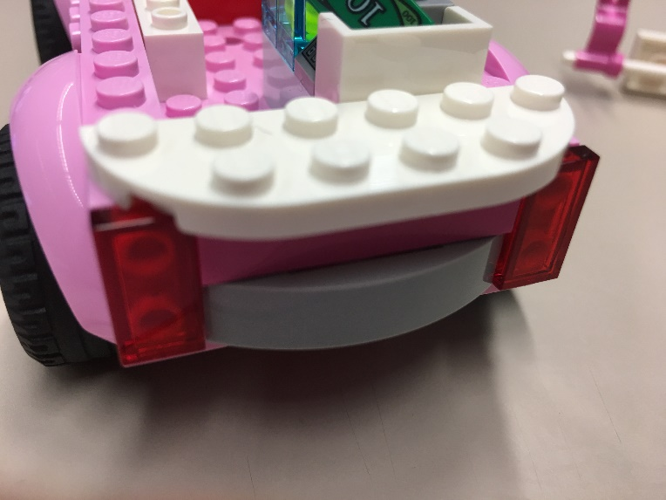
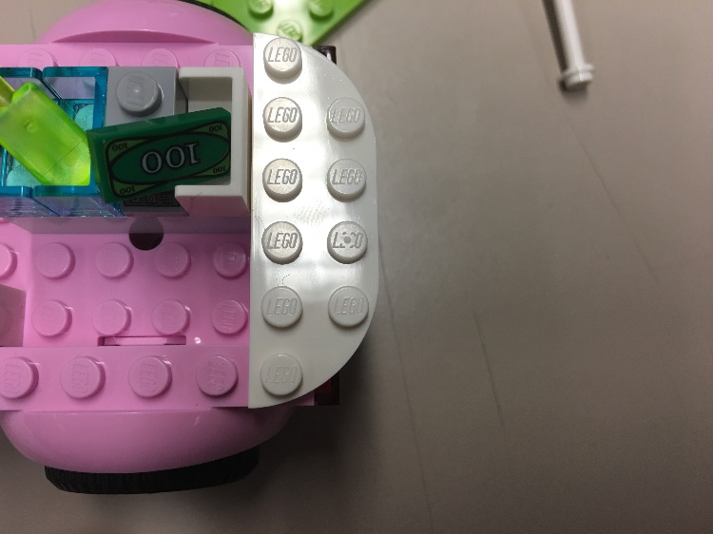
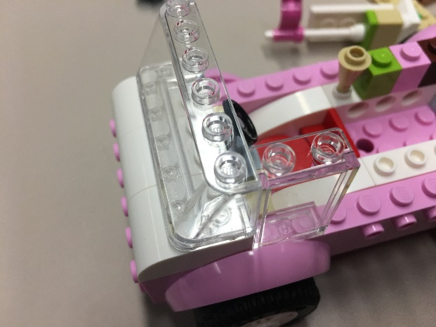
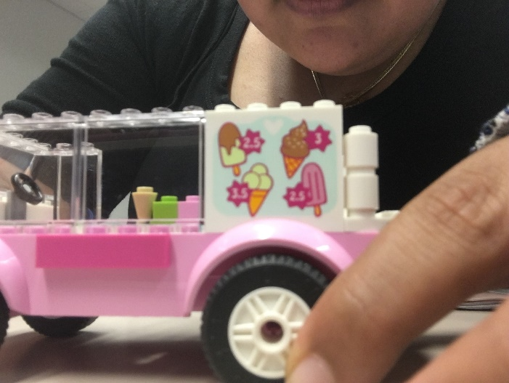
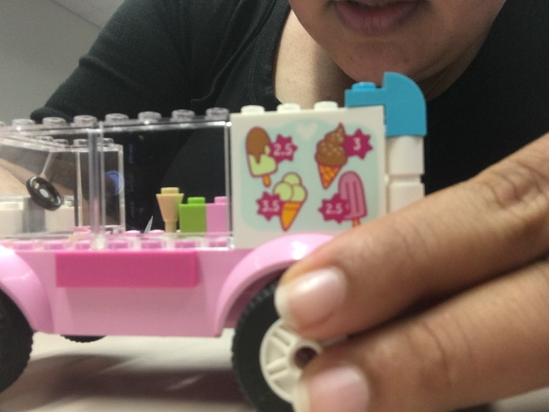
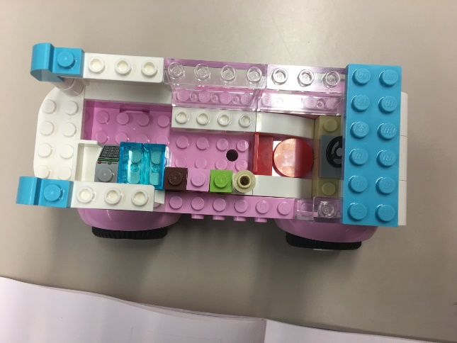
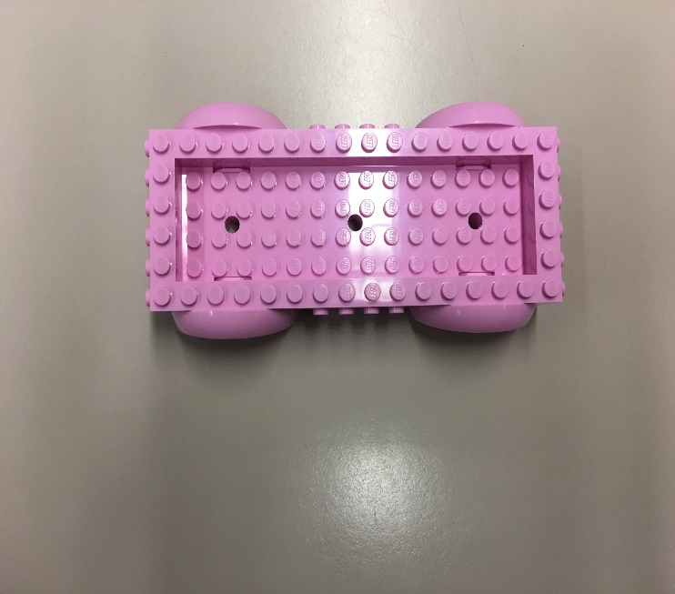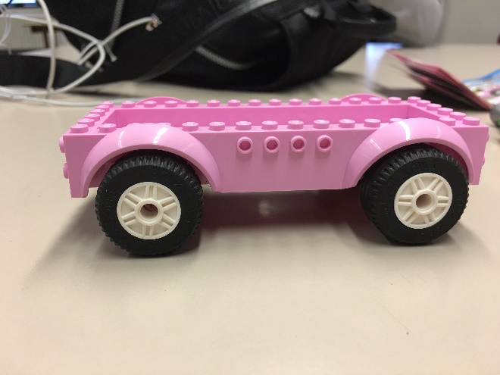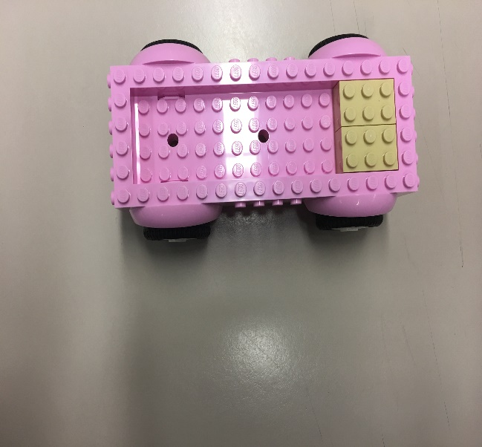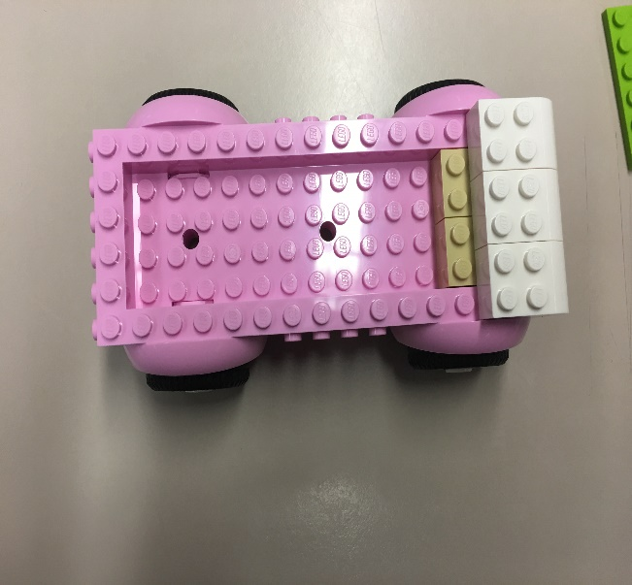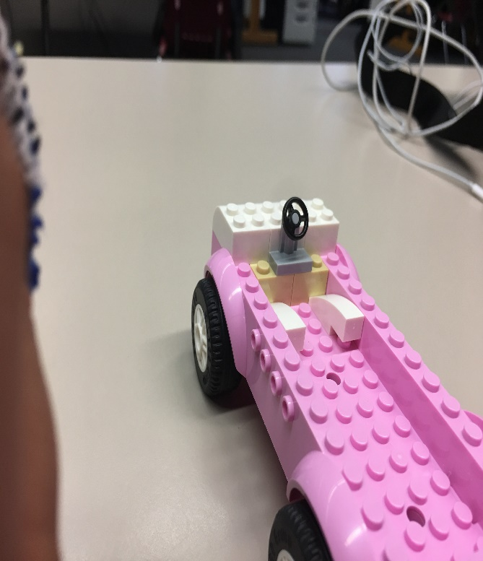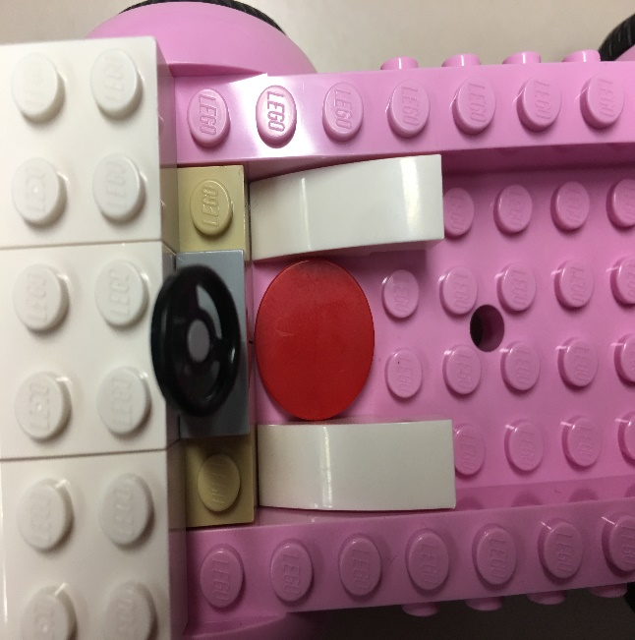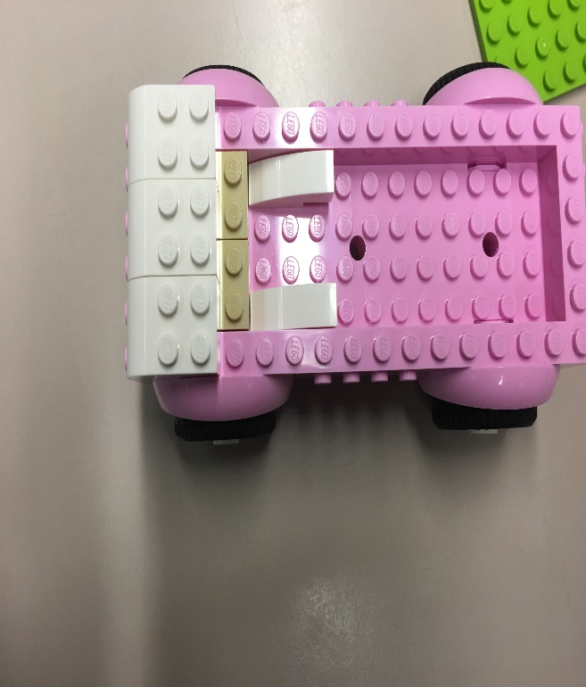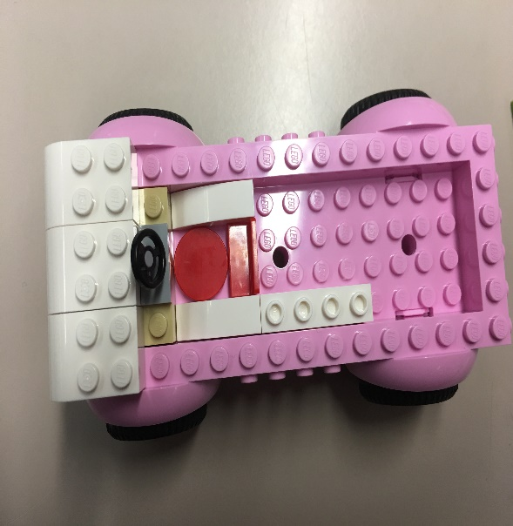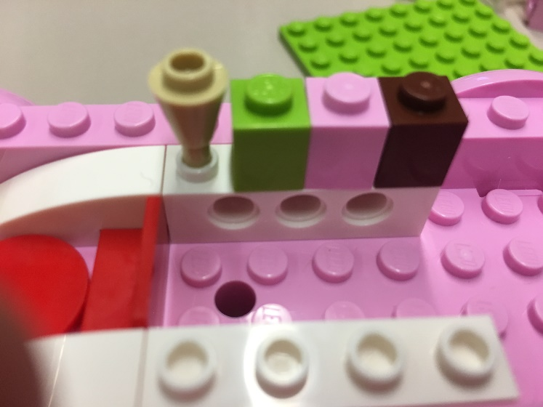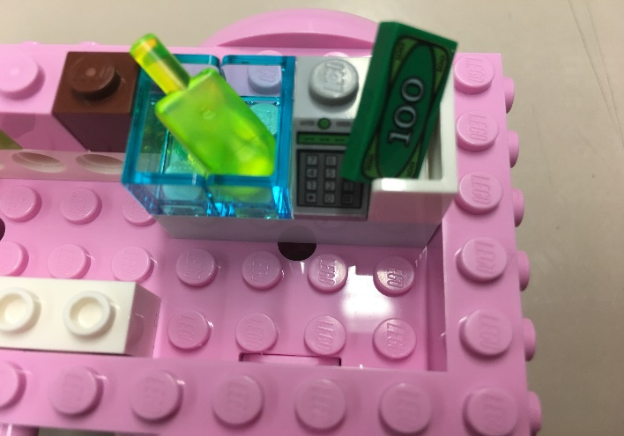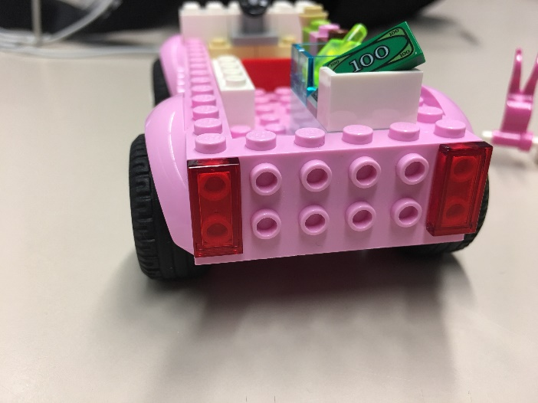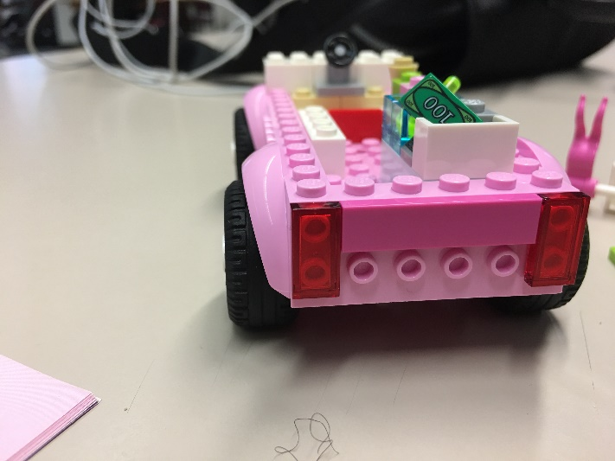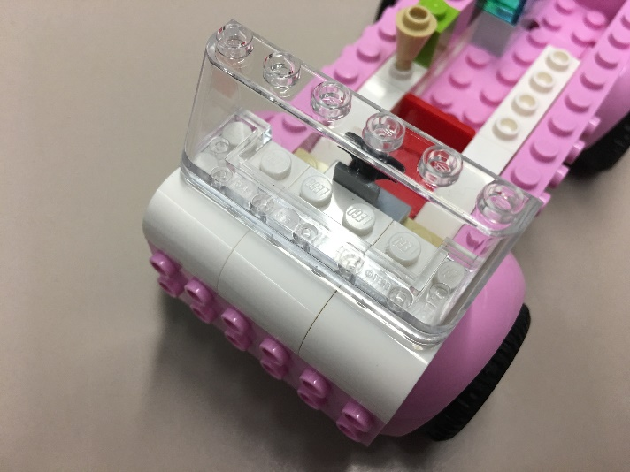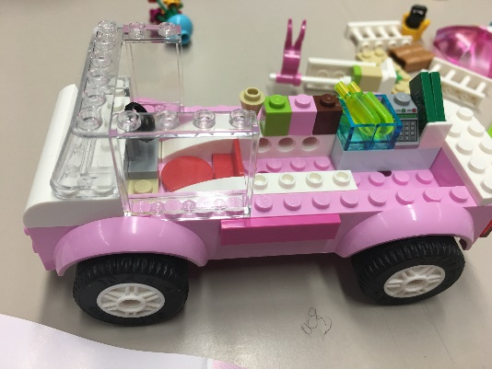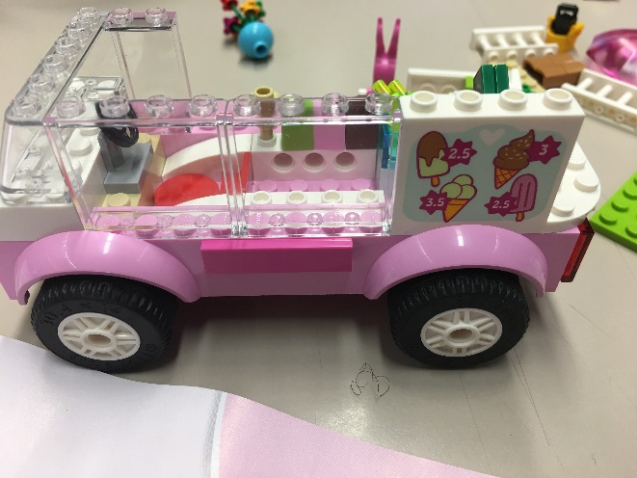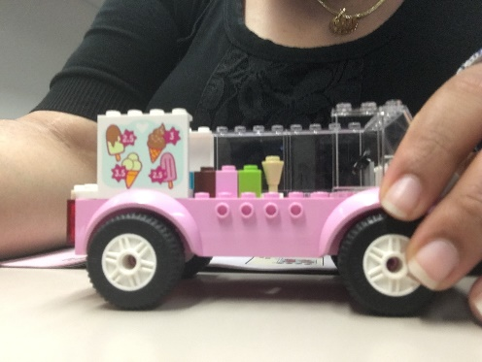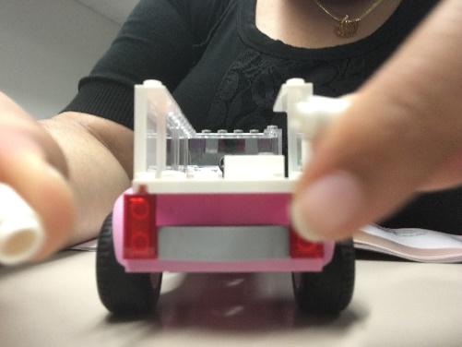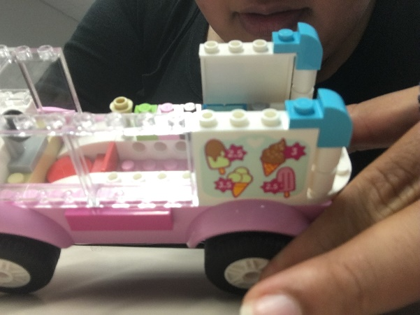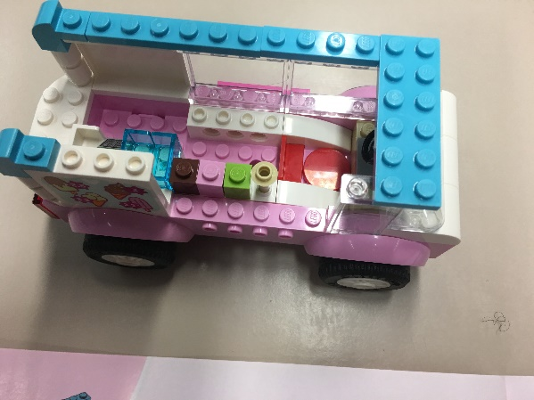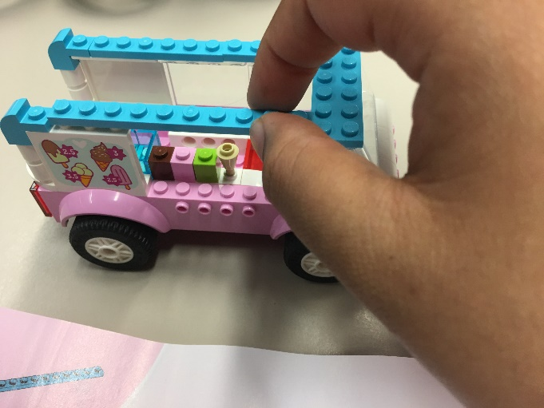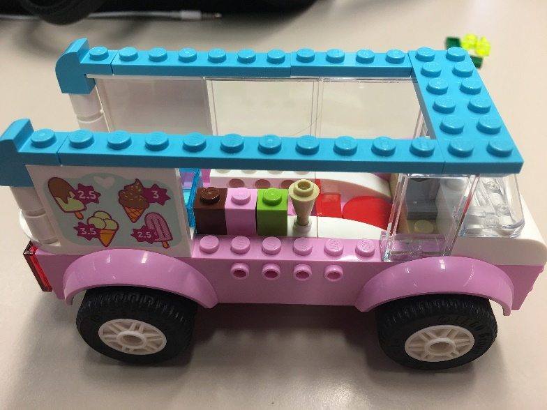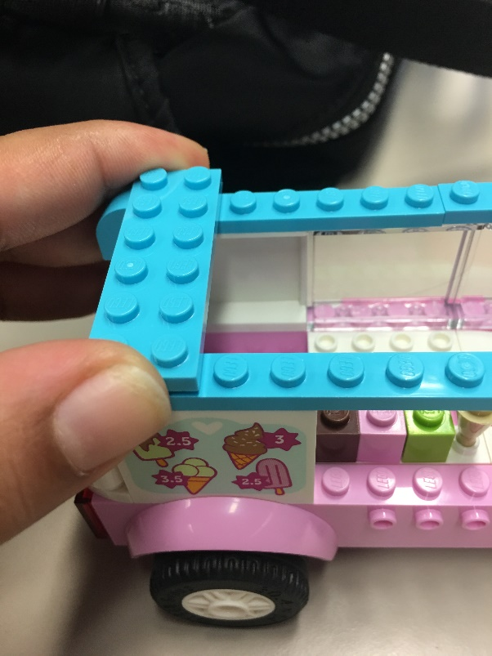
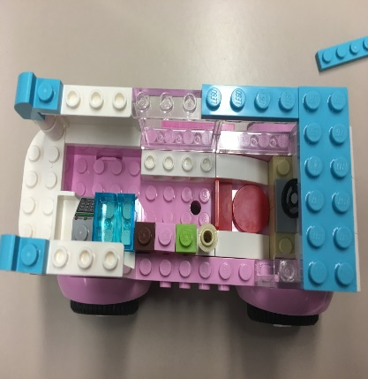
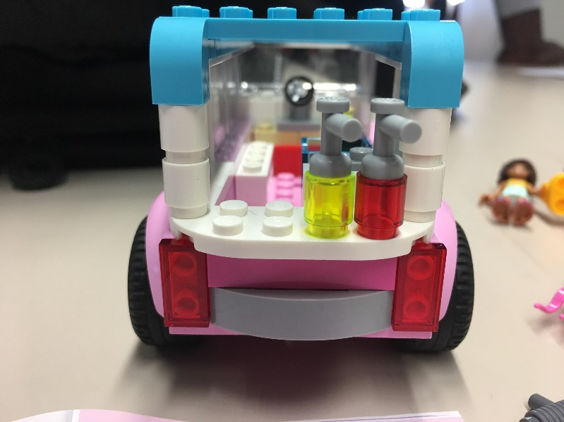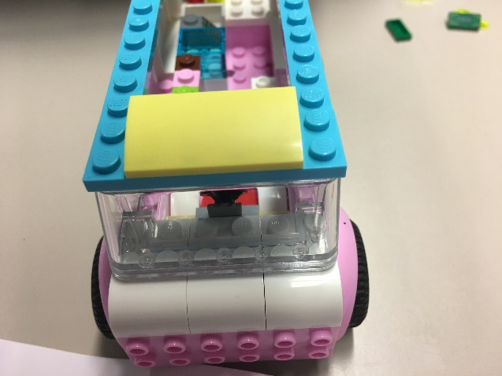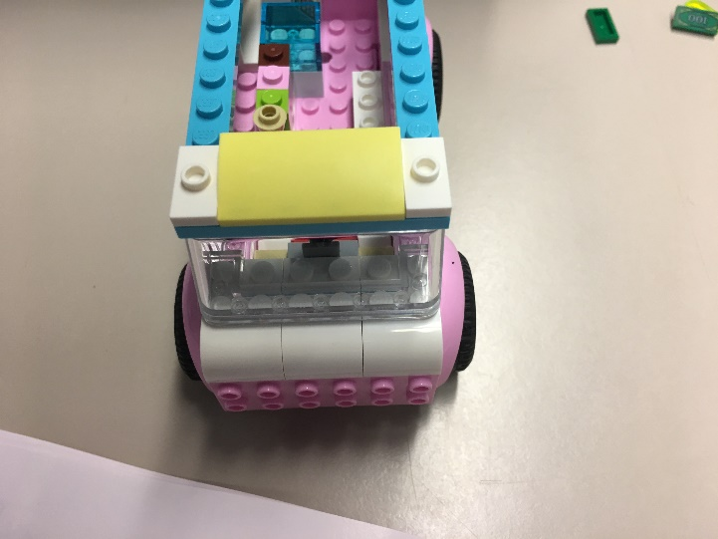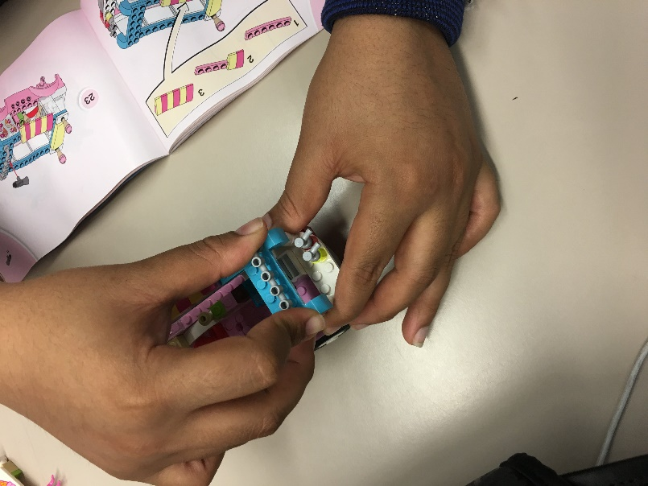
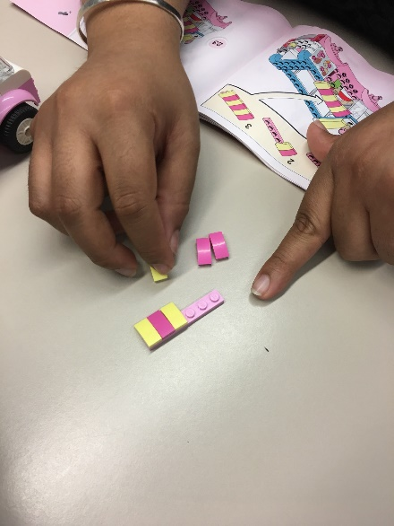
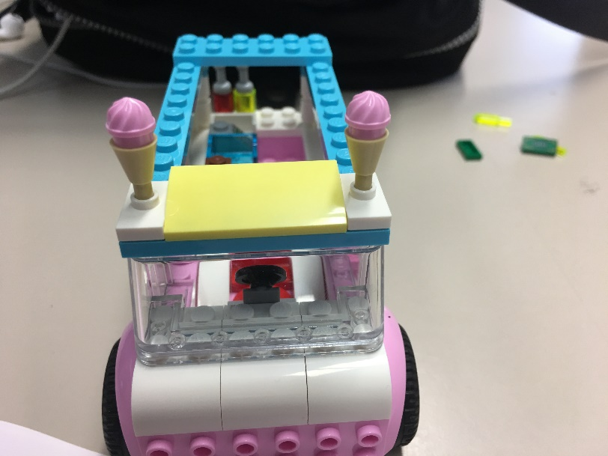
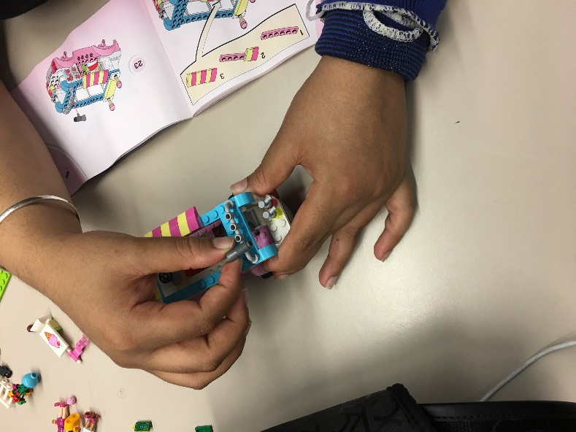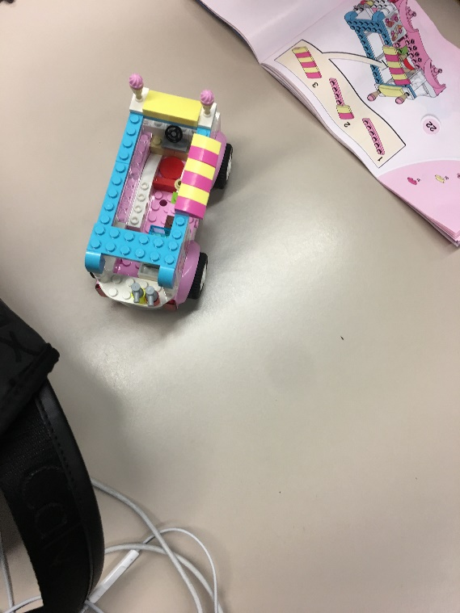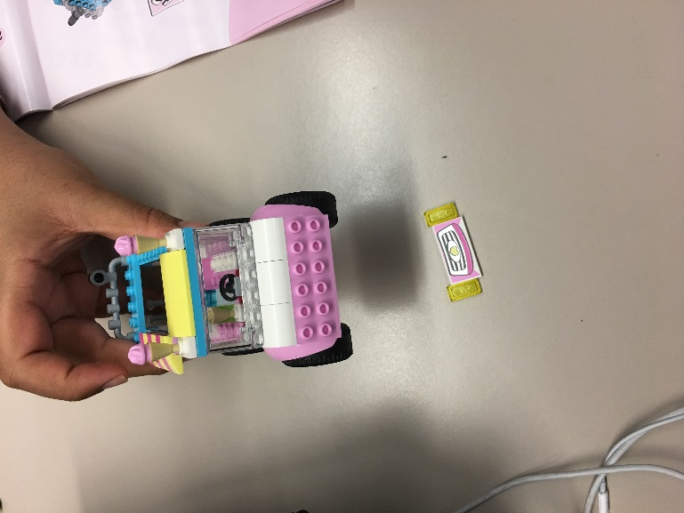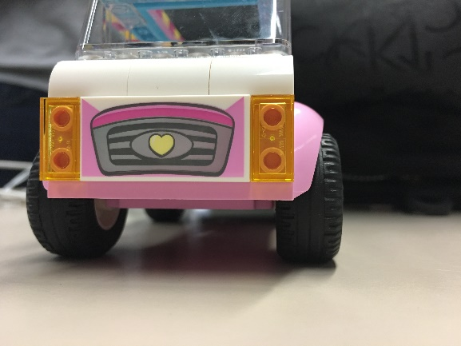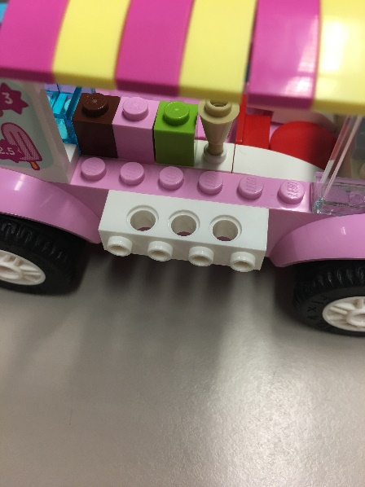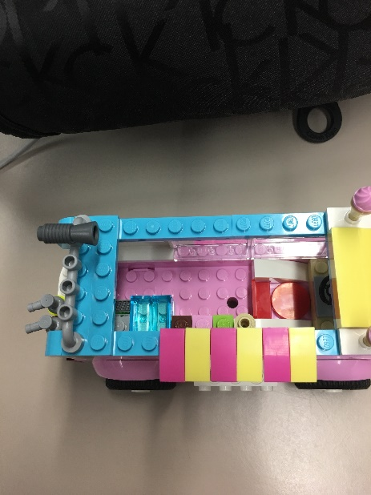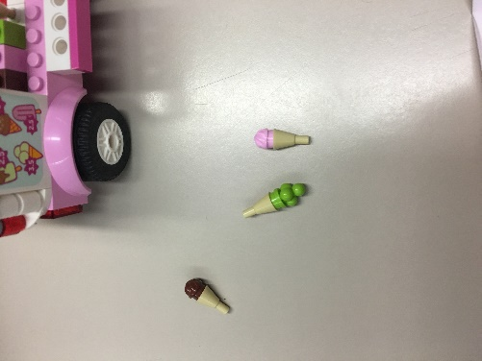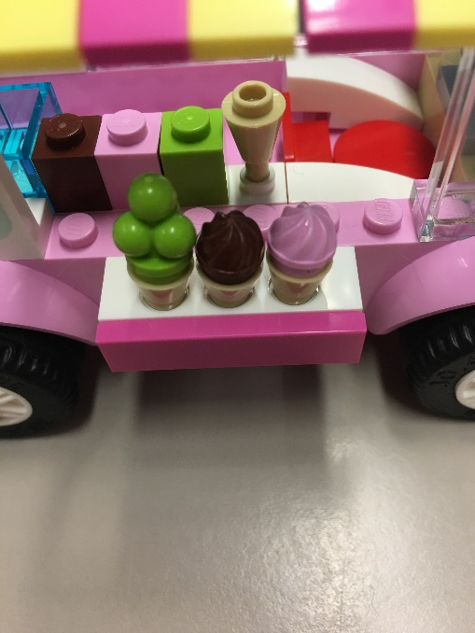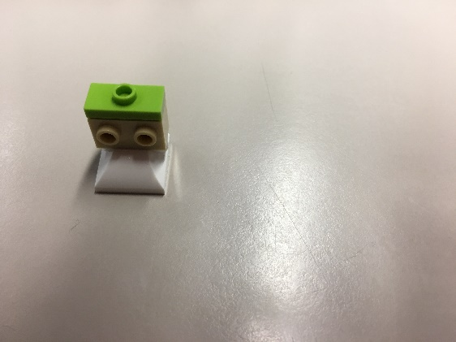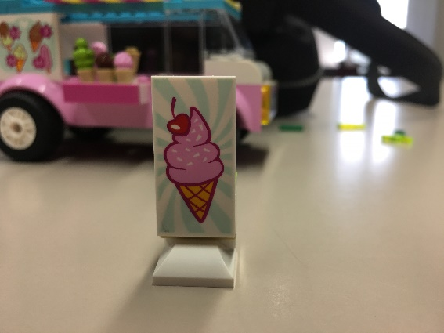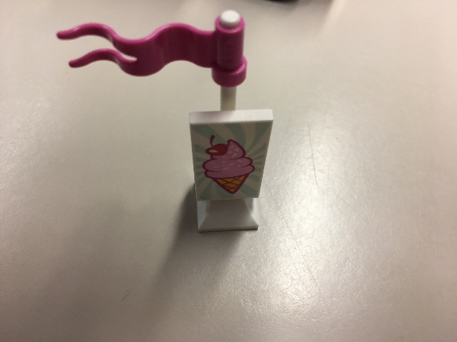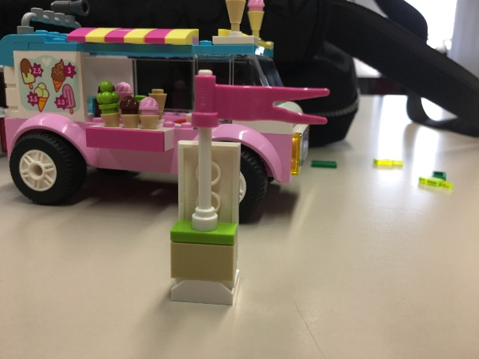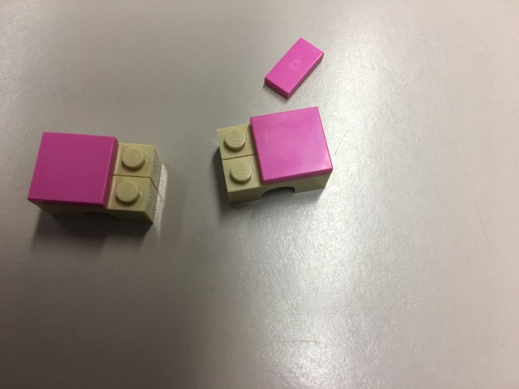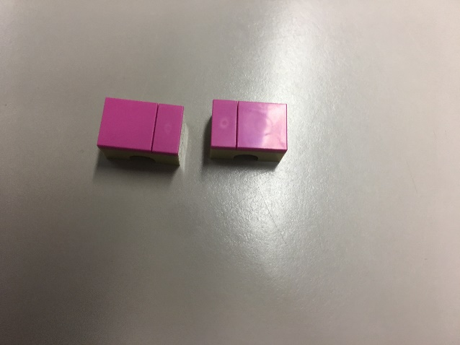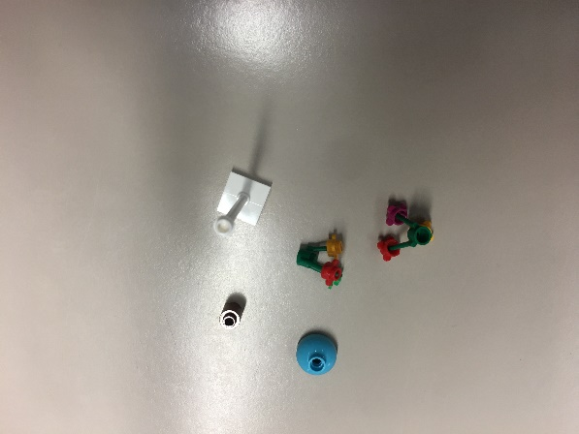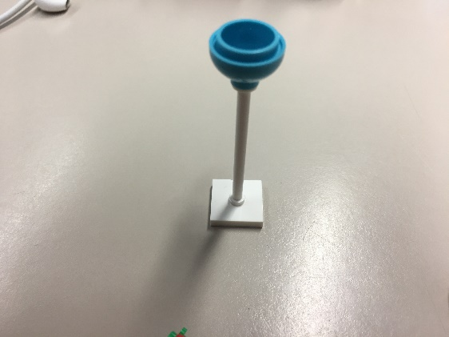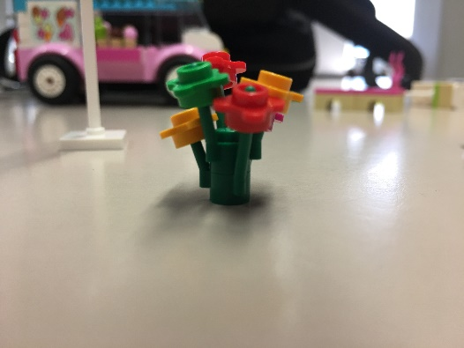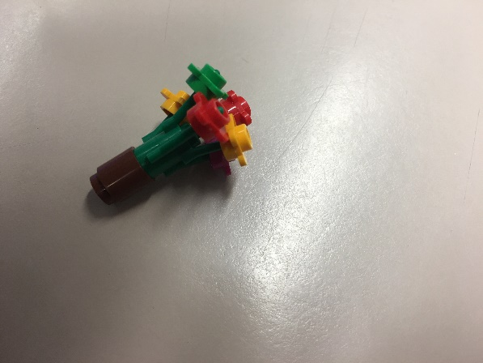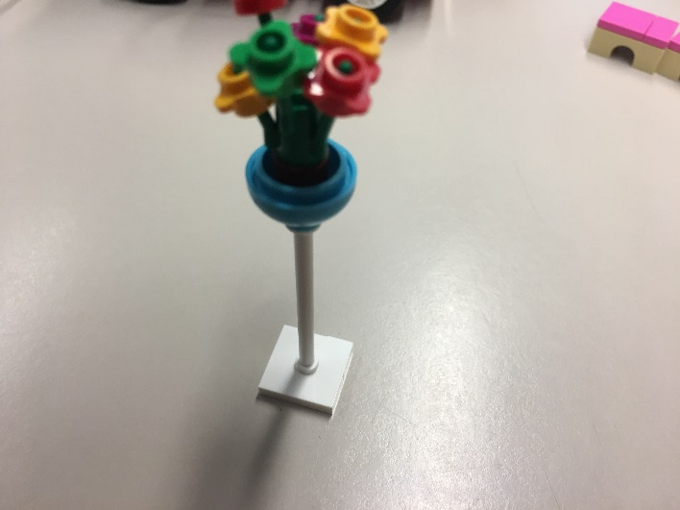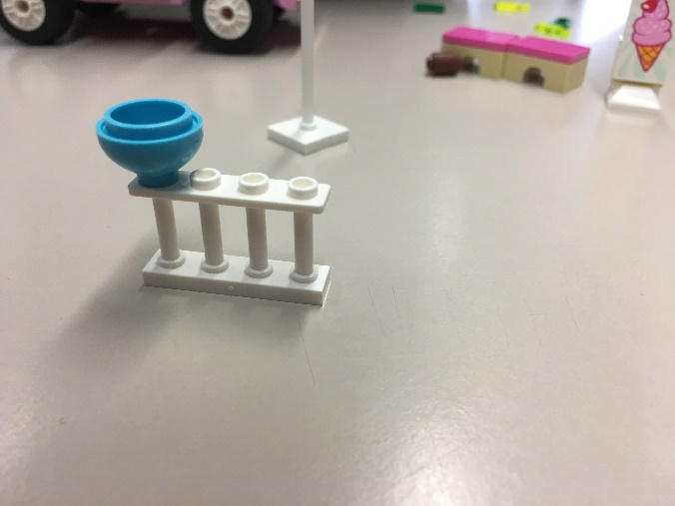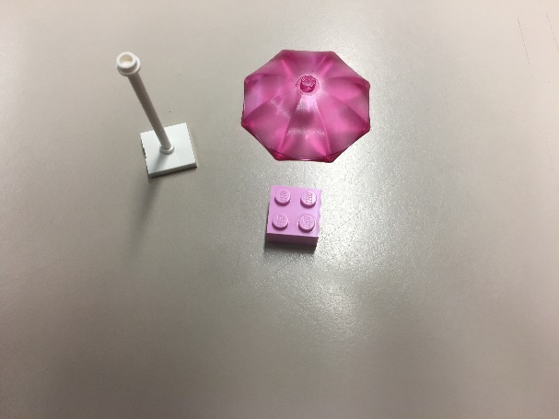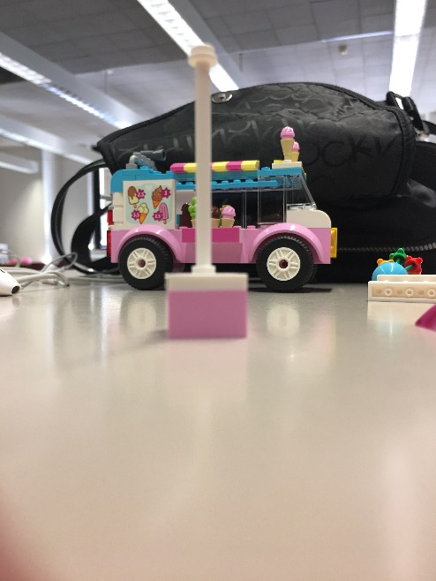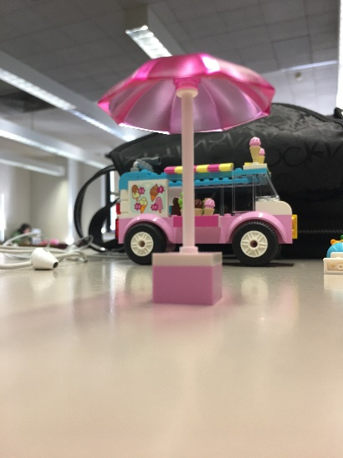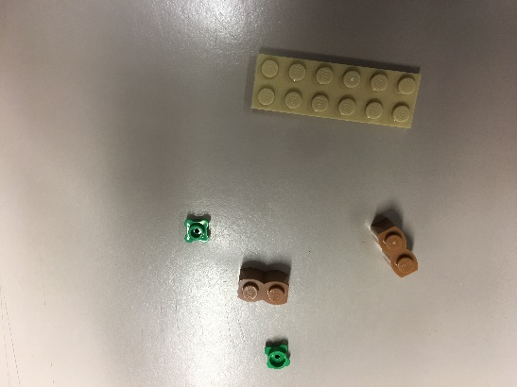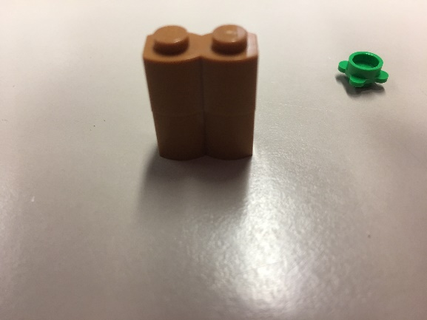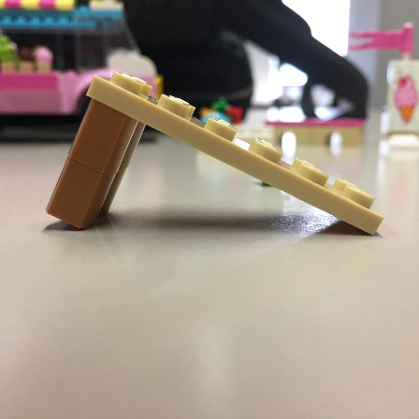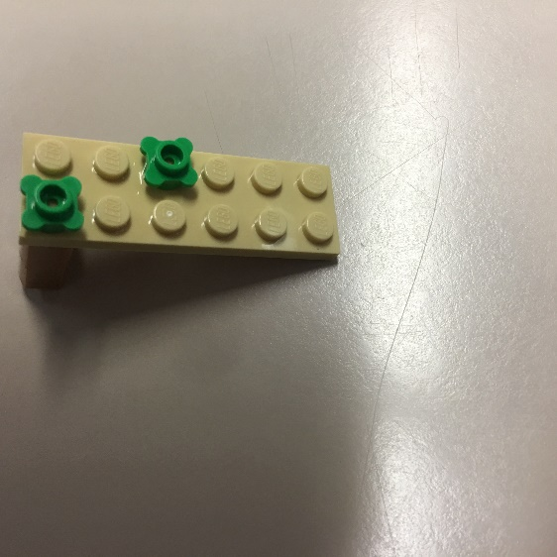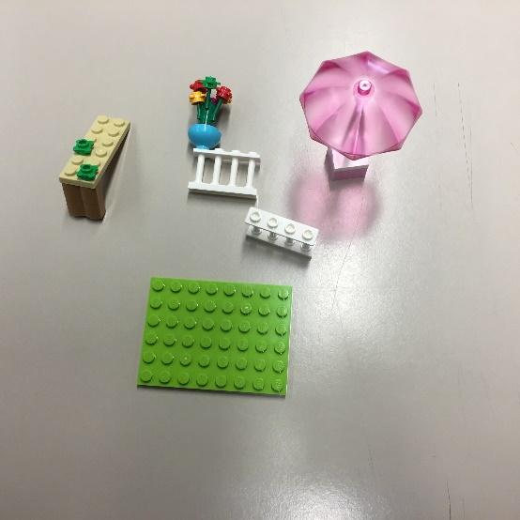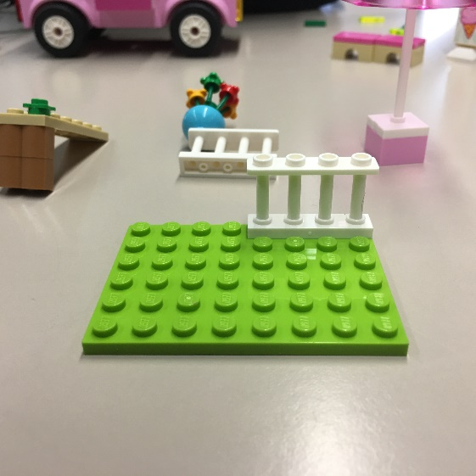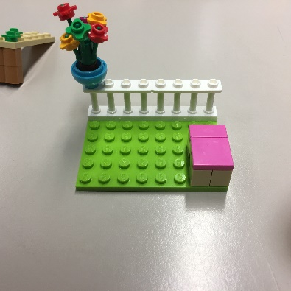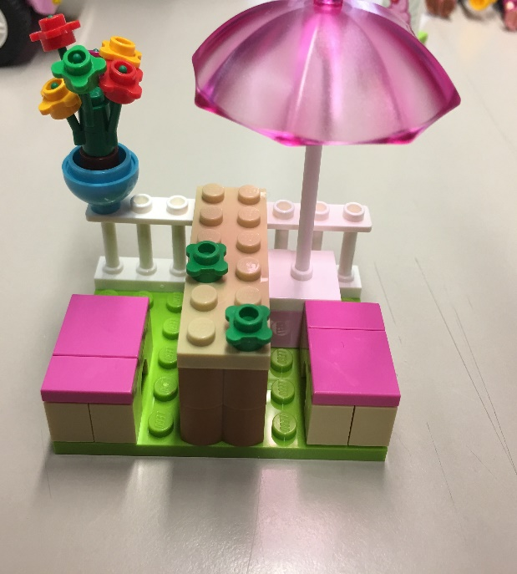
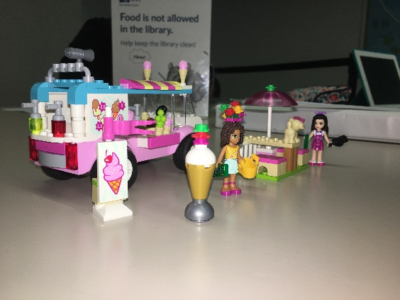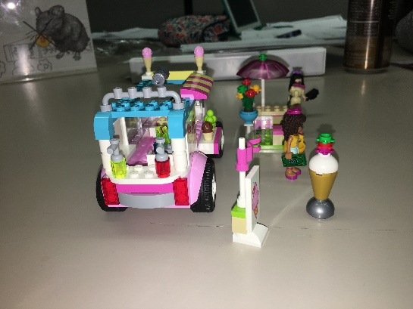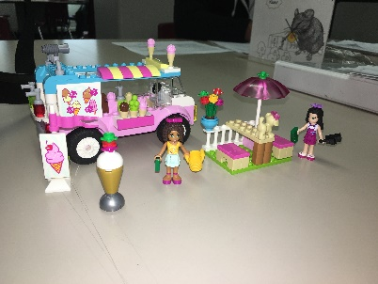
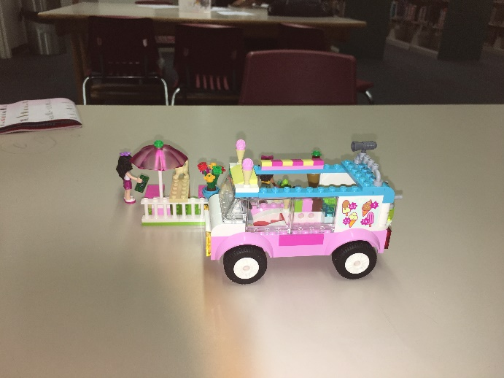

This is how your final product should look.
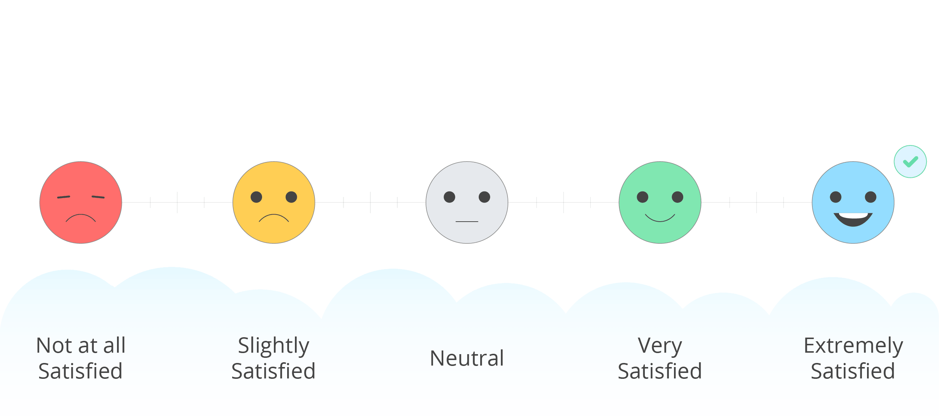

Skills Development:
- Lego provides tools that develop lateral thinking in a fun environment
- It teaches kids to think in three dimensions
- It improves literacy as kids work with instructions
- It develops problem-solving, organization, and planning by construction
- It improves creativity
- It enhances communication and critical thinking
- It boosts their motor development.

