Building a Red, White & Blue Tower

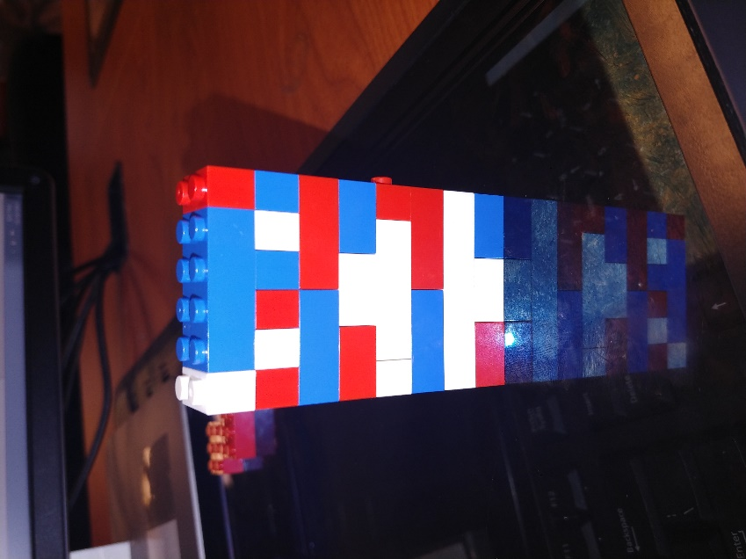

Marcia Elias
ENG 2575
November 2, 2017

Table of Contents
Introduction & Glossary Pg. 3
Instructions
Getting Started Pg. 4
Step 1 Pg. 5
Step 2 Pg. 6
Step 3 Pg. 7
Step 4 Pg. 8
Step 5 Pg. 9
Step 6 Pg. 10
Step 7 Pg. 11
Step 8 Pg. 12
Step 9 Pg. 13
Step 10 Pg. 14
References Pg. 15

Introduction
I have created a basic rectangular tower with the colors red, white and blue that represents both my countries; United States of America and Puerto Rico. I created a simple design because I am an easy going and I wanted it straight to the point. This model and instructions are for 6-8 years old. School age children cognitive abilities deal with problem solving and longer attention spans.
Glossary
- Cognitive Development
- The development of thought processing, problem solving, remembering and decision making from childhood through adolescence to adulthood.

Getting Started
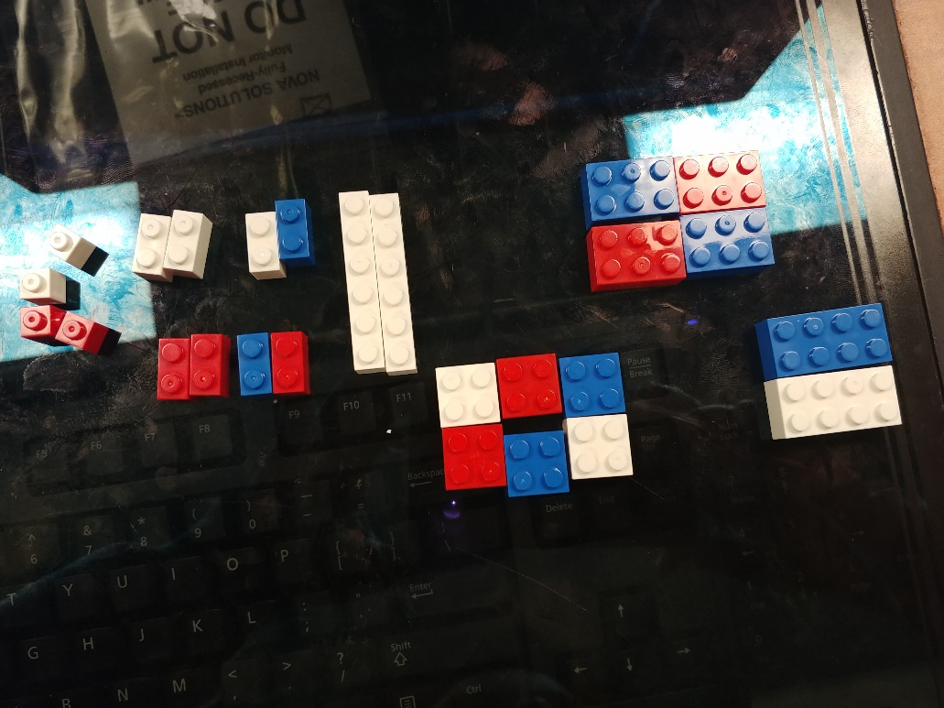
Figure 1. Pieces Needed
What you’ll need:
- 4 single connector pieces ( 2 red and 2 white)
- 8 two connector pieces ( 3 white,3 red, and 2 blue)
- 2 white thin six connector pieces
- 6 square four connector pieces ( 2 red, 2 white and 2 blue)
- 2 medium rectangular eight connector piece (1 white and 1 blue)
- 4 small rectangular six connector piece ( 2 red and 2 blue)

Step 1
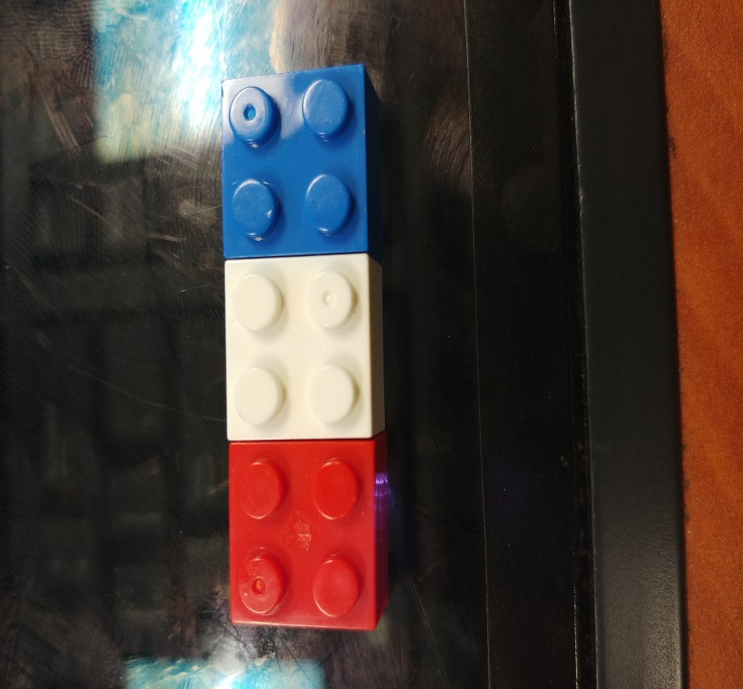
Figure 2. Base of Tower
In this step, you would need to have 3 square (1 white, 1 red and 1blue) four connector pieces and place them together side by side. These pieces are going to be the bottom of your tower and help build the rest of your pieces.

Step 2

Figure 3. Top View
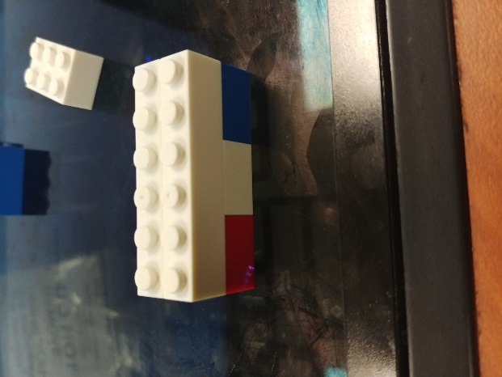
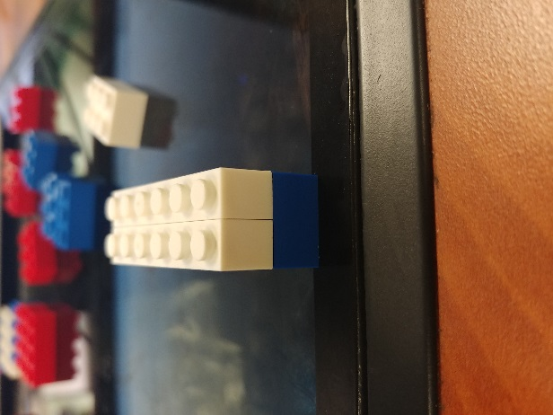
Figure 4. Left Side View
Now that you have the bottom of your tower, you will need to place 2 white thin connector pieces to place it on top. These pieces will help the bottom of the tower stay in place.
Step 3

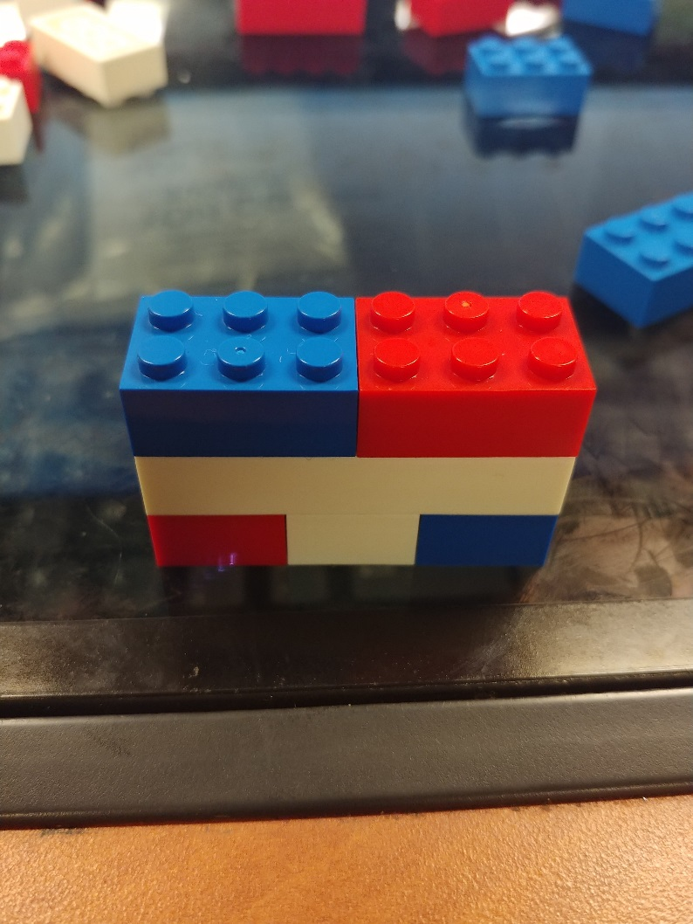
Figure 5. Top View

Now that your tower is coming together just fine, you will need to connect both small rectangular six connector piece and place it on top of the thin white piece. If your tower doesn’t begin to look like the picture above, look again at Step 1 to find your mistake and try again.

Step 4

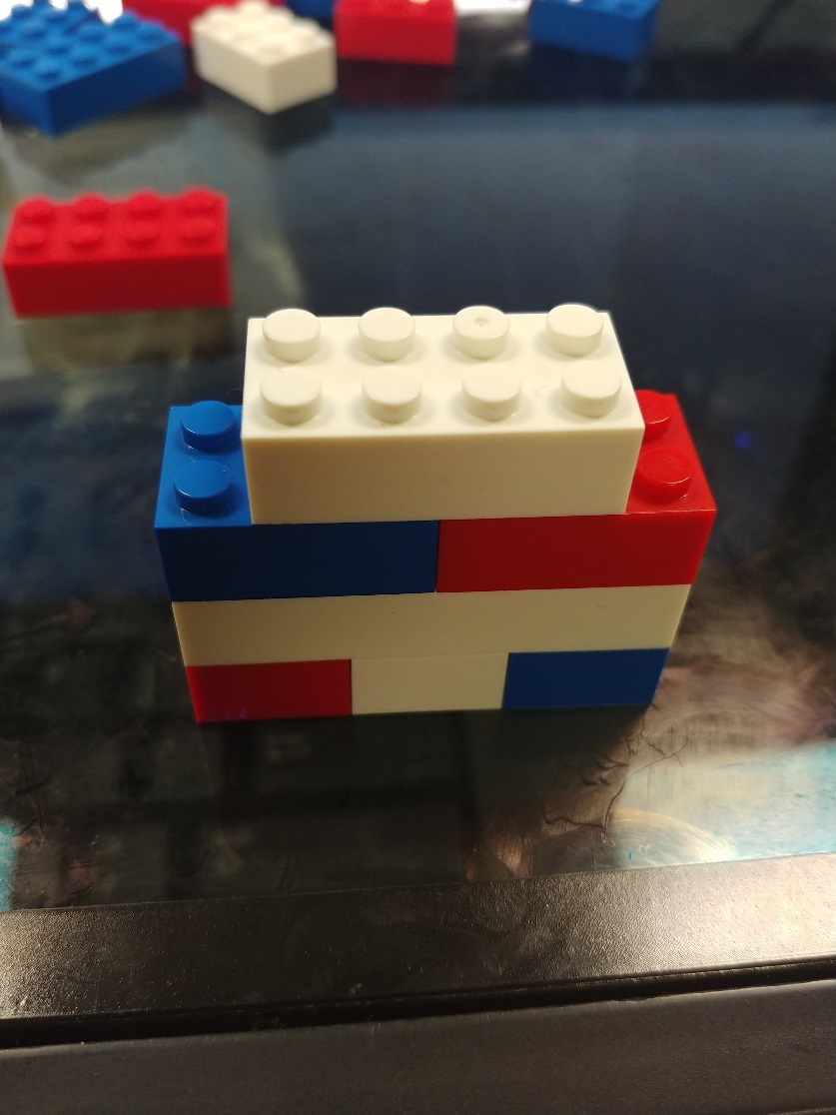
Figure 6. Top View

Take the white medium eight connector piece and place in the middle of where you placed the last two pieces. To know if you placed the piece in the middle, each side of the tower should have 2 connectors visible. These connectors are left empty for the next step to come.

Step 5
Figure 7. Left Side View
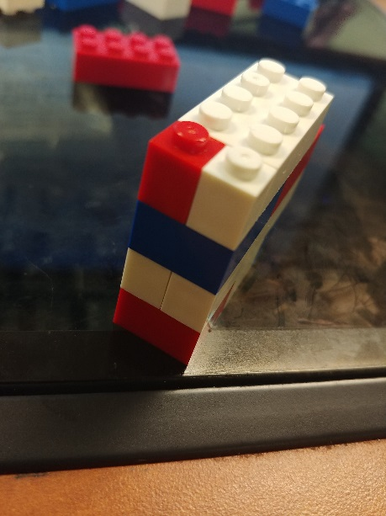
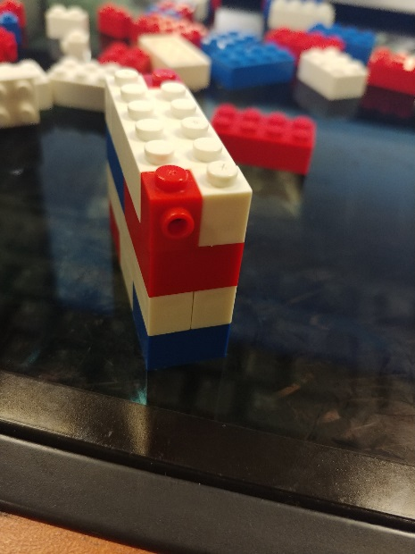
Figure 8. Right Side View

Take those 4 single connector pieces and place two on each side of the medium rectangular piece as Figure 7 and 8 show. These pieces fill in the empty spots from Step 4.

Step 6
Figure 9. Top View
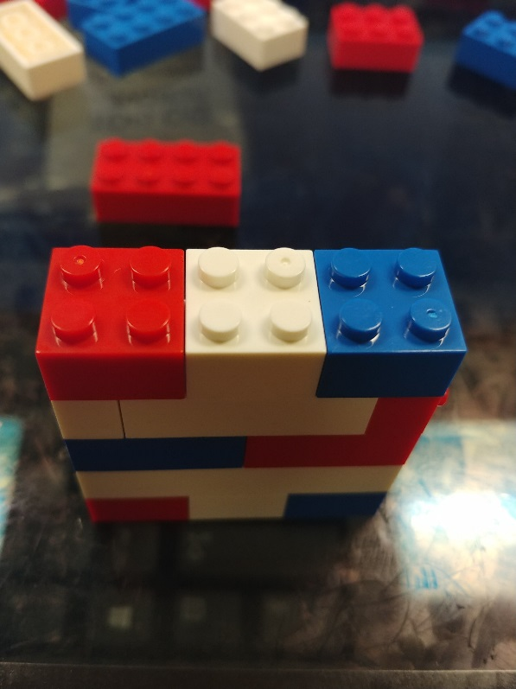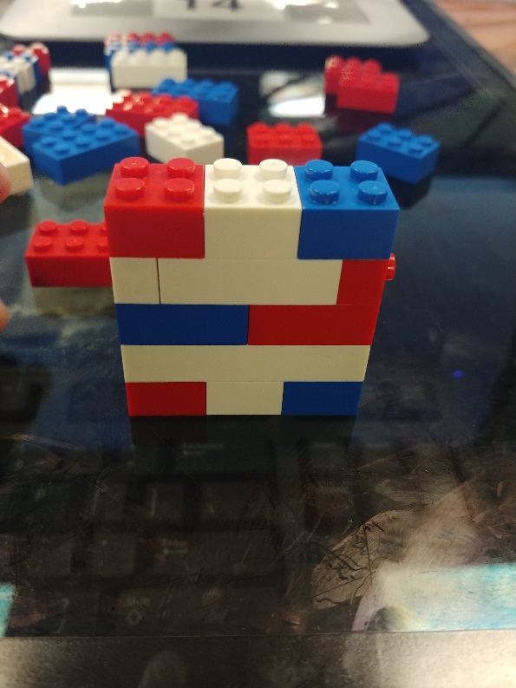
Figure 10. Front View

Take the rest of the 3 four small square connector pieces and place them right on top just like Figure 9 and 10. Remember follow the color placement.

Step 7
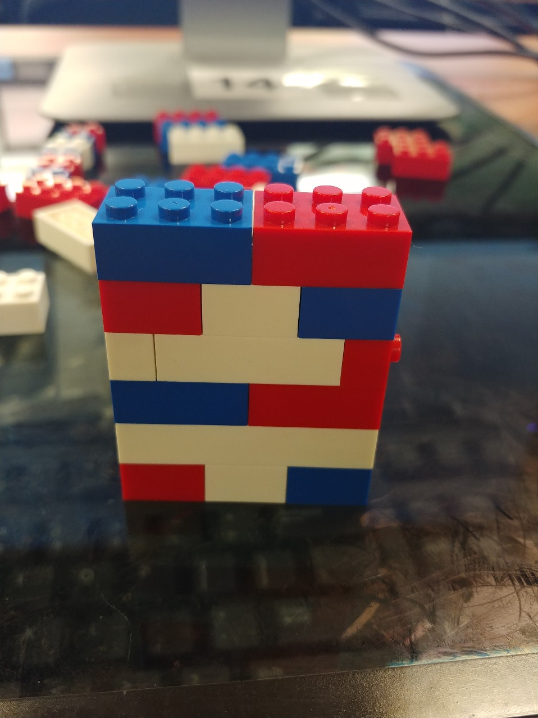
Figure 11. Front View

In this step you will be using the last two small rectangular 6 connector piece and place it right on top of the three small square pieces with the blue piece first like how Figure 11 shows.
Step 8
Figure 12. Top View
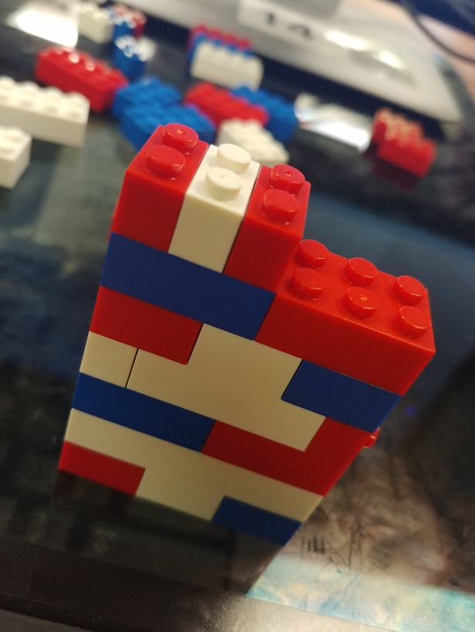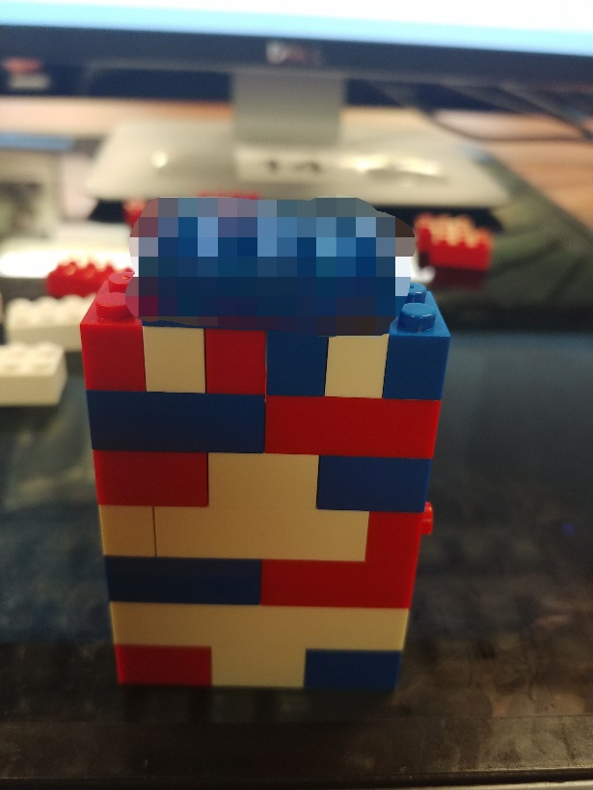
Figure 13. Front View

Take 6 of the 8 two connector pieces (2 red, 2 white and 2 blue) and place them on top of the two medium pieces. Make sure the color pattern stays the same.

Step 9
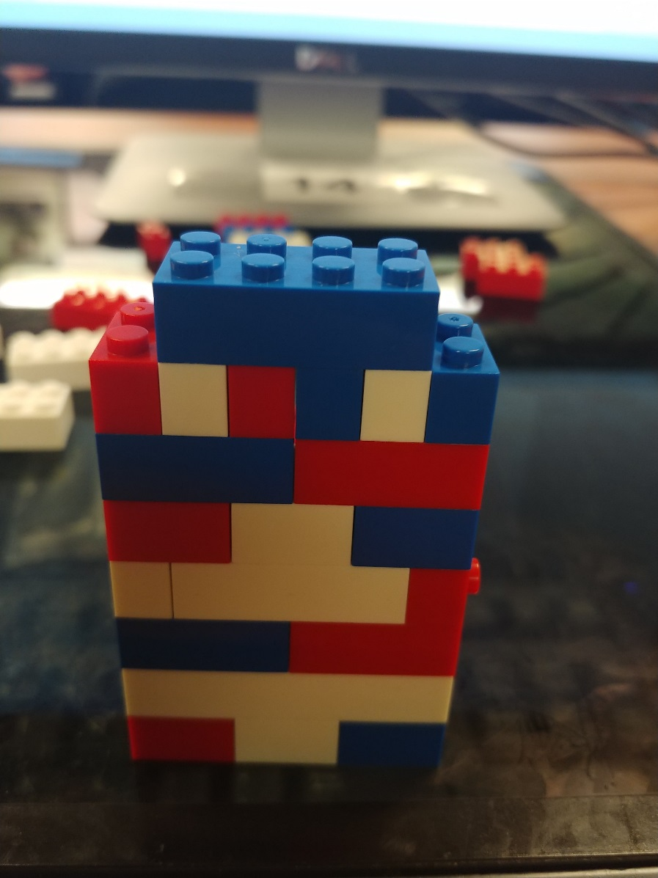
Figure 14. Front View

Take the last medium eight connector piece that is blue and place it in the middle of Figures 12 and 13 leaving the two sides empty with the 4 connectors showing as shown in Figure 14.

Step 10

Figure 15. Top View
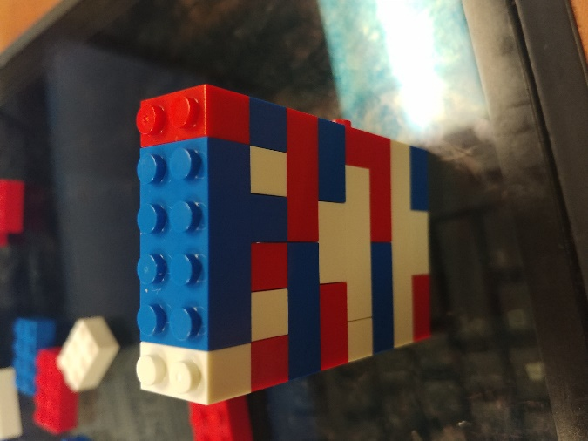

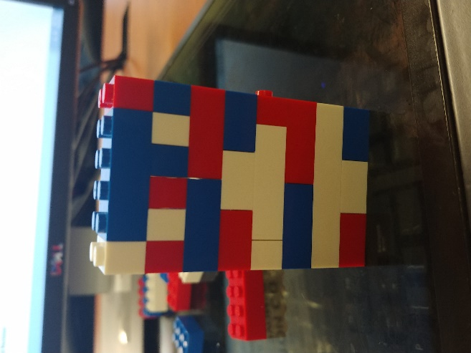
Figure 16. Front View
With the last two connector pieces, place them on top of the empty spaces next to the blue medium 8 connector piece. Once those pieces are connected, your tower is complete.
References
Cognitive development. (n.d.). Retrieved November 02, 2017, from http://www.healthofchildren.com/C/Cognitive-Development.html

