Online  Business | Online business can be a good platform specifically young girl or boy who is trying to get some extra pocket money to maintain their regular expenses and the women entrepreneurs who stay at home parent and house wife. that can give them a new starting point which can lead to a career.
Benefits of Online business  -No investment required or less investment  -No schedule work hours,freedom of works  -Work from anywhere in the world | 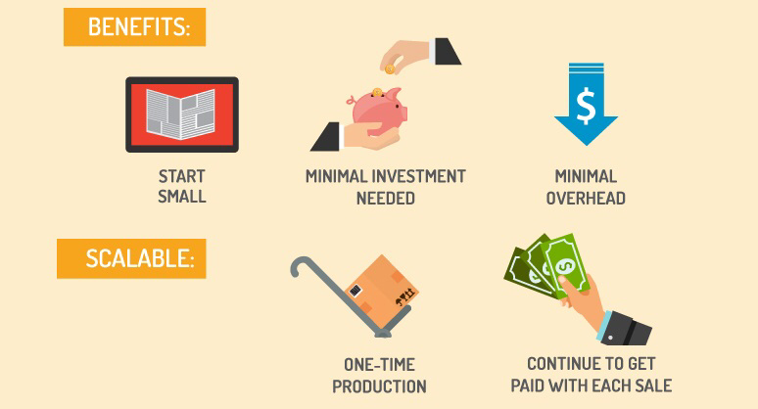
  - Women entrepreneurs

  - Women entrepreneurs should involve more in online business because this will give them opportunity to freedom of work.

Online business as a career

How it works
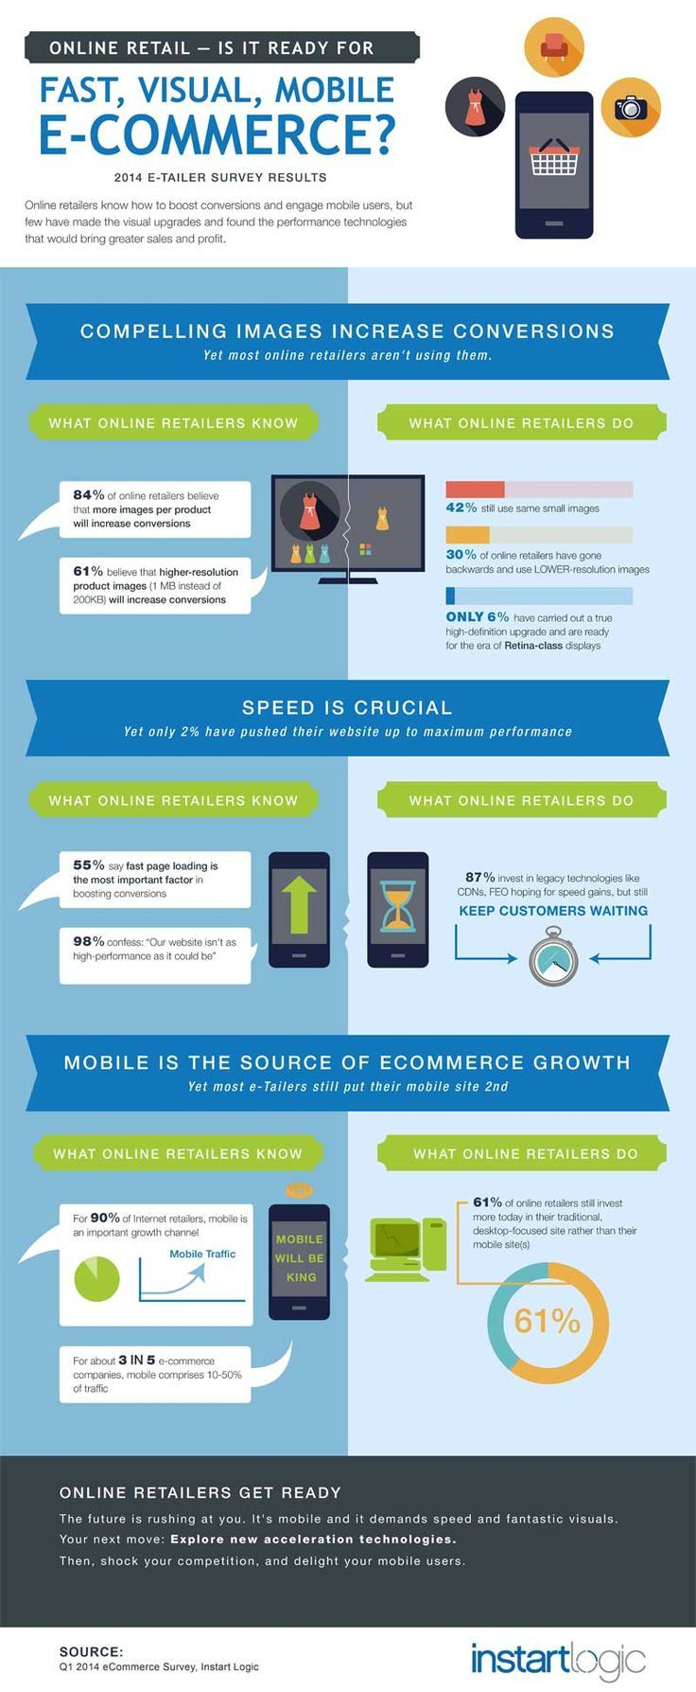

How to start online business?
To build a career in online business they need to know how to use internet and how to build an website to attracts buyers and also need to know how to use social media apps for example- Facebook, Twitter, Instagram etc because these apps helps to promote online business and helps to grow. They can also make some YouTube videos to promote their online business. Because advertisement is the expansion is the main motto of success Incase of online business.
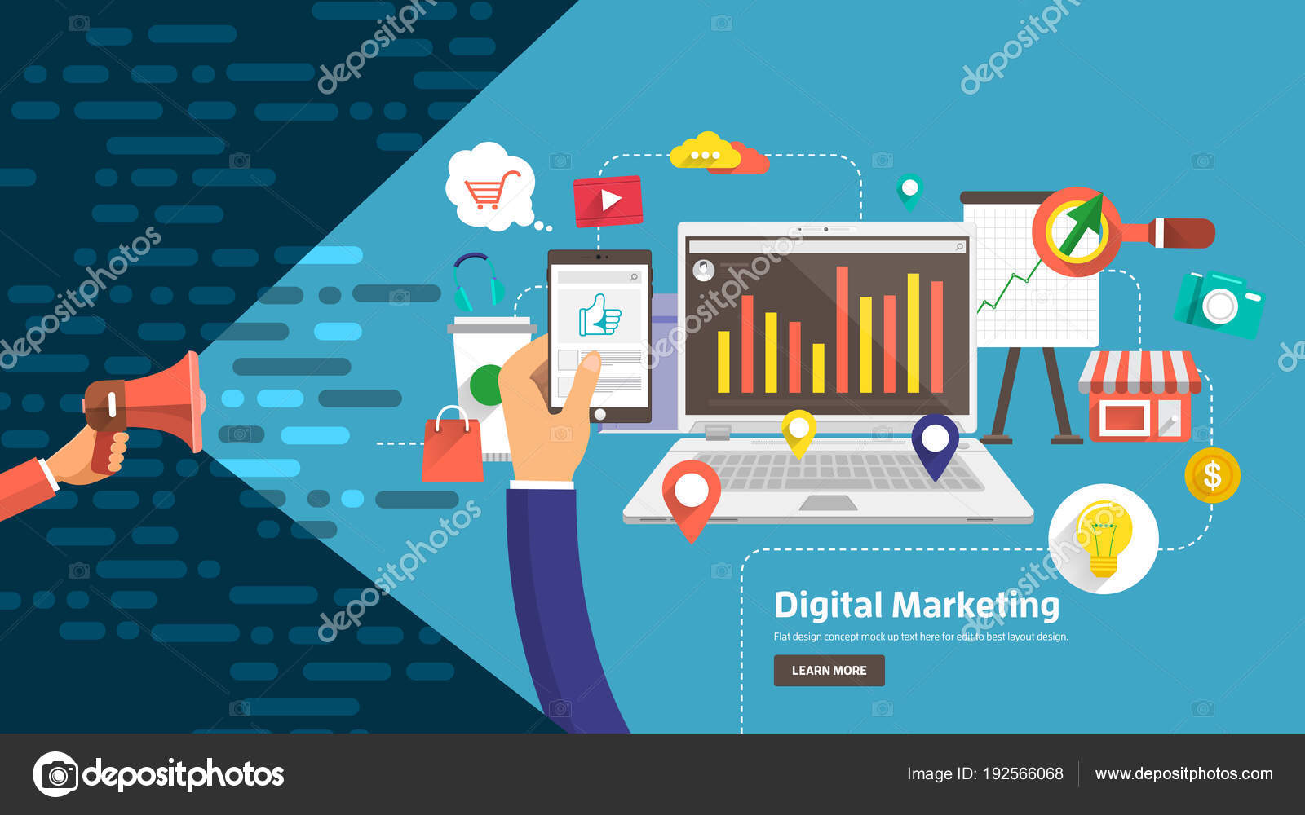

How to get their attention?

I think the best way to catch their attention is brochure, videos and images because people are more influenced by what they see and read.

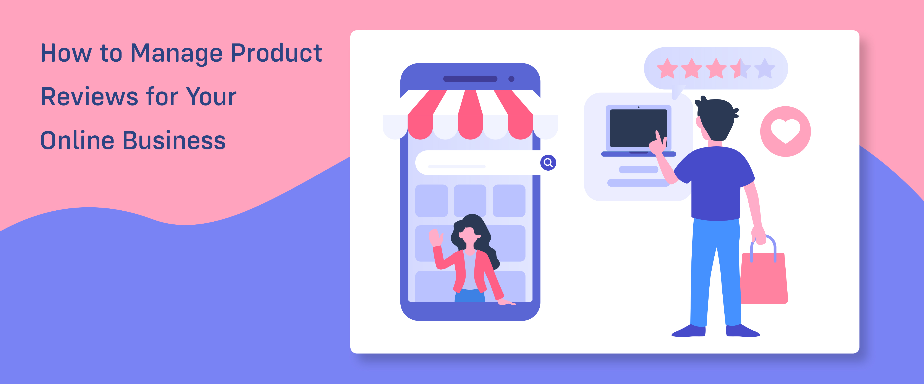

Promotion is the key of online business
The more good reviews you receive the more customer will come to you and your business will be more popular. And to get good reviews you need to provide good service and good quality products.

