Bibin Koshy Professor Viviana

TCET 2220

12/16/13

Homework #5

5-1. A 50-Ω lossless line is terminated in Z2 =15-j20 Ω.

1. Plot the normalized impedance on Smith chart.
2. Using the Smith chart, determine the corresponding normalized admittance y2.
3. Using the result of (b), determine the actual admittance Y2.

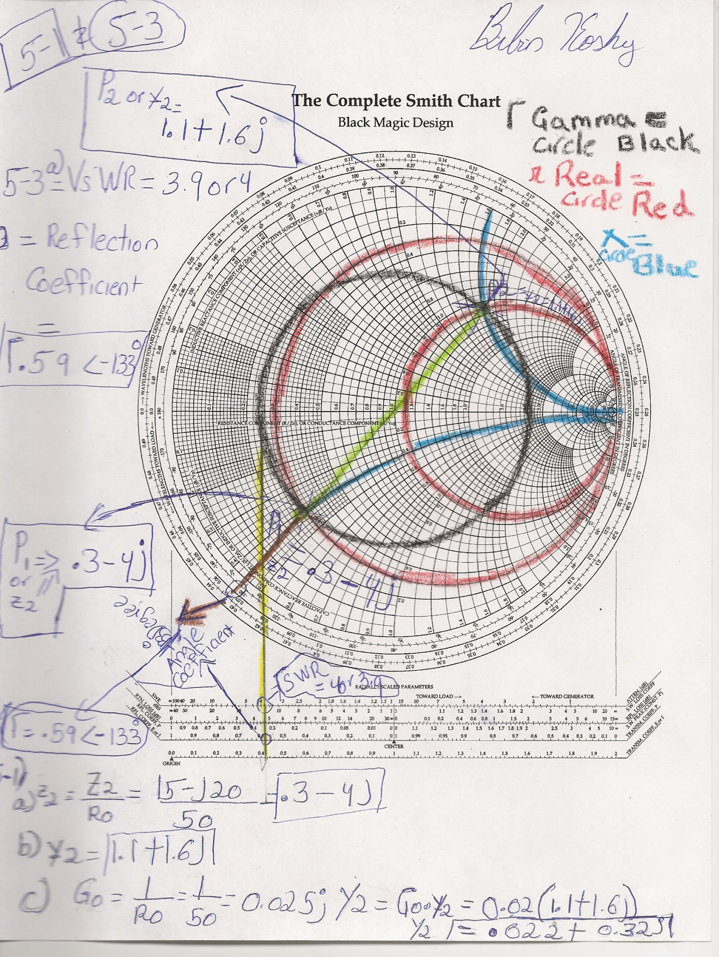

5-2. A 50-Ω lossless line is terminated in Y2 =.001 +j0.02S.

(a) Plot the normalized admittance on Smith chart.

(b) Using the Smith chart, determine the corresponding normalized impedance Z2.

(c) Using the result of (b), determine the actual impedance Z2. 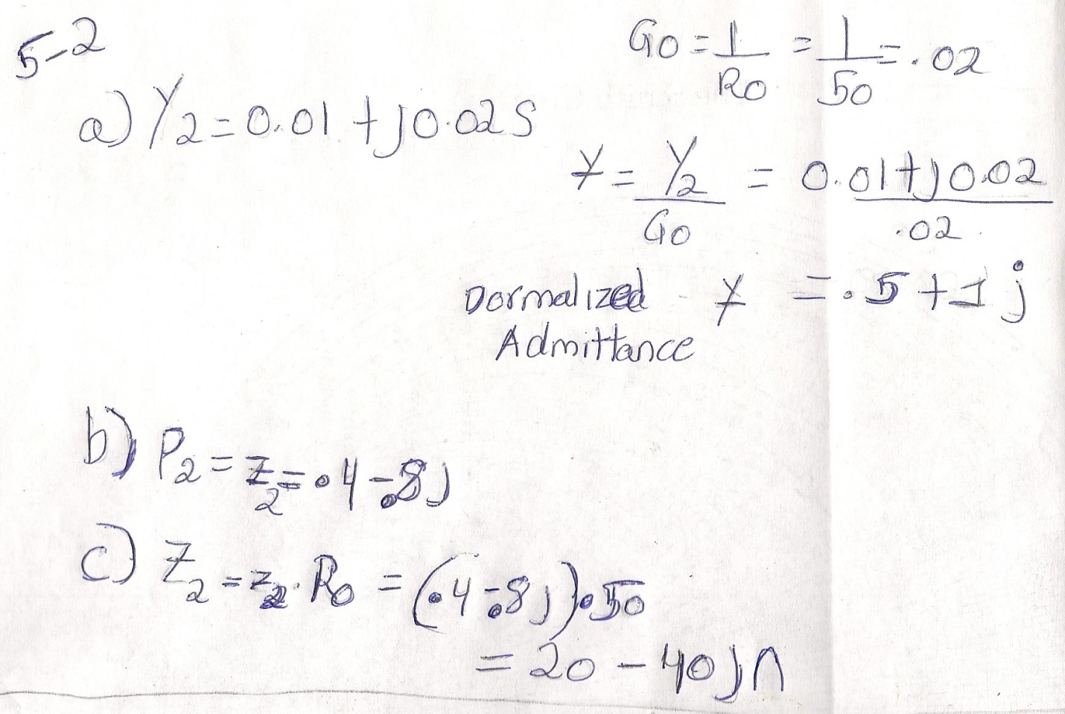

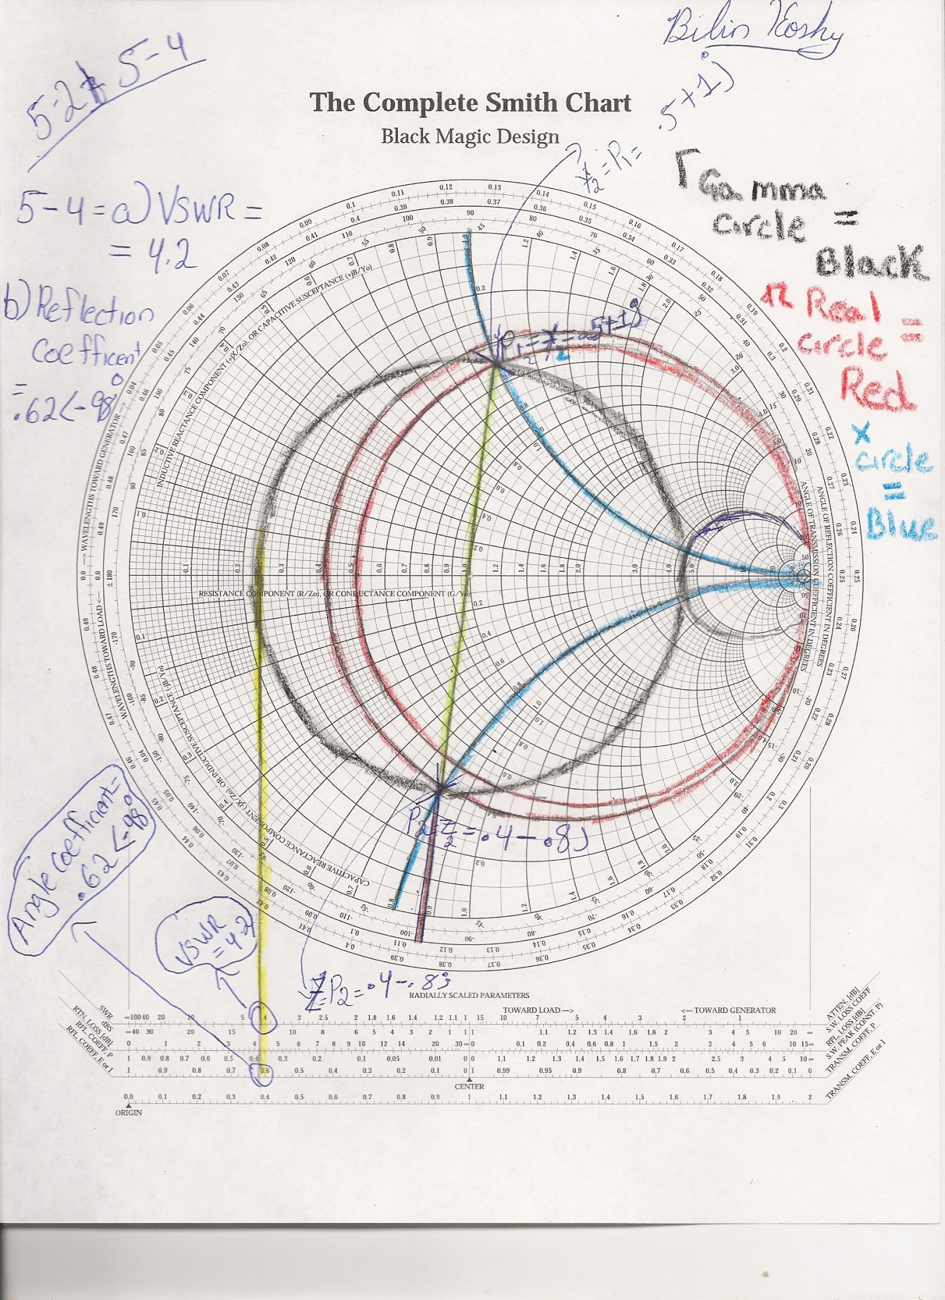

5-3. For the system of Problem 5-1, determine the VSWR and the reflection coefficient.

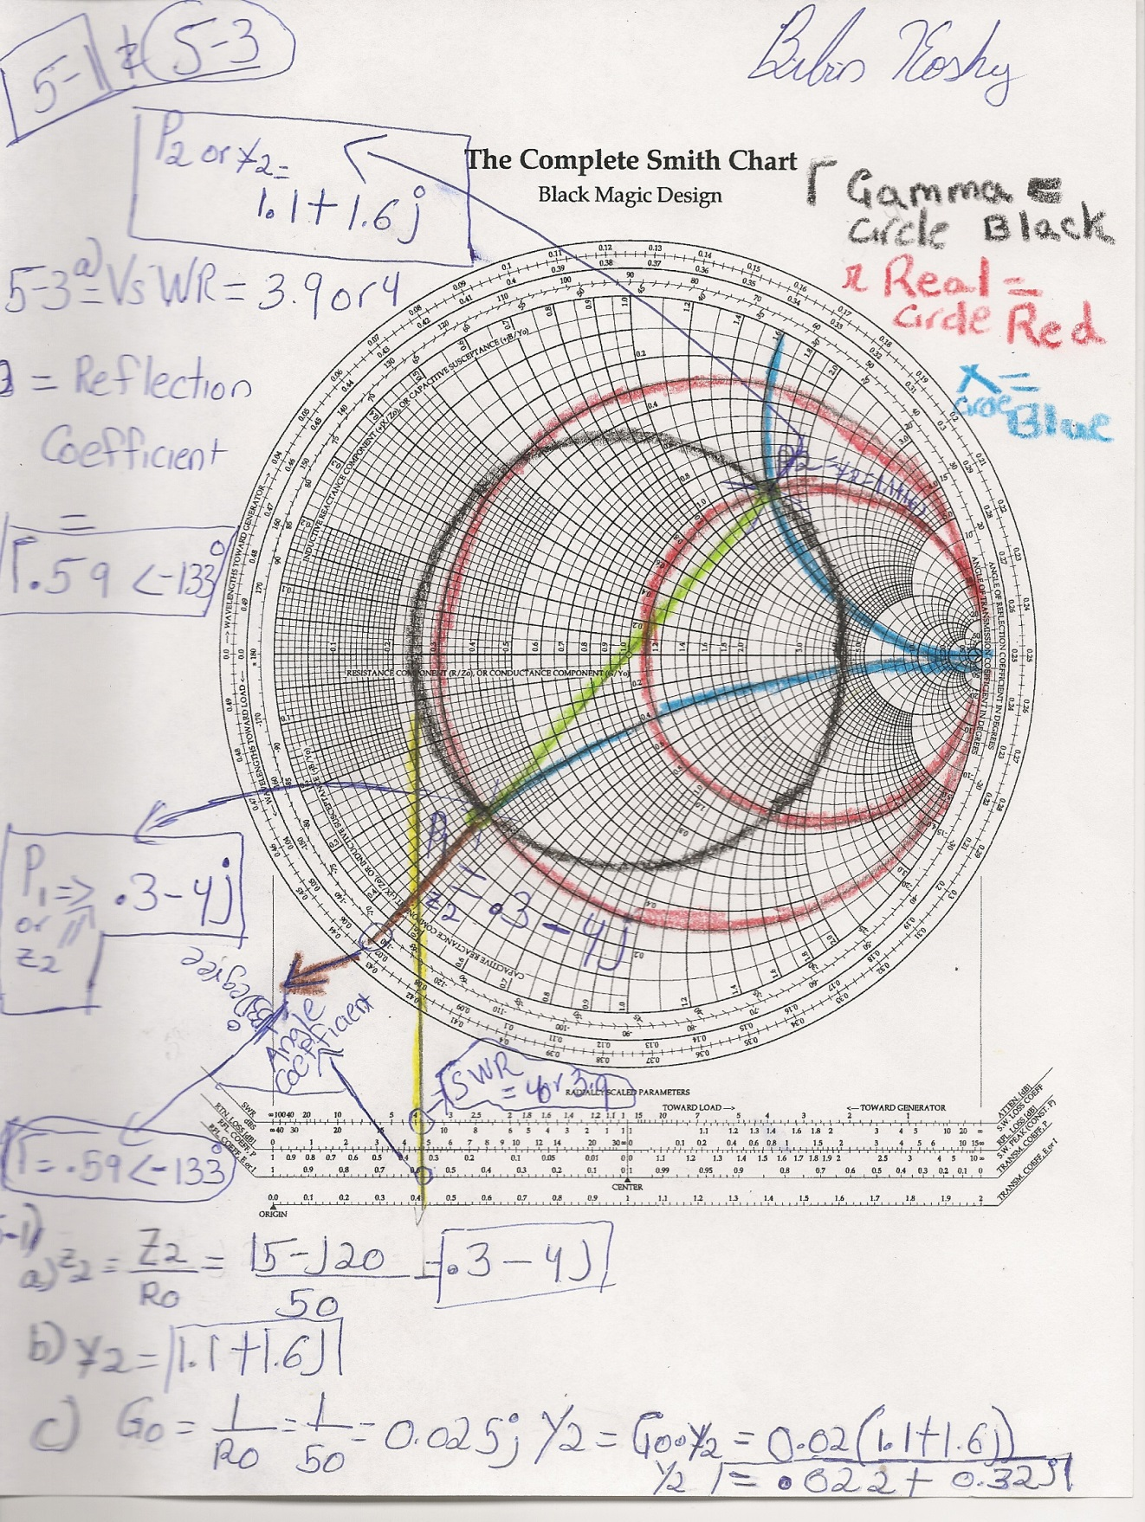

5-4. For the system of Problem 5-2, determine the VSWR and the reflection coefficient.

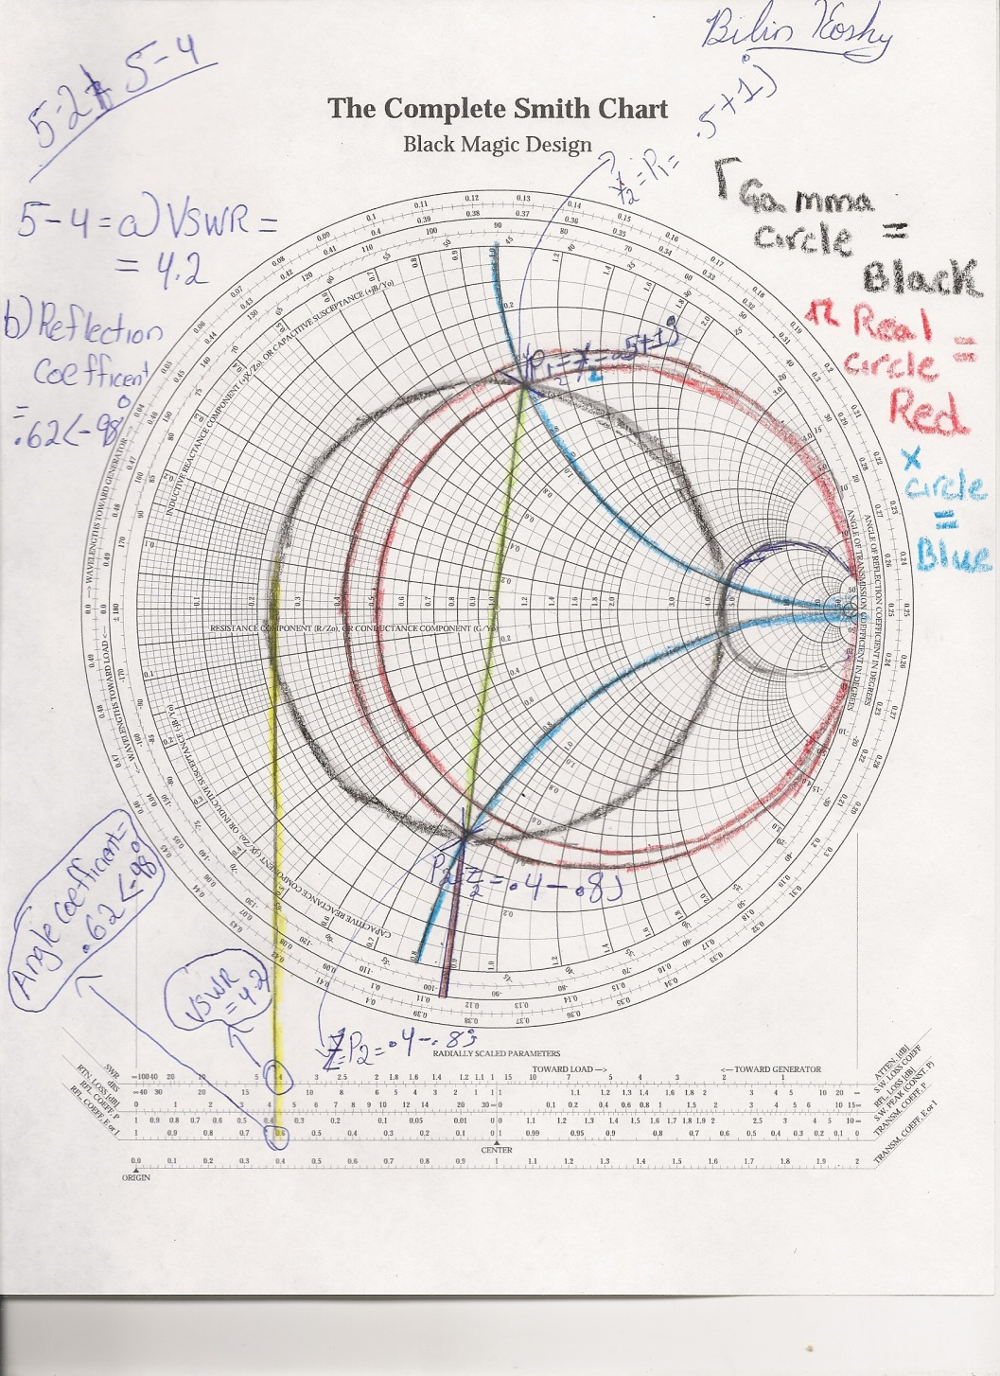

5-5. A 50-Ω lossless line is terminated in a real load impedance Z2 =R2=150Ω. Using a Smith chart, determine the input impedance for each of the following line lengths:

1. 0.15 λ
2. 0.25 λ
3. 0.35 λ
4. 0.45 λ

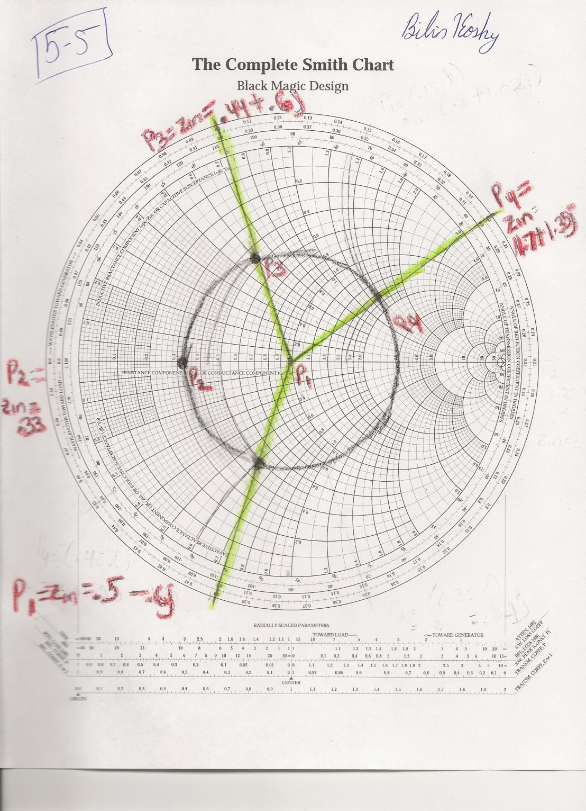

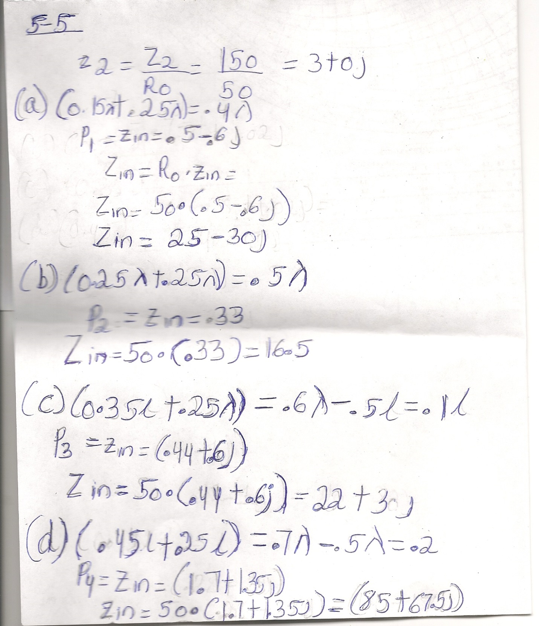

5-6. A 50-Ω lossless line is terminated in a real load admittance Y2 =0.01S. Using a Smith chart, determine the input admittance for each of the following line lengths:

1. 0.125 λ
2. 0.25 λ
3. 0.375 λ
4. 0.50 λ

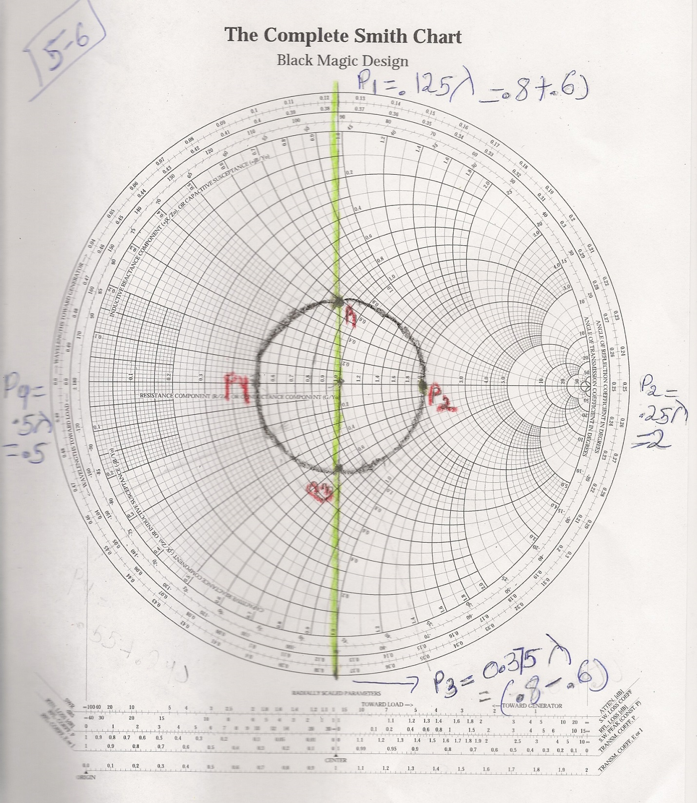

5-7. A 50-Ω lossless line is terminated in a real load impedance Z2=75+j100 Ω.

1. Using a Smith chart, determine the input impedance for a line of length 0.2 λ.
2. Determine the VSWR and the reflection coefficient at the load.

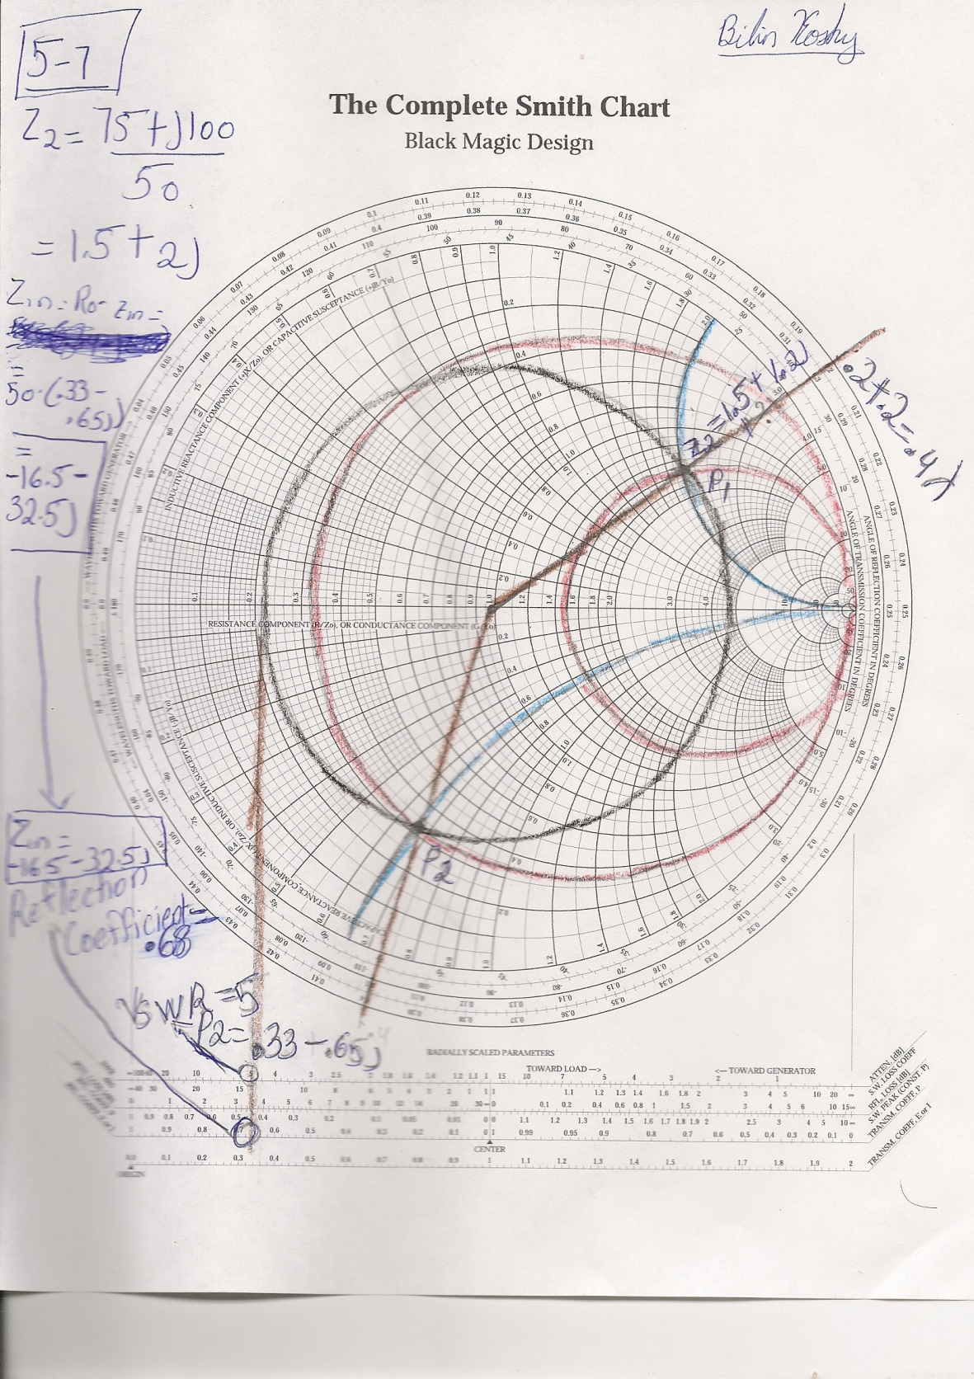

5-8. A 50-Ω lossless line is terminated in a real load impedance Z2=150-j240 Ω.

1. Using a Smith chart, determine the input impedance for a line of length 0.3 λ.
2. Determine the VSWR and the reflection coefficient at the load.

