Elements of Art and Design
Bria Hill
BUF 2203 Visual Merchandising
Professor Kat Roberts
New York City College of Technology

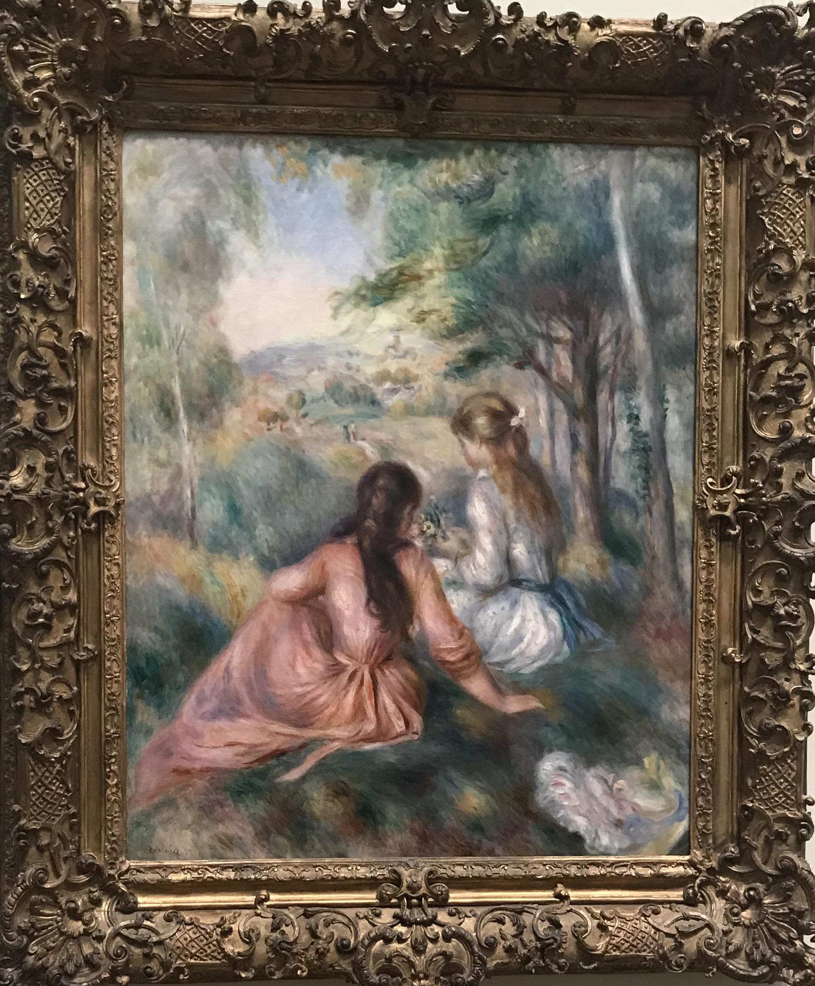
Figure 1. In the Meadows, 1888-92 by Auguste Renoir. Taken at The Met April 2018

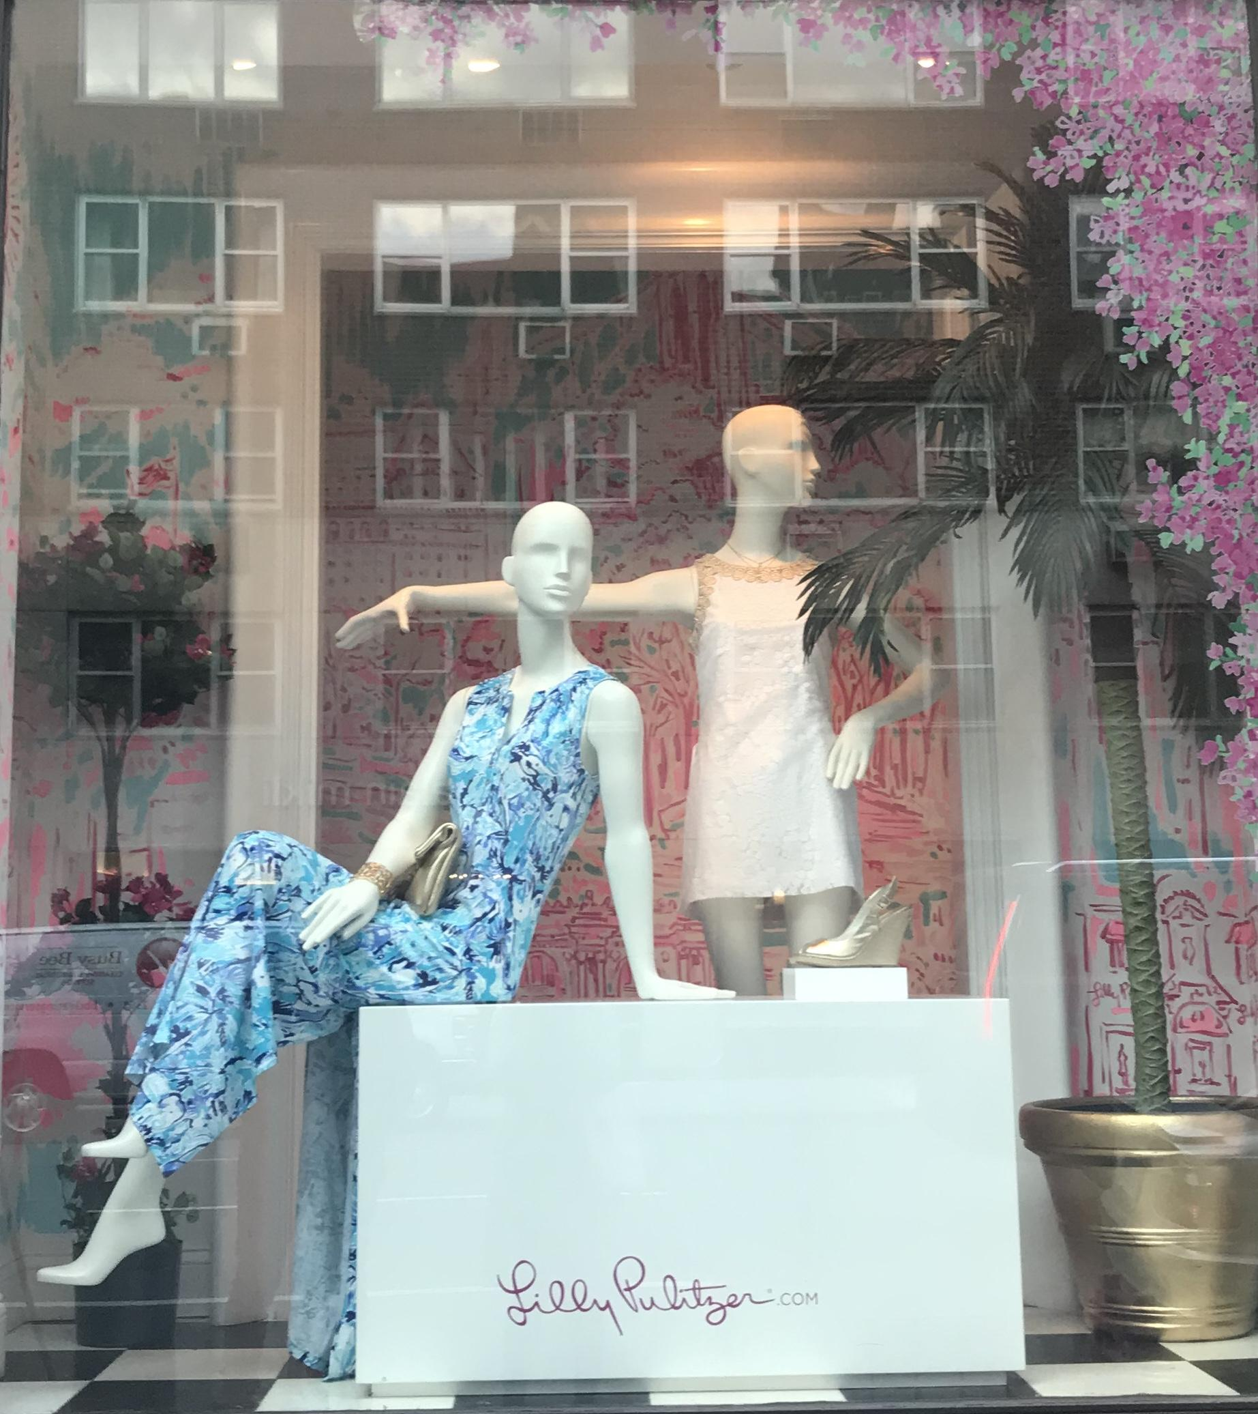
Figure 2. Lilly Pulitzer, Upper East Side, NYC, April 2018.

The window display in Figure 2, was found on 79th Street and Madison Avenue for a store called Lilly Pulitzer. I chose this image because it seems to be very closely related to a painting that caught my eye titled In the Meadows, painted by Auguste Renoir. These two images relate especially on the premise of color. Both painting (Renoir, 1888-92) and display (Pulitzer, 2018) feature a fun swirl of pinks, blues, and whites that render a light hearted mood, kind of like cotton candy. The painting (Renoir, 1888-92) features an image of two girls, one in a blue and white dress and another in a pink dress, while homogeneously the display window (Pulitzer, 2018) features two mannequins, one in a blue and white dress and the other in a pale pink dress. However the painting (Renoir, 1888-92) features muted/ dusty tones that may portray a type of innocence and a state of relaxation and calmness, while the window display (Pulitzer, 2018) features a mixture of pastels and bright colors that compliments the clothing the mannequins are wearing and contains an eye catching effect for its audience. There is also a hint in metallics represented in the gold flower pot housing a palm tree, and the color of the sitting mannequins accessories (a bag and bracelet). One could also notice the huge white box the mannequin dressed in blue is sitting on which gives a beautiful contrast to the pink in which the Lilly Pulitzer website is written, and gives a platform for the white espadrille being displayed. The window also features a floor made of black and white tile.
Texture can be described as “how a surface actually feels to the touch or how it might feel if touched” (Bell, Ternus, 2012). One can describe the texture of the painting (Renoir, 1888-92) by having really smooth strokes, it almost becomes difficult to decipher the difference in texture between the girl’s hair, dress and the grass they sit in if the painting were an actual picture. The display window (Pulitzer, 2018) uses multiple textures, some in relationship to the painting and others freestanding. The window’s background shares a textural relationship with the painting as they are both really smooth, the back wall actually looks like it may have been painted as well. The three plants featured in the window’s background also add another element of texture, one can assume that they are artificial, but the leaves look smooth by the way the light reflects off of them, the trunk of the palm tree however looks a little more rigid. The window (Pulitzer, 2018) also includes floral appliques that gives a three dimensional feel. One may assume that the creative director of this window wanted to give any passersby the feeling of them looking into a freeze framed outing with two friends and the painting gives a similar feeling, except the painting may seem a little more intimate as the two girls featured are facing the opposite direction like they may not even realize that the audience is present.
“Proportion is the relationship between the apparent size, mass, scale, or optical weight of two or more objects” (Bell, Ternus, 2012). Featured in both painting (Renoir, 1888-92) and display window (Pulitzer, 2018) , there are two main objects that are centered and scaled largest of all items so it becomes the place where one might draw most of their attention. In the painting (Renoir, 1888-92) the two main objects are two young girls that seem to be sitting in grass observing a bouquet of flowers, and in the display window (Pulitzer, 2018) there are two mannequins and the one sitting is optically scaled larger than the mannequin standing in the background because the mannequin sitting is slightly closer to the audience. This can also be because the legs of the standing mannequin are cut off due to the cube that the other mannequin is sitting on. In both images, the main objects are surrounded by some sort of floral aspect. Also, both images include an accessory, small in proportion to the main objects but both featured in the bottom right corner of their respective displays, in the painting (Renoir, 1888-92) it is a hat that presumably belongs to one of the little girls and in the display window (Pulitzer, 2018) it’s a shoe displayed on an elevated surface.
Direction as it relates to visuals “refers to the design element or tool that leads the shopper’s eye from one place to another” (Bell, Ternus, 2012). One can observe a great deal of direction in the painting In the Meadows (Renoir, 1888-92). Near the bottom of the painting brush strokes seem to move downward, up near the trees brush strokes seem to move left and right giving the illusion that there may have been some sort of wind blowing (renoir.net, 2018).
According to Silent Selling (Bell, Ternus, 2012), “lines guide the eye to a feature or linear element that sets a mood”. The window display (Pulitzer, 2018) gives off a very linear feel both vertical and horizontal. Horizontal lines are strengthened due to the placement of the mannequins arms, the sitting mannequin is sitting in a very relaxed almost lounging position with its palm faced down and pointing the audiences right, while the standing mannequin literally has its arm straight out pointing left. Another element of horizontal line is represented with the website written on the box, it looks to be written in a font unique to the brand’s aesthetic but for the most part written in a straight line. These two positions create two parallel lines that makes it difficult for one’s eye not to skim across the image in both directions. The window display (Pulitzer, 2018) also contrarily proposes an idea vertical lines, especially from the right hand side of the window represented in the tree that literally stretches from the top to the bottom of the frame, the standing mannequin and plants on the opposite side of the window compliment the vertical lines.
Shape is defined as “a standard or universally recognized spatial form like a circle or triangle that helps the viewer identify various objects” (Bell, Ternus, 2012). Many shapes come to form in both the painting (Renoir, 1888-92) and the window display (Pulitzer, 2018) some being more obvious than others. For example, the huge white box in the window display may be more obvious to the audience than the triangles created by the mannequin sitting, and the girl in the painting dressed in pink. The display window’s floor is comprised of black and white square tile and there is also an added rectangular center frame in the middle of the back wall. The painting (Renoir, 1888-92) does not have many defined shapes as it is quite muted and shapes kind of flow within each other.
The sequence “is the particular order in which items are presented for viewing” (Bell, Ternus, 2012). First the audience would view the girls in the painting (Renoir, 1888-92) . Then their eyes might drift to the scenery in the surrounding. Lastly the audience would view smaller details like the hat in the far right corner, the two figures in the far distance, and the bouquet of flowers the young girl in the white dress is holding. For the window display one’s eyes may first go to the mannequins in the center, followed by the box with the written website at the bottom, and then to background elements like the plants and wall decor.
Tension is described “an arrangement of elements that causes the viewer to wonder if opposing forces will disturb balance or equilibrium in a display” (Bell, Ternus, 2012). Both images hold tension in the two objects that are leaning slightly to the side. In the painting, In the Meadows (Renoir, 1888-92) the girl dressed in pink is leaning slightly as if to take a look at the bouquet of flowers her counterpart is holding, however if she were to sit up ever so slightly it may risk blocking the figures in the far distance and take away one of the only identifiable shapes in the painting. In the window display for Lilly Pulitzer (Pulitzer, 2018), the sitting mannequin is leaning which forms tension because of the angle in which she was leaning because if she were a real person it would be incredibly difficult to hold that pose without one resting their feet on something
Art influences life by sometimes just being an inspiration guide. One may view artwork that may evoke emotion within them that leads to certain reactions, which I believe is the purpose of art. Visual display may have the same effect on people, and one may discover that visual merchandising is an artform in itself especially if one is giving the platform to be creative with direction as opposed to just strictly following planograms allocated by a company, as August Renoir said, “In painting, as in the other arts, there's not a single process, no matter how insignificant, which can be reasonably made into a formula” (Renoir.net, 2018). The point of visual display is for it to be executed in a way that catches the viewer's attention and essentially leads to purchases (Bell, Ternus, 2012).
This assignment taught me how closely fine art and visual merchandising can be related. Someone who may not have the opportunity to conduct this experiment, who maybe a passerby to a display window and/or an onlooker at a museum may never even think that the two can be a related art form. Any form of art, is still considered art, and no form should be weighted heavier or given more respect than another because unless one is there during the entire process and duration of time it took to create art, one can find themselves in an incredibly difficult place to judge someone’s work. “The work of art must seize upon you, wrap you up in itself and carry you away. It is the means by which the artist conveys his passion. It is the current which he puts forth which sweeps you along in his passion. - Auguste Renoir” (Renoir.net, 2018).

References
Bell, J., Ternus, K. Silent Selling; Fourth Edition. Fairchild Books, 2012.
Pulitzer, L. 2018. Spring 2018 Window Display. Upper East Side, New York, NY
Renoir, A. (1888-92). In The Meadows [Painting]. New York, NY: The Metropolitan Museum of Art.
http://www.renoir.net/in-the-meadow.jsp

