Brittany Greene-Lee
Digital Media Foundations

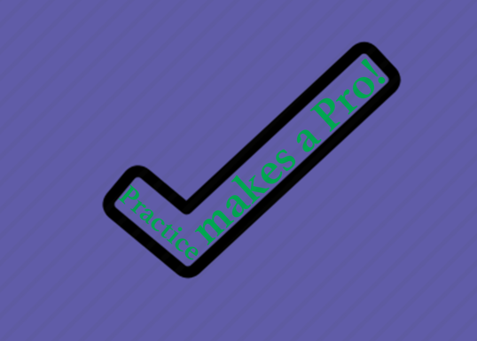

My concept of this logo relates to what the quote states. The check represents excellent work, or a excellent job of whatever was achieved for that person that reads this. The image used was a black check mark. My initial design was the text written out across with a small thumbs up icon at the end of the statement. My second design was the text written out across with a small check mark at the end of the statement. Then, I decided to stay with the checkmark idea, but have it transparent, to add text inside of the check mark.

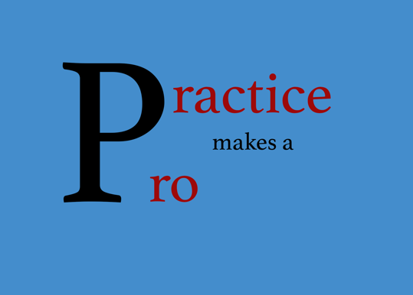

My concept of this logo design was just simple. I thought of a way to make it how acrostic poems are with the main word being used to create new words that represents that word but different. The huge letter “P” is the beginning letter of the words “Practice” and “Pro”. My initial design of this was the “P” spelling out only the word “Practice”. But I decided to let the “P” spell out the word “Pro” also to give it some type of balance.

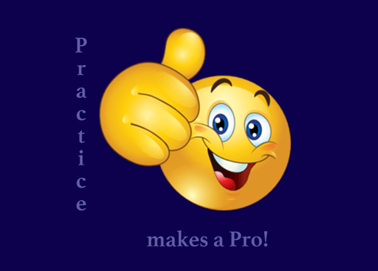

This logo reminds me of those good work or excellent work stickers that teachers used to put on their students tests or homeworks, that was my whole concept behind this design. My initial design was the words across at the very top and a huge image of the Facebook “Like” button. Then I thought of those stickers that was given to me by teachers whenever I did a good job on any assignment.

