Brittany Greene-Lee
Digital Media Foundations
Logo Research

Adidas Logo History

The Adidas logo was created by Adolf ‘Adi’ Dassler. In 1924, is when he first started making the shoes, in 1949, is when he registered his company’s name. He started using the three stripes to identify the shoes in 1967. Adidas has 3 logos, one is the three stripes, the second is the trefoil and the third is the three bars. Adolf Dassler returned from World War I, him and his brother Rudolf ‘Rudi’ Dassler started a shoe company called Dassler Brothers Shoe Factory. In 1936, they both asked an famous Olympian sprinter Jessie Owens to wear and promote their brand by wearing their shoes. That was the first African American as a sponsor of a company. Jesse Owens scored four gold medals, after that the deman for the Dassler shoes plummeted. The brother both were selling over 200,000 pairs a year.

The first logo shown above would be the three stripes logo. This logo is very simple and seen on all logos which are the three stripes. The owner of this company would always called this business “The three stripe company”. The second logo shown above is The Trefoil and was introduced to the world in 1971. The traditional black three stripes isn’t there but they created the design where it’s still shown. The three stripes in logo are shown diagonally and white. The three leaves in the trefoil represents the main landmasses of the Americas, Europe and Africa, and Asia. The lines that lay diagonal represents diversity. This logo has been popular in the music industry. Some artists such as Run DMC, Bob Marley, The Doors, David Bowie, The Sex Pistols and The Clash. Run DMC even has a song entitled “My Adidas”.

The products that are within Adidas are footwear, sportswear, sports equipment and toiletries. The headquarters is in Herzogenaurach, Germany. They sell both women’s and men’s clothing and footwear, such as, t-shirts, jackets, shorts, hoodies, pants and leggings. The Franz Beckenbauer tracksuit was the first apparel item created in 1967. Adidas are featured in many sports such as football, baseball, basketball, cricket, golf, gymnastics, lacrosse, track, skateboarding, tennis, and kabaddi. Adidas also designed accessories such as, slide slippers, watches, eyewear, bags, baseball caps, socks, deodorants, perfumes, aftershave and lotion.

In 1947, the brothers went their separate ways. Their split caused them both to move forward with their own company, going head to head with each other. Rudolf Dassler created a “Ruda”, which was later named “Puma”. Then, as you know Adolf “Adi” Dassler created “Adidas”. Adidas was first named “Adidas AG” in August 1949. Adidas is an acronym for “All Day I Dream About Sports”. But when it was originally made, it stood for “Adi”, which is Adolf’s nickname and “Das”, which is from the last name “Dassler”. Both rival brands, even started a rivalry between sports teams. Two football clubs were both siding with both brothers. One football team would wears Rudolf’s footwear while the other team would wear Adidas. The Dassler brothers never rekindled their relationship. They both are now dead and buried in the same cemetery, but far from one another. It’s like they’re still rivals even after death. The three stripes logo came after the brothers split. When the brothers were working together their logo was two stripes to hold the shape of the shoe (Image below). When Adi started Adidas, he knew he couldn’t use the two stripes because their last company owned it. So, what he came up with is to place one last stripe between the two original stripes.
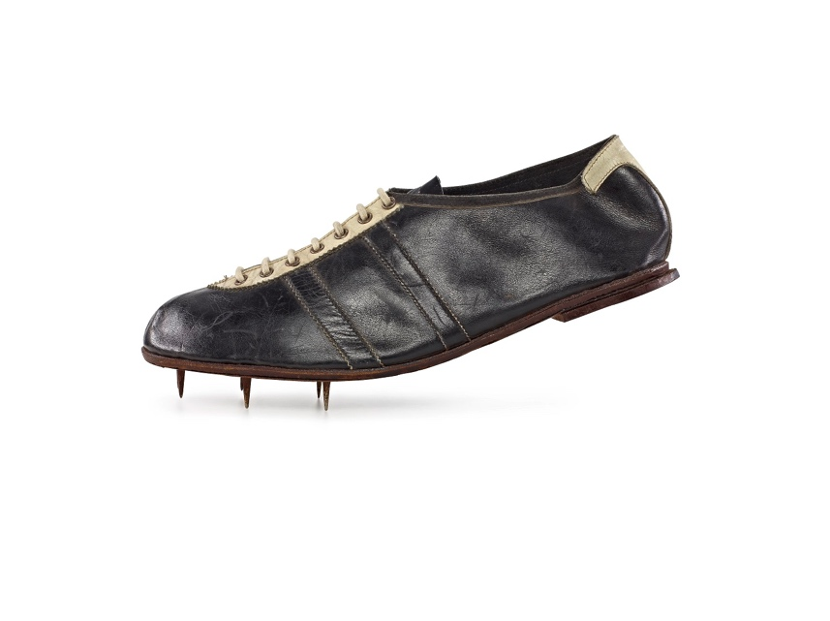

The most popular Adidas sneaker of all time are the “Superstar”. This sneaker was well known in the music industry and for the shell toe since 1969. Also, this sneaker was very inexpensive, so all ages were wearing, such as babies, toddlers, teenagers, adults and elders.
This sneaker is considered one of the many sneakers that meant for sports or exercise but is used for a fashion look. Adidas has grew by 20% in North America, Western Europe and Greater China. Adidas has stolen the spotlight from Nike.

Bibliography

https://en.wikipedia.org/wiki/Adidas

https://www.creativebloq.com/logo-design/how-adidas-logo-earned-its-stripes-11135390

https://www.logaster.com/blog/adidas-logo/

http://www.thelogofactory.com/adidas-logo-the-strange-story/

https://www.quora.com/Why-does-the-Adidas-logo-have-three-lines

http://business.financialpost.com/investing/trading-desk/nike-vs-adidas-the-three-stripes-is-making-gains-on-the-swoosh-but-that-doesnt-tell-the-whole-story

