Karl Jagdipsingh
Project #2
Professor Belli
5/12/15

Dear Professor Belli,

The thought of the process came to me immediately upon hearing the concept of the overall project. When I entered the class I was hoping that somewhere along the lines we would touch upon the concept of steampunk since it was one of the major subgenres I use to categorize science fiction. Although we actually did not touch upon it I did notice in the movie Bladerunner that aspects of cyberpunk was present. So somewhere along the lines I believe someone in the class asked what was cyberpunk and so I put it upon myself to break it down while also comparing and contrasting my alternative genre Steampunk. This entire project was an eye opener for me as I soon found out that my limited concept punk genres spread out farther than I thought. Besides steampunk and cyberpunk there was also; Biopunk focusing around biohazardous environment, Atomicpunk which focusing on a space like future(The Jetsons), Dieselpunk which focus on a future based around the World War 2 era. The list goes even longer than that but soon I found that I was mixing up Cyberpunk with different subcultures which meant I needed to do more research on my two topics. So after I got the what I needed and got my research across starting off with Wikipedia as a base to get an idea of how I wanted to approach this project visually. My main problem came along as I noticed that my essay started rambling, their only so much one can go when it comes to discussing the visual difference between two genres but not enough to really stretch 6 pages. After I found out that I could use images in my essay I thought it would help but I began to realize that I had no control over the placement, also I began to worry about my image to text ratio. Although, after all that I was still in questioning on what to use as content since I pretty much described the main differences at the beginning. I mostly felt the page rule was for people with elaborate essays. Most of my major thought would be place in my powerpoint presentation since a visual display would best describe the major differences between my two subjects.

Karl Jagdipsingh
Project #2
Professor Belli
5/12/15
Steampunk Vs. Cyberpunk

Within the genre science fictions there are two subgenres that contest with one another visually, they are Cyberpunk & Steampunk. Steampunk is based on the Victorian era around the time of industrialization and represents a steam powered timeline. Cyberpunk represents a more futuristic timeline in which computers have a large control over society and has some ties to the asian culture. Both subgenres(or to some people subcultures) are unique in their; fashion, color pallet, and technological advances. They are present in many forms of media in today's society but many people the general public are unknown to the genres that they identify with.
Steampunk has been around since the 19th centuries and famously presented in pieces by Jules Verne and H. G. Wells. Although the title steampunk was not present until the late 1980’s when the author J.W. Jeter created a series of stories to combat the genre cyberpunk that was categorising the sci fi genre during the time. One of the fathers of the cyberpunk era in the 1980s was William Gibson with his novel ‘Neuromancer’. The novel became a big hit as it caused anxiety over growing technological advances. Although, in 1982 the movie 'Bladerunner' directed by Ridley Scott presented one of the most astounding futuristic world to date.
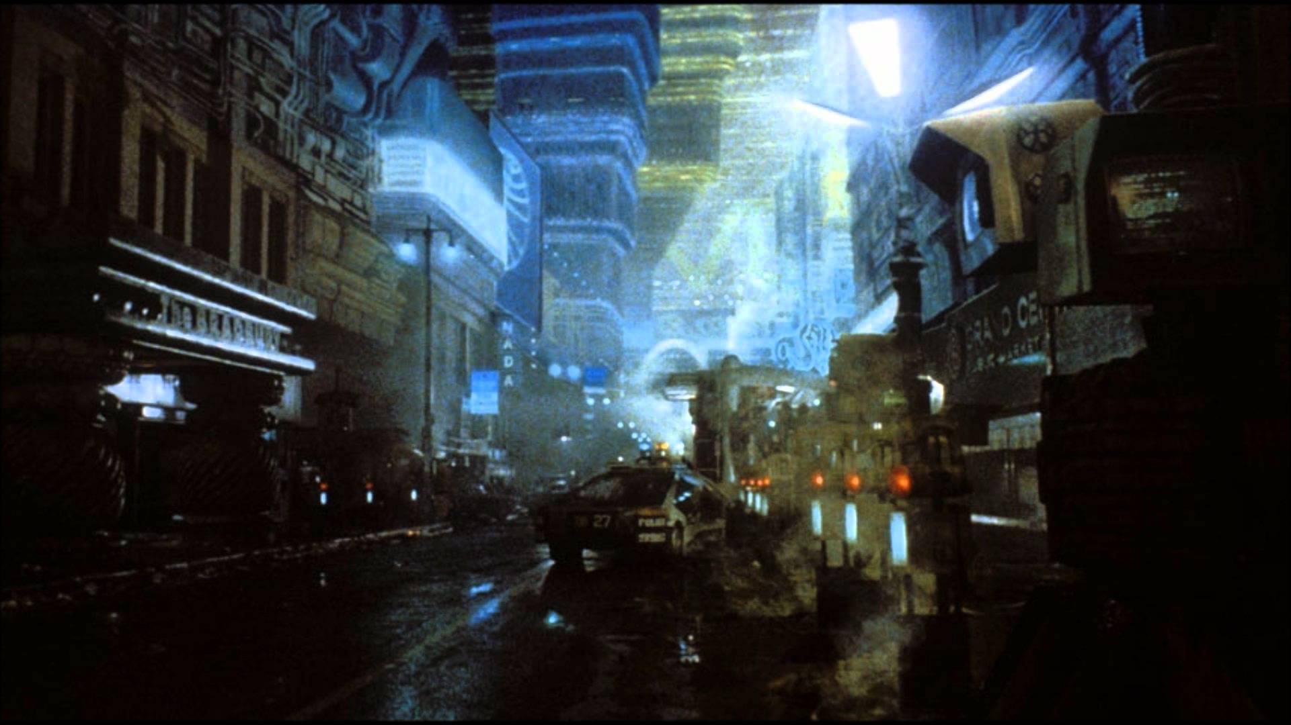
Cyberpunk is known for its dark environments where certain parts of the environment is in a neon radiant color (usually blue). Although, in certain aspect of cyberpunk genre the environment is not always as technologically advanced as one would believe. Cyberpunk characters and environments do usually show an aspect of technological advancement over society today with aspect such as; flying cars, physical upgrades, and equipment. In cyberpunk worlds humans become less attached to other humans around them as technology becomes the major power in society. Also, class difference is usually more defined as people with more money seem to look more human compared to lower class who have more bodily attachment as they become more cybernetic.
Steampunk is known for its bronze victorian design where the environment is industrialized with steam and copper. The characters of this genre vary from classy gentlemen and ladies to hardcore engineers and brutes. The sub genre combines aspects of the britain victorian era with those of the American wild west. This genre usually incorporates class with deadliness as characters dressed in more vibrant high class clothing end up being the more dangerous characters. Steampunk has evolved into a subculture in today's society as people wear dapper hats and canes in honor of the classy gentleman.

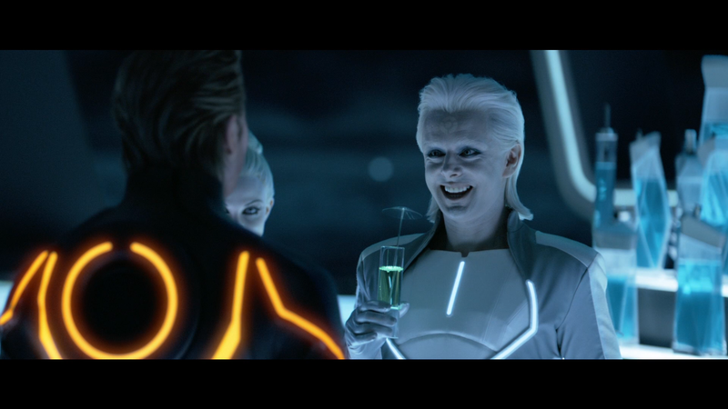

In many media today characters who live in a cyberpunk world show a distinct difference in style based on their social positioning. In the movie ‘TRON: Legacy’ directed by Joseph Kosinski in 2010, Zuse a flamboyant nightclub owner represents a character of higher social position. The character wears a white outfit compared to the others who wear a black outfit with white strips. Although, in the image Zuse is confronted by the current ruler of the grid Clu who wears the color black. Since the character is known for confrontation he uses the same color as his soldiers to identify his connection with them.
A famous steampunk film that started a rise in the steampunk subculture fashion was ‘Wild Wild West’ directed by Barry Sonnenfeld. The film involved many aspects of the genre mostly those involving the main villain Dr. Loveless. The character himself was in a steam powered wheelchair and operated a giant 80 foot mechanical steam spider. the setting of the movie took place in the old western times and the characters wore western/ victorian attire. The movie also portrayed examples of character who have been altered using steam technology as their is even a steampunk Frankenstein to fight the main hero.
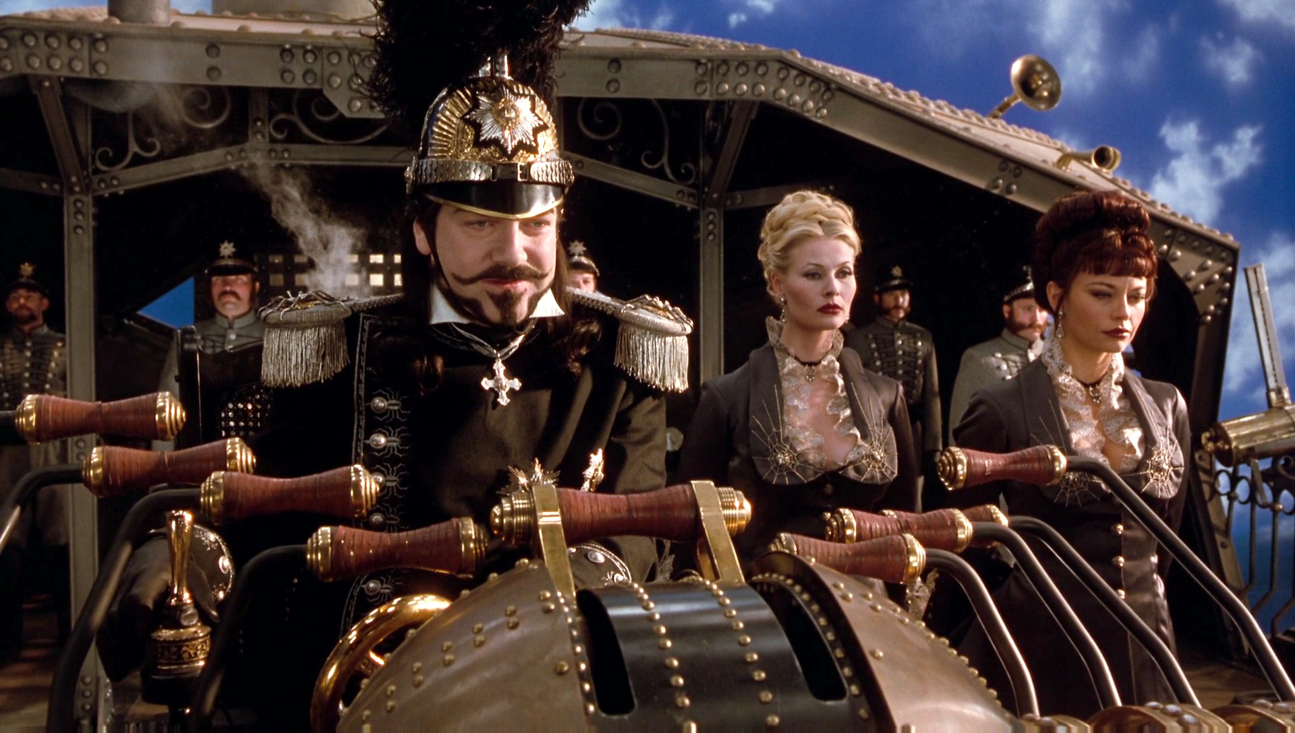
Cyberpunk was a baseline for the subculture cybergoth, which incorporate aspects of goth, raving, and cyberpunk. The term cybergoths is based on the Role Playing game ‘Dark Future’ created in 1988 and had not flourished as a fashion statement until the 2000s. Cybergoths are categorized by their style usually using the normal black attire as a basis but incorporating major color variety to their hair. Usually,
Cybergoths wear a dreadlocks which are normally referred to in their culture as cyberlocks which vary in many different neon colors.
In today's society steampunk fashion is present all across the world but not under a different name. The culture (which is rather expensive) has connected to the comic book and manga genre making their merchandise. The fashion basically consists of goggles or a top hat with a long coat and suspenders. The fashion statement also follows the game industry as now some merchandise are recognizable to games such as; Assassin's Creed, Final Fantasy, and Bioshock. The pursuers of this culture are not entirely known for patrolling the streets wearing their outfits like Cyber goths.
Both sub genres differ widely in terms of their overall style but they both share common items used. In the steampunk genre clocks and pocket watches or a very big part and usually are elegantly designed. Cyberpunk does not focus too much on them but their are usually digital and square. Steampunk uses vehicles such as blimps and steam powered cars as a mode as transportation. Cyberpunk uses blimps but with a more futuristic neon design and usually have flying cars. Finally, steampunk characters are known to wear brown old clothing compared to cyberpunk characters who usually wear black or white with neon patterns.
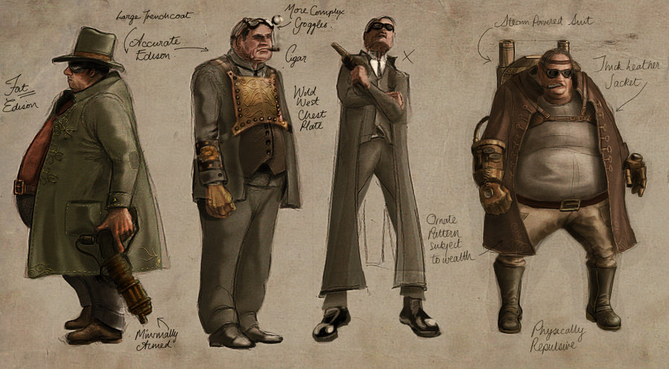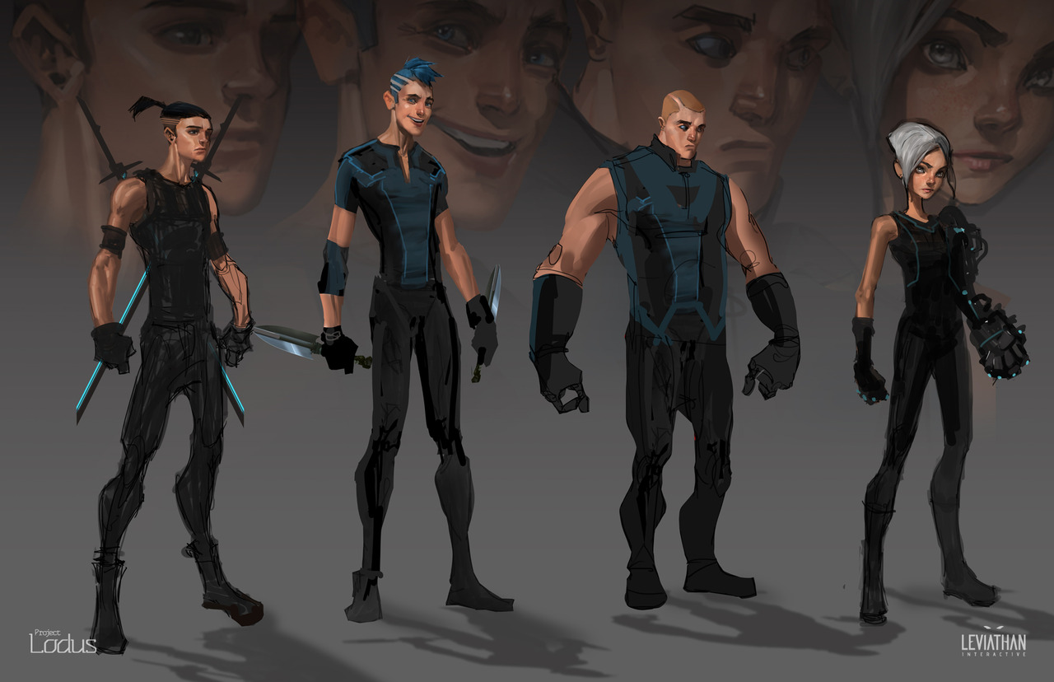

Work Cited
Falksen, G.D. "What Is Steampunk." What Is Steampunk. Web. 14 May 2015.
J., H. "Cyberpunk." Cyberpunk. Web. 14 May 2015.
"What Is Cyberpunk? - Definition from Techopedia." Techopedias. Web. 14 May 2015.
Tron: Legacy. Perf. Michael Sheen. Buena Vista Home Entertainment, 2011. Film.
Wild Wild West. Perf. Micheal Dunn. Warner Home Video, 1999. Film.
Berry, Bob, and Joey Marsocci. How to Draw Steampunk. Irvine, Calif.: Walter Foster, 2011. Print.
Le, Khang, and Mike Yamada. The Skillful Huntsman: Visual Development of a Grimm Tale at Art Center College of Design. Culver City, CA: Design Studio, 2005. Print.
Taylor, Geoff. How to Draw and Paint Science Fiction Art: A Complete Course in Building Your Own Futurescapes and Characters, from Scientific Marvels to Dark, Dystopian Visions. Hauppauge, N.Y.: Barron's, 2011. Print.
Landau, Lev Davidovic, and Evgenij Mihajlovic Ic. Mechanika. Wyd. 4. ed. Warszawa: Wydawnictwo Naukowe PWN, 2006. Print.

