**New York City College of Technology Of The City University Of New York**



**Electrical and Telecommunications Engineering Technology Department**

***Sensors and Instruments***

**Course: EET 3120 Section: E260**

**Experiment 2:**

**Graphical Programming in Lab VIEW**

**Name**

**Busayo Daramola**

Michaelangelo D. Brown

Zeeshan Ahmed

Experiment Date: Report Date: 02/25/2015 03/05/2015

Instructor: Prof. Viviana Vladutescu

Objective…….…………………………………………………………………………………….3

Equipment……………...………………………………………………………………….………3

Theory………………………………………………………………..…………………………3-4

Procedure…………………………………………………………………………..…….……….5

Result………………………………………………………………………….….……………6-8

Calculation……………………………………………………………………………………9-10

Conclusion………………………………………………………………………………………10

Reference……………………………………………………………………………………….10

**Objective**

This lab introduces the idea of a computer graphical programming instrument in the LabVIEW through building a simple instrument by using some tools from function palette workstation and controlling it with a LabVIEW program. The lab also gives a short tutorial for LabVIEW graphical programming and also to wire the circuit into LabVIEW to see how it works

**Equipment**

* Desk-top computer
* LabVIEW software

**Theoretical Background**

LabVIEW ties the creation of user interfaces (called front panels) into the development cycle. LabVIEW programs/subroutines are called virtual instruments (VIs). Each VI has three components: a block diagram, a front panel and a connector panel. The last is used to represent the VI in the block diagrams of other, calling VIs. The front panel is built using controls and indicators. Controls are inputs – they allow a user to supply information to the VI. Indicators are outputs – they indicate, or display, the results based on the inputs given to the VI. The back panel, which is a block diagram, contains the graphical source code. All of the objects placed on the front panel will appear on the back panel as terminals. The back panel also contains structures and functions which perform operations on controls and supply data to indicators. The structures and functions are found on the Functions palette and can be placed on the back panel. Collectively controls, indicators, structures and functions will be referred to as nodes. Nodes are connected to one another using wires – e.g. two controls and an indicator can be wired to the addition function so that the indicator displays the sum of the two controls. Thus a virtual instrument can either be run as a program, with the front panel serving as a user interface, or, when dropped as a node onto the block diagram, the front panel defines the inputs and outputs for the given node through the connector pane. This implies each VI can be easily tested before being embedded as a subroutine into a larger program.



***Figure 2-1 above shows the typical programming of Lab VIEW on Front Panel & Block Diagram Panel***

**PROCEDURE**

**The Voltage.vi**

For the first part of the experiment we created a simulation of a voltage ranging from 4.2 to 10. A random number generator was used to generate a number between 0 and 1. This number was then multiplied by 0.1 and added to 4.2 which resulted in a number in the range of 4.2 to 10.

To build this voltage simulator, the following steps were performed:

1. A Meter indicator was moved from Express>>Numeric Indicators in the Controls Palette and placed on a blank Panel. It was labeled Voltage. This is shown in Figure 2-2.
2. A Random Number (0-1) function was placed in the Diagram window from the Function Palette.
3. From Express>>Arithmetic& Comparison>>Express Numeric in the Function Palette, one multiply function, one Add function, and two Numeric Constant functions were placed in the Diagram window. The Numeric Constants were given the values 4.2 and 0.1.
4. The connections were made as shown in Figure 2-2.

**Experimental results:**

* **The Voltage. Vi**

This results shows that we have a temperature sensor that gives out voltage that is proportional with the temperature on the Celsius scale by using following equation:



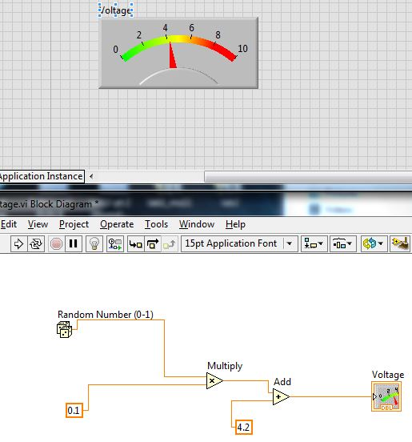

Figure 2-2: The Panel and Diagram for the Voltage.vi

Kelvin

Celsius 

Fahrenheit

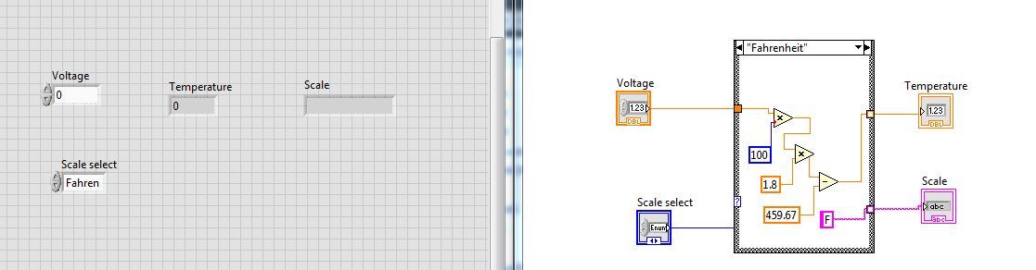

Figure 2-3: Connection of the Fahrenheit case structure

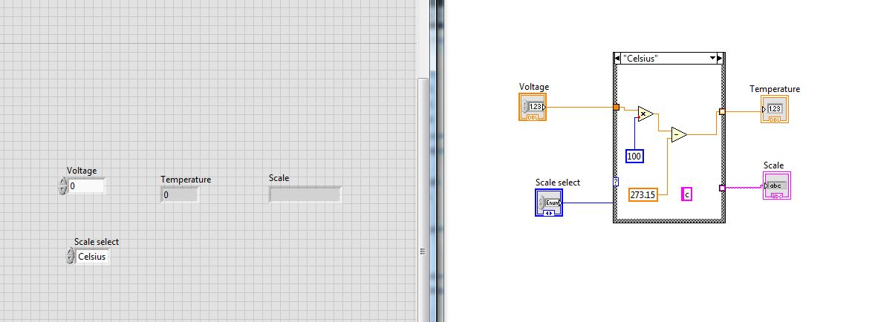

Figure 2-4: Connection of the Celsius case structure

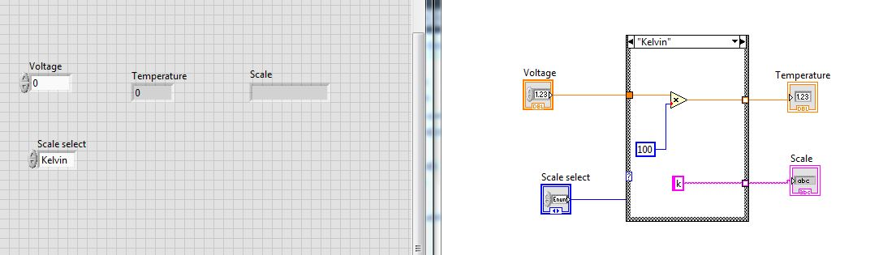Figure 2-5: Connection of the Kelvin case structure



Figure 2-6: Editing the Connector

$$V=R*a+b$$

|  |  |  |  |
| --- | --- | --- | --- |
| **Random No.** | **a** | **b** | **Voltage** |
| **1** | **0.4** | **2.9** | **2.9** |
| **1** | **0.5** | **4** | **4.2** |
| **1** | **0.6** | **4.5** | **4.9** |

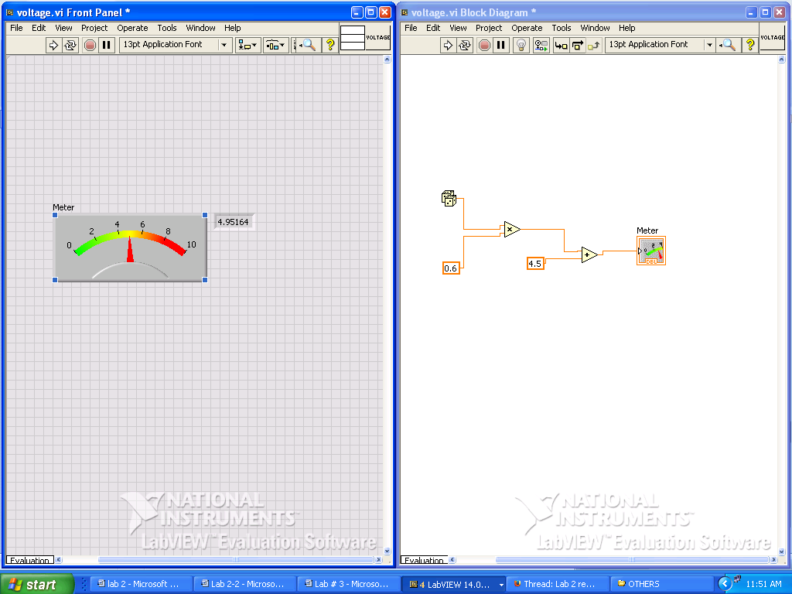

Figure 2-7: Shows

$V=R*a+b$ = 4.9

$V=1*0.6+4.5$ = 4.9

$$t\left[K\right]=U\left[V\right]*a$$

|  |  |  |
| --- | --- | --- |
| Voltage | a | K |
| 05 | 100 | 50 |
| 1 | 100 | 100 |
| 1.5 | 100 | 250 |

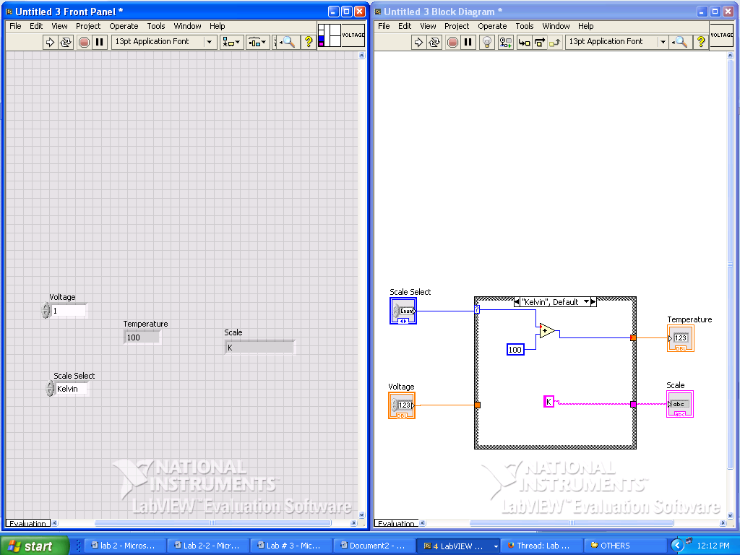

Figure 2-8: Shows

$K=V*a$ = 100

$V=1*100$ = 100

$$t\left[℃\right]=U\left[V\right]*a-273.15$$

|  |  |  |  |
| --- | --- | --- | --- |
| Voltage | a | b | Celsius |
| 1 | 100 | 273.15 | -73.15 |
| 2 | 100 | 273.15 | -73.15 |
| 3 | 100 | 273.15 | -73.15 |

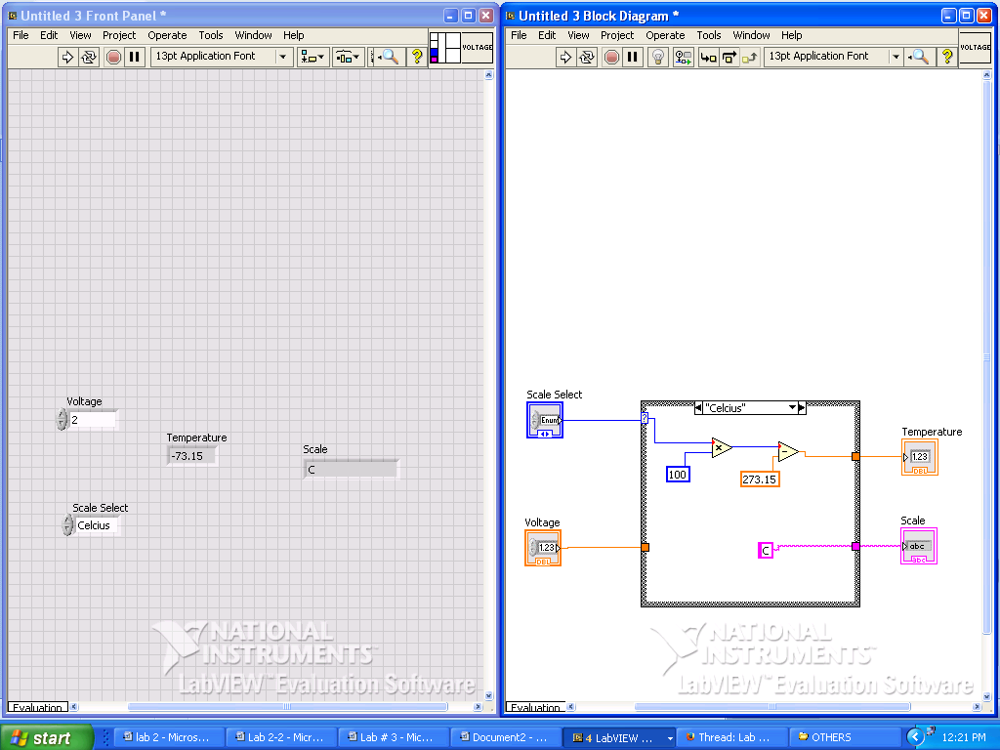

Figure 2-9: Shows

$C=V*a$-273.15 = -73.15

$C=2*100-273.15$ = -73.15

**Conclusion**

This experiment introduces my knowledge in the LABVEIW graphical programming son how I can manipulate and use the LabVIEW to see the relationship between voltage and temperature. Also, it showed me how to represent the voltage-temperature relationship on the lab view through graphical representation.

**Reference**

*EET 3120 Sensors and Instruments Laboratory Manual* by Professor Viviana Vladutescu, Spring 2015.