NEW YORK City College of Technology

Electrical and Telecommunication Engineering Technology Department
Workshop:
Learn to design Electronic Projects
Introduction to Arduino (keyboard Instrument)

EET 3120 Sensors and Instruments
Submitted To: Prof. VivianaVladutescu
Submitted By: Busayo Daramola
Semester: Spring 2015
Date: 05/8/2015

Introduction:
On May 8th, a workshop to design Electronic circuits with Arduino was organized by 2015 IEEE Club of NYCCT hosted by Prof. X. Wei who gave us the instruction and the basic idea on how to build the circuit, components included and details how to do the programming. IEEE Club also provides us all the components and program code.

Components:
- Arduino /Chipkit UNO 32.
- Breadboard.
- Desktop computer.
- MPEID or Arduino software
- Jumpers (wire).
- 2 – 10 KΩresistors
- 1 – 220Ω resistors.
- 1 – 1MΩ resistor.
- 4- Switch.
- Buzzer, Piezo

Procedure:
- Connected the Chipkit UNO32 Board to the personal computer.
- Typed the program provided to us by Professor Wei into MPLAB Editor Window.
- Made the following jumper connections on the Breadboard:
- Program the UNO32.
- Press the switches to check the circuit working.

CODES

int buttons[6];
// set up an array with 6 integers

int buttons[0] = 2;
// give the first element of the array the value 2 note that it counts from zero

int notes[] = {262, 294, 330, 349};
//corresponds to the notes C, D, E and F

void setup() {
Serial.begin(9600);
}

void loop () {
int keyVal = analogRead(A0);
Serial.println(keyVal);

if (keyVal == 1023){
tone(8, notes[0]);
}
else if (keyVal >= 990 && keyVal <= 1010) {
tone(8, notes[1]);
}
else if(keyVal >= 505 && keyVal <= 515) {
tone(8, notes[2]);
}
else if(keyVal >= 5 && keyVal <= 10) {
tone(8, notes[3]);
}

else{
noTone(8);
}
}

Experimental Results

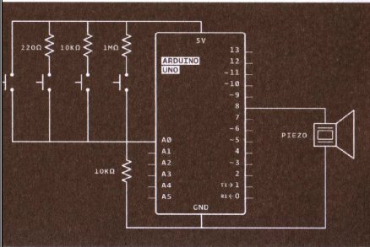
Figure # 1 shows the Circuit Diagram

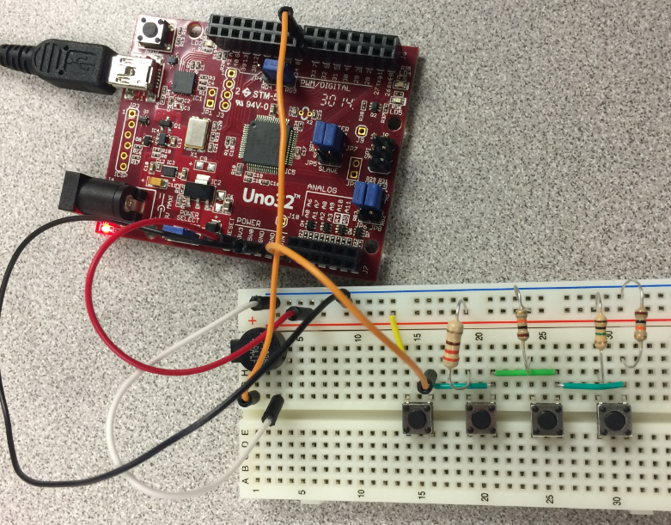
Figure # 2 shows the Keyboard Instrument after wiring

Conclusion
In this lab experiment, we first programmed our code into the UNO32 and then make the jumper wires connecting to the circuit and to the breadboard. We verify to make sure the connection is good and the right code is applied. We then press the switch one after the other to a get sound and by pressing the switches we get different sound.

