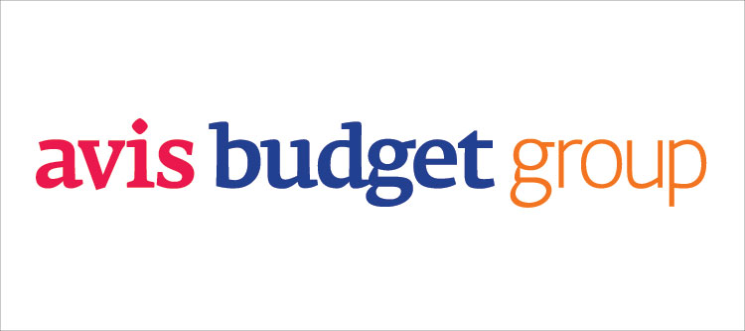 P.O. Box 699000

Tulsa, OK 74169-9000

800-352-7900

E-mail: [custserv@avis.com](mailto:custserv@avis.com)

October 16, 2013

Davis Theopolis

President, Wingnutty, Inc.

324 Chestnut Dr.

Crescent City, CA 95531

Dear Mr. Theopolis,

Thank you for sharing your feedback with us regarding your unsatisfying experience you had with our company’s new automated self-service phone system.

Avis Budget Group prides itself on convenience and strong customer service at AVIS Car Rental Company. We have established the Tellme and Voxify system, two of the industry’s prominent speech providers to reduce the amount of time for customers who can have their questions handled in a quick and efficient manner through the automated system.

Our agents handle between 16-20 million calls annually. Due to the high caller volume daily, many of the callers do not have the opportunity to speak with a representative immediately. On an average basis, customers’ need to wait a minimum of 3 minutes in order to get routed to a customer service representative. Such delay deprives our valued customer’s precious time and it is our sincere apologies in which they have to deal with the prolonged waiting periods.

Fortunately, our company has implemented a resolution dealing with the issue of lengthy waiting periods for our patrons. The solution of the new system eliminated the need for callers to supply personal data twice, or to have agents start the calls by confirming information already supplied. With this new automated system, the agent can begin the call by addressing the caller by name, mentioning the caller’s location, and then assisting to book the vehicle.

We appreciate your investment share of stocks in our company.Without your financial support, the corporation will not have the opportunity to address the issue presented above. Consequently, after the launch of the new implementation of the system, it has proven to satisfy customers’ needs and has saved our company approximately $1.5 million in the first year after the launching of the system. This has proved to be a win-win situation for both the customers and for the investors of our company.

I sincerely hope you will allow us the opportunity to continue serving you in the future at AVIS Car Rental Company. We value you as our customer.

Sincerely,

Jack Hemingsworth

Director of Customer Service

cc: Jack Hemingsworth and Corporate Communications

**Problem Evaluation Report**

Customer complaint #1:

He does not like to deal with robo-voices.

Customer complaint #2:

He may consider withdrawing investments from the company.

ABG’s position:

The company is in favor of the new automated system because not only did it improve customer service quality, but also help the company save $1.5 million.

How ABG’s position benefits customers:

* Eliminate the need for callers to supply personal data twice
* Gives callers a convenient self-service option for common tasks
* New customers would be able to have more time to speak with agents

How ABG’s position may disappoint customer:

* Some customers prefer human to human interaction, rather than speaking to a “robo-voiced” automated system
* Inconvenient for new customers who wants to book new reservations

The value of ABG’s position despite customer’s complaints:

* They value positive financial impact of the company
* “The company is increasingly successful in deflecting non-sales calls away from agents, so that more of the sales calls get through to them more quickly, and they can handle them more efficiently.”

What is ABG’s goodwill offering to close:

With the newly implemented mechanical phone system, the goodwill that the company is offering to customers is by providing them a quicker way to have their problems resolved.